Boxing against drones: Drones in sports education

This paper talks about how drones could be integrated into the sports, boxing in particular. The aim of the project was to design a drone application which would allow direct and embodied interaction. A concept application was developed and was compared against human boxing. Sports provide a context for very interesting applications, such as using drones as a jogging companion, fitness applications by being an interactive partner. The sport of boxing was chosen cause some of the drone's drawbacks could be beneficial. For example, the drone has a short flight time, but a boxing round only takes a few minutes. The drone is very fragile, and this quality can be used to fight, without harming the opponent. The important problem could be that physical contact with the drone could both harm the user and the drone. Box training also has scenarios like physical contact, training and also soft controlled physical defense training.

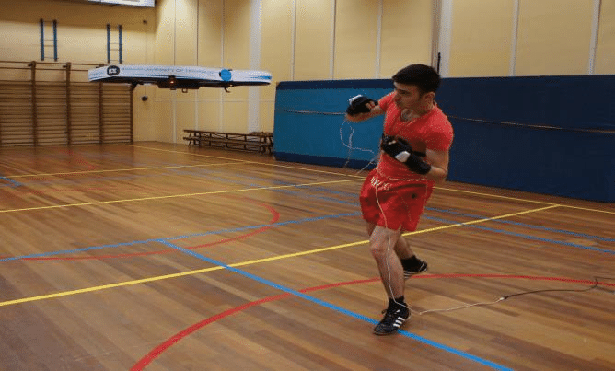

This experiment has three elements, the drone, the control application and body sensors placed in the user's boxing gloves. The drone is a flying quadcopter that has the ability to navigate indoor, locate its user and perform different preprogrammed patterns. We use an App to control the drone, to start or stop it and choose specific training programs. the sensor integrated to the

boxing glove provides information about the user's location, technique and force when hitting the drone. The drone is safe to use as it cannot cause any damage when colliding with the person. Since the drone was very fragile the experiment needed to be redesigned to minimize both the chance and force of impact, attempts were made to create an autopilot function, body sensor and flight control apps. Different situations were identified that didn’t include hitting the opponent, like walking, condition training, strategic training and shadow boxing.

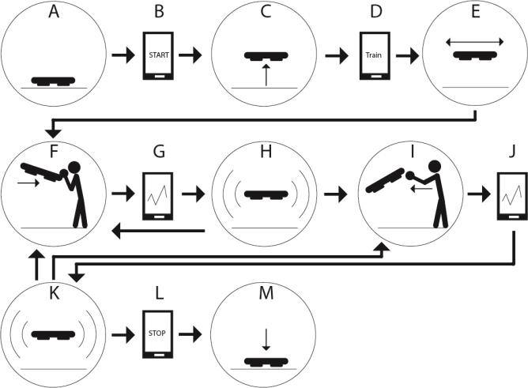

Beginning boxers were chosen as a target group and the following behaviors of the drone were recreated with the manually controlled drone.

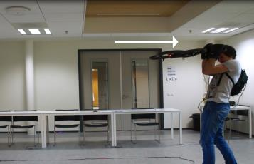 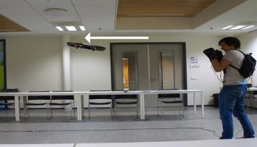

1. Attacking behavior 2. Defensive/feeling behavior

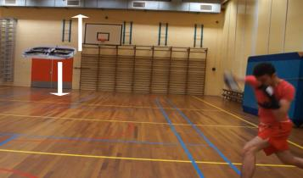 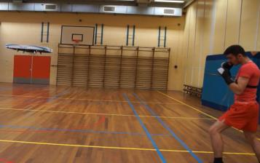

3. Non responsive behavior 4. Responsive behavior

**Results/Conclusion:**

They compared 5 Human Boxing participants with 6 Coach Bird participants. they were given a questionnaire with following categories; enjoyment, performance and performance with 2nd try. The results said that participants enjoyed more with the drone training program. The observer concluded that the slow response time of the drone influenced the exercise by decreasing its intensity. There were limitations of the drone, these limitations were described in the coach bird concept. In this process it was concluded that all the elements were very difficult to prototype, because of this some behavior were tele-operated by the control application. The research couldn’t prove the actual possibility of designing a box training drone but showed novel design opportunities for the future drone application. The quadcopter drone isn’t at the moment fast, stable, safe and robust enough for sparring exercises with impact, the drone can use flying movements to show behaviors which can instruct and inform users. In future drone research allows a realization of the Coach Bird concept, it could be possible to design more sports, game and education applications, based on this design, creating an opportunity to integrate these extraordinary technologies into our daily lives.