DIWASP

DIrectional WAve SPectra Toolbox
Version 1.3
For MATLAB

User Manual
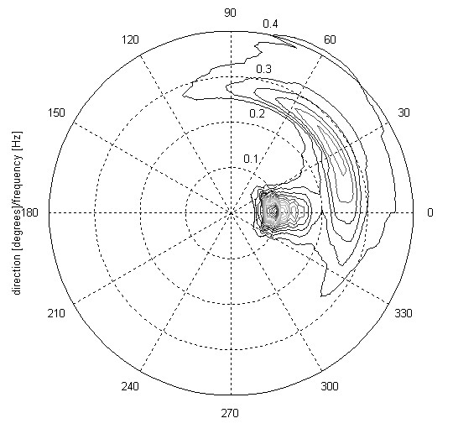

David Johnson

MetOcean Solutions Ltd

Contents
1. DIWASP overview 1
1.1. What is new in Version 1.3 1
1.2. Supported data types 1
1.3. Estimation methods 1
2. Installation 2
3. DIWASP Data Structures 2
3.1. The instrument data structure 3
3.2. The spectral matrix structure 4
3.3. The estimation parameter structure 6
4. DIWASP functions 9
4.1. dirspec 9
4.2. plotspec 10
4.3. writespec 11
4.4. readspec 11
4.5. infospec 12
4.6. interpspec 12
4.7. testspec 13
4.8. makespec 14
4.9. Internal functions 16
5. The DIWASP spectrum file format 17
6. Code, bugs and modifications 18
7. References 19

License agreement and disclaimer

DIWASP, is free software; you can redistribute it and/or modify it under the terms of the GNU General Public License as published by the Free Software Foundation.

This software is distributed in the hope that it will be useful, but WITHOUT ANY WARRANTY; without even the implied warranty of MERCHANTABILITY or FITNESS FOR A PARTICULAR PURPOSE. In addition the author is not liable in any way for consequences arising from the application of software output for any design or decision-making process.

This document should be referenced as:

“DIWASP, a directional wave spectra toolbox for MATLAB®: User Manual. Research Report WP-1601-DJ (V1.1), Centre for Water Research, University of Western Australia.”

DIWASP was originally developed at the Coastal Oceanography Group, Centre for Water Research, University of Western Australia, Perth.
It is now distributed and maintained by MetOcean Solutions Ltd., New Zealand (http://www.metocean.co.nz/software).

DIWASP overview
DIWASP is a toolbox of MATLAB functions for the estimation of directional wave spectra. Spectra can calculated from a variety of data types using a single function dirspec. Five different estimation methods are available depending on the quality or speed of estimation required. Miscellaneous functions are also included to manage the spectra files, plot the spectra and run tests on the estimation methods.

What is new in Version 1.3
Again no major changes to core functionality, but some minor additions, and tidying and improvements to the directional axis of the spectral matrix:
- Inclusion of new csd function (diwasp_csd.m) to remove dependence on Matlab signal processing toolbox.
- Specification of frequency and directional units for the spectral matrix.
- Conversion function between different matrices, including improved interpolation.

Supported data types
All the standard wave recorder data types are supported. These are:
- Surface elevation
- Pressure
- Current velocity components
- Surface slope components
- Water surface vertical velocity
- Water surface vertical acceleration

Estimation methods
Five different estimation methods can be used. Each has different levels of performance in terms of accuracy, speed and suitability for different data types:

- DFTM: Direct Fourier Transform Method (Barber 1961)
- EMLM: Extended Maximum Likelihood Method (Isobe et al.1984)
- IMLM: Iterated Maximum Likelihood Method (Pawka 1983)
- EMEP: Extended Maximum Entropy Method (Hashimoto et al.1993)
- BDM: Bayesian Direct Method (Hashimoto and Kobune1987)

The code for the implementation the EMEP and BDM methods are based on algorithms described by Hashimoto (1997). The IMLM method uses a modified algorithm based on the one described by Pawka (1983).
Performance tests of the different methods have been carried out by Hashimoto (1997) and Benoit (1993) for different measurement arrangements and spectral shapes.

Installation
DIWASP is simply a collection of MATLAB m-file functions which carry out the calculation of the directional spectrum and perform functions like plotting and reading/writing data files. To make sure the functions work correctly:
- Unzip or copy files to the same directory. This directory should be called “diwasp”.
- Supporting functions must remain in a subdirectory called private. If you move the main functions you must move this subdirectory and its files to the same location.
- Add the new directory called “diwasp” with the main files (dirspec,plotspec…etc..) to the MATLAB path. Do this using pathtool: see MATLAB help for details.
The functions operate in the same way as any other MATLAB functions. Type help [function name] for command-line help information. Type help diwasp at the matlab prompt for help overview of the package.

DIWASP Data Structures
Data structures are used to manage input and output data compactly. A structure is like a container and has a set of fields for each data types. Each field is referenced using the ‘.’ operator between the structure name and the field name. So Struct.A would references the data in field A of structure Struct. See the MATLAB help regarding structures if you are unfamiliar with these ideas. The advantage is that the entire data container can be passed as a single argument to various functions

There are 3 main data structures used in DIWASP:

- The instrument data.(ID) This contains the layout of the instrument sensors, the type of sensors and the actual sensor data itself.
- The spectral matrix.(SM) This is the output from the main calculation and contains fields which define the bins of the output matrix, the orientation of the axes system relative to true north and the spectral density itself.
- The estimation parameters.(EP) This contains all the information regarding how the directional spectrum estimation is actually carried out.

The variable names in brackets are used throughout to identify a structure of that type. Note however that each of the structures can be given an arbitrary unique name and then passed to the functions to carry out operations. As with any other structures however, the field names must not be changed. Each of the three main structures is discussed in more detail below.

The instrument data structure
The structure which defines the instrument data consists of five fields:

ID.data Measured wave data matrix - data in columns, one column per sensor

ID.layout Layout of the sensors - x,y,z in each column. x and y from arbitrary origin and z measured upwards from seabed (m)

ID.datatypes Sensor type. Enter as cell list: e.g. {'elev' 'pres'}
Currently supported:
'elev' surface elevation
'pres' pressure
'velx' x component velocity
'vely' y component velocity
'velz' z component velocity
'vels' vertical velocity of surface
'accs' vertical acceleration of surface
'slpx' x component surface slope
'slpy' y component surface slope

ID.depth Mean overall depth of measurement area (m)

ID.fs Sampling frequency of instruments - must be single figure for all(Hz)

Organizing your data for use with dirspec
There are 3 main fields associated with the actual input data. Each of these has one column for each instrument. The ID.data field contains the processed (e.g. cleaning and quality control at the instrument level) raw data from the instrument organized in sequential columns. E.g.:

ID.data= [0.3256 0.3421 0.4324
0.3345 0.5643 0.2345
0.3546 0.7658 0.1235
I₁(t₄) I₂(t₄) I₃(t₄)
…. … … ];

where I_{m}(t_{n}) is data from the m^{th} instrument at the n^{th} timestep. All of the data streams from each instrument must be the same length so that the complete matrix is of size[n by m];
The ID.layout field contains the data about the instrument layout. As with the ID.data field, each instrument has its own column with a row for x,y and z position respectively (x and y relative to arbitrary origin, z height above seabed). Continuing the example above, if the three instruments were pressure gauges spread in a triangle on the sea floor the layout field might be:

ID.layout = [ 0.0 5.0 -5.0
0.0 5.0 5.0
0.0 0.0 0.0];

The instrument positions are [0,0] ,[5,5] and [-5,5] on a coordinate system with the first sensor as the origin and the x axis defined to coincide with the x axis of the instrument setup (directions are returned relative to these axes).
The datatype field describes the sensor type using one of the defined sensor codes. These must be in single quotes and entered as a cell array using curly brackets. For the example above, this would be:

ID.datatypes = {‘pres’ ‘pres’ ‘pres’};

As a second example, if a directional current meter and a pressure sensor were all mounted on the same pod 0.5m above the seabed the layout and datatypes fields would be:

ID.layout = [ 0.0 0.0 0.0
0.0 0.0 0.0
0.5 0.5 0.5 ];
ID.datatypes = {‘velx’ ‘vely’ ‘pres’};
with ID.data placed in columns accordingly.

The sampling frequency, ID.fs must be the same for all of the sensors (data columns) and each data stream is assumed to be synchronous (i.e. data point no.254 is assumed to be from the same time for all instruments). The ID.depth field is an average for the sampling area and is used in calculations involving the linear dispersion relation.

The spectral matrix structure
The spectral matrix structure has four fields:

SM.freqs Vector of length nf defining bin centres of the spectral matrix frequency axis

SM.dirs Vector of length nd defining bin centres of the spectral matrix direction axis

SM.S Matrix of size [nf,nd] containing the spectral density

SM.xaxisdir The compass direction of the x axis from which angles are measured.
SM.funit Frequency units: can be ‘Hz’ or ‘rad/s’ [Default ‘Hz’]

SM.dunit Directional units: [Default ‘cart’]
‘rad’ : Cartesian radians
‘cart’ : Cartesian degrees (original DIWASP units)
‘naut’ : Absolute nautical bearing waves coming from

The layout of the spectral matrix is specified as a vector of evenly spaced frequencies, SM.freqs and a vector of evenly spaced directions, SM.dirs. These form the bin structure for the matrix and are the values are the centre of the bin (Figure 1). Frequencies (f) can be Hz or rad/s (SM.funit) and directions (θ) are specified in degrees or radians measured anticlockwise from the positive x axis. Version 1.3 also adds the option of direction in nautical convention – these are the direction the waves are coming from as a true compass bearing.
Internally, the orientation of a wave component is calculated relative to the x direction of the instrument layout and wave recorder directional components (Figure 2). SM.xaxisdir defines the compass direction of the x axis. In Figure 2 this would be 90º as with the axis orientation as shown by the north arrow. At the end of the estimation function, directions are converted to the user specified units SM.dunit.

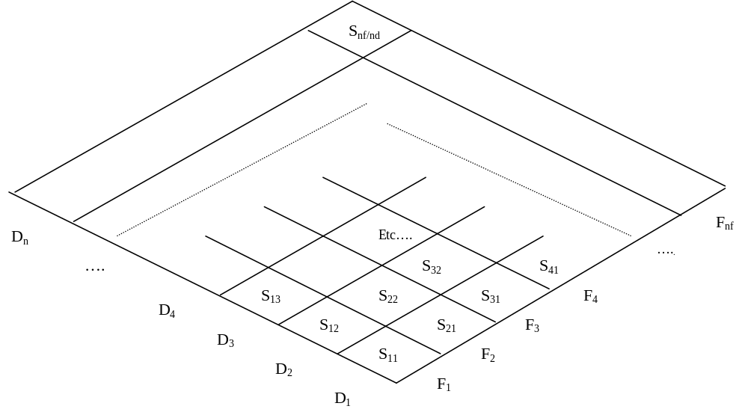
Figure 1 Spectral matrix layout for components S_{ij}. The frequency bin vector is F_{i}(1:nf) and the direction bin vector is D_{j}(1:nd).
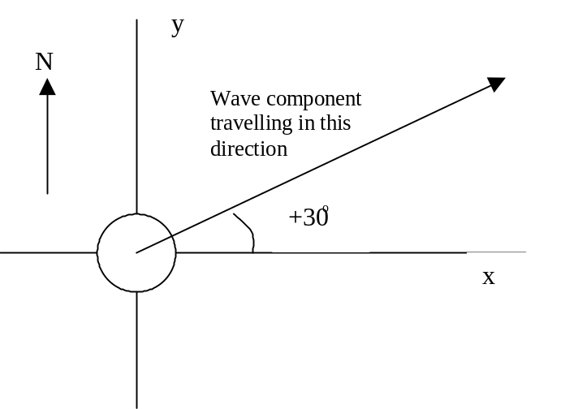
Figure 2 Orientation of direction relative to coordinate system for instrument layout and velocity components. With the compass orientation shown, the x axis direction is 90º in the file header.
The spectral density itself, SM.S is a matrix such that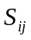 contains values of the spectral power density for the ith frequency and the jth direction. The energy is per unit [Hz.degree]. Therefore to convert to component wave amplitudes you need to multiply by the bin sizes df and d θ:
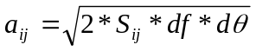
where 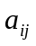 is the amplitude of the component with the ith frequency and the jth direction and is the value in the spectral density matrix. If you change between Hz & rad/s or degrees & rads then you must also convert the energy density value.

The estimation parameter structure
The structure which defines the estimation method and other parameters consists of five fields:

EP.method Estimation method used. Currently supported:
'DFTM' Direct Fourier transform method
'EMLM' Extended maximum likelihood method
'IMLM' Iterated maximum likelihood method
'EMEP' Extended maximum entropy principle
'BDM' Bayesian direct method

EP.nfft Number of DFTs used to calculate the frequency spectra: frequency resolution is ID.fs / EP.nfft

EP.dres Directional resolution of calculation itself specified as the number of directional bins which cover the whole circle. Note that the actual output resolution is determined by SM.dirs

EP.iter Number of iterations: this has various effects for different methods

EP.smooth Smoothing applied: 'ON' or 'OFF'

If any fields default settings will be used for the others if not directly specified.

Estimation methods
A full discussion of the relative merits or disadvantages of each method are beyond the scope of this manual. The papers by Hashimoto (1997) or Benoit (1993) are good places to start looking for more information. A brief summary of each method is given below:

- DFTM Very fast method that is good for an initial overview of the spectral shape. However directional resolution is poor and negative energy distribution sometimes occurs. Poor tolerance of errors in the data.
- EMLM Fast method that performs well with narrow unidirectional spectra. Can provide extremely good accuracy per computation time in some cases. Poor tolerance of errors in the data can lead to negative energy or even failure of the method.
- IMLM Refinement of the EMLM that iteratively improves the original EMLM estimate. Highly dependent on the quality of the original solution so will tend to perform poorly in the same situations as the EMLM. Will tend to reduce anomalies such as negative energy in the EMLM solution. Computation time directly dependent on number of refining iterations but provides good accuracy for reasonable computing time. Can overestimate peaks in the directional spectra by overcorrecting the original estimate.
- EMEP Good all-round method that accounts for errors in the data. Computation time is highly variable depending on how easily the iterative computation finds the solution. This method can be as fast as the IMLM(running with a default 100 iterations) and give far superior results. In other cases it is significantly slower. Low spectral energies at low and high frequencies can cause problems with the solution and slow the computation. In these cases the computation may need to be successively over-relaxed to achieve a converging solution. This is used as the default method.
- BDM Overall probably the best estimate but very computationally intensive. Computational expense is highly dependent on the directional resolution. As with the EMEP low energies can slow the computation due to the need for progressively relaxing the computation to achieve convergence. This method can also have problems with three quantity (i.e. pressure + velocities or heave-roll-pitch from a single location) measurements.

One recommended procedure for deciding which method to use is to use testspec to test a given instrument array with a directional spreading similar to what is expected from the data. This should give a good idea of the accuracy and speed of operation of each method. However testspec does not simulate errors which occur in real data.
Other tips (see options below for changing settings):
- All: Reduce the frequency resolution to increase computation speed
- EMEP/BDM: Reduce the directional resolution to increase computation speed
- EMEP/BDM: There is usually an optimal number of iterations to allow before the computation is relaxed. Too few and relaxation occurs when not necessary, too many and a lot of iterations are performed in cases where the computation does need to be relaxed..
- Use the EMEP or BDM method for data heavily contaminated with errors.
- If complete garbage comes out of the EMEP/BDM methods, do a check with the DFTM method. This method is very unlikely to blow up so if this does not produce something sensible, chances are the inputs are wrong.

Resolution of the estimation method

The fields EP.nfft and EP.dres control the resolution of the calculation and hence the maximum resolution that can be achieved in the output spectral matrix.

EP.nfft is the number of DFTs carried out in the calculation of the cross-power spectra. Higher numbers result in greater frequency resolution. This argument is passed to the function diwasp_csd, which performs the same function as the MATLAB function csd. The actual number of frequencies over which the directional estimation is performed is bounded at the upper limit by the highest value in the SM.freqs field. If EP.nfft is not explicitly specified a default value based on the sampling frequency is used.

EP.dres is the number of directional bins used in the estimation calculation. The computation is carried out for a complete circle of directions. The default setting of 180 therefore gives a bin size of 2 degrees. The actual directions of the bins in the output matrix are specified by SM.dirs and SM.dunit. Reducing this value can dramatically improve computation speed for the EMEP and BDM methods.

EP.smooth is a simple on/off switch that determines if smoothing is applied to the final spectra. This can be beneficial as it removes any spikes (which are in any case not physically likely) and by default is on. The smoothing algorithm uses a simple 5-point weighted average along both the frequency and directional axes.

Algorithm iterations

The IMLM, EMEP and BDM methods use an iterating algorithm. EP.iter sets the number of iterations which has a slightly different effect in each method. The exact effect is slightly different in each case. By default it is set to 100.
For the IMLM method this is the number of ‘improvement’ corrections carried out at each frequency. It therefore directly affects the computation time but higher numbers in theory give better results.
For the EMEP and BDM methods this value limits the number of iterations before the computation algorithm ‘relaxes’ the iterative calculation. Reducing this parameter does not necessarily lead to greater speed for these methods if the algorithm is not reaching the iteration limit.

DIWASP functions

dirspec
Main directional estimation routine. Takes measured data and information about sensors and returns the estimated directional spectrum.

[Smout,EPout]=dirspec(ID,SM,EP,{options})

Outputs:
SMout A spectral matrix structure containing the results
Epout The estimation parameters structure with the values actually used for the computation including any default settings.

Inputs:
ID An instrument data structure containing the measured data
SM A spectral matrix structure; data in field SM.S is ignored.
EP The estimation parameters structure. To use all default values enter an empty matrix:[ ].
{options} options entered as cell array with parameter/value pairs: e.g.{‘MESSAGE’,1,’PLOTTYPE’,2};
Available options with default values:
'MESSAGE',1, Level of screen display: 0,1,2 (increasing output)
'PLOTTYPE',1, Plot type: 0 none, 1 3d surface, 2 polar type plot, 3 3d surface(compass angles), 4 polar plot(compass angles)
'FILEOUT','' Filename for output file: empty string means no file output

Input structures ID and SM are required. EP must be included but can be input as an empty matrix if the default estimation parameters are required. {options} is an optional input.

dirspec calculates the directional spectra using internally defined frequency and directional bins.

The actual output is mapped onto the spectral matrix defined by SM.freqs and SM.dirs. For more information on the spectral matrix see section 3.2. Choosing a resolution that matches the resolution of the calculation is also important, as excessively small bin sizes will result in a memory hungry output that does not contain additional information. Also see the section 3.3.2 below for more information on setting the resolution of the calculation.

The options input allows you to control the screen and file output. These must be arranged in a cell array in parameter/value pairs as follows:
- 'MESSAGE' Default value=1
This sets the ‘noise level’ of screen display: 0 show minimal screen information, only showing the main calculation steps. 1 shows more information including the frequency being calculated and the model number in the case of the EMEP and BDM methods. With this setting (and 0) MATLAB warning messages are also suppressed. 2 outputs all available information including warnings and state of relaxation. Note that warnings regarding matrix solutions may be shown but the algorithms should deal with these in most cases.
- 'PLOTTYPE' Default value=1
This sets the type of plot output shown at the end of the calculation. Plot type 0 suppresses the plotting function, 1 - 4 are passed directly to plotspec as parameter ptype.
- 'FILEOUT' Default value=’’
This option sets the filename for the output file containing the calculated spectrum. This simply enables or disables a switch that calls writespec with input arguments SM and the filename. An empty string: ’’ means no file is output.

plotspec
Plotting routine for directional spectrum.

plotspec(SM,ptype)

Inputs:
SM A spectral matrix structure
ptype plot type:
- 3D surface plot
- polar type plot
- 3D surface plot (compass bearing angles)
- polar type plot (compass bearing angles)

The 3D surface plot type is a MATLAB surface plot with SM.freqs on the x axis, SM.dirs on the y axis and the spectral density, SM.S as the z value. The polar type plot is a MATLAB polar plot with the direction showing values in SM.dirs, the radius showing values in SM.freqs and contours representing the spectral density, SM.S. An example of the polar type plot is shown on the front cover of the manual.
For both plot types 1 and 2, the direction is the direction of propagation relative to the Cartesian axis.
For options 3 and 4 the direction is coming from as a true compass bearing (this has changed from previous versions).
Directions are corrected internally from the SM.xaxisdir and SM.dunit fields that define the orientation of the axes and directional units in the spectral matrix.

writespec
Function to write out directional spectrum in DIWASP format.

writespec(SM,filename)

Inputs:
SM A spectral matrix structure
filename String containing the filename including file extension if required

All inputs required
See 5.The DIWASP spectrum file format for information on the DIWASP format.

readspec
Function which reads in directional spectrum in DIWASP format.

[SM]=readspec(filename)

Outputs:
SM A spectral matrix structure containing the file data

Inputs:
filename filename for the file in DIWASP format including file extension

infospec
Function which calculates and displays information about a directional spectrum

[Hsig,Tp,DTp,Dp]=infospec(SM)

Outputs:
Hsig Signficant wave height
Tp Peak period
DTp Direction of spectral peak
Dp Dominant direction

Inputs:
SM A spectral matrix structure containing the file data

Hsig is the significant wave height. Tp is the peak frequency, the highest point in the one dimensional spectrum. DTp is the main direction of the peak period (i.e the highest point in the two-dimensional directional spectrum). Dp is the dominant direction defined as the direction with the highest energy integrated over all frequencies.

interpspec
Function which interpolates between different matrix bases

[SMout]=infospec(SMin, SMout)

Outputs:
SMout Output spectral matrix with interpolated spectral density

Inputs:
SMin A spectral matrix structure containing the input spectrum
SMout The spectral matrix specifying the frequency and directional axes.

The spectral density in SMout is ignored in the input, but needs to have frequency and directional axes defined.

testspec
Testing function for directional wave spectrum estimation methods.

[EPout] = testspec(ID,theta,spread,weights,EP)

Outputs:
EPout The estimation parameters structure used in the test.

Inputs:
ID An instrument data structure containing the measured data. The ID.data field is ignored.
theta vector with the mean directions of a sea state component
spread vector with the spreading parameters of a sea state component
weights vector with relative weights of sea state components
EP The estimation parameters structure with the values under test used. Default settings are used where not specified.

All inputs are required
Testspec details:

The fields ID.layout and ID.datatypes and ID.depth are used to specify the arrangement of the imaginary sensors.

The function outputs a plot of the specified spreading function (solid line) and the estimated spreading shape (dotted line).

The calculation is carried out for a frequency of 0.2 Hz.

The inputs theta, spread and weights determine the shape of the directional spreading function. Each of these inputs is a vector of length n where n is the number of sea state components. Each sea state component has a mean direction and a spreading parameter. The directional spreading is calculated with a cosine power function (Mitsuyasu et al.1975):

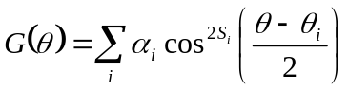

where 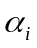 is the weighting value, weights(i), 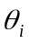 is the mean direction, theta(i) and S_{i} is the spreading parameter, spread(i) where i=1…n.

The weights are normalized so that:

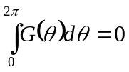

Typical values for the spreading function would be 10 (wind waves) to 75 (narrow banded swell).

testspec provides a powerful and quick way of testing the estimation functions for specific instrument layouts. Note however that there are no errors simulated so the pseudo cross power spectra are clean in that respect. This may cause the methods to perform better than they would with similar real data.

makespec
Function to generate an idealized directionally spread spectrum and fake data for testing estimation routines.

[SM,IDout]=makespec(freqlmh,theta,spread,weights,Ho,SM,ndat,noise)

Outputs:
SM Spectral matrix structure of the generated spectrum
IDout Returns the input ID with data in field ID.data filled

Inputs:
freqlmh 3 component vector [l p h] containing the lowest frequency(l),peak, frequency(p) and highest frequency(h)
theta vector with the mean directions of a sea state component
spread vector with the spreading parameters of a sea state component
weights vector with relative weights of sea state components
Ho RMS wave height for generated spectrum
ID An instrument data structure; field ID.data is ignored
ndat length of simulated data
noise level of simulated noise: Gaussian white noise added with variance of [noise*var(eta)]

All inputs are required

The generated spectrum is plotted on the screen and written to a file called ‘specmat.spec’ in DIWASP file format. The spectrum has 50 frequency bins and 60 directional bins. The frequencies are spread between freqlmh(1) and freqlmh(3). Directions cover a complete circle.

The input ID specifies the imaginary layout and type of the instruments for which the pseudo data is generated. The length of the data is ndat with a sampling frequency of ID.fs.

The input noise allows the addition of noise to the fake data to more closely simulate real sensor outputs. The noise added is gaussian white noise with a variance of noise*var(eta) where var(eta) is the variance of the simulated data eta before addition of noise. The input noise should be set to zero for a clean signal.

The simulated spectrum is constructed using a TMA spectral shape (Bouws et al.1985):

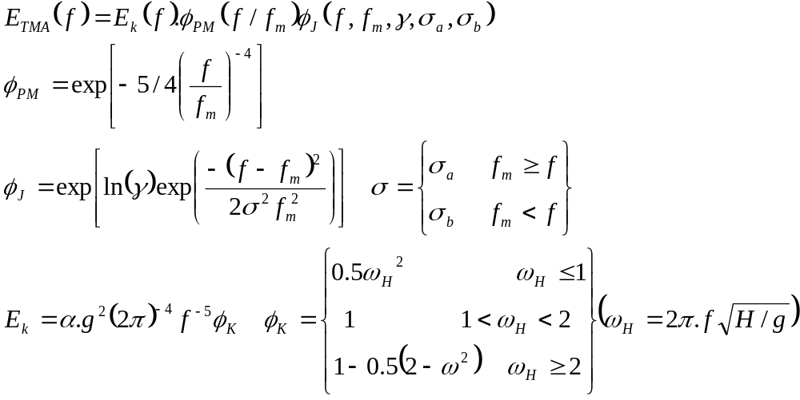

where H is the depth and 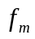is the dominant frequency, input freqlmh(2) and the other parameters are constants set internally to:
= 0.014
= 2
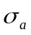= 0.07
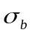= 0.09

The spectrum is scaled so that it has H_{rms} equal to the input Ho. The directional spreading is calculated as described in Error: Reference source not found using inputs theta, spread and weights.

Internal functions
The functions contained in the private subdirectory are used internally.

Transfer functions
The transfer functions map a surface elevation to an equivalent instrument response for a given depth. The transfer functions have the same name as the datatypes described in The instrument data structure.

New transfer functions or estimation methods can be incorporated by simply including a new transfer function m-file and then using calling the filename as a new datatype argument. New transfer functions must operate as follows:

[trm]=newf (ffreqs,ddirs,wns,z,depth)

ffreqs is a column vector of size [nf,1] and ddirs is a row vector of size [1,nd] containing the frequency and direction bins of the calculation (as distinct from the spectral matrix bins). wns is a vector the same size as ffreqs of wavenumbers corresponding to the frequencies.

z is the height of the instrument sensor above the bed and depth is the total mean depth of the instrument location.

trm must be returned as a size[nf,nd] matrix with the [i,j] element corresponding to the transfer function for the i^{th} frequency and the j^{th} direction.

Other functions
Some of the private functions may be useful as stand alone functions for other applications. These include:

wavenumber.m Calculates wavenumbers for given frequency and depth from linear wave dispersion relation.

makerandomsea.m Creates a random surface elevation for a given spectrum of component amplitudes. Useful for visualising sea states.

makewavedata.m Make random sea elevation data for a specified spectrum and layout of probes.

diwasp_csd.m Replacement function for Matlab csd/cpsd that only requires inbuilt fft function.

Usage is described in the command line help

The DIWASP spectrum file format

DIWASP uses its own format for storing the spectrum files. It is intended to be simple and easy to incorporate into other software on any platform.
The file format consists of a single ASCII stream of numbers. The header section contains information about the layout of the spectral matrix, and the body of the file contains the energy of each component.

Position in file | Type(FORTRAN)
1 | Real | Compass direction of x axis
2 | Integer | Number of frequency bins (nf)
3 | Integer | Number of directional bins (nd)
4..  nf+3 | Real | List of frequencies starting with low values  This is the vector SM.freqs
nf+4..  nf+nd+3 | Real | List of directions starting with low values  This is the vector SM.dirs
nf+nd+4 | Integer | Value:999 Marks end of the header
nf+nd+5..  nf+nd+(nf*nd)+4 | Real | Spectral density for each bin with frequency as the outside of the loop*  This is the matrix SM.S
*All the directions are given for the first frequency then all for the second frequency etc.

The FORTRAN code for reading the spectral density is:

do i=1,nspec
do j=1,ndir
read(##,*) S(i,j)
enddo
enddo

A Fortran subroutine readspec.f with code to read the DIWASP format is provided with the DIWASP package.
The functions readspec.m and writespec.m read and write from DIWASP spectral matrix structures to DIWASP file format.

Code, bugs and modifications
DIWASP is written to be functional and easy to use. Although V1there is some error checking, this really only verifies the shapes of the inputs, not whether they make sense. If you are getting garbage out of dirspec check your inputs - chances are they are somehow incorrect.
The code has not been fully streamlined to keep the program structure clear and user modification of code should be relatively easy. This does mean however that the functions do not run as fast as they might, although recent versions of MAtlab have improved execution speeds. If you want high-end performance some modification will help or rewrite code in Fortran or similar.
Updated versions of DIWASP will be made available as and when they are produced. I am grateful for the bug reports and suggestions I have received to date. If you find bugs in the code, have any suggestions for modifications or, more seriously, find errors in the actual algorithms, please contact the author:

Email: d.johnson@metocean.co.nz
David Johnson
Metocean Solutions Ltd. (www.metocean.co.nz)
New Zealand

This version of DIWASP is freeware and doesn’t come with any kind of official support. It is intended for the benefit of the coastal and ocean science community. Hopefully it might save you some time in analysing your wave data.

Good luck and enjoy.

References

Barber,N.F. (1961) The directional resolving power of an array of wave detectors, Ocean Wave Spectra. Prentice Hall. Inc. pp.137-150
Benoit,M. (1993) Practical comparative performance survey of methods used for estimating directional wave spectra from heave-pitch-roll data. Proc.23rd ICCE Vol 1. ASCE pp.62-75
Bouws,E., Gunther,H., Rosenthal,W. and Vincent,C.L. (1985) Similarity of the wind wave spectrum in finite depth water. 1.Spectral form. J.Geophys.Res. 90(C1) 975-985
Hashimoto,N. (1997) Analysis of the directional wave spectra from field data. Advances in Coastal and Ocean Engineering Vol.3. ed.Liu,P.L-F. World Scientific, Singapore. pp.103-143
Hashimoto,N. and Kobune,K. (1988) Estimation of directional spectrum from a Bayesian approach. Proc.21st ICCE Vol 1. ASCE pp.62-72
Hashimoto,N. Nagai,T and Asai,T. (1993) Modification of the extended maximum entropy principle for estimating directional spectrum in incident and reflected wave field. Rept. Of P.H.R.I. 32(4) 25-47
Isobe,M., Kondo,K. and Horikawa,K. (1984) Extension of MLM for estimating directional wave spectrum. Proc. Symp. on Description and Modeling of Directional Seas, Paper No.A-6. 15pp.
Mitsuyasu,H. et al.(1975) Observation of the directional spectrum of ocean wave using a cloverleaf buoy. J.Phys.Oceanogr. 5 750-760
Pawka,S.S.(1983) Island shadows in wave directional spectra. J.Geophys.Res. 88(C4) 2579-2591

Note that no correction is carried out for the effect of a mean current even when the velocities are given as part of the input data. Results may be significantly affected in the case of strong mean currents. In these cases, the data must be pre-processed before use in DIWASP.

