***Derangement***

In combinatorial mathematics, a derangement is a permutation of the elements of a set, such that no element appears in its original position. In other words, derangement is a permutation that has no fixed points.

**Example:**

The derangements of $\{1,2,3\}$ are $\{2, 3, 1\}$ and $\{3, 1, 2\}$, but $\{3,2, 1\}$ is not a derangement of $\{1,2,3\}$ because 2 is a fixed point.

**Formula:**

Let D(n) be the number of derangements for n different objects, then

$$D_{n}=n!\sum_{k=0}^{n}{\frac{{(-1)}^{k}}{n!}}$$

**Proof of formula:**

Let there be $n$  distinct objects with their $n$  distinct respective positions. Then the number of derangements is $n$ !-N where N is the number of ways of arranging the $n$ objects in such a way that at least one object goes to its right position.

Therefor,

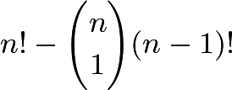.

Again,

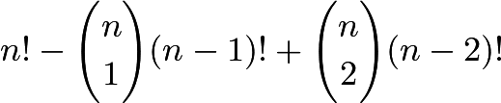.

PIE continues to give us this pattern. Now, we can change the form of 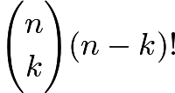. This is written as 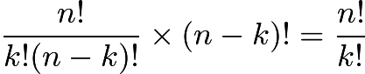. We can now write our relation as  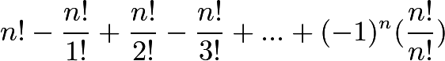. We can factor out $n!$ and get 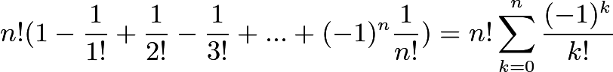.

**Limit as n approaches $\infty$:**

From the recurrence $!n=n\cdot!(n-1)+(-1)^{n}$, we can find that 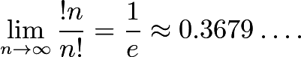

Also, 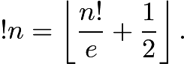

**Permutations having at least one fixed point**

The number of permutations $f_{n}=n!-!n$  = n!- $n!\sum_{k=0}^{n}{\frac{{(-1)}^{k}}{k!}}$ = $n!\sum_{k=1}^{n}{\frac{{(-1)}^{k}}{k!}}$

where the second summation gives the empty sum for n=0.

**Derangement problem:**

### Soppose,6 people removed their coats entering in the hall.What is the probability that no gets coat?

Using complementary probability, we see that there are 6!  ways to give out the coats. The number of ways where nobody gets their coats is

$6!(\frac{1}{0!}-\frac{1}{1!}+…+\frac{1}{6!}$)

=6! -6! + $\frac{6}{2!}$- .... +1 =256