  **UMMALETI SAI NIKHIL**

**Visakhapatnam, Andhra Pradesh,530018|+91-7416626903**

[**nikhilummaleti121@gmail.com|21981a05h4@raghuenncollege.in**](mailto:nikhilummaleti121@gmail.com|21981a05h4@raghuenncollege.in)

**www.linkedin.com/in/ummaleti-sai-nikhil-49598a279**

**Career Objective:**

I aim to obtain a position as a full-stack developer where I can utilize my knowledge to develop scalable and efficient web applications and contribute to innovative projects.

**Educational Details:**

* Bachelor Of Technology | JNTUGV | 2021-2025

RAGHU ENGINEERING COLLEGE, VISAKHAPATNAM

COMPUTER SCIENCE AND ENGINEERING

- 6.74 CGPA

**Work Experience:**

**Asset Management Internship| Frontend Developer | 12/06/2024 – 23/07/2024**

* Developed a web-based asset management system to track and manage workable and non-workable computers in a laboratory setting.
* The system enables administrators to efficiently store, update, and retrieve information about lab computers, ensuring accurate inventory management and reducing downtime.

**SKILLS:**

* Front-end: HTML, CSS, JavaScript
* Python(Basic)
* Database: MYSQL
* MS Word
* MS Excel

**PROJECT:**

**TITLE: AIRFARE PRICE PREDICTION**

* It was developing a sophisticated system to predict flight ticket prices using a combination of GRU and LSTM networks. Enhanced the model by incorporating additional data like weather, events, economic indicators, and historical fare trends to improve prediction accuracy.
* Integrated an attention mechanism to enhance interpretability and performance. Fine-tuned the model with advanced hyperparameter optimization techniques to achieve the best results.
* The system was built using Python, TensorFlow, Keras, and Scikit-learn, ensuring real-time and precise fare predictions.
* This model provides valuable insights for travelers and airlines, helping in better planning, decision-making, and revenue optimization.
* It stands out by effectively capturing complex patterns and dependencies in ticket prices, offering a significant improvement over traditional forecasting models.

**CERTIFICATES:**

* NPTEL (Introduction To Internet Of Things) -63%
* SKILLDRIZE (Full stack java)
* TECH OCTANET(Web Development Internship)

**Strengths:**

* Hard worker
* Friendly nature
* Positive attitude

**Declaration:**

* I request your good self to consider my application favorably and allow me to serve under your Guidance. I assure your good self that I will strive hard to bring credit to your Esteemed Organisation. I now declare that the above information is true to my knowledge and belief.

**Place:**

**Date:**

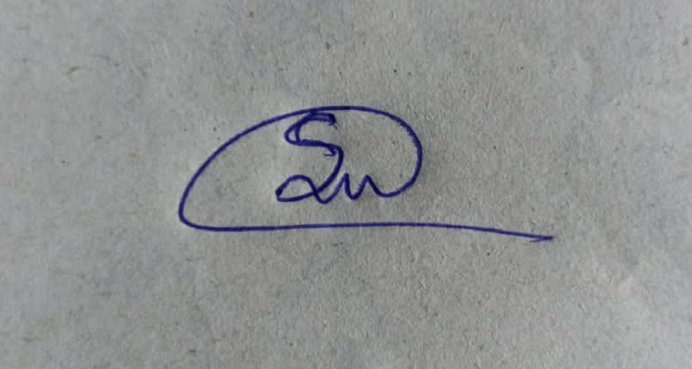

**(UMMALETI SAI NIKHIL)**