BANK CUSTOMER CHURN
ANALYSIS

Exploratory Data Analysis and Visualization Using Python
Prepared by: Aiman
Internship Project
2026

1. Project Overview
This project analyzes a bank customer churn dataset containing 28,382 customer records to understand patterns related to customer demographics, account balances, transaction activity, customer relationship duration, occupation, customer net-worth category, and churn status.
The project follows a data-analysis workflow including data understanding, data cleaning, exploratory data analysis, statistical analysis, correlation analysis, and visualization using Python.
The main purpose of the project is to identify patterns and characteristics associated with customer churn and to generate useful insights that can support customer retention analysis.
2. Objectives
- Analyze the overall distribution of customer churn.
- Understand customer demographic characteristics.
- Examine the relationship between age and customer churn.
- Compare churn rates between male and female customers.
- Analyze churn across different occupation categories.
- Compare churn rates across different age groups.
- Examine the relationship between dependents and churn.
- Analyze customer net-worth categories in relation to churn.
- Examine account balance and transaction-related variables.
- Analyze the relationship between vintage and churn.
- Analyze transaction recency and customer churn.
- Identify correlations between important numerical variables.
- Create meaningful visualizations to present the findings.
- Provide useful insights and recommendations based on the analysis.
3. Dataset Description
The dataset contains 28,382 customer records and 22 variables.
The dataset includes information related to customer demographics, customer relationship duration, occupation, city, customer net-worth category, account balances, credit and debit transactions, last transaction date, and customer churn.
Important variables include:
- customer_id — Unique customer identification number
- vintage — Customer relationship duration
- age — Age of the customer
- gender — Gender of the customer
- dependents — Number of dependents
- occupation — Customer occupation
- city — Customer city
- customer_nw_category — Customer net-worth category
- current_balance — Current account balance
- previous_month_end_balance — Previous month's ending balance
- current_month_credit — Current month credit
- previous_month_credit — Previous month credit
- current_month_debit — Current month debit
- previous_month_debit — Previous month debit
- current_month_balance — Current month balance
- previous_month_balance — Previous month balance
- churn — Customer churn indicator
- last_transaction — Date of the customer's last transaction
- age_group — Categorized age group
4. Tools and Technologies
- Python
- Pandas
- NumPy
- Matplotlib
- Seaborn
- Jupyter Notebook
- VS Code
- Microsoft Word
5. Data Cleaning
The dataset was examined and cleaned before performing the exploratory analysis.
Missing values were identified in several columns.
The missing values were handled as follows:
- Missing values in gender were replaced with "Unknown".
- Missing values in occupation were replaced with "Unknown".
- Missing values in city were replaced with "Unknown".
- Missing values in dependents were replaced using the median value.
- Missing values in last_transaction were not replaced with artificial dates because doing so could introduce misleading transaction information.
The original dataset contained the following missing values:
Column | Missing Values
Gender | 525
Dependents | 2,463
Occupation | 80
City | 803
Last Transaction | 3,223
Duplicate checking was also performed.
Validation Results
- Duplicate rows: 0
- Total records: 28,382
- Total variables: 22
- Missing values in churn: 0
6. Exploratory Data Analysis
Exploratory Data Analysis was performed to understand customer characteristics and identify patterns associated with customer churn.
6.1 Customer Churn Distribution
The dataset contains:
- 23,122 non-churned customers
- 5,260 churned customers
- Overall churn rate: 18.53%
The analysis shows that the majority of customers did not churn, while approximately 18.5% of customers were classified as churned.
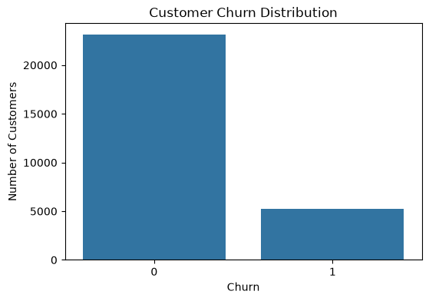
6.2 Age Distribution
The age distribution of customers was analyzed to understand the demographic structure of the dataset.
The visualization shows the distribution of customers across different ages and helps identify the common age ranges within the dataset.
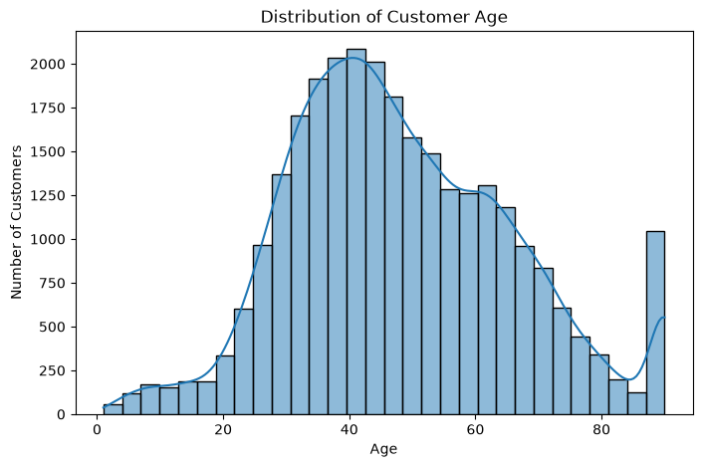
6.3 Age vs Churn
The relationship between customer age and churn was examined using visualization.
The age distributions of churned and non-churned customers overlap considerably. This suggests that age alone does not strongly distinguish between churned and non-churned customers.
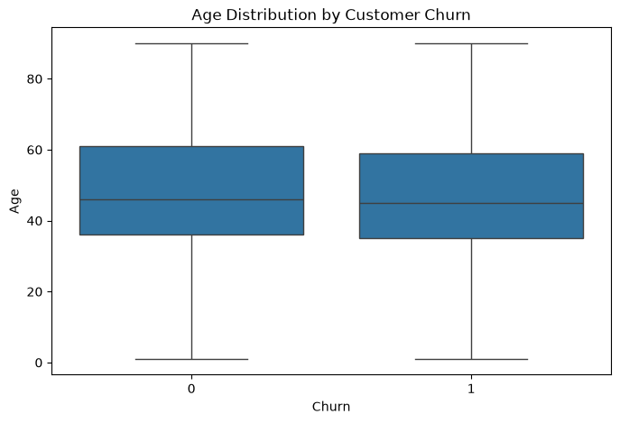
6.4 Gender vs Churn
Gender-based churn rates were analyzed to identify differences between male and female customers.
The churn rate among male customers was approximately 19.15%, while the churn rate among female customers was approximately 17.55%.
Male customers therefore showed a slightly higher churn rate. However, the difference was relatively small.
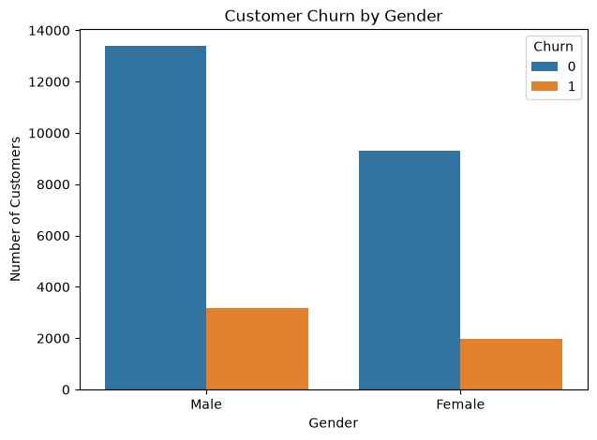
6.5 Occupation vs Churn
Customer churn was analyzed across different occupation categories.
The analysis showed noticeable differences in churn percentages between occupation groups. Comparing percentages is more useful than comparing only the number of churned customers because occupation groups may contain different numbers of customers.
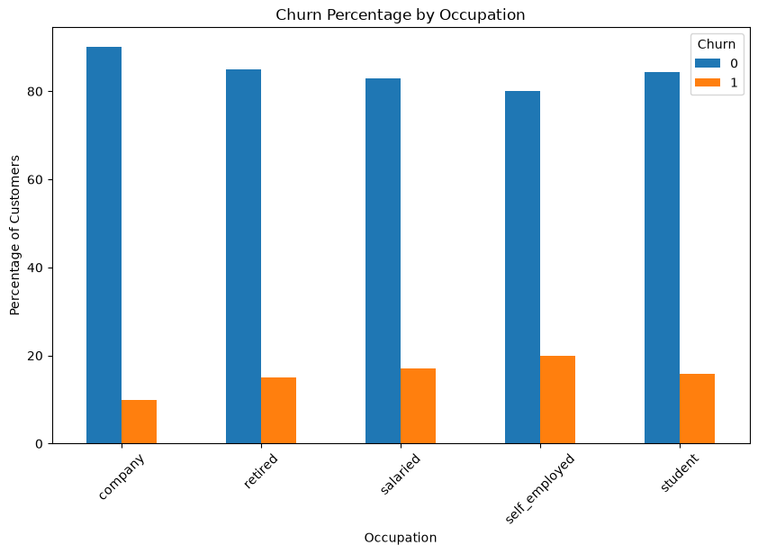
6.6 Age Group vs Churn
Churn rates were compared across different age groups.
The 26–35 age group showed the highest churn rate at approximately 20.46%.
The 46–55 age group had a churn rate of approximately 19.46%.
The 65+ age group showed the lowest churn rate at approximately 15.83%.

6.7 Dependents vs Churn
The relationship between the number of dependents and customer churn was examined.
The visualization shows the distribution of churn among customers with different numbers of dependents.
[INSERT DEPENDENTS VS CHURN GRAPH HERE]
6.8 Customer Net-Worth Category vs Churn
Customer churn was compared across different customer net-worth categories.
The visualization helps identify differences in churn distribution between the various financial customer categories.
[INSERT CUSTOMER NET-WORTH CATEGORY VS CHURN GRAPH HERE]
6.9 Current Balance vs Churn
The current account balance was analyzed in relation to customer churn.
The current_balance variable contains significant extreme values. Therefore, a logarithmic scale was used to make the distribution easier to visualize.
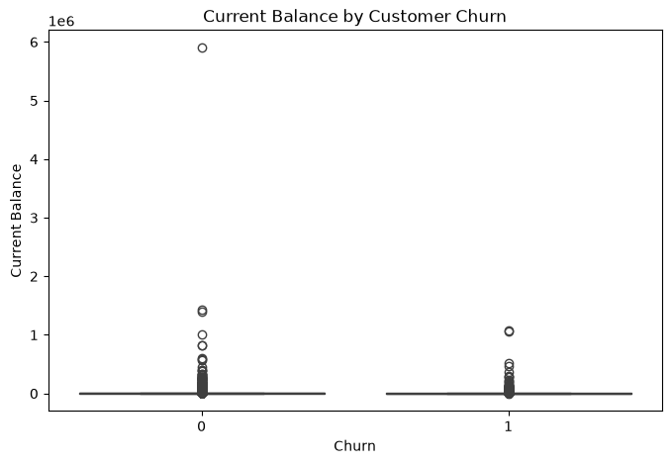
6.10 Current Month Credit vs Churn
Current-month credit activity was compared between churned and non-churned customers.
The visualization helps examine whether recent credit activity shows differences between the two customer groups.
6.11 Current Month Debit vs Churn
Current-month debit activity was analyzed in relation to customer churn.
The visualization helps identify differences in debit behavior between churned and non-churned customers.
6.12 Vintage vs Churn
The vintage variable represents the duration of the customer's relationship with the bank.
The distributions of vintage for churned and non-churned customers are relatively similar. This suggests that customer relationship duration does not show a strong association with churn.
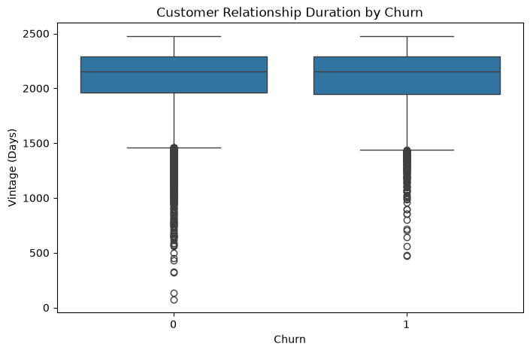
6.13 Transaction Recency vs Churn
Transaction recency was calculated using the latest available transaction date as the reference date.
Among customers with available transaction dates, the mean transaction recency was approximately 70 days, while the median was approximately 30 days.
The analysis helps examine whether customers with different levels of transaction recency show different churn behavior.
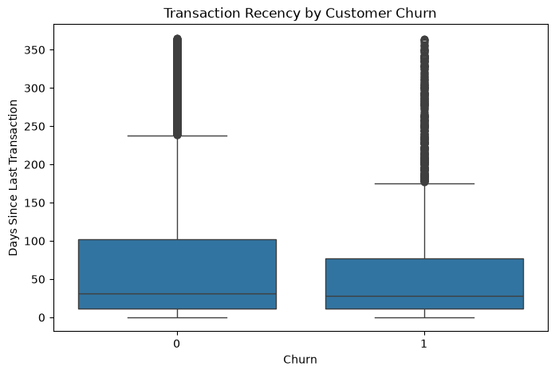
7. Correlation Analysis
Correlation analysis was performed to examine the relationships between numerical variables and customer churn.
The strongest correlations with churn were relatively weak.
Variable | Approximate Correlation with Churn
Previous Month Debit | 0.073
Current Month Debit | 0.048
Previous Month Credit | 0.042
Transaction Recency | -0.056
The results indicate that none of the analyzed numerical variables has a strong linear relationship with customer churn.
Previous-month debit showed the strongest positive correlation with churn, but the relationship was still weak.
Age and experience-related customer characteristics may provide additional information when combined with other variables.
It is important to note that correlation does not imply causation.
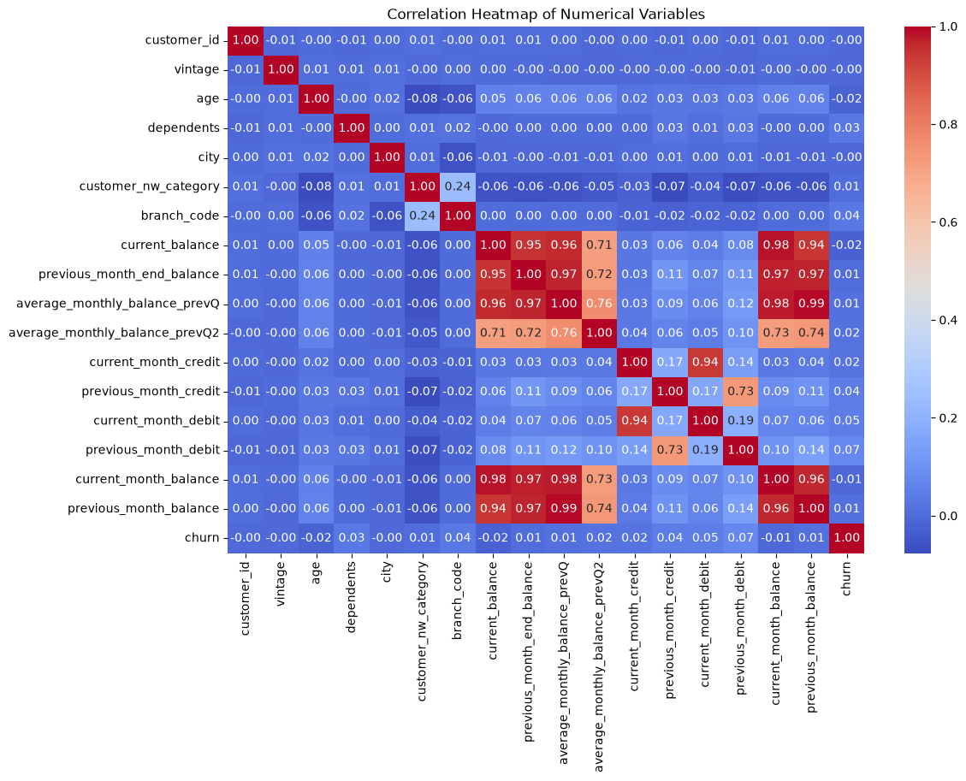
8. Key Insights
- The dataset contains 28,382 customers.
- The dataset contains 22 variables.
- The overall customer churn rate is 18.53%.
- There are 5,260 churned customers.
- There are 23,122 non-churned customers.
- Male customers have a slightly higher churn rate than female customers.
- Male churn rate is approximately 19.15%.
- Female churn rate is approximately 17.55%.
- Occupation categories show noticeable differences in churn percentages.
- The 26–35 age group has the highest churn rate at approximately 20.46%.
- The 65+ age group has the lowest churn rate at approximately 15.83%.
- Age distributions overlap considerably between churned and non-churned customers.
- Vintage distributions are relatively similar between churn groups.
- Transaction recency shows overlapping distributions between churn groups.
- Current balance contains significant extreme values.
- Previous-month debit has the strongest positive correlation with churn among the analyzed numerical variables, but the relationship is weak.
- No single numerical variable strongly explains customer churn.
9. Business Insights
The analysis indicates that customer churn is not strongly associated with a single customer characteristic.
Differences can be observed across age groups and occupation categories, while gender shows only a relatively small difference.
Financial and transaction-related variables may also provide useful information for understanding customer behavior.
The results suggest that banks should consider multiple customer characteristics together when studying customer retention rather than relying on a single variable.
10. Recommendations
- Monitor customers showing reduced transaction activity.
- Examine occupation groups with relatively higher churn percentages.
- Analyze age groups with higher churn rates.
- Use multiple customer characteristics when assessing churn risk.
- Study credit and debit transaction behavior in greater detail.
- Use transaction recency as an additional customer engagement measure.
- Conduct deeper customer segmentation based on financial and behavioral characteristics.
- Develop a machine-learning model in future work to predict the probability of customer churn.
11. Limitations
The project is based on Exploratory Data Analysis and identifies patterns and relationships in the available dataset. It does not establish causal relationships between variables and customer churn.
Some variables contain missing values, particularly transaction-date information.
Several financial variables also contain extreme values, which may affect statistical analysis and visualization.
The analysis is limited to the variables available in the dataset. Other factors that may influence customer churn are not included.
12. Future Scope
The project can be extended beyond Exploratory Data Analysis by applying machine-learning techniques.
Future work may include:
- Developing customer churn prediction models.
- Comparing different classification algorithms.
- Performing feature selection.
- Evaluating model performance.
- Creating customer risk categories.
- Performing customer segmentation.
- Developing an interactive churn dashboard.
- Using additional customer behavioral data.
- Building a system to identify customers with a higher probability of churn.
13. Conclusion
This project demonstrates a complete Exploratory Data Analysis workflow using Python on a bank customer churn dataset containing 28,382 customer records and 22 variables.
The dataset was cleaned by identifying and handling missing values, checking duplicate records, and preparing the data for analysis. Different statistical techniques and visualizations were then used to examine customer demographics, account balances, transaction activity, occupation, age groups, customer net-worth categories, and customer relationship duration.
The analysis found an overall churn rate of 18.53%. Differences were observed across occupation and age groups, while the difference between male and female churn rates was relatively small.
The analysis also showed that age, vintage, and transaction recency do not strongly separate churned and non-churned customers. Correlation analysis showed that no single numerical variable has a strong linear relationship with churn.
Overall, the project demonstrates how data cleaning, Exploratory Data Analysis, correlation analysis, and visualization can be combined to understand customer behavior and identify patterns associated with customer churn. The findings can provide a foundation for future customer retention analysis and machine-learning-based churn prediction.
14. Project Structure
The final project is organized into the following folders:
- data/ — Bank customer churn dataset
- notebooks/ — Jupyter Notebook containing data cleaning, analysis, and visualization
- report/ — Final project report and analysis charts
- screenshots/ — Screenshots demonstrating the analysis and results

