

**HOTEL BOOKING ANALYSIS:**

**Project Objective:**

In this project, My main objective of conducting a **Hotel Booking Analysis** using Power BI is to **gain actionable insights** into booking trends, customer behaviour, revenue performance, and operational efficiency to **support data-driven decision-making** in the hospitality business. Also, a comprehensive study and analysis of hotel booking and cancellation patterns using PowerBI. This involves examining a large dataset to identify trends, correlations, and potential causative factors behind booking behaviours and cancellations. By leveraging PowerBI's advanced data visualization and analytical capabilities, I aim to uncover insights into peak booking times, cancellation rates, customer preferences, and the impact of various factors such as seasonality, booking channels, and lead times. The ultimate goal is to pinpoint probable reasons for cancellations and suggest data-driven solutions to improve booking retention, enhance customer satisfaction, and increase overall profitability for the business. This analysis will provide actionable insights to optimize operational strategies and drive business growth.

**Requirements:**

**KPI Cards**

● Find the total number of special requests made.

● Find the total number of cancellations in City Hotel and Resort Hotel

● Find the total number of customers required car parking spaces

**Filter Pannel**

● Filter our report data with Arrival Year wise & Country wise

**Charts used in our Power BI Report**

● Stacked Bar Chart: Showing Arrival Count by arrival date month

● Area Chart: Count of customer type by market segment

● Line Chart: Showing stays in weekend nights & stays in week nights with arrival month date.

● Donut Chart: Showing the cancellation Count by Hotel Type

● Pie Chart: Showing Sum of previous bookings not cancelled by assigned room Type

**PowerBI Report/ Dashboard:**

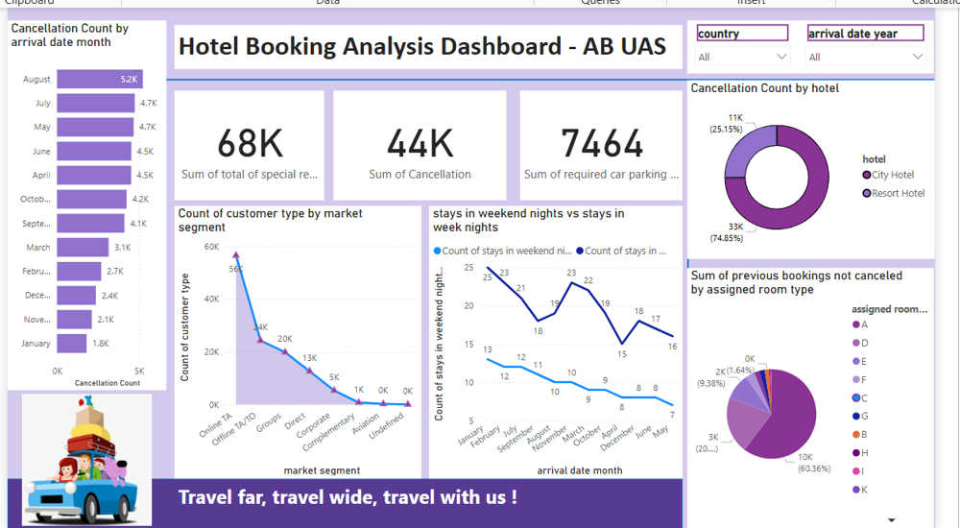

**Conclusion:**

Overall, the analysis empowers stakeholders to make **data-driven decisions** that enhance **guest experience**, improve **revenue performance**, and support **strategic growth** in a competitive hospitality market. This dataset comprises 119,390 observations, encompassing both City Hotel and Resort Hotel bookings. Each observation corresponds to an individual hotel booking made between 1st July 2015 and 31st August 2017. The data includes a wide array of booking details, such as bookings that arrived ahead of schedule and those that were subsequently cancelled. The dataset's rich information will enable a thorough examination of patterns and anomalies within the hotel industry, facilitating a deeper understanding of the dynamics at play in both city and resort hotel bookings over this two-year period.

GitHub Link: <https://github.com/umme-asma/M4_AB_PowerBI>