

Assignment 01: Git, Gitea, GitHub, Git LFS and GitHub Pages
Cloud Computing Assignment
Name: Umme Ammara Chaudhary
Reg No: FA24B1-SE-060
Sem/Sec: V/B
Submitted to: Sir Waqas Saleem

GitHub username: ummeammara60
Links:
- CC repository: https://github.com/ummeammara60/CC
- GitHub Assignment01: https://github.com/ummeammara60/Assignment01
- Portfolio repository: https://github.com/ummeammara60/ummeammara60.github.io
- Live site: https://ummeammara60.github.io/

Task 1: Install Gitea and Push a Repository from the Ubuntu Server

Step 1.1: Install and run Gitea
Docker, Docker Compose and Git were installed on the Ubuntu server and Gitea with PostgreSQL was started using the instructor compose.yaml without changes.
sudo apt update -y
sudo apt install -y docker.io curl git-lfs
sudo mkdir -p /usr/local/lib/docker/cli-plugins
sudo curl -SL https://github.com/docker/compose/releases/latest/download/docker-compose-linux-x86_64 -o /usr/local/lib/docker/cli-plugins/docker-compose
sudo chmod +x /usr/local/lib/docker/cli-plugins/docker-compose
sudo systemctl start docker
sudo usermod -aG docker $USER
exit
# log in again, then:
git --version
docker --version
docker compose version
cd ~
git clone https://github.com/WaqasSaleem97/Gitea.git
cd Gitea
docker compose up -d
docker compose ps
curl -sS -o /dev/null -w "Gitea HTTP status: %{http_code}\n" http://127.0.0.1:3000/
ip addr

Gitea was opened at http://192.168.244.130:3000/ and installed with PostgreSQL (host db:5432, user/password/database gitea). Server domain 192.168.244.130, base URL http://192.168.244.130:3000/. An administrator account was created.
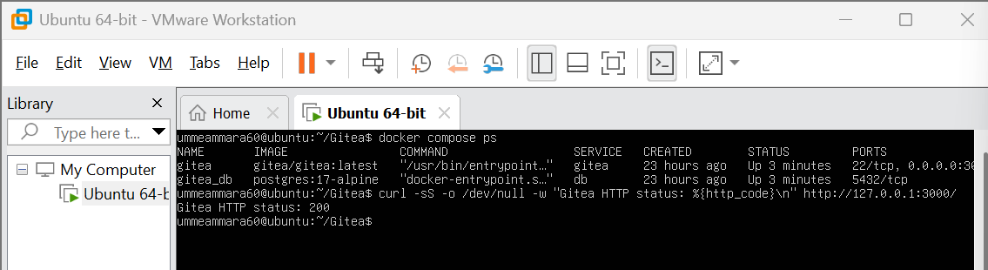

Step 1.2: Create and push the initial repository
An empty public repository Assignment01 was created in Gitea (no README, .gitignore or license). A local repository was created on the server and pushed using a personal access token (ubuntu-server-token, write:repository) entered at the password prompt.
cd ~
mkdir Assignment01
cd Assignment01
git init
git branch -M main
echo "# Assignment01" > README.md
echo "Name: YOUR FULL NAME" >> README.md
echo "Registration No: YOUR REGISTRATION NUMBER" >> README.md
git add README.md
git commit -m "Add student information"
git remote add gitea http://<gitea-username>@127.0.0.1:3000/<gitea-username>/Assignment01.git
git remote -v
git push -u gitea main
# paste the token at the Password prompt (nothing is shown)

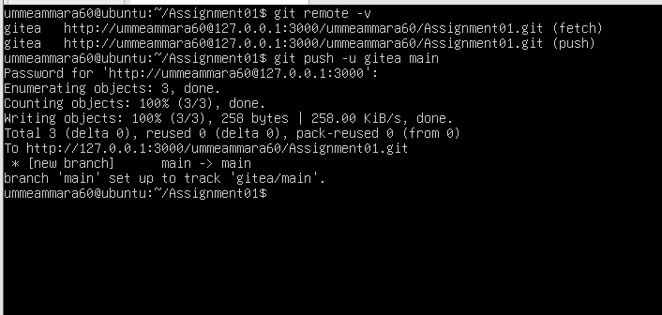

Step 1.3: Verify the Gitea repository
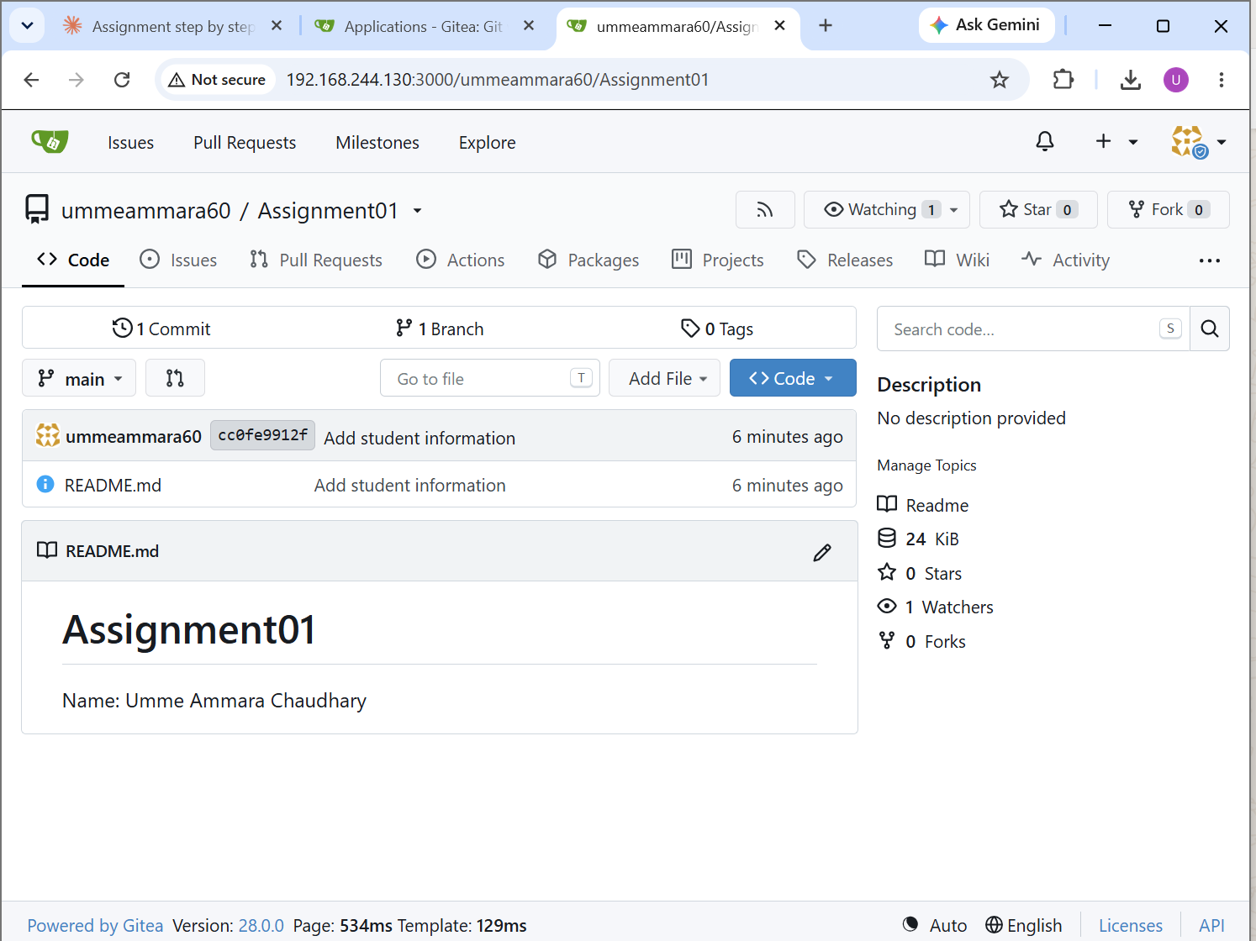

Task 2: Push the Same Repository to GitHub

Step 2.1: Add the GitHub remote
An empty public GitHub repository Assignment01 was created. GitHub was added as the second remote to the same local repository.
cd ~/Assignment01
git remote add github https://github.com/ummeammara60/Assignment01.git
git remote -v

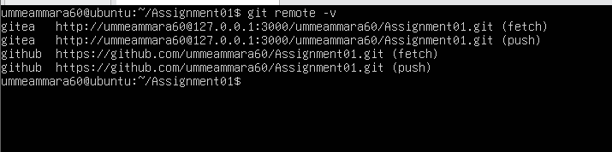

Step 2.2: Push to GitHub
git push -u github main
# username: ummeammara60 password: GitHub personal access token (hidden)

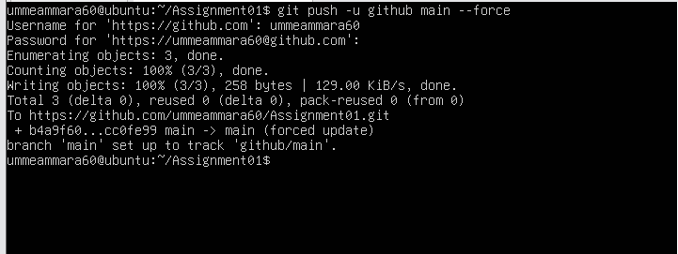

Step 2.3: Verify the GitHub repository
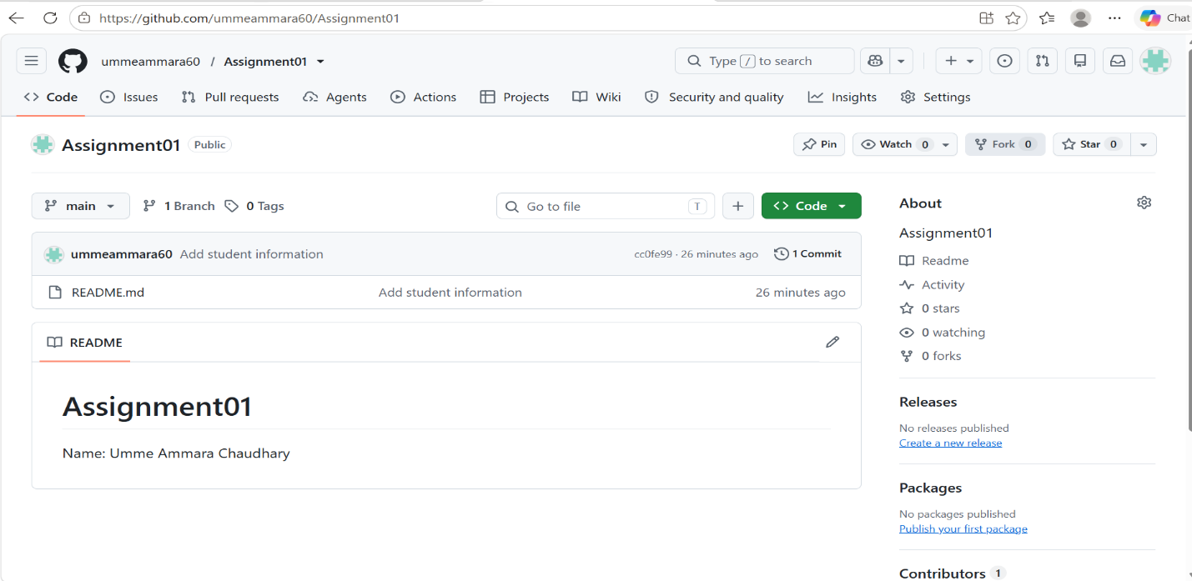

Task 3: Track Three Large Files with Git LFS

Step 3.1: Configure Git LFS
cd ~/Assignment01
git lfs install
git lfs version
git lfs track "*.bin"
cat .gitattributes

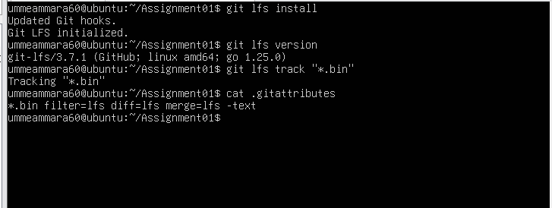

Step 3.2: Create and verify three LFS files
truncate -s 101M large-file-1.bin
truncate -s 102M large-file-2.bin
truncate -s 103M large-file-3.bin
git add .gitattributes large-file-1.bin large-file-2.bin large-file-3.bin
git lfs ls-files --size

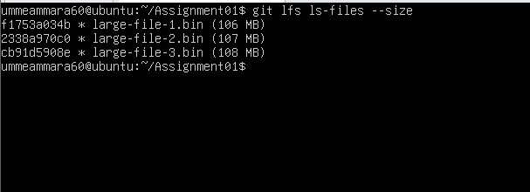

Step 3.3: Commit and push the LFS files
git commit -m "Add three files using Git LFS"
git push github main

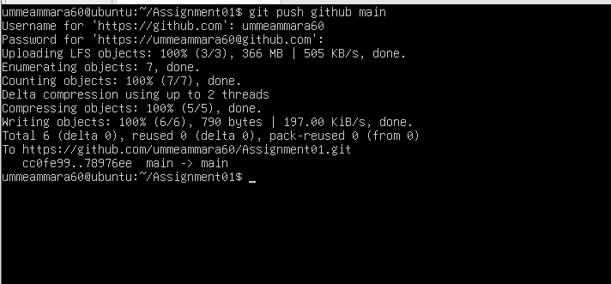

Task 4: Create a Portfolio or CV with GitHub Pages

Step 4.1: Portfolio repository
A public repository named ummeammara60.github.io was created containing index.html and styles.css with the sections About Me, Education, Skills and Projects, pushed to the main branch.
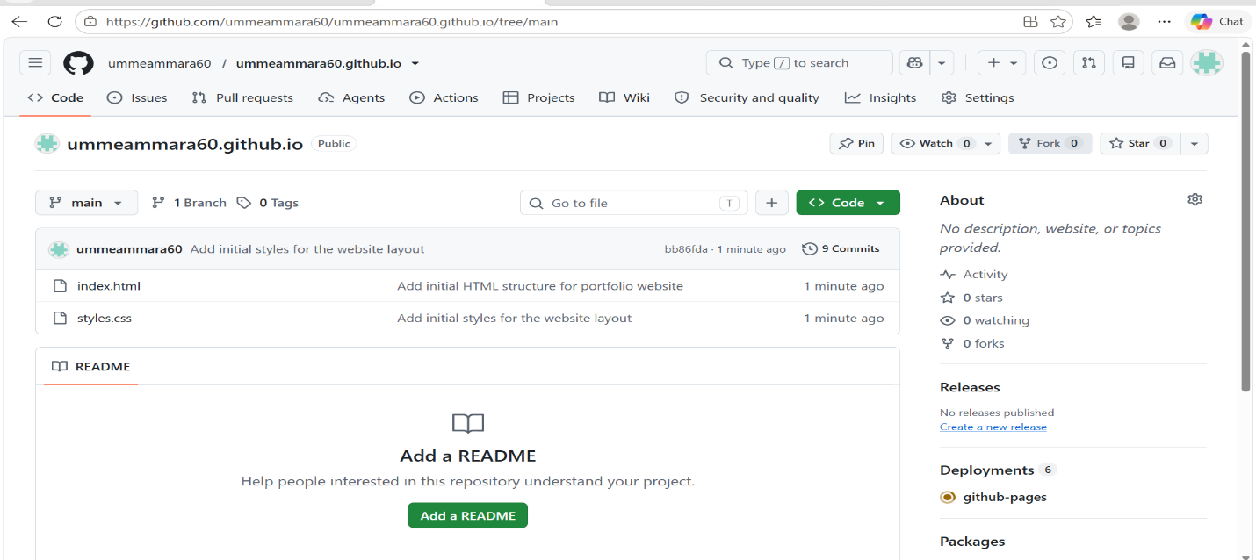

Step 4.2: Publish with GitHub Pages
Settings > Pages > Build and deployment > Deploy from a branch > main and / (root) > Save.
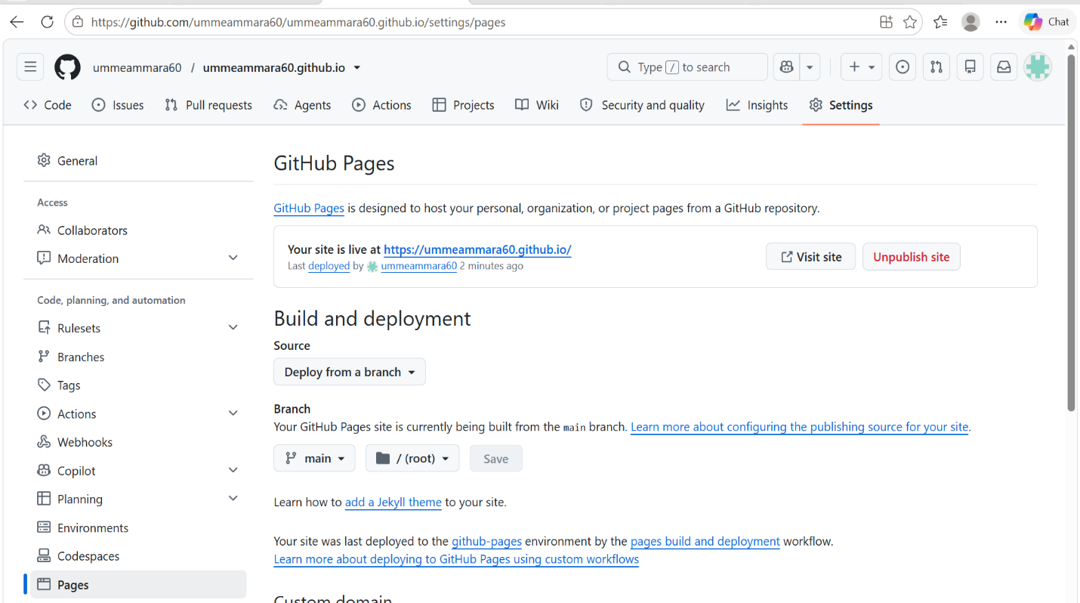

Step 4.3: Verify the live portfolio
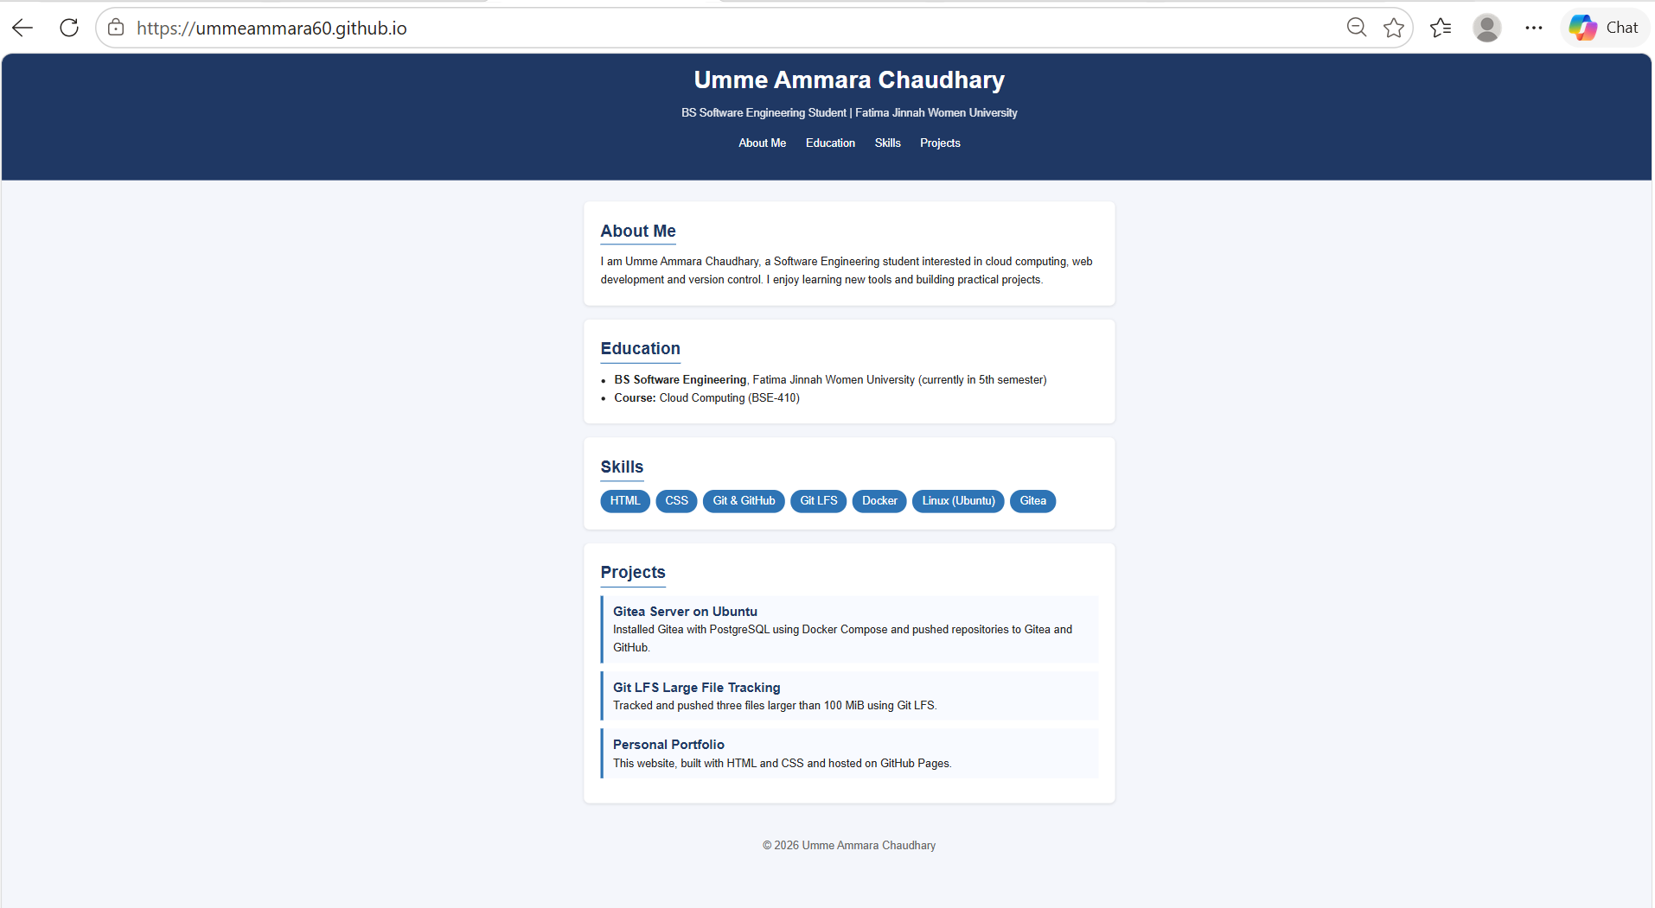

Conclusion
Gitea was installed on the Ubuntu server with Docker Compose, a repository was pushed to both Gitea and GitHub using two remotes without exposing credentials, three files larger than 100 MiB were tracked with Git LFS, and a portfolio was published with GitHub Pages.

