**Air Quality Life Index (AQLI) test response**

All test solutions and code have been updated in the GitHub repository linked here: <https://github.com/ummedss01/AQLI_Assignment>

**1. Basic wrangling tasks and questions**

1.1 How many GADM2 regions are present in India?

Ans: According to the 'gadm2_aqli_1998_2021.csv' dataset, India is divided into 35 GADM level 1 and 663 GADM level 2 administrative regions.

1.2 Calculate population weighted pollution average of all years at country (GADM0) level

●  Save the country level file as a CSV.

Ans: data store in ﻿Pop_weig_avg_Poll_country.csv file.

●  What are the 10 most polluted countries in 2021?

Ans: The ten countries with the highest PM2.5 pollution levels in 2021 were evenly split between South Asia and Africa, with five nations from each region. Bangladesh recorded the highest pollution levels, followed by India, Nepal, Pakistan, Myanmar, the Democratic Republic of the Congo, Cameroon, the Republic of the Congo, Rwanda, and Burundi. The annual population-weighted PM2.5 concentrations in these countries ranged from 71.8 to 32.1 µg/m³. (Data available in ﻿most_10_polluted_country_21.csv)

1.3 What was the most polluted GADM2 region in the world in 1998, 2005 and 2021?

Ans: India contained the most polluted regions in 1998, 2005, and 2021. Specifically, Unnao district in Uttar Pradesh was the most polluted in 1998, while the National Capital Territory of Delhi held this distinction in both 2005 and 2021. (data available in ﻿top_GADM2_region.csv)

1.4 Plot a population weighted pollution average trendline plot for Uttar Pradesh from 1998 to 2021. Save this plot as a high quality PNG file.

Ans:

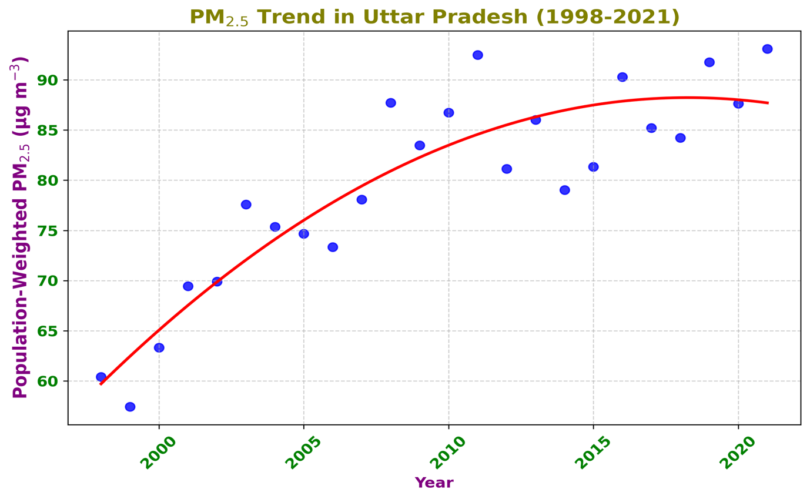

**Figure 1**. The trend in population-weighted PM2.5 levels for Uttar Pradesh from 1998 to 2021. Blue dots represent the annual mean values, and the red line depicts the overall trend.

**2. Geospatial Tasks And Questions**

2.1 Plot a bar graph for the life years lost relative to the WHO guideline in the 10 most polluted countries in the world and also plot them on a global country level map. For the map, the 10 most polluted country boundaries should be filled in with “dark red” and the rest of the map should be grayed out. Save both the bar graph and the map as high quality PNG files.

Ans:

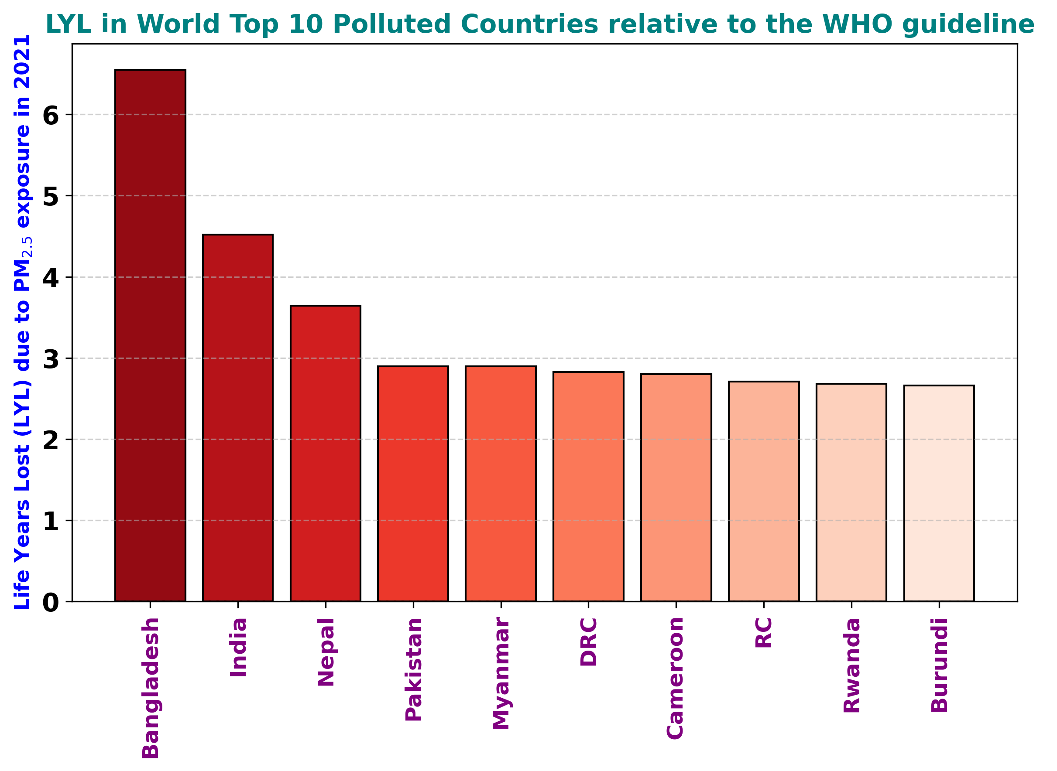

**Figure 2a**. The life years lost relative to the WHO guideline in the 10 most polluted countries in the world during 2021. Here, DRC(Democratic Republic of the Congo) and RC (Republic of the Congo).

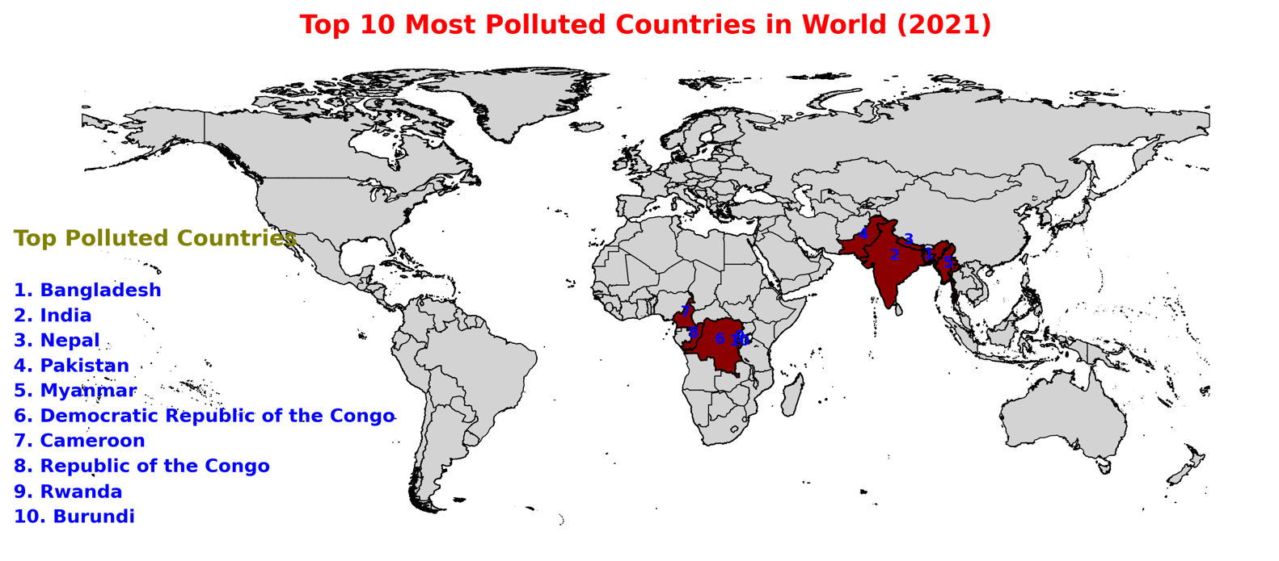

**Figure 2b** The geographical distribution of the ten most polluted countries worldwide in 2021. These countries are highlighted in dark red, while the remaining map areas are shown in gray.

2.2 Create a potential gain in life expectancy (relative to the WHO guideline) map of eastern v/s western europe at GADM level 2 and save it as a high quality PDF.

●  Plot should be in AQLI “Potential gain in life expectancy” color scale. Visit AQLI website Index page > See legend for “Potential gain in life expectancy” and infer “exact” colors from that.

Ans: The potential gain in life expectancy map, based on WHO air quality guidelines, has been saved as EST_WST_EUROPE_map.pdf.

In 2021, the average population-weighted PM2.5 exposure in Eastern Europe (14.6 µg/m³) was nearly twice as high as in Western Europe (7.5 µg/m³). As a result, the potential gain in life expectancy, relative to WHO standards, was significantly higher in the East. While Western Europe saw an average life expectancy gain of 2.7 months, Eastern Europe experienced a gain of 9.4 months.

●  You can define east and west europe based on any acceptable definition online, but whatever definition you use - mention the source.

Ans: The delineation of Eastern and Western European countries used in this analysis follows the classification provided by the Assembly of States Parties to the Rome Statute and the International Criminal Court (﻿<https://asp.icc-cpi.int/states-parties>).

2.3 Look at the AQLI website > switch to Air pollution tab > plot a static version of the global pollution map you see there, in those “exact” same colors. Export it as a high quality (320 dpi) SVG file.

Ans: The global pollution map for 2021 has been generated, and is available as global_pm2021_map.svg.(<https://drive.google.com/file/d/1mLp3YVRIaPaZTZ1jeELfyRbtn2RHur-4/view?usp=sharing>)

**4. Verbal reasoning and writing**

Ans: The report highlights the following key findings:

1. Global Pollution Disparity: The most polluted regions experience six times more pollution, resulting in a 2.7-year reduction in life expectancy compared to the cleanest regions.
2. Policy and Enforcement Matter: Globally, only 101 countries and territorieshave established national air quality standards, and enforcement varies. 33% of the global population resides in areas exceeding their country level air pollution standards limits.
3. Urgent Need for Standards: 151 countries lack air quality standards, including highly polluted nations such as the Republic of Congo and Cameroon, hindering pollution control efforts.