🚀 Centralized Email Automation Platform
High-Level System Design & Execution Plan
🎯 Objective
Design a centralized, reliable, and scalable email automation system that supports hundreds of independent email accounts while allowing logic and configuration changes to be applied universally—without modifying individual account setups.
🧩 System Architecture (Conceptual)
The platform is organized into three clearly separated layers, each with a well-defined responsibility.
🧠 Central Backend Layer (Decision & Control)
- Defines automation rules, schedules, and templates
- Determines what action should run and when
- Tracks execution state, retries, and failures
- Exposes secure APIs for workers
- Never sends emails directly
🧑‍🏭 Execution Layer (Per-Account Workers)
- Runs within each individual email account
- Polls backend periodically for work
- Executes Gmail-level actions
- Reports results back to backend
🗄️ Persistence Layer (Database)
- Stores scheduled actions with timestamps
- Maintains execution status
- Append-only execution logs
- Single source of truth

📐 Visual Architecture Diagram
The diagram below illustrates the relationship between the central backend, per-account workers, and the database.
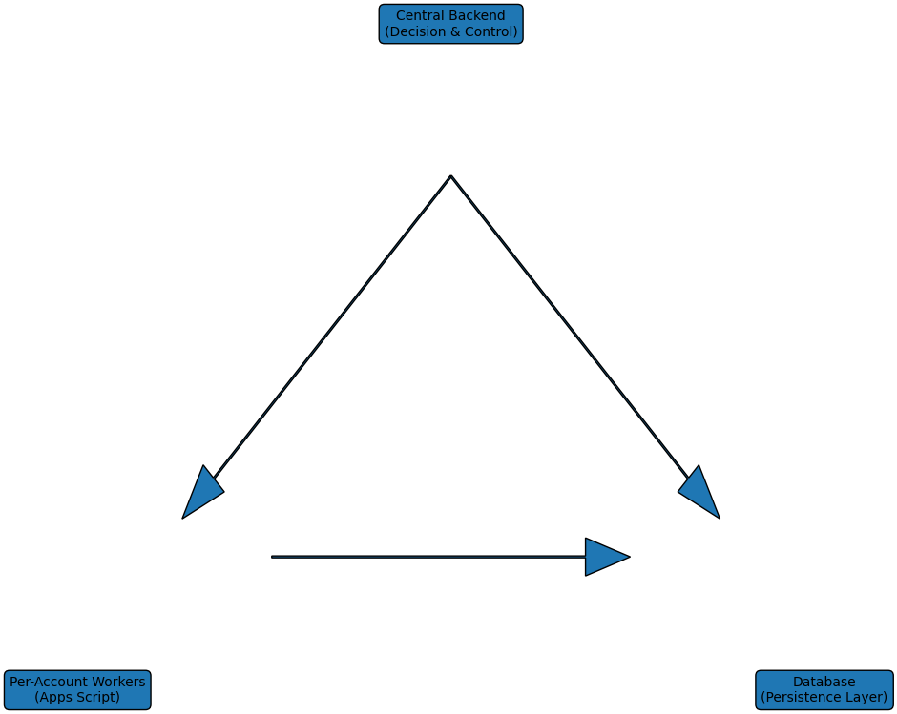

🗺️ Implementation Roadmap
- Phase 1 — Foundation
- Phase 2 — Observability
- Phase 3 — Execution Control
- Phase 4 — Advanced Automation (Optional)
✅ Final Summary
This design centralizes decision-making and state management while preserving secure, account-level execution. It improves reliability, scalability, and maintainability, and enables system-wide changes without touching individual accounts.

🧭 Workflow Diagram (End-to-End)
This workflow shows how scheduling, execution, and logging operate together across the backend, database, and per-account workers.
