**2. A first look at the captured trace**

1. IP address: 192.168.2.250 (Figure 1, A)

TCP port number: 57275 (Figure 1, B)

1. IP address: 130.113.68.10 (Figure 1, C)

TCP port number: 80 (Figure 1, D)

B

A



D

C

Figure 1

**3. TCP Basics**

1. Sequence number: 0 (relative sequence number) (Figure 2, A)

The 0x002 SYN flag identifies the segment by setting the Syn bit. (Figure 2, B)

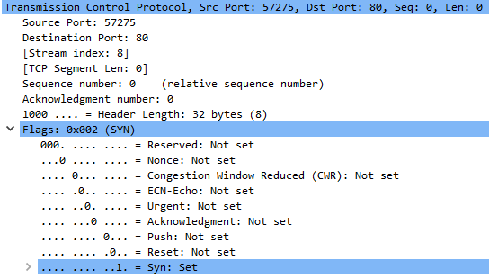

B

A

Figure 2

1. Sequence number: 0 (relative sequence number) (Figure 3, A)

Acknowledge number: 1 (relative ack number) (Figure 3, B), determined by incrementing the SYN sequence number.

The 0x012 SYN, ACK flag identifies the segment. (Figure 3, C)

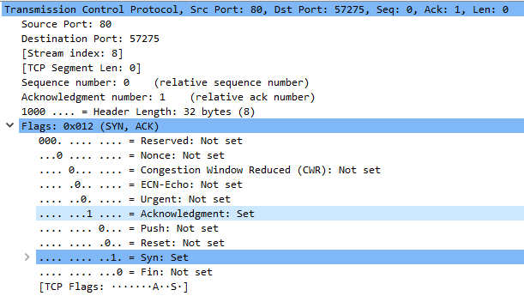

C

A

B

Figure 3

1. Sequence number: 1 (relative sequence number) (Figure 4, A)



A

Figure 4

|  |  |  |  |  |  |
| --- | --- | --- | --- | --- | --- |
| Segment | Sequence Number | Time sent | ACK received | RTT | EstimatedRTT |
| 1 | 1 | 8.013127 | 8.028646 | 0.015519 | 0.015519 |
| 2 | 1381 | 8.013157 | 8.028729 | 0.015572 | 0.015526 |
| 3 | 2761 | 8.013229 | 8.030084 | 0.016855 | 0.015692 |
| 4 | 4141 | 8.013246 | 8.031479 | 0.018233 | 0.01601 |
| 5 | 5521 | 8.028769 | 8.044303 | 0.015534 | 0.015951 |
| 6 | 6901 | 8.028786 | 8.044442 | 0.015656 | 0.015914 |

Sequence Number (Figure 5, A)

Time sent (Figure 5, B)

ACK received (Figure 5, C)

RTT for packet with sequence number 1381 in frame number 46. (Figure 6, A)

Estimated RTT = (1-0.125) * EstimatedRTT + 0.125 * RTT

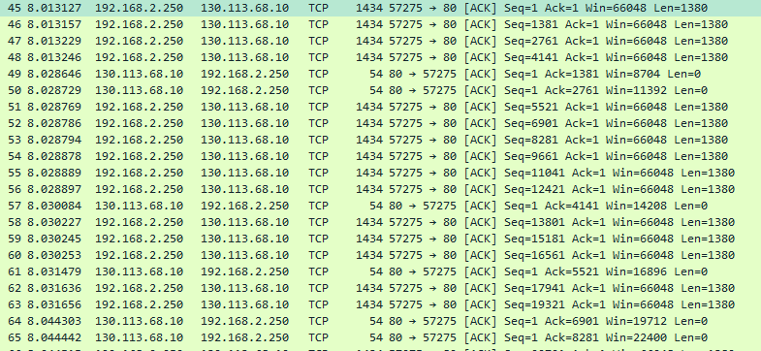

D

C

B

A

Figure 5

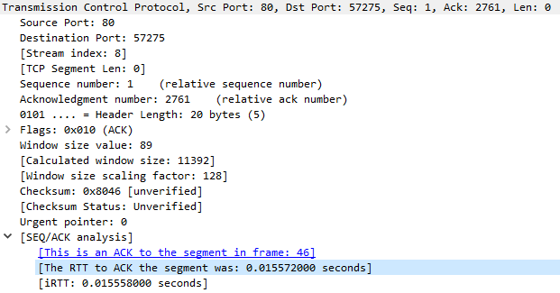

A

Figure 6

1. 1380 bytes for all six packets (Figure 5, D)
2. Minimum available buffer space (receiver window size value): 5840 (Figure 7, A) from the (SYN, ACK). The lack of receiver space does not throttle the sender due to lack of receiver buffer space.

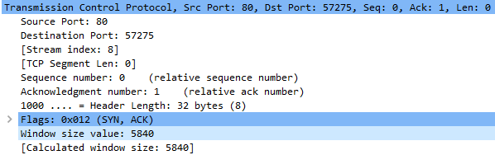

A

Figure 7

1. Yes, there are retransmitted segments in the trace file. By checking for a TCP duplicate acknowledgement and [TCP Retransmission] packets in the trace. (Figure 8, A)

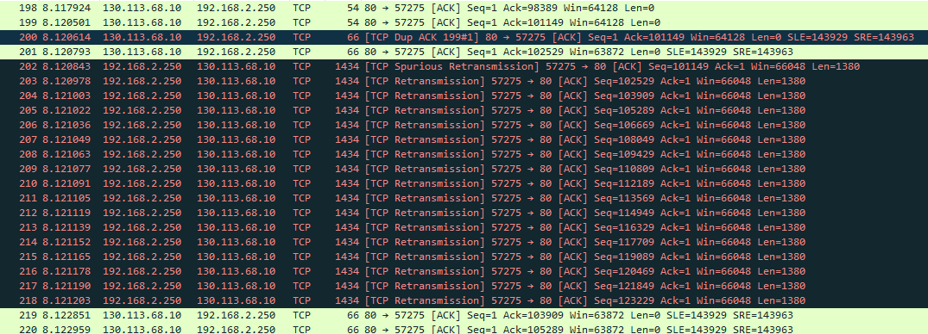

A

Figure 8

1. The difference between ACK sequence numbers of two consecutive ACKs is the amount of data acknowledged by the receiver. As seen below, the receiver typically acknowledges 1380 bytes, but I find some instances, such as acknowledgement sequence number 69001 where 2760 bytes of data was acknowledged. (Figure 9, A)

|  |  |
| --- | --- |
| ACK Sequence Number | Data |
| 1381 | 1380 |
| 2761 | 1380 |
| 4141 | 1380 |
| 5521 | 1380 |
| 6901 | 1380 |
| 8281 | 1380 |
| 9661 | 1380 |
| … | |
| 66241 | … |
| 69001 | 2760 |
| … | |



A

Figure 9

1. I calculate the throughput by averaging over the entire time duration during which the file was transferred.

$$\frac{143929- 1}{8.104559-8.013127}=1574153.47 bytes/seconds$$

**3. TCP congestion control in action**

1. TCP slowstart phase begins at 0.015558 seconds and ends at 0.1056, after which congestion avoidance takes over. The ideal TCP sender behaviour follows the AIMD algorithm, sending plenty of data and then decreasing the window size upon detecting congestion. An application effects TCP behavior. For an application with several small objects where transmission time is less than the length of the slow start phase, transmission experiences long delays.

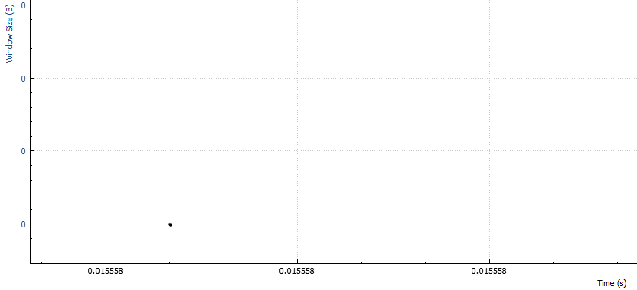

Figure 10

