1. Algorithms for:

* Is the graph a tree?

For an undirected graph such as the network topology, the algorithm returns true if there is no cycle and the graph is connected i.e. all vertices are reachable from the source (nodes[0]).

check_spanning_tree(nodes, G):

Mark all nodes in the topology as not visited, by initializing their value to False in the visited dictionary.

Check if there is a cycle in the topology from the source and mark all nodes visited on the way to True.

If there is a cycle in the topology from the source: return False.

Iteratively check if a node is not visited from source.

If there exists such a node: return False.

return True.

isCycle(node, nodes, visited, G, parent):

Set the value of node to True in the visited dictionary.

For all neighbouring nodes, adj of node:

If adj is not marked True in visited:

Recursively check if there is a cycle in the topology from adj and mark all nodes visited on the way to True.

If there is a cycle: return True.

Else if adj is not visited and not the parent of node, then there is a cycle: return True.

No cycle found: return False.

* Diameter of graph:

For an undirected, unweighted graph such as the network topology, the Floyd Warshall Algorithm solves the All Pairs Shortest Path problem in O(n3) where n is the number of nodes in the topology. The result of this algorithm is iteratively checked to find the maximum shortest path i.e. the diameter. The input representation is modified to the adjacency matrix to use as input to the Floyd Warshall Algorithm.

diameter(nodes, G):

Represent the topology as an adjacency matrix: graph = adjMatrix(nodes, G).

Initialize the distance matrix as the graph matrix.

For all nodes, interim in the graph:

Iteratively pick all nodes as the source:

For each source, pick all vertices as the destination:

If node interim is on the shortest path from source to destination, then update the value in distance[source][destination] as:

distance[source][destination] = minimum(distance[source][destination], distance[source][interim] + distance[interim][destination])

Iterate through all distance pairs to find the maximum value, where the maximum value is not infinity.

Return the maximum value.

adjMatrix(nodes, G):

For each node, i:

For each node, j:

If j is equal to i: initialize graph[i][j] to 0.

If j is a neighbour to i: initialize graph[i][j] to 1.

Else: initialize graph[i][j] to infinity.

Return graph.

1. Final spanning tree with --mdst parameter for PA3-test.py:

Command: sudo python PA3-test.py

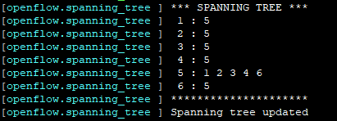

Final spanning tree without --mdst parameter for PA3-test.py:

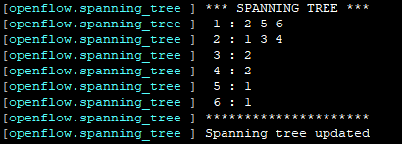

1. From the RTT Histogram below, it is clear that with an improved implementation of spanning tree that minimizes the diameter, average RTT is lower and packets are transmitted faster.

A screenshot of a cell phone

Description generated with high confidence

* with --mdst:

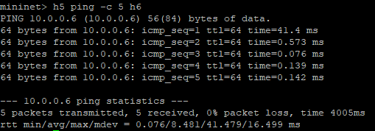

* without --mdst:

