- General background on the project and its objectives

description of the input data (EO, ancillary, and model data where relevant)

EO data processed by SAR-SeaStaR (DLR)

S1- Interferometric Wide Swath Mode (IW) GRD (Ground Range Detected) L1 products
S1- Extra Wide (EW) GRD L1 products.
S1- wave mode (WV) SAR Single Look Complex (SLC) L1 products.

The VV or HH polarization data were used, with priority to VV products for S1 IW and S1 EW.

Tab.DLR.1: GRD S1 IW, S1 EW and S1 WV SLC products common information
Name | ca. coverage | pixel spacing | GB  per SAR  L1 original ID product | N  of worldwide/ocean scenes  per day  (S1A+ S1B in 2020)
S1 IW  /GRD | 250×200 km | 10 m | ca. 3 GB | ca. 900 / 500
S1 EW  /GRD | 400×350 km | 40 m | ca. 0.6 GB | ca. 260 / 200
S1 WV  /SLC | 20×20 km  each 100 km along-track imagettes | ca. 3.5 m | ca. 5 GB  (min – ca. 2 GB  max.- 16 GB) | ca. 50  ID-products each with ca. 80–120 imagettes.  All imagettes in oceans

Fig.DLR.1: An example of S1 worldwide acquisitions on 2020-09-01. There are 54 S1 WV tracks (red), 894 S1 IW images (green), 229 S1 EW images (grey).

Ancillary data (Land masks)

- SRTM - Shuttle Radar Topography Mission (SRTM) -60°<LAT<60°.
- GSHHG - Global Self-consistent, Hierarchical, High-resolution Geography Database.

Model data (training/validations)

- Météo-France WAve Model (MFWAM) with a spatial resolution of 1/5° degrees. Global Ocean Waves Reanalysis (https://data.marine.copernicus.eu/product/GLOBAL_MULTIYEAR_WAV_001_032/description) past sea states since years 1980.
- WaveWatch-3 (WW3) model of National Oceanic and Atmospheric Administration (NOAA, https://polar.ncep.noaa.gov/waves/(https://polar.ncep.noaa.gov/waves/) ) with a spatial resolution of 1/2 degrees (spatially interpolated for collocation) for collocations before 2016.

summary of the retrieval algorithms, processing chain, and the approach for harmonisation of the multi-mission data streams.

DLR Algorithm SAR-SeaStaR

The empirical algorithm SAR-SeaStaR (SAR Sea State Retrieval) is developed at German Aerospace Center DLR, Maritime Safety and Security Lab Bremen. From SAR data, SAR-SeaStaR estimates a series of integrated sea state parameters: total significant wave height SWH, wave heights of dominant and secondary swells and windsea, mean, first and second moment wave periods, and windsea period. SAR scenes are processed in raster format, the output are fields for each parameter showing their spatial distribution.

SAR-SeaStaR is adopted for different satellites Sentinel-1 (S1) and TerraSAR-X (TS-X) and modes (state-of-the-art 2024):
− S1 Wave Mode (WV) Level-1 (L1) products
− S1 Interferometric Wide Swath Mode (IW)
− S1 Extra Wide (EW)
− TerraSAR-X (TS-X) StripMap (SM)

SAR-SeaStaR is based on combination of the linear regression function CWAVE_EX (Pleskachevsky et al., 2022) and a machine learning approach using the support vector machine (SVM) technique.

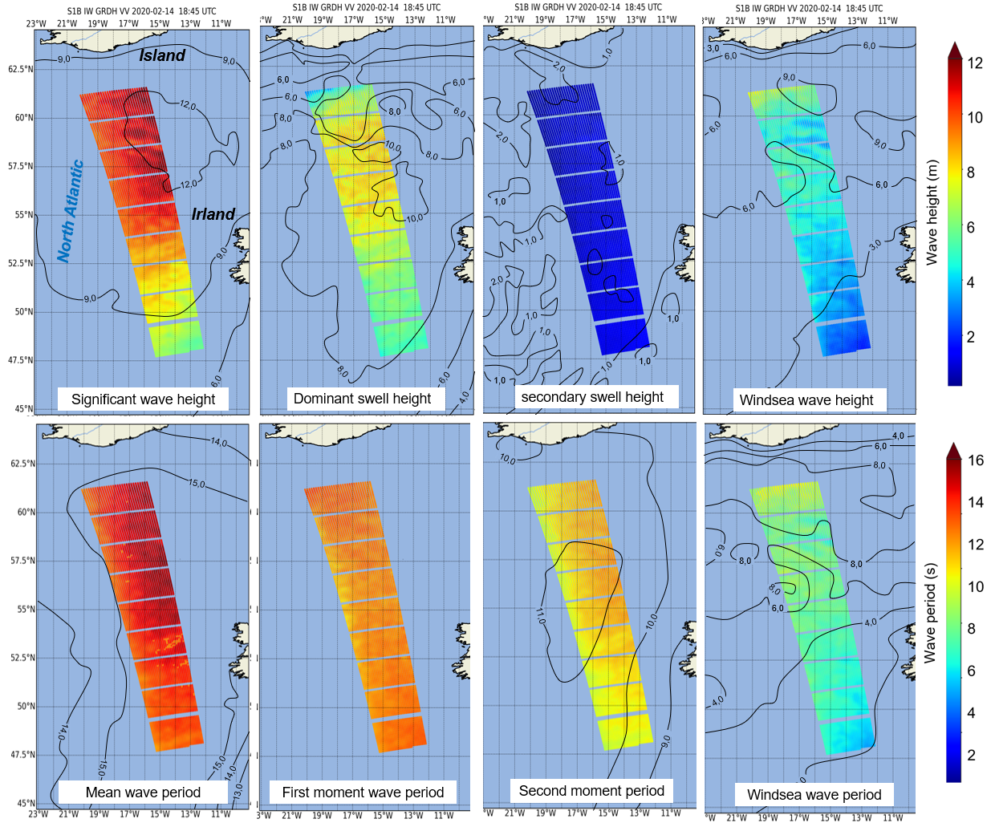
Fig.DLR.2: DLR SAR-SeaStaR outputs. Example of eight sea state parameter grids retrieved from a S1 IW scene with ca. 1600 km × 200 km coverage acquired during a strong storm in the North Atlantic on 2020-02-14 at 18:45 UTC with SWH reaching ca. 13 m. Processing in a 5 km raster results in ca. 1500 subscenes (approximately ~30×50) for each individual IW image. Isolines shows the results of forecast WFWAM at 18:00 UTC (excluding first moment not provided by Copernicus Marine Environment CMEMS).

Fig.DLR.3: Example of Sentinel-1 WV archive processing. In the right half of the figure only one-day of acquisitions is displayed on the globe, on the left half all data acquired during February 2021 is displayed.
The SAR-SeaStaR algorithm includes the complete processing chain with a series of steps needed to reach high accuracy:
- Filtering of the image artefacts (e.g. ships, wakes, offshore windfarms constructions, etc.).
- Resampling and denoising (e.g. for S1 IW resampling from 10 m to 2.5 m pixel spacing).
- SAR features estimation and control-of-features.
- Model functions (linear regression and machine learning models) for estimation of sea state parameters.
- Control-of-results using filtering procedures.

The SAR-SeaStaR estimation of sea state parameters is based on an analysis of the normalized radar cross-section (NRCS) of a subscene. A series of subscenes are initialized in a raster format and their analysis results in a continuous grid for series of integrated sea state parameters. The grid’s raster step is the distance between the centre points of analysed subscenes. One of the basic variables represents the SAR image spectrum obtained using fast Fourier transformation (FFT) applied to radiometrically calibrated, filtered, denoised, land-masked and normalised subscenes with a size of 1024×1024 pixels in wave number domain.
Linear regression. The empirical linear regression CWAVE_EX (extended CWAVE) model function uses primary SAR features estimated directly from the subscenes and secondary features. Secondary features are combinations of primary features in quadratic and inverse form. In total, 54 primary and the 77 most significant secondary features are applied in CWAVE_EX. Normalization of features using mean (MEAN) and standard deviation (STD) for each feature was found to be optimal. The primary features are of five different types:
- NRCS and NRCS statistics (variance, skewness, kurtosis, etc.), in total 9 features.
- Geophysical parameters (surface wind speed estimated from analysed subscene using CMOD-5N algorithms for C-band and XMOD-2 for X-Band), 1 feature.
- Grey Level Co-occurrence Matrix (GLCM) parameters (homogeneity, dissimilarity, etc.), in total 8 features.
- Spectral parameters based on image spectrum integration for different wavelength domains (0-30 m, 30-100 m, 100-400 m, etc.) and spectral width parameters (Longuet-Higgins, Goda), in total 17 features.
- Spectral parameters using products of normalized image spectrum with orthonormal functions (CWAVE approach) and cutoff wavelength estimated using autocorrelation function (ACF), in total 21 features.
Note, sea state is estimated form prefiltered subscenes, where the NRCS of outliers (ships, wakes, oil, etc.) and noise are essentially removed.
Machine learning. The SVM technique was applied to SAR-SeaStaR with nu-SVR Support Vector Regression (ν-SVR) with a radial basis function as kernel type. For practical applications, the high-performance ThunderSVM (TSVM) library was applied. TSVM runs an order of magnitude faster than the standard LibSVM and allows training of large datasets. The input for the SVM are the primary features complemented with:
- first-guess H_{s} from CWAVE_EX linear regression solution.
- precise incidence angle with an accuracy of third decimal place.
- flag identifying the satellite (S1-A or S1-B for Sentinel-1).
- pixel spacing (different for e.g. EW GRDH (25 m pixel) and GRDM (40 m pixel) products)
- flag identifying polarisation (HH or VV).

how users should cite the CRDP in their work, as well as any relevant publications

- cite the CRDP in their work

Pleskachevsky, A., Tings, B., Jacobsen, S., Wiehle, S., Schwarz, E., and D. Krause, 2024: A System for Near Real Time Monitoring of the Sea State using SAR Satellites. IEEE Transactions on Geoscience and Remote Sensing, VOL. 62, 2024
Pleskachevsky, A., Tings, B., and S, Jacobsen, 2022: Multiparametric Sea State Fields from Synthetic Aperture Radar for Maritime Situational Awareness, RSE, vol. 280, 22 pp.

- relevant publications

Pleskachevsky, A., Jacobsen, S., Tings, B., and E. Schwarz, 2019. Estimation of sea state from Sentinel-1 Synthetic aperture radar imagery for maritime situation awareness. IJRS, Vol. 40-11, pp. 4104-4142.
Pleskachevsky, A., W. Rosenthal, and S. Lehner, 2016: Meteo-Marine Parameters for Highly Variable Environment in Coastal Regions from Satellite Radar Images.” JPRS, Vol. 119, pp. 464-484., 2016.

references to other public CCI documentation for further details (e.g. ATBD, E3UB, PVIR, CAR)

contact details for questions and user feedback

Dr. Andrey Pleskachevsky,
German Aerospace Center, Remote Sensing Technology Institute,
Maritime Safety and Security Lab Bremen,
Am Fallturm 9,
28359 Bremen
Tel: +49 (0) 421 24420 1854
Andrey.Pleskachevsky@dlr.de

Mr. Björn Tings,
German Aerospace Center, Remote Sensing Technology Institute,
Maritime Safety and Security Lab Bremen,
Am Fallturm 9,
28359 Bremen
Tel: +49 (0) 421 24420 1860
Bjoern.Tings@dlr.de

***

- describe in detail all products made publicly available

DLR processed sea state parameters using SAR-SeaStaR from three S1 SAR modes:
- S1 WV - averaged values for each imagette 20 km x 20 km in along-track imagettes each 100 km apart
- S1 IW - grids (5 km grid’s step with ca. 1500 subscenes/image)
- S1 EW - grids (17.5 km grid’s step with ca. 400 subscenes/image )
Tab.DLR.2. Eight sea state parameters processed by DLR (uncertainties based on Pleskachevsky et al., 2024 (https://ieeexplore.ieee.org/document/10584481))

Parameter | Abb. | Unit | RMSE for  satellite mode
 |  |  | S1 IW | S1 EW | S1 WV (wv1/wv2)
total significant wave height | swh | m | 0.42 | 0.51 | 0.24 / 0.28
mean wave period Tm0-1 | Tm0 | s | 0.88 | 0.92 | 0.46 / 0.51
first moment wave period | Tm1 | s | 0.97 | 0.85 | 0.51 / 0.56
second moment wave period | Tm2 | s | 0.96 | 0.86 | 0.46 / 0.51
wave height swell dominant system | swell_swh_primary | m | 0.57 | 0.60 | 0.42 / 0.47
wave height swell secondary system | swell_swh_secondary | m | 0.38 | 0.44 | 0.41 / 0.46
significant wave height windsea | windwave_swh | m | 0.48 | 0.57 | 0.40 / 0.46
mean period windsea | windwave_period | s | 0.97 | 0.95 | 0.62 / 0.67

- list the product data volumes, so users can estimate the time required to download the data

Tab.DLR.3: DLR ocean products in netCDF format (2020 with both S1-Anand S1-B):
 | 1 ID product | 1 day worldwide | 1 month worldwide
S1 IW | ca. 0.4 MB | ca. 500 IDs – ca. 200 MB | ca. 15000 IDs - ca. 6 GB
S1 EW | ca. 0.2 MB | ca. 200 IDs – ca. 80 MB | ca. 6000 IDs - ca. 2.4 GB
S1 WV | ca. 0.1 MB | ca. 65 IDs – ca. 7 MB | ca. 2000 IDs - ca. 200 MB

- provide a full and detailed description of the data format, and the meanings of all metadata, quality flags and fill-values

DLR ocean products description (OCN-DLR)

The results are stored using original IDs in netCDF format, e.g.:

S1A_IW_GRDH_1SDH_20141006T074120_20141006T074149_002706_00306E_BAE5-fv04.nc

The time-stamp (UTC) is stored in file names (2014-10-06 07:41:20 for the given example).
The stored data are all 2D arrays:
- geo-coordinates (latitude, longitude)
- 8 integrated sea state parameters (see Tab.DLR.2)
- quality, and rejection flags (see.Tab.DLR.4)
- uncertainties for all 8 parameters

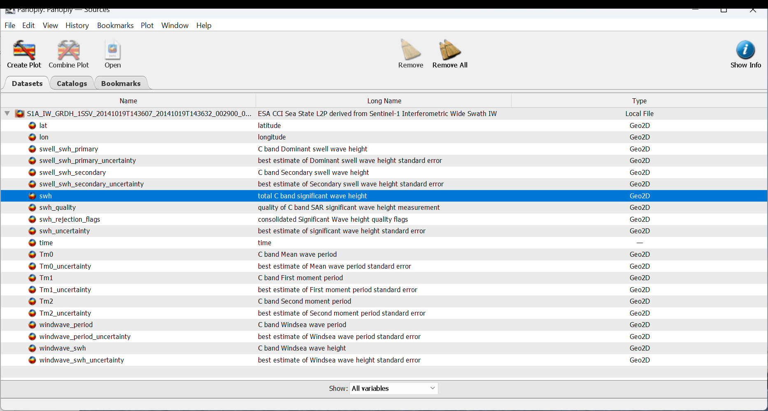
Fig.DLR.4: DLR ocean product example (view with Panoply(https://www.giss.nasa.gov/tools/panoply/)).

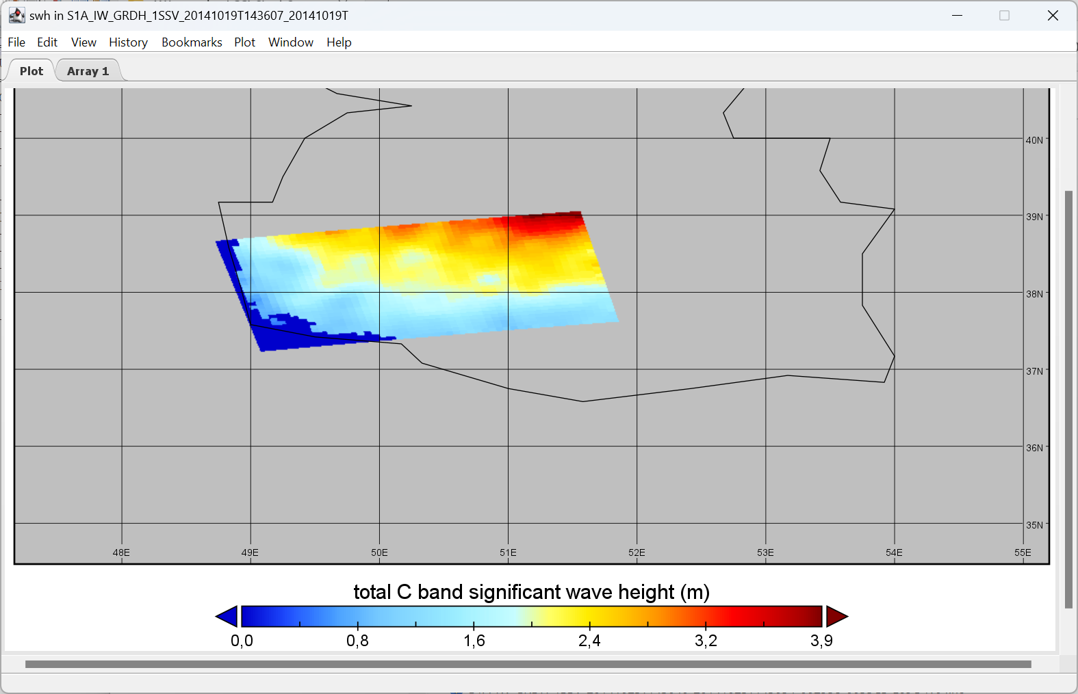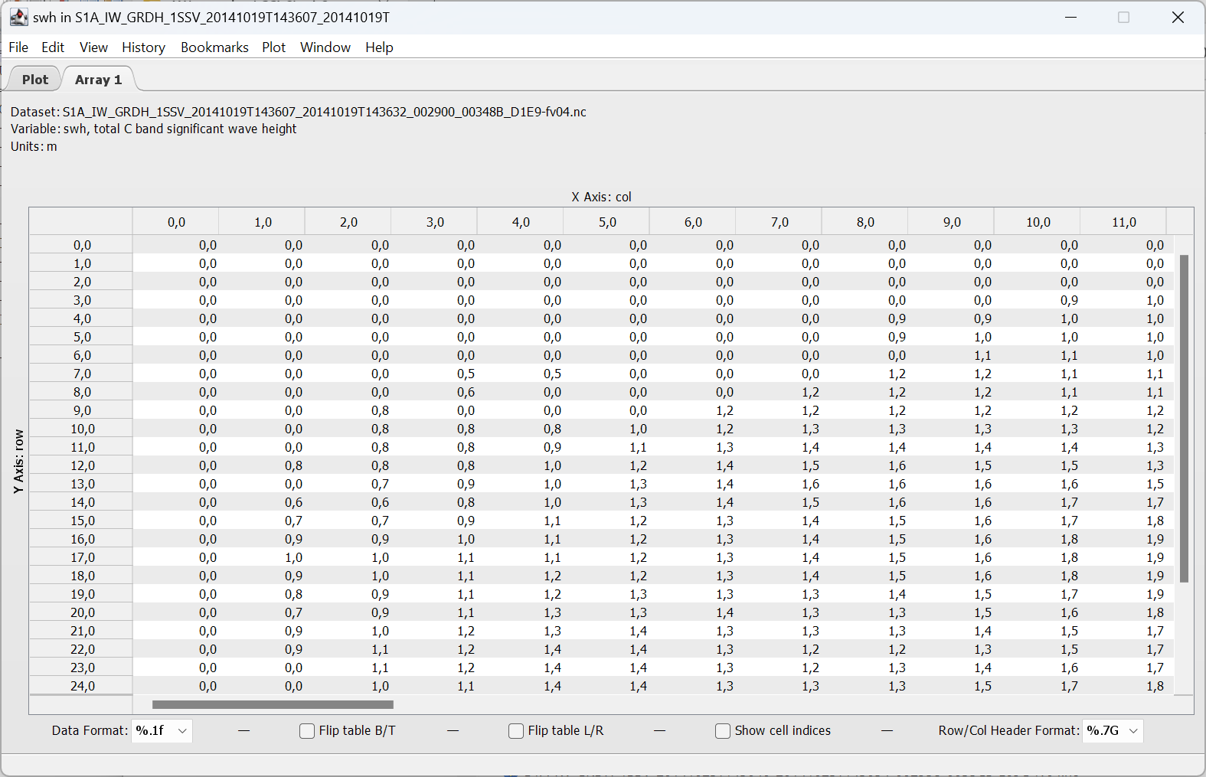
Fig.DLR.5: DLR ocean product example. SWH field (5 km raster) plot and 2-D array (Panoply(https://www.giss.nasa.gov/tools/panoply/)).

Tab.DLR.4: DLR ocean products quality, and rejection flags
 | Abb. in netCDF product | Description in netCDF product | Meaning
quality flag | swh_quality | Quality of C band SAR significant wave height measurement | 0 – undefined (e.g. land)  1 – bad  2 – acceptable (not used)  3 – good
Rejection flag | swh_rejection_flags | consolidated Significant Wave height quality flags | 1 - Nv (variance) > max (not more used)  2 - swh outlier  4 - invalid values  8 - wind below 2 m/s (not more used)  16 - not_water (land)
uncertainty  SWH | swh_uncertanty | Best estimate of significant wave height standard error | to MFWAM (CMEMS) estimated for each swh domains 0-1.5 m, 1.5-3m, 3-6m, >6m and interpolated/extrapolated.
uncertainty  SW1 | swell_swh_primary_uncertanty | Best estimate of dominant swell wave height standard error | to MFWAM (CMEMS) estimated for each swh domains 0-1.5 m, 1.5-3m, 3-6m, >6m and interpolated/extrapolated.
Uncertainty  SW2 | swell_swh_secondary_uncertanty | Best estimate of  secondary swell wave height  standard error | to MFWAM (CMEMS) estimated for each swh domains 0-1.5 m, 1.5-3m, 3-6m, >6m and interpolated/extrapolated.
Uncertainty  SWW | windwave_swh_uncertanty | Best estimate of windsea wave height standard error | to MFWAM (CMEMS) estimated for each swh domains 0-1.5 m, 1.5-3m, 3-6m, >6m and interpolated/extrapolated.
Uncertainty  Tm0 | Tm0_uncertanty | Best estimate of  mean wave period  standard error | to MFWAM (CMEMS) estimated for each swh domains 0-4 s, 4-7 s, 7-10s, >10 s and interpolated/extrapolated.
uncertainty  Tm1 | Tm1_uncertanty | Best estimate of  first moment wave period  standard error | to WW3 estimated for each swh domains 0-4 s, 4-7 s, 7-10s, >10 s and interpolated/extrapolated.
uncertainty  Tm2 | Tm2_uncertanty | Best estimate of  second moment wave period  standard error | to MFWAM (CMEMS) estimated for each swh domains 0-4 s, 4-7 s, 7-10s, >10 s and interpolated/extrapolated.
Uncertainty  Tmw | windwave_period_uncertanty | Best estimate of  mean period windsea  standard error | to MFWAM (CMEMS) estimated for each swh domains 0-4 s, 4-7 s, 7-10s, >10 s and interpolated/extrapolated.

- provide guidance on strengths, weaknesses and limitations of the products, and summarise quantitative results on product quality from the PVIR and the E3UB, including: o scientific quality of the products with respect to GCOS target requirements and the URD.

The uncertainties of the results are connected to uncertainties in ground truth data. From global point of view, the in-situ measurements cover very limited areas, mostly in shelf regions. To estimate accuracies of the methods worldwide, only model results are available. However, the comparisons between different wave forecast models shows, the shelf regions and also series of golfs and local seas (e.g. Philippine Sea) and coasts (Aleutian Islands) have stronger uncertainties between different models (RMSE between models are around 0.40 m) in comparison to open ocean regions (RMSE between models are around 0.20 m).

  - explain the meaning of, and how to use the prognostic uncertainty estimates, highlighting any known or potential sources of uncertainty that are so far poorly assessed (known unknowns).

The DLR uncertainties in the Tab.DLR.2. are based on comparisons with MFWAM reanalysis with 1/5° and 3h time step (20 min interpolated) performed for S1 archive processed data. The detailed information on comparisons can be found in Pleskachevsky et al., 2024 (https://ieeexplore.ieee.org/document/10584481).

