**Name: Umram Yaqoob**

**Rollno: 21-11485**

**Course: Technology management**

**Assignment no 2**

**Report**

**Service management tool:**

A service management tool is a software that is used to provide end-to-end technical, business and project management of IT services. It's also responsible for initiating activities. In this assignment, we will look at how an open source service management software handles these tasks. The aim is to understand how you are managing such services, your team if any and customers by sharing the screenshots of your activities or statistical charts shared in the tool with all these details regarding the tools' usage.

I used my tool Jira for ITSM

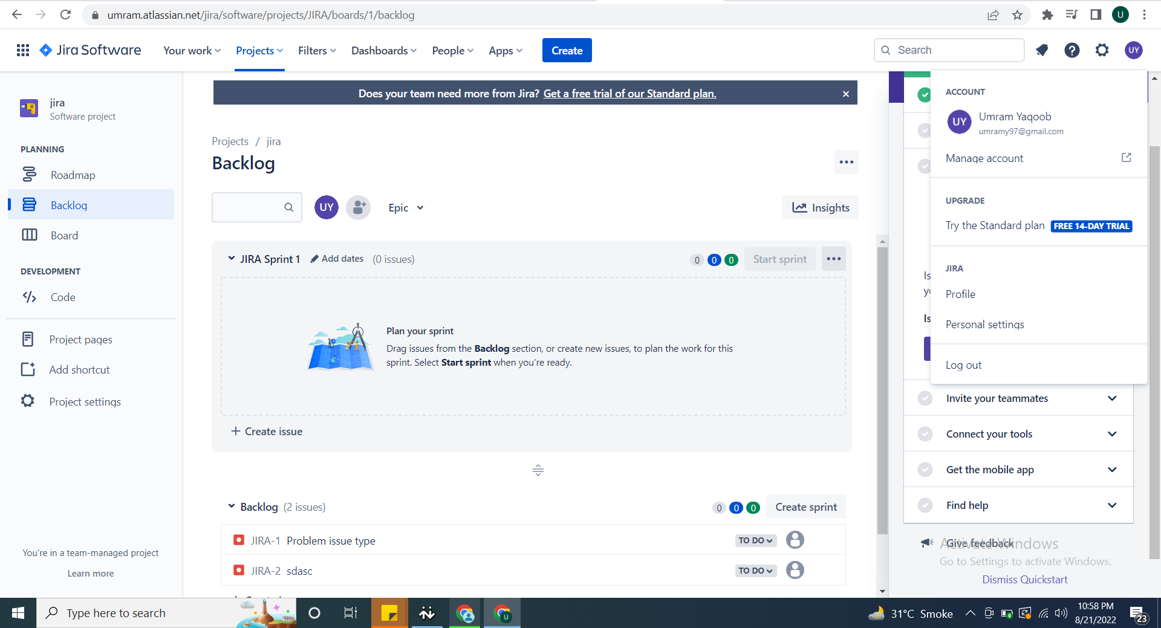

Link for my Jira is https://umram.atlassian.net/jira/servicedesk/projects/IP/queues/custom/1

**Practices used in Jira**

**Problem management**

In problem management we identify and manage problems and their causes to prevent isues in future.

To create a problem issue:

1. Select Create.
2. Select Problem as the issue type.
3. Enter relevant information.

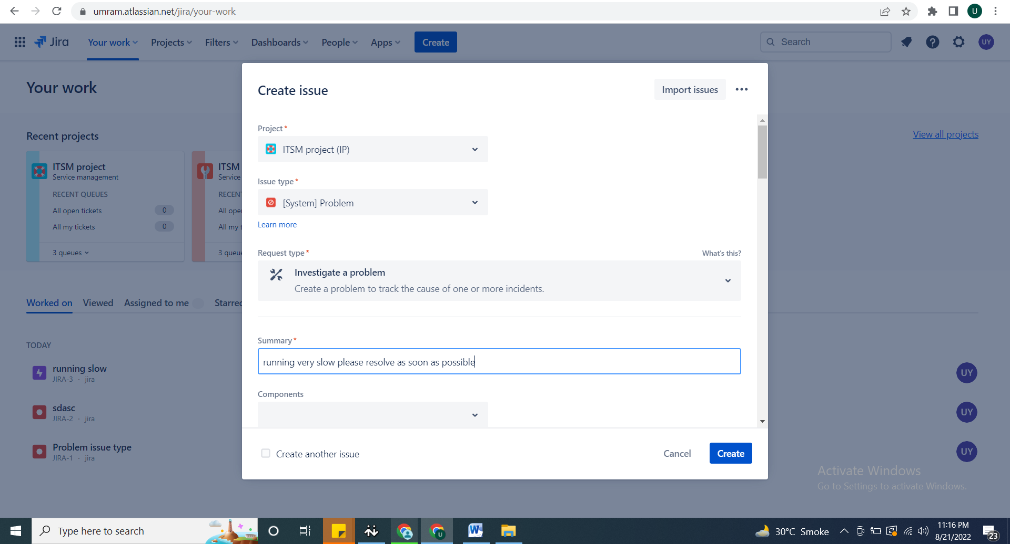

How to customize your problem workflow

To customize your problem workflow:

1. From your service project, select **Project settings > Workflows**.
2. Select the edit icon (  ), in the entry titled **Problem Management workflow for Jira Service Management**.
3. Use the workflow editor to add or remove steps and transitions.

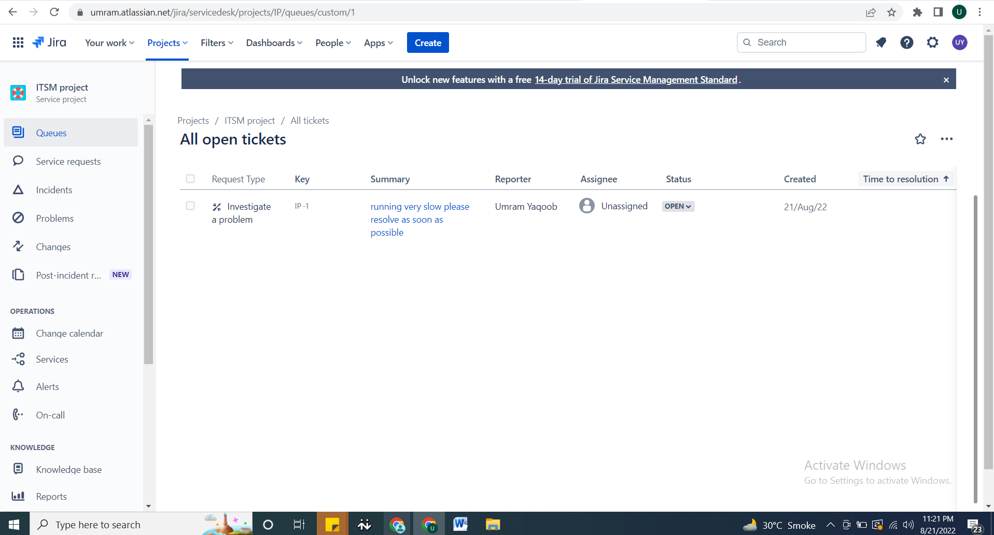

**Change Management:**

Here we change, add or remove to modify things that interrupt our service.

1. Use the default individual/group approval fields or [create fields](https://support.atlassian.com/jira-service-management-cloud/docs/add-a-new-custom-field-to-a-project/) for entering approvers
2. [Add the approval step to a workflow status](https://support.atlassian.com/jira-service-management-cloud/docs/add-an-approval-to-a-workflow/)

