WORLD HAPPINESS ANALYSIS

Ümran Kazar 211005055
Rumeysa Acar 211005001
Kamil Eren 211005015
Yusuf Emre Öner 211005022

Table of Contents

- Dataset’s (Happiness) Features

- Library Definitions

- First 10 Data in Our Dataset X and Y Variables

- Definition of Test Size

- Why Linear Regression?

- Learning Rate (Optional if advanced model used)

- Model Structure and Training

- Evaluation and Metrics

- References

Features of the Dataset
This dataset is created by merging data from different years of the World Happiness Reports. Our goal is to predict the happiness scores of countries based on factors such as economic status, social support, health, and freedom.

Variables Used:
- GDP per capita (gdp)
- Social support (social_support)
- Healthy life expectancy (health)
- Freedom to make life choices (freedom)
- Perceptions of corruption (trust)
- Generosity (generosity)
- Country name (country)
- Happiness score (happiness_score) → Target variable to be predicted

Library Definitions
- Pandas: For data reading, manipulation, and cleaning
- NumPy: For numerical operations
- Matplotlib / Seaborn: For data visualization and plotting
- Scikit-learn: For regression modeling and evaluation metrics

First 10 Data in Our Dataset
- data.head(10)

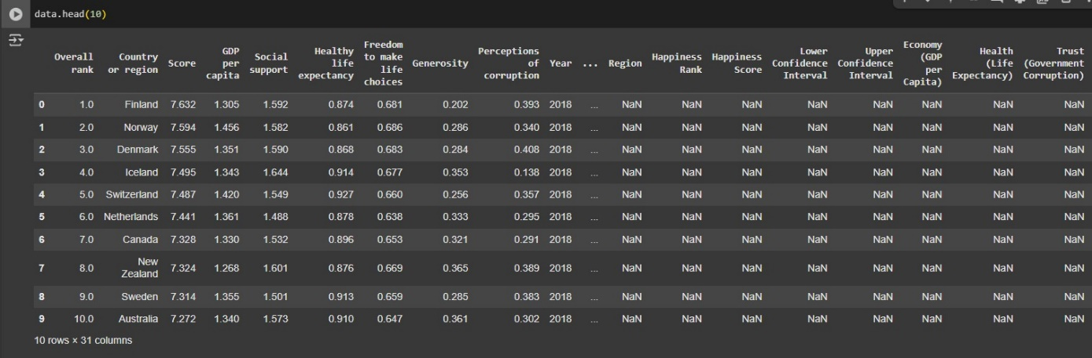

X and Y Variables
X Variables (independent):
gdp, social_support, health, freedom, trust, generosity

Y Variable (dependent / target):
happiness_score

These variables were selected after standardizing column names across different versions of the dataset using the combine_columns() function.

Definition of Test Size
- from sklearn.model_selection import train_test_split
x_train, x_test, y_train, y_test = train_test_split(x_scaled, y, test_size=0.2, random_state=0)

We split our dataset into 80% training and 20% testing to ensure generalization.

Why Linear Regression?
We chose Multiple Linear Regression because:
- It’s interpretable and suitable for numerical predictions
- Our problem is continuous (0–10 happiness score)
- It allows understanding the effect of each independent variable

Model Structure and Training
- from sklearn.linear_model import LinearRegression
model = LinearRegression()
model.fit(x_train, y_train)

We trained our model using the standardized input values.

Evaluation and Metrics
- from sklearn.metrics import r2_score, mean_absolute_error
y_pred = model.predict(x_test)
print("R² Score:", r2_score(y_test, y_pred))
print("MAE:", mean_absolute_error(y_test, y_pred))
Expected Example Output:
- R² Score: 0.83 → The model explains 83% of variance
- MAE: 0.39 → Average error in predicted happiness scores

The regression model achieved an R² Score of 0.83, indicating that it explains 83% of the variance in happiness scores. The Mean Absolute Error (MAE) was 0.39, meaning the average difference between predicted and actual values is relatively low.

**GDP per capita** had the strongest positive impact (**coefficient = 0.469**)
- Followed by **healthy life expectancy** (**0.239**)
- **Freedom to make life choices** (**0.235**)
- **Social support** (**0.214**)
- **Trust (perception of corruption)** (**0.075**)
- **Generosity** (**0.063**)

These results show that economic well-being, health, and personal freedom are the most influential factors in predicting national happiness, while trust and generosity play a smaller but still positive role.

Correlation Heatmap
This graph shows the distribution between the happiness score and other variables. For example:
There is high positive development with GDP and social support.
Trust and Generosity show lower but positive performance.

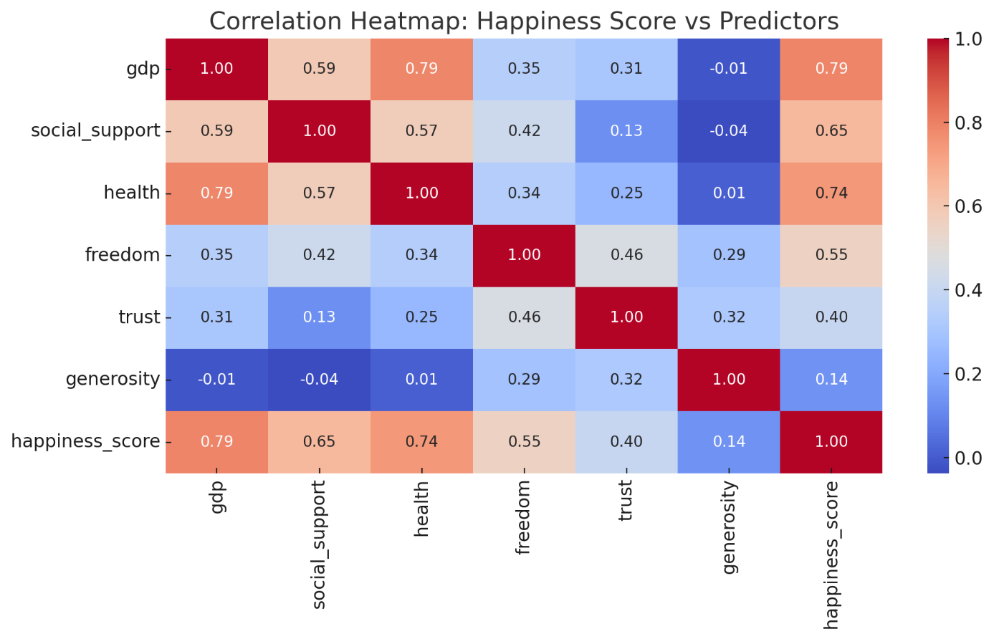

Actual vs Predicted Plots
This graph compares the actual happiness scores in the test data with the scores predicted by the model.
- The predictions are generally correct.
- Even though there are minor deviations, the model generalizes well
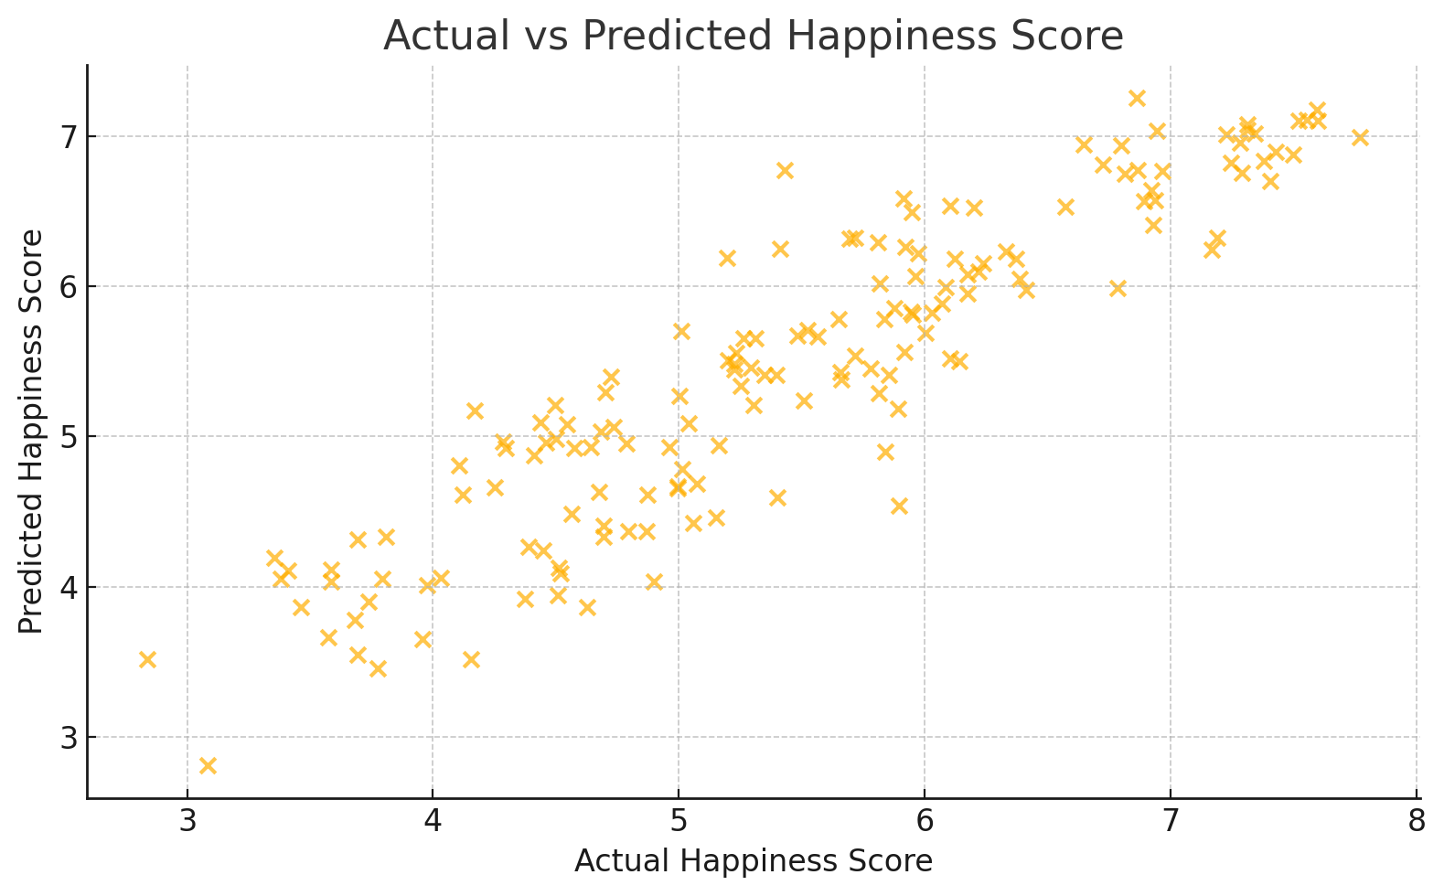

Residual Plot
This graph shows the residual values ​​corresponding to the predicted happiness scores. Well:
residual=actual−predicted

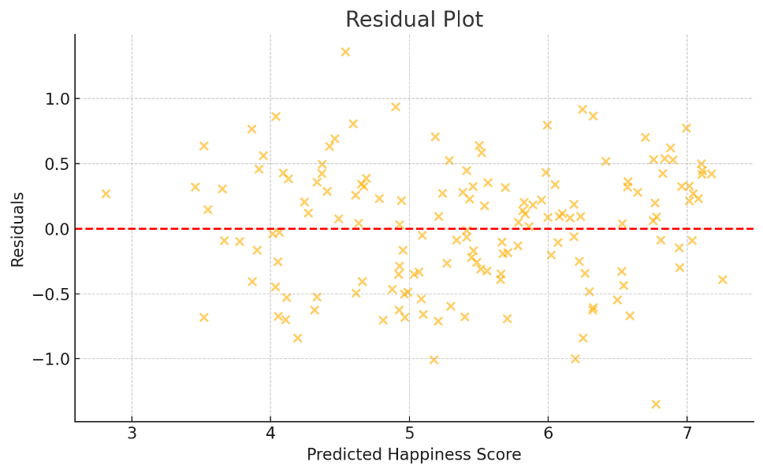

References
1. World Happiness Report Dataset. Kaggle. https://www.kaggle.com/datasets

