STATISTICAL GENOMICS AND BIOINFORMATICS PLATFORM

SAMPLE DATA ANALYSIS REPORT

Yong Won Jin

2022-11-15

PROJECT TITLE:  
Sample docx report  
SYNOPSIS:   
PREPARED FOR: R for Researchers  
REPORT PREPARED BY: Yong Won Jin  
 Statistical Genomics and Bioinformatics Platform  
 Max Rady College of Medicine  
 University of Manitoba  
 E-mail: yong.jin@umanitoba.ca  
 Tel: 204-789-3364  
TIME SPENT ON ANALYSIS:

# Table of content

# List of figures

# List of tables

# Project description

## Study summary

This is where I would write a *summary* about the study/project - i.e. how it came about, who is involved, research question, what types of data were delivered, etc.

## Objectives

* List research objectives here
* You can use asterisk or dash to make a list

# Data preparation

## Load data

For the demo, we’ll just use the mtcars dataset.

head(mtcars)

**Table** : First 6 rows of the mtcars dataset

| mpg | cyl | disp | hp | drat | wt | qsec | vs | am | gear | carb |
| --- | --- | --- | --- | --- | --- | --- | --- | --- | --- | --- |
| 21.0 | 6 | 160 | 110 | 3.90 | 2.620 | 16.46 | 0 | 1 | 4 | 4 |
| 21.0 | 6 | 160 | 110 | 3.90 | 2.875 | 17.02 | 0 | 1 | 4 | 4 |
| 22.8 | 4 | 108 | 93 | 3.85 | 2.320 | 18.61 | 1 | 1 | 4 | 1 |
| 21.4 | 6 | 258 | 110 | 3.08 | 3.215 | 19.44 | 1 | 0 | 3 | 1 |
| 18.7 | 8 | 360 | 175 | 3.15 | 3.440 | 17.02 | 0 | 0 | 3 | 2 |
| 18.1 | 6 | 225 | 105 | 2.76 | 3.460 | 20.22 | 1 | 0 | 3 | 1 |

# Plots and Figures

Output from plotting functions are included.

mtcars %>%  
 select(mpg, cyl, disp, hp) %>%  
 rownames_to_column(var='Model') %>%  
 pivot_longer(cols=-Model) %>%  
 ggplot(mapping=aes(x=Model,value)) +  
 geom_bar(stat='identity') +  
 facet_grid(name ~ ., scales='free') +   
 theme(axis.text.x = element_text(angle = 90, vjust = 0.5, hjust=1))

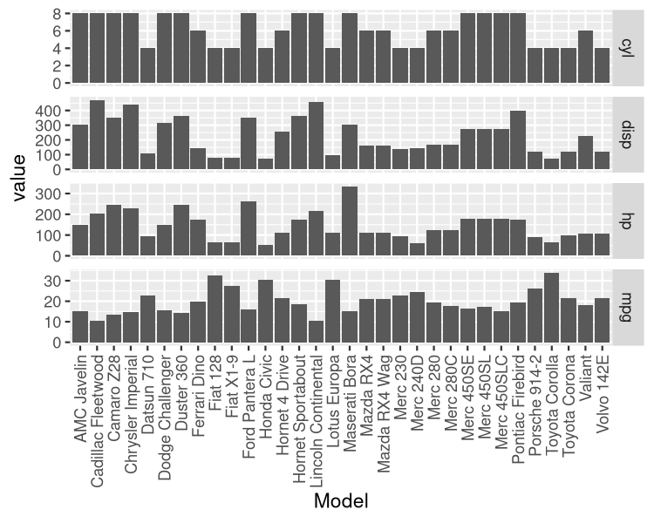

**Figure** : Bar plots of mpg, cyl, disp, and hp

## Plots

For .html output, you can include 3D interactive plots using plotly package.

### Principal Component Analysis

res.pca <- prcomp(mtcars)  
fviz_pca_ind(res.pca,  
 col.ind=as.factor(mtcars$cyl),  
 addEllipses = TRUE,  
 legend.title='cyl',  
 repel=TRUE,  
 title='')

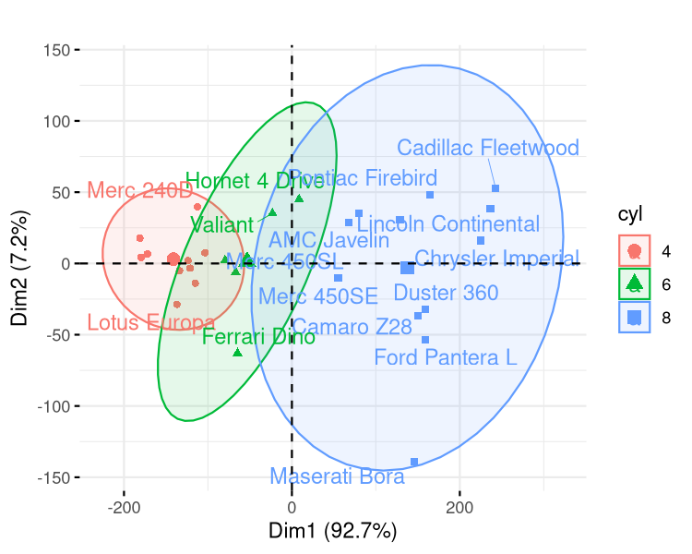

**Figure** : PCA plot of car models from mtcars dataset

# Appendix

## Code

knitr::opts_chunk$set(  
 echo = TRUE,  
 include = TRUE,  
 cache = FALSE,  
 dpi = 150,  
 cache.lazy = FALSE  
 )  
# Markdown  
library(officedown)  
library(officer)  
# Data wrangling  
library(tidyverse)  
# Plotting  
library(cowplot)  
library(plotly)  
library(factoextra)  
source('/home/jin/OneDrive/SGB/projects/functions.R')  
coverpage_par <- fp_par(  
 text.align = "left",   
 padding = 0,  
 padding.left = 0.63,  
 padding.right = 0.63,  
)  
head(mtcars)  
mtcars %>%  
 select(mpg, cyl, disp, hp) %>%  
 rownames_to_column(var='Model') %>%  
 pivot_longer(cols=-Model) %>%  
 ggplot(mapping=aes(x=Model,value)) +  
 geom_bar(stat='identity') +  
 facet_grid(name ~ ., scales='free') +   
 theme(axis.text.x = element_text(angle = 90, vjust = 0.5, hjust=1))  
res.pca <- prcomp(mtcars)  
fviz_pca_ind(res.pca,  
 col.ind=as.factor(mtcars$cyl),  
 addEllipses = TRUE,  
 legend.title='cyl',  
 repel=TRUE,  
 title='')  
sessionInfo()

## R session info

sessionInfo()

## R version 4.1.3 (2022-03-10)  
## Platform: x86_64-redhat-linux-gnu (64-bit)  
## Running under: CentOS Stream 9  
##   
## Matrix products: default  
## BLAS/LAPACK: /usr/lib64/libopenblas-r0.3.15.so  
##   
## locale:  
## [1] LC_CTYPE=en_CA.UTF-8 LC_NUMERIC=C   
## [3] LC_TIME=en_CA.UTF-8 LC_COLLATE=en_CA.UTF-8   
## [5] LC_MONETARY=en_CA.UTF-8 LC_MESSAGES=en_CA.UTF-8   
## [7] LC_PAPER=en_CA.UTF-8 LC_NAME=C   
## [9] LC_ADDRESS=C LC_TELEPHONE=C   
## [11] LC_MEASUREMENT=en_CA.UTF-8 LC_IDENTIFICATION=C   
##   
## attached base packages:  
## [1] stats graphics grDevices utils datasets methods base   
##   
## other attached packages:  
## [1] factoextra_1.0.7 plotly_4.10.0 cowplot_1.1.1 forcats_0.5.1   
## [5] stringr_1.4.0 dplyr_1.0.9 purrr_0.3.4 readr_2.1.2   
## [9] tidyr_1.2.0 tibble_3.1.8 ggplot2_3.3.6 tidyverse_1.3.2   
## [13] officer_0.4.3 officedown_0.2.4  
##   
## loaded via a namespace (and not attached):  
## [1] httr_1.4.3 jsonlite_1.8.0 viridisLite_0.4.0   
## [4] carData_3.0-5 modelr_0.1.8 assertthat_0.2.1   
## [7] googlesheets4_1.0.0 cellranger_1.1.0 yaml_2.3.5   
## [10] ggrepel_0.9.1 gdtools_0.2.4 pillar_1.8.0   
## [13] backports_1.4.1 glue_1.6.2 uuid_1.1-0   
## [16] digest_0.6.29 ggsignif_0.6.3 rvest_1.0.2   
## [19] colorspace_2.0-3 htmltools_0.5.3 pkgconfig_2.0.3   
## [22] broom_1.0.0 haven_2.5.0 scales_1.2.0   
## [25] tzdb_0.3.0 googledrive_2.0.0 car_3.1-0   
## [28] farver_2.1.1 generics_0.1.3 ggpubr_0.4.0   
## [31] ellipsis_0.3.2 cachem_1.0.6 withr_2.5.0   
## [34] lazyeval_0.2.2 cli_3.3.0 magrittr_2.0.3   
## [37] crayon_1.5.1 readxl_1.4.0 memoise_2.0.1   
## [40] evaluate_0.15 fs_1.5.2 fansi_1.0.3   
## [43] rstatix_0.7.0 xml2_1.3.3 tools_4.1.3   
## [46] data.table_1.14.2 hms_1.1.1 gargle_1.2.0   
## [49] lifecycle_1.0.1 munsell_0.5.0 reprex_2.0.1   
## [52] zip_2.2.0 compiler_4.1.3 systemfonts_1.0.4   
## [55] rlang_1.0.4 grid_4.1.3 rstudioapi_0.13   
## [58] htmlwidgets_1.5.4 labeling_0.4.2 rmarkdown_2.14   
## [61] gtable_0.3.0 abind_1.4-5 DBI_1.1.3   
## [64] R6_2.5.1 rvg_0.2.5 lubridate_1.8.0   
## [67] knitr_1.39 fastmap_1.1.0 utf8_1.2.2   
## [70] stringi_1.7.8 Rcpp_1.0.9 vctrs_0.4.1   
## [73] dbplyr_2.2.1 tidyselect_1.1.2 xfun_0.31