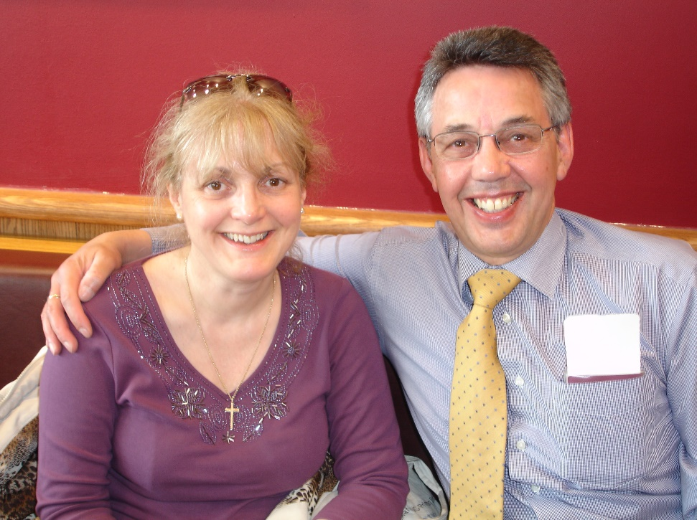

**Dr. Nicholas D. Priest**

Professor Priest, until his recent retirement, managed the Radiobiology and Health Branch at the Chalk River Laboratory of the Canadian Nuclear Laboratory (formerly Atomic Energy of Canada Ltd). Before this he was: Professor of Environmental Toxicology and Head of the Decision Analysis and Risk Management research centre at Middlesex University, London; Business Development Manager Health and head of Harwell Biomedical Research at the United Kingdom Atomic Energy Authority; research scientist at the UK National Radiological Protection Board. His first degree (Wales) was in Zoology followed by a PhD in Medicine (London). His special interest is in the physiology, metabolism and toxicity of metals including stable metals, but he has wider interests in radiobiology, radioecology and analytical radiochemistry. He is a member of the Royal Institute of Biology, Fellow of the International Union of Pure and Applied Chemistry. In 2007 he was awarded the NATO Science Prize and in 2015 he was given a distinguished Achievement Award by the Canadian Radiological Protection Society.