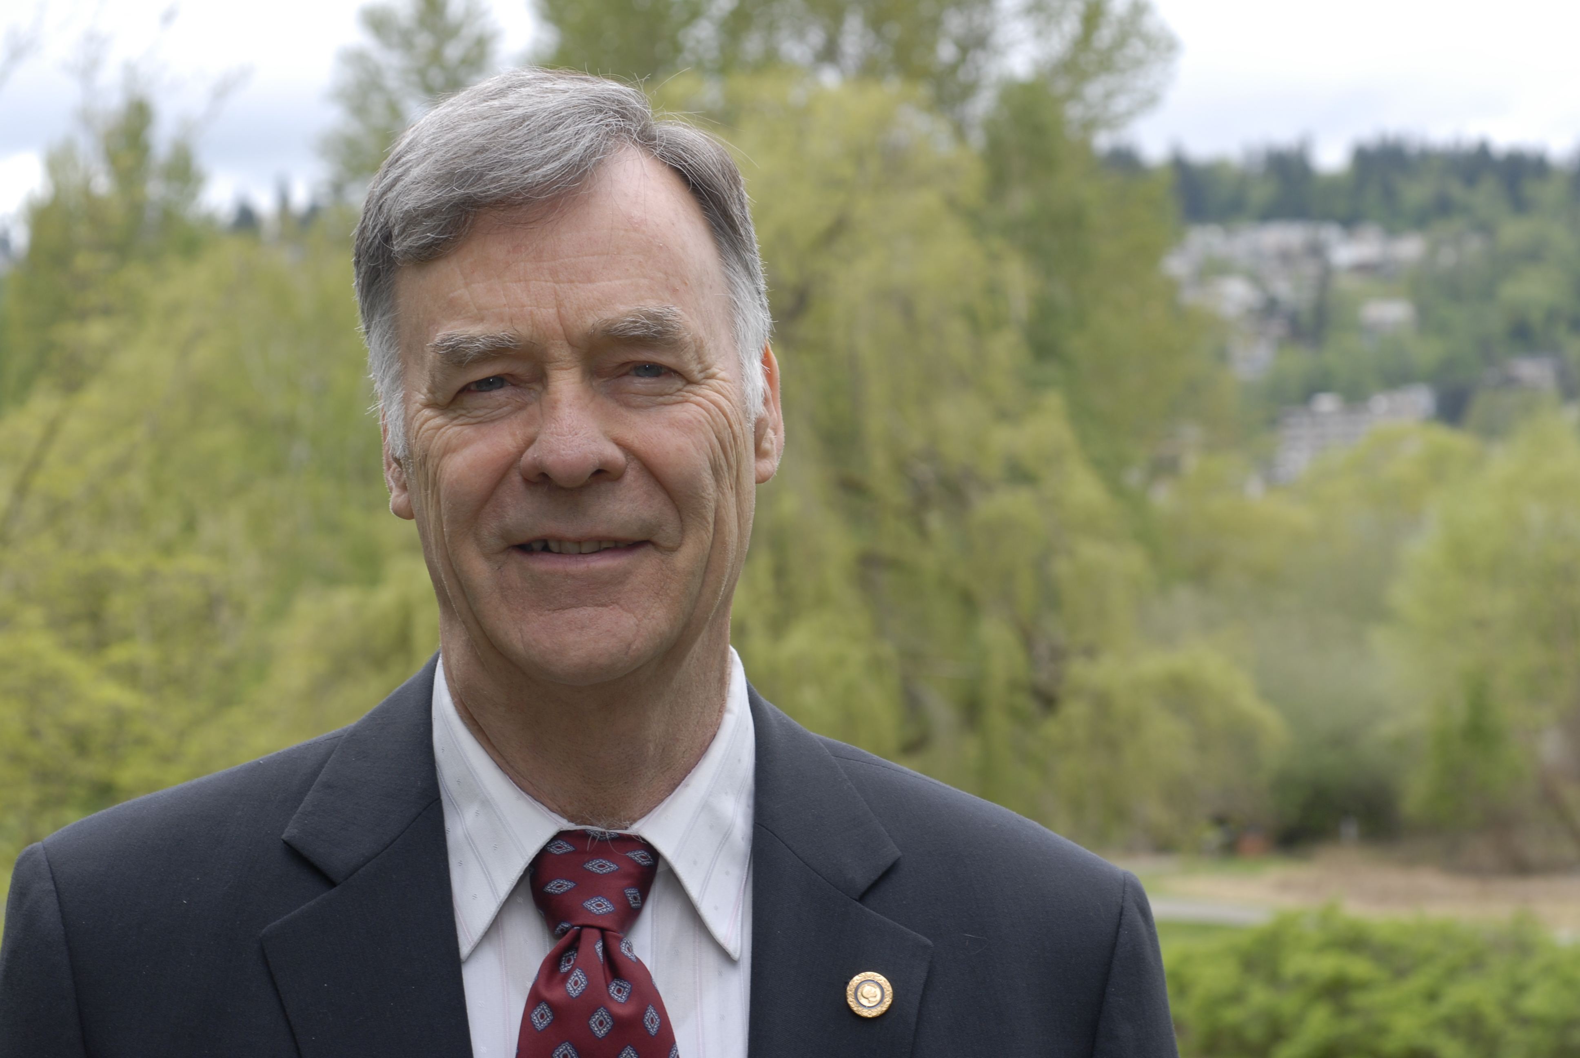

**ALAN E. WALTAR, Ph.D.**

Alan E. Waltar recently retired as Director of Nuclear Energy at the Pacific Northwest National Laboratory (PNNL) after previously retiring as Professor and Head of the Department of Nuclear Engineering at Texas A&M University. Whereas the bulk of his career focused on fuels and safety development for fast reactors, he has recently become interested in helping to update radiation response models to low dose protection standards. This interest grew out of the unintended consequences of applying the current, ultra conservative standards and the associated ethical issues.

He is Past President and Fellow of the American Nuclear Society. He holds a BS in Electrical Engineering from the University of Washington, a MS in Nuclear Engineering from MIT, and a PhD in Engineering Science from the University of California, Berkeley. Along with over 75 open literature scientific articles, he has authored or co-authored four books (two textbooks on fast reactors and two focused on helping the general public better understand the enormous benefits of harnessed radiation).

Dr. Waltar was instrumental in the formation of the World Nuclear University (WNU) Summer Institute (SI) and has served as a mentor, lecturer, and MC for all fourteen SIs —as well as both WNU Radioisotopes Schools in Korea (2010 and 2012) and the 2014 Radiation School in Qatar. He also led a People-to-People Ambassadors Nuclear Delegation to China in October 2007 and India in 2009.