PLSQL Assignment One – Sunrise Supermarket
Student Information
Information | Details
Full Name | UMUMARARUNGU Kethia
Student ID | 27845
Group | C
DBMS Used | Oracle Database
REPOSITORY Name https://github.com/kethiaumumararungu-tech/assignment_1_Umumararungu_Kethia_27845

1. Business Scenario
Sunrise Supermarket is a retail business that sells different products to customers. Customers place orders containing one or more products.
The management of Sunrise Supermarket wants to understand:
- Who their customers are
- Where their customers are located
- What products customers purchase
- How much customers spend
- Which customers spend above the average
- How customers' orders are distributed over time
- How much revenue the supermarket generates over time
- How frequently customers return to place new orders
To support these requirements, a relational database was created using Oracle Database. The database contains information about customers, products, orders, and individual order items.
SQL JOINs, a Common Table Expression (CTE), aggregate functions, and window functions were used to analyze the supermarket's transactional data.

2. Database Management System
Database Management System: Oracle Database
Oracle SQL was used to create the database tables, insert sample data, and execute the required analytical queries.

3. Database Structure
The database consists of four main tables:
Customers
Stores information about customers.
Column | Description
customer_id | Unique identifier for each customer
customer_name | Customer's full name
email | Customer's email address
city | Customer's city
Products
Stores information about products sold by Sunrise Supermarket.
Column | Description
product_id | Unique identifier for each product
product_name | Name of the product
category | Product category
price | Price of the product
Orders
Stores customer orders.
Column | Description
order_id | Unique identifier for each order
customer_id | Customer who placed the order
order_date | Date the order was placed
Order Items
Stores the individual products contained in each order.
Column | Description
order_item_id | Unique identifier for each order item
order_id | Associated order
product_id | Product purchased
quantity | Quantity purchased

4. Database Relationships
The tables are related as follows:
CUSTOMERS
|
| customer_id
|
v
ORDERS
|
| order_id
|
v
ORDER_ITEMS
|
| product_id
|
v
PRODUCTS
The relationships allow customer information, order information, and product information to be combined for analysis.

5. Data Population
The database was populated with data that satisfies the assignment requirements.
Requirement | Data Populated
Customers | 5
Products | 8
Product Categories | 4
Orders | 15
Order Items | 30
The products are distributed across four categories:
- Groceries
- Dairy
- Household
- Personal Care
The orders were placed across multiple dates in September 2026.

6. Project Files
The repository contains the following files:
assignment_1_your_name-your_id/
│
├── README.md
├── schema.sql
├── data.sql
├── queries.sql
│
└── screenshots/
├── 01_tables_created.png
├── 02_data_verification.png
├── 03_join_query_1.png
├── 04_join_query_2.png
├── 05_join_query_3.png
├── 06_cte_query.png
├── 07_window_query_1.png
├── 08_window_query_2.png
├── 09_window_query_3.png
└── 10_window_query_4.png

7. Table Creation Verification
After executing schema.sql, the four required tables were created:
- CUSTOMERS
- PRODUCTS
- ORDERS
- ORDER_ITEMS
Screenshot

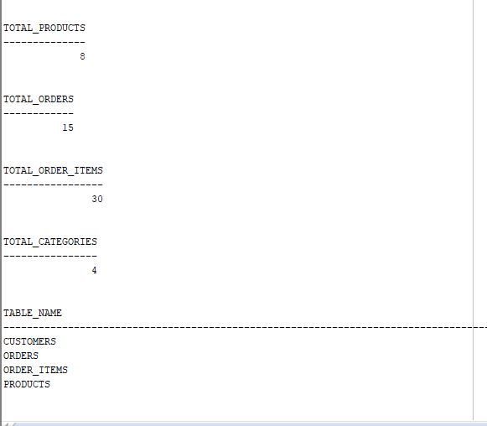

8. Data Verification
The database was populated with:
- 5 customers
- 8 products
- 4 categories
- 15 orders
- 30 order items
The data was verified using SQL COUNT() queries.
Screenshot
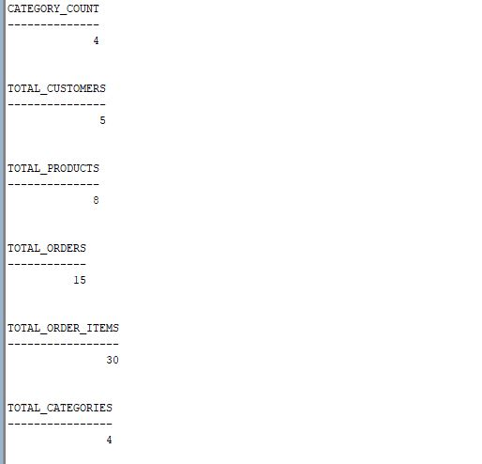

9. JOIN Queries
9.1 JOIN Query 1 – Orders with Customer Information
Requirement
List every order with the customer's name, city, and order date.
SQL Query
SELECT
o.order_id,
c.customer_name,
c.city,
o.order_date
FROM orders o
INNER JOIN customers c
ON o.customer_id = c.customer_id
ORDER BY o.order_date;
Explanation
This query uses an INNER JOIN between the `orders
