**Introduction to Microservices**

1. **Introduction**
2. Definition of Microservices Architecture:

Microservices architecture involves designing an application as a series of small services, each running in its own process and communication with lightweight mechanisms, often an HTTP resource API. Each service is built around a specific business capability and is independently deployable by fully automated deployment machinery.

1. Comparison with Monolithic Architecture:

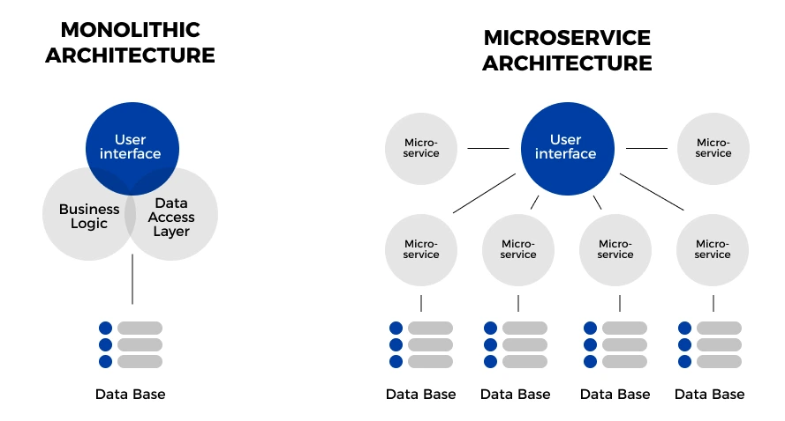

|  | **Monolithic** | **Microservices** |
| --- | --- | --- |
| **Deployment** | Simple and fast deployment of the entire system | Requires distinct resource, making orchestrating the deployment complicated |
| **Scalability** | It is hard to maintain and handle new changes; the whole system needs to be redeployed | Each element can be scaled independently without downtime |
| **Agility** | Not flexible and impossible to adopt new tech, languages or frameworks | Integrate with new technologies to solve business purposes |
| **Resiliency** | One bug or issue can affect the whole system | A failure in one microservice does not affect other services |
| **Testing** | End-to-end testing | Independent components need to be tested individually |
| **Security** | Communication within a single unit makes data processing secure | Interprocess communication requires API getaways raising security issues |
| **Development** | Impossible to distribute the team’s efforts due to the huge indivisible database | A team of developers can work independently on each component |

**II. Principles of Microservices**

1. Decentralization:

Microservices promote decentralization of data management and service governance. For example, each microservice manages its own database, either different instances of entirely different database systems, which helps in isolating the services from each other, enhancing fault tolerance and service autonomy

1. Componentization:

Services in a microservices are treated like separate components or modules that can be replaced or updated without affecting other services. This is like replacing parts of a machine but no need to rebuild the whole machine, facilitating easier maintenance as faster updates.

1. Autonomy:

Each microservice is developed and deployed independently, managed by a small team that handles the full software development lifecycle of the service. This reduces dependencies and coordination overhead and innovation.

1. Technology Diversity:

Microservices architectures allow different services to be written in different programming languages, use different data storage technologies, and different third-party services, depending on what is the best for each service’s requirements. For instance, a real-time chat service might use a NoSQL database like MongoDB for its performance in handling high volumes of small, simple transactions, while an accounting service might use a relational database like PostgreSQL for its needs for complex queries and transactions.

**III. Advantages of Microservice**

1. Scalability:

* Each service can be scaled independently, allowing more precise allocation of resources, which can be adjusted to match demand for each service without affecting others. For instance, if an e-commerce application experiences high demand for payment processing during a sale, only the payment service can be scaled up without scaling the entire application.

1. Resilience:

* Because services are isolated, the failure of one service doesn't directly bring down the entire system. For instance, if the recommendation service fails, the rest of the application still functions, and the failure can often be handled gracefully.

1. Technological Agility:

* Microservices enable an organization to experiment with new technologies and processes in a controlled manner. For example, a new service can be developed using a different technology stack to evaluate its performance and suitability without the risk of affecting existing services.

**IV. Challenges of Microservices**

1. Complexity:

* Managing multiple services, especially in a large system, introduces operational complexity. Monitoring, logging, and orchestrating these services require robust infrastructure and tools such as Kubernetes or Docker.

1. Data Integrity:

* Each service manages its own database, which can lead to challenges in maintaining data consistency across services. Strategies like distributed transactions or eventual consistency are often employed to manage these issues.

1. Network Issues:

* Inter-service communication over networks introduces latency and can become a bottleneck. Techniques like API gateways, service meshes, and proper load balancing strategies are critical to mitigating these issues.

1. Skill Set:

* The diverse array of technologies and the need for specialized skills in areas like cloud infrastructure, DevOps, and specific programming frameworks can pose a significant challenge in adopting microservices.