# Introduction to Microservices Introduction

Microservices architecture is an architectural style that structures an application as a collection of small, loosely coupled services that operate together to achieve a common goal. Each service in a microservices architecture is built around a specific business capability, operates independently, and can be deployed, scaled, or updated without depending on other services in the application. This approach enables continuous delivery and deployment of large, complex applications and allows for better testability and deployability​.

# Comparison with Monolithic Architecture

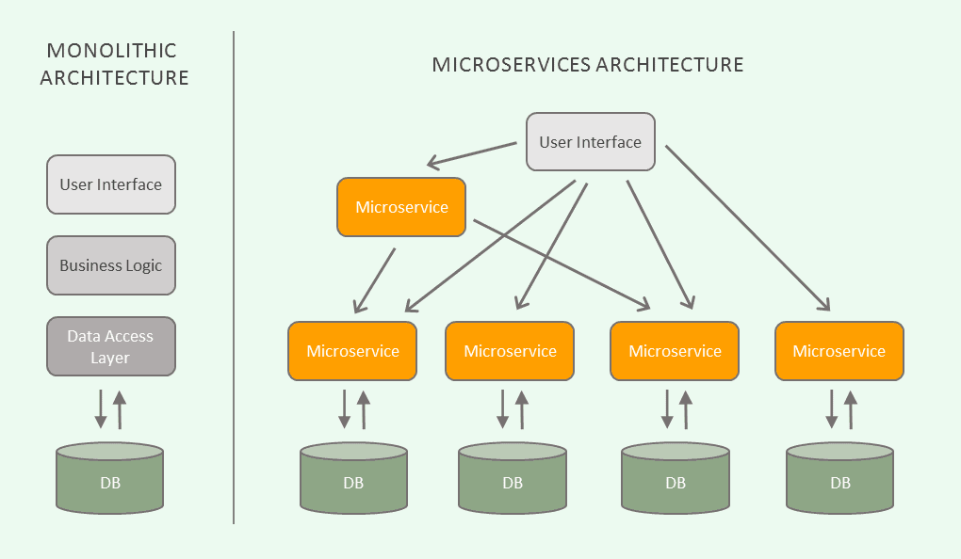

Source: <https://www.datarobot.com/blog/introduction-to-microservices/>

## Monolithic Architecture

In a monolithic architecture, the application is built as a single unit. All components of the application are interconnected and interdependent. If the application grows too large, it becomes **complex to understand**, **slow to start**, and **challenging to scale**. Any changes require redeploying the entire application, and **a bug in any module can potentially bring down the entire process**. However, monolithic applications are **simpler to develop**, **deploy**, **and horizontally scale by running multiple instances behind a load balancer​​**.

## Evolution to Microservices Architecture

Microservices architecture emerged as a solution to the drawbacks of the monolithic architecture, particularly for larger, more complex applications. By decomposing an application into multiple smaller services, microservices allow for **independent development**, **testing**, and **deployment**, which enhances **agility** and **scalability**. This architecture also improves **fault isolation**, as issues in one service do not directly impact others. Despite these advantages, microservices introduce complexities of their own, such as the need for sophisticated service discovery mechanisms and handling inter-service communications effectively​.

## Real-World Applications of Microservices

One notable example is **Netflix**, a pioneer in adopting microservices to replace its monolithic architecture. This transition allowed Netflix to handle millions of concurrent users by dynamically scaling services based on demand, thus enhancing performance and user experience. Another example is **Amazon**, which utilized microservices to enable the continuous deployment of its expansive and complex applications, improving innovation speed and operational reliability. Each service in Amazon's architecture is independently scalable and deployable, which allows for quicker updates and better system stability. Additionally, **Uber’s** shift to microservices facilitated their rapid global expansion. By breaking their large monolithic application into smaller, interconnected services, Uber could scale specific functions of their platform independently to meet regional demand and regulatory requirements, thus optimizing resources and streamlining operations. These cases underline the efficacy of microservices in supporting scalability, reliability, and business agility.

# Principles of Microservices

1. **Decentralization**:

In microservices architecture, decentralization refers to the **distribution of responsibilities across different services rather than having a centralized management system**. **Each microservice manages its own data and logic**, and they interact with each other using well-defined APIs.

This principle allows for **greater flexibility** and **resilience**. Services can be developed, deployed, and scaled independently, which **minimizes the impact of changes or failures in one service on others**.

1. **Componentization**:

Componentization in microservices means treating each service as an independent component that can be **independently deployed**, **maintained**, **and replaced without impacting the rest of the system**.

This approach promotes **modularity**, making it easier to **update or replace components without affecting the entire application**. It also enhances the **maintainability** of the system by **isolating** **responsibilities** into different components.

1. **Autonomy**:

Autonomy in the context of microservices refers to the **independence of teams in terms of development**, **deployment**, and **scaling of their respective services**. Each team is **responsible for the complete lifecycle of their service**.

This **reduces coordination overhead among different teams**, enabling them to **operate more efficiently** and **respond quicker to changes or issues**. It fosters a culture of **ownership** and **accountability** **as each team is fully responsible for their service.**

1. **Technology Diversity**:

Technology diversity **allows teams to choose the most suitable technology stack for their specific requirements of the service they are handling**, rather than being bound to a single technology across the entire application.

This principle **encourages innovation and optimizes performance**, as teams can use the best tools and technologies for their particular needs. It also helps in **attracting and retaining talent**, as developers prefer environments where they can work with a variety of technologies and tools.

# Advantages of Microservices

1. **Scalability**:

In microservices architecture, scalability refers to **the ability to increase or decrease the capacity of each service independently**, based on the demand or load specific to that service.

This independent scalability **allows organizations to optimize resource usage and costs**. For instance, a component experiencing high demand can be scaled up separately without affecting the performance of other components. This flexibility is crucial for maintaining high performance and availability without incurring unnecessary costs.

1. **Resilience**:

Resilience in microservices means that the architecture is designed in such a way that **if one service fails, it does not bring down the entire system**. **Services are isolated, and failures are contained within the individual service**.

This isolation helps in maintaining system stability and availability. It also **simplifies the process of recovery from errors**, as only the affected service needs to be addressed. The resilience of the system enhances user experience by ensuring that system functionalities remain available even in the face of partial system failures.

1. **Technological Agility**:

Technological agility in the context of microservices architecture refers to **the ability of an organization to adopt new technologies and processes more flexibly.**

Since microservices are loosely coupled and operate independently, introducing new technologies or updating existing ones can be done in a more controlled and risk-mitigated manner. Teams can choose different technology stacks that are best suited for their specific services without the risk of affecting other parts of the system. This capability not only allows for continuous improvement and innovation but also supports a more agile development process.

# Challenges of Microservices

1. **Complexity**:

Microservices architecture **increases the operational and management complexity because it involves handling multiple small, independent services** as opposed to a single monolithic application.

This complexity arises from the need to manage and monitor each service individually, including deployment, scaling, and troubleshooting. The orchestration of these services, ensuring they work together seamlessly, adds another layer of complexity.

1. **Data Integrity**:

Ensuring data consistency across distributed services in a microservices architecture can be challenging due to **each service managing its own database**.

This isolation of data stores **necessitates implementing strategies for maintaining data integrity and consistency across services**. Common issues include handling distributed transactions and ensuring that all services reflect the most current and accurate state of the data, which can be complicated by the eventual consistency model often used in these architectures.

1. **Network Issues**:

Microservices heavily **rely on network communication as services frequently interact over the network**. This reliance introduces challenges **related to network latency and the need for effective load balancing**.

**Network latency can affect the performance of the microservices,** especially when the services are distributed across different physical locations. Effective load balancing is crucial to distribute traffic evenly across services, ensuring no single service becomes a bottleneck.

1. **Skill Set**:

Microservices architecture requires development teams to possess a **broad set of skills**, including expertise in DevOps practices, cloud technologies, continuous integration/continuous deployment (CI/CD) processes, and decentralized data management.

The demand for a diverse skill set can make it challenging to find or develop the right talent within an organization. Teams must be adept not only at developing services but also at managing their entire lifecycle, which includes monitoring, logging, updating, and scaling. This multifaceted requirement can lead to a steep learning curve and necessitates ongoing training and adaptation.

# Conclusion

Microservices architecture has significantly transformed how modern enterprises approach software development and deployment. By decomposing applications into smaller, independent services, organizations can achieve unprecedented levels of agility, scalability, and resilience. This architectural style enables businesses to adapt quickly to changing market demands and technological advancements, fostering a culture of innovation.

While microservices offer advantages such as enhanced flexibility in scaling, improved fault isolation, and technological agility, they also introduce a set of challenges. The complexity of managing multiple services, maintaining data integrity across distributed systems, handling network latency, and the broad skill sets required for effective implementation can be daunting. However, these challenges are not avoided. With robust planning, the right tools, and a committed investment in skills development, organizations can effectively navigate these obstacles.