**Introduction to Microservices**

1. **Introduction**
2. **Definition of Microservices Architecture:**

* Microservices are small, independent, and loosely coupled. A single small team of developers can write and maintain a service.
* Each service is a separate codebase, which can be managed by a small development team.
* Services can be deployed independently. A team can update an existing service without rebuilding and redeploying the entire application.
* Services are responsible for persisting their own data or external state. This differs from the traditional model, where a separate data layer handles data persistence.
* Services communicate with each other by using well-defined APIs. Internal implementation details of each service are hidden from other services.
* Supports polyglot programming. For example, services don't need to share the same technology stack, libraries, or frameworks.

1. **Comparison with Monolithic Architecture**

| **Aspect** | **Microservice** | **Monolithic** |
| --- | --- | --- |
| Development and Deployment | Decentralized development, each service developed and deployed independently | Single codebase, straightforward development and deployment processes |
| Scalability and Performance | Granular scalability, optimal resource allocation based on service needs | Scaling the entire application, potential resource wastage |
| Maintainability and Extensibility | Independent services, easier to add new features without impacting the entire application | Single codebase, easier to understand and maintain |
| Technology Diversity and Autonomy | Diverse technologies for each service, freedom to choose best-fit technologies | Limited technology stack, tied to a specific set of technologies |
| Fault Tolerance and Resilience | Isolated failures, better fault tolerance and resilience | Single point of failure, failures affect the entire application |
| Communication and Coordination | Inter-service communication, additional effort for coordination and data consistency | Direct function calls, easier communication and data sharing |

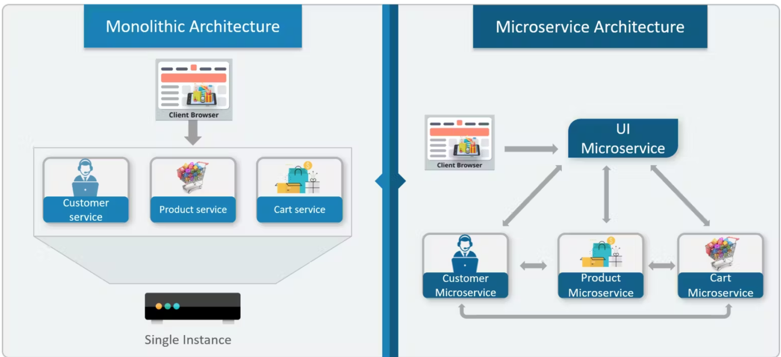

**II. Principles of Microservices**

1. **Decentralization:**

* Microservices are like separate mini-apps that work on their own, so the usual way of overseeing everything centrally doesn't really fit. In microservices, each team takes care of its own section, including keeping it running all the time. More and more, companies are asking the teams that build these services to also manage them day-to-day.

1. **Componentization:**

* In a microservices architecture, each service is like a separate piece of a machine. You can replace or update these pieces without having to take apart the whole machine. This makes it easier to keep everything running smoothly and allows for quicker updates.

1. **Autonomy:**

* Autonomy in microservices means each service is built and managed independently by a small team responsible for the entire development process of that service. This independence cuts down on the need for coordination with other teams and speeds up innovation, as teams can make changes without waiting on others.

1. **Technology Diversity:**

* This means that each service can be created using the technology that best suits its needs. For example, a service designed for real-time chatting might use a NoSQL database like MongoDB because it's good at managing lots of simple, quick transactions. On the other hand, a service for accounting might use a relational database like PostgreSQL, which is better for handling complex queries and transactions. This flexibility allows each part of the system to perform optimally based on its specific requirements.

**III. Advantages of Microservice**

1. **Scalability**

* Services can be scaled independently, letting you scale out subsystems that require more resources, without scaling out the entire application. Using an orchestrator such as Kubernetes, you can pack a higher density of services onto a single host, which allows for more efficient utilization of resources.

1. **Resilience**

* In a microservices architecture, each service operates independently. This isolation means that if one service fails, it doesn't cause the entire system to crash. For example, if a recommendation service stops working, the rest of the application continues to function, and the issue can be managed smoothly.

1. **Technological Agility**

* Microservices also allow organizations to try out new technologies and methods without disrupting their existing systems. For instance, a team can build a new service using a different set of technologies to see how well it performs. This can be done without risking the stability of other services, providing a safe environment for experimentation and innovation.

**IV. Challenges of Microservices**

1. **Complexity**

* A microservices application has more moving parts than the equivalent monolithic application. Each service is simpler, but the entire system as a whole is more complex.

1. **Data Integrity**

* In microservices, each service controls its own database, which can make it tricky to keep data consistent across different services. To handle this, strategies such as distributed transactions or eventual consistency are used. Distributed transactions help coordinate changes across multiple databases to maintain consistency, while eventual consistency allows for temporary discrepancies but ensures that all data will eventually be synchronized across services. This approach helps manage the complexity of having multiple, independent data sources while trying to maintain overall system accuracy.

1. **Network Issues**

* The use of many small, granular services can result in more interservice communication. Also, if the chain of service dependencies gets too long (service A calls B, which calls C...), the additional latency can become a problem. You will need to design APIs carefully. Avoid overly chatty APIs, think about serialization formats, and look for places to use asynchronous communication patterns like queue-based load leveling

1. **Skill Set**

* Microservices are highly distributed systems. Carefully evaluate whether the team has the skills and experience to be successful.