iVote

**Functional Requirements**

1. The system will be available for the polls which support one and multiply answers for voting.
2. There will be 5 types of users in the system. Each of them will have different functions.
3. An unregistered user is only a visitor of the page, he can register to the system to create a poll. Therefore, he or she can attend polls if the user has the poll link.
4. After an unregistered user is registered, it becomes automatically an poll owner in the system if he or she create a poll successfully.
5. Admin can access all polls and it has all authority on them for customer support.
6. Voters can vote only once in a poll.
7. Voters can not change their votes after the finish of voting process.
8. Polls can not be edited at all, but it’s deadline can be changed for specific situations.
9. Polls can be public or private.
10. All polls can be accessible via a deep link, but private polls needs extra pin code to be voted.
11. Questions of a poll can not be edited after it’s creation.
12. Candidates can have their profile pages which include their personal information and why voters should select them.
13. Profile pages of candidates can not be edited after their creation for equality and safety.

**Use Cases**

1.

|  |
| --- |
| Use Case Name: Login |
| Participating Actors: Initiated by User, Communicates with System |
| Flow of Events:  1.User types his/her id and password on the login form.  2.System validates the User's id and password.  3.System logs him/her into the system.  4.System directs the User to the main page. |
| Entry Condition: None |
| Exit Condition: User logs in to the system and directed to the main page. |

2.

|  |
| --- |
| Use Case Name: Logout |
| Participating Actors: Initiated by User, Communicates with System |
| Flow of Events:  1.User clicks on the logout button.  2.The System logs the user out and invalidates the cookie/session.  3.The System redirects to the default logout page. |
| Entry Condition: User is logged into the system. User no longer wants to be logged in. |
| Exit Condition: User has logged out . |

3.

|  |
| --- |
| Use Case Name: Register |
| Participating Actors: Initiated by User, Communicates with System |
| Flow of Events:  1.User clicks on the register button.  2.User enters his/her register information.  3.The System validates his/her cookie/session and automatically invokes "Login".  4.User is registered and logged on to the system. |
| Entry Condition: None. |
| Exit Condition: User has registered into the System. |

4.

|  |
| --- |
| **Use Case** **Name:** seeResults |
| **Participating Actors:** Initiated by Use**r,** Communicates with System |
| **Flow of Events**:  1.User clicks on the See Results button.  2.System displays the user election results. |
| **Entry Condition:**  Election/Survey is ended. |
| **Exit Condition:**  Result screen is displayed |

5.

|  |
| --- |
| **Use Case** **Name:** vote |
| **Participating Actors:** Initiated by Use**r,** Communicates with System |
| **Flow of Events:**  1.User selects his choice or types his/her answer.  2.User clicks Vote/Submit button.  3.The System saves his/her choice/answer to database. |
| **Entry Condition**:  An election or survey has created.  User is eligible to vote |
| **Exit Condition:**  User gets a feedback about voting status.  User is no longer eligible for vote or answer again on this election/survey. |

6.

|  |
| --- |
| **Use Case** **Name:** createVoting |
| **Participating Actors:** Initiated by Use**r,** Communicates with System |
| **Flow of Events:**  1.User clicks on the Create new Election/Survey button.  2.User selects election/survey options.  3.User clicks on the Create button.  4.A(an) Survey/Election is created by the System. |
| **Entry Condition:**  User is logged in. |
| **Exit Condition:**  A(an) Survey/Election is created by the System. |

7.

|  |
| --- |
| **Use Case** **Name:** changeEmail |
| **Participating Actors:** Initiated by Use**r,** Communicates with System |
| **Flow of Events:**  1.User clicks on the Profile Settings button.  2.User selects Change E-Mail option.  3.User types his/her new E-Mail.  4.The System checks this data and verifies.  5.The System sends User an e-mail to activate his/her new e-mail address. |
| **Entry Condition:** User is logged in. |
| **Exit Condition:** User has replaced her/his e-mail successfully |

8.

|  |
| --- |
| **Use Case** **Name:** changePassword |
| **Participating Actors:** **:** Initiated by Use**r,** Communicates with System |
| **Flow of Events.:**  1.User clicks to Forgot Password Button.  2.User enters e-mail and clicks Recovery Button.  3.System sends User an Recovery E-mail.  4.User clicks on the Recovery Link. |
| **Entry Condition:** User cannot login |
| **Exit Condition:** A Recovery E-mail has sent. |

9.

|  |
| --- |
| **Use Case** **Name:** LoginError |
| **Participating Actors:** Initiated by Use**r,** Communicates with System |
| **Flow of Events:**  1.User has entered his/her username or password wrong.  2.User click on login button.  3.System cannot verifies his/her login info.  4.An error is displayed by the System |
| **Entry Condition:** User has entered his/her username or password wrong |
| **Exit Condition:** User gets Wrong Username cannot logged Error. |

10.

|  |
| --- |
| **Use Case** **Name:** : RegisterError |
| **Participating Actors:** Initiated by Use**r,** Communicates with System |
| **Flow of Events:**  1.User has entered an existing username/e-mail  2.User click on register button.  3.System matches with existing username/e-mail entered by User.  4.An error is displayed by the System. |
| **Entry Condition:** User has entered his/her username or e-mail which is already used. |
| **Exit Condition:** User gets Username or e-mail has already used error. |

11.

|  |
| --- |
| **Use Case** **Name:** : VoteError |
| **Participating Actors:** Initiated by Use**r,** Communicates with System |
| **Flow of Events:**  1.User opens election/survey link which he/she already voted.  2.The system verifies that the user has already voted in this election/survey.  3.An error is displayed by the System. |
| **Entry Condition:** User has voted in this election. User tries to re-enter this election/survey. |
| **Exit Condition:** User gets You cannot vote/answer again in this election/survey error. |

**Diagrams**

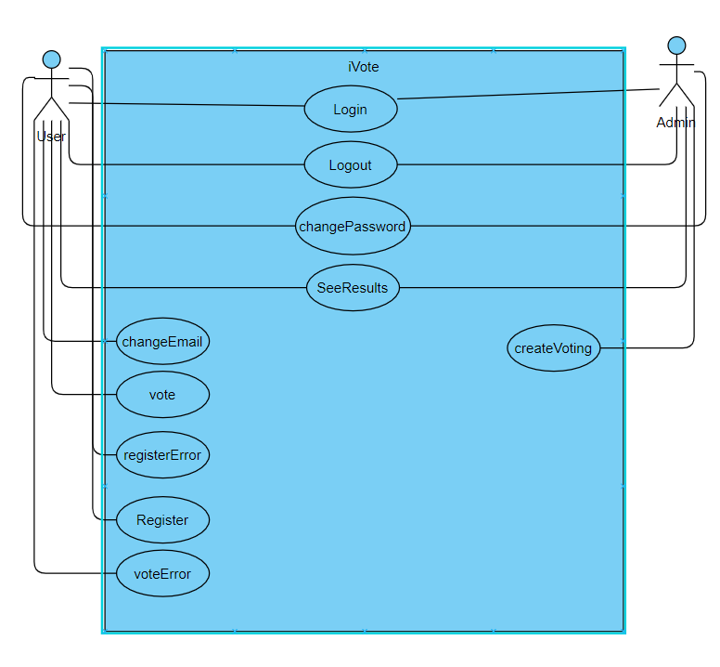

Yunus Umurbey Taşkın 218SE2129

Elif Sezin Aladağ 218SE2122

Taylan Cengiz 216SE2307

Burak Şentürk 217SE2321