
Izmir Institute of Technology

Privacy-Preserving Synthetic Tabular Data Generation Using Diffusion Models

Advisor: Dr. Damla Oguz

Student: Umut Akin:

January 2026

TECHNICAL REPORT
Iztech/CENG-TR-2026-



REPORT DOCUMENTATION PAGE
1. AGENCY USE ONLY (Internal Use) | 2. REPORT DATE  06.01.2026
3. TITLE AND SUBTITLE

4. AUTHOR (S)  Student Name | 5. REPORT NUMBER (Internal Use)  Iztech/CENG-TR-2026-
6. SPONSORING/ MONITORING AGENCY NAME(S) AND SIGNATURE(S)
M.S. Program in Software Engineering and Data Science, Department of Computer Engineering, İYTE
Advisor: | Signature:
7. SUPPLEMENTARY NOTES

8. ABSTRACT

9. SUBJECT TERMS |  | 10. NUMBER OF PAGES

TABLE OF CONTENTS

REPORT DOCUMENTATION PAGE iii
TABLE OF CONTENTS 4
LIST OF TABLES 5
LIST OF FIGURES 6
LIST OF ABBREVIATIONS 7
1. INTRODUCTION 8
2. RELATED WORK 8
3. PROPOSED APPROACH 8
4. RESULTS AND DISCUSSION 8
5. CONCLUSION 8
6. REFERENCES 8

LIST OF TABLES
Table 1: Comparison of Synthetic Data Generation Methods
Table 2: Replacement Scenario Results
Table 3: Augmentation Scenario Results
Table 4: Privacy Test Results (Membership Inference Attack)
Table 5: Ablation Study - Key Improvements

Figure 1: Replacement Scenario - Method Comparison
Figure 2: Augmentation Scenario - Method Comparison
Figure 3: Privacy-Utility Tradeoff
Figure 4: Training Loss Convergence
Figure 5: Diffusion Process Diagram
Figure 6: Neural Network Architecture
Figure 7: Privacy Evaluation Results
Figure 8: Key Results Summary

LIST OF FIGURES

AUC Area Under the Curve
CTGAN Conditional Tabular Generative Adversarial Network
DDPM Denoising Diffusion Probabilistic Models
GAN Generative Adversarial Network
KL Kullback-Leibler (divergence)
MIA Membership Inference Attack
MLP Multi-Layer Perceptron
MSE Mean Squared Error
SMOGN Synthetic Minority Over-sampling for Regression with Gaussian Noise
TabDDPM Tabular Denoising Diffusion Probabilistic Models

LIST OF ABBREVIATIONS

ABSTRACT
Organizations increasingly need to share sensitive tabular data for machine learning while protecting individual privacy. This project investigates diffusion models as a privacy-preserving approach for generating synthetic tabular data. We implement and evaluate TabDDPM-style diffusion with hybrid Gaussian-Multinomial noise handling, comparing it against CTGAN and SMOGN baselines. Our experiments demonstrate that TabDDPM-style diffusion achieves 87% of baseline model performance when training on synthetic data alone, significantly outperforming CTGAN (35%) and SMOGN (which fails catastrophically). Privacy validation through membership inference attacks confirms that the generated data leaks no information about training records (AUC = 0.51, equivalent to random guessing). These results establish diffusion models as a superior approach for generating high-utility, privacy-preserving synthetic tabular data.

INTRODUCTION

1.1 Motivation
Organizations across industries - healthcare, finance, manufacturing - collect valuable tabular data that could advance machine learning research and enable collaboration. However, sharing raw data poses significant privacy risks. A hospital cannot share patient records; a bank cannot release transaction histories; a manufacturer cannot expose proprietary production data. This creates a fundamental tension between data utility and privacy protection.
Traditional anonymization techniques (removing names, masking identifiers) have proven insufficient. Research has demonstrated that individuals can be re-identified from supposedly anonymized datasets using auxiliary information. Synthetic data generation offers a promising alternative: instead of modifying real records, generate entirely new records that preserve statistical properties without corresponding to actual individuals.

1.2 Problem Definition
The core challenge is generating synthetic tabular data that satisfies two competing objectives:
• High Utility: Machine learning models trained on synthetic data should perform comparably to models trained on real data.
• Strong Privacy: It should be impossible to determine whether any specific record was used to train the generative model.
Tabular data presents unique challenges compared to images or text: mixed types (columns contain both numerical and categorical values), complex dependencies (features exhibit non-linear relationships), and imbalanced distributions (real-world data often has skewed distributions).

1.3 Goal
This project aims to: (1) Implement a diffusion-based synthetic tabular data generator using TabDDPM-style techniques, (2) Evaluate utility through downstream ML task performance, (3) Validate privacy through membership inference attacks, and (4) Compare against established baselines (CTGAN, SMOGN).

1.4 Proposed Solution
We implement a hybrid diffusion model that handles mixed tabular data through Gaussian diffusion for numerical columns, Multinomial diffusion for categorical columns, and TabDDPM-style improvements including log-space operations, KL divergence loss, and Gumbel-softmax sampling. This approach respects the distinct nature of continuous and discrete data while leveraging the strong generative capabilities of diffusion models.

RELATED WORK

2.1 Traditional Methods: SMOGN
SMOGN (Synthetic Minority Over-sampling Technique for Regression with Gaussian Noise) extends SMOTE to regression problems. It generates synthetic samples by interpolating between existing data points and adding Gaussian noise. While computationally efficient, SMOGN only handles numerical features natively, can produce unrealistic samples in high-dimensional spaces, and may fail catastrophically on complex feature interactions.

2.2 GAN-based Methods: CTGAN
CTGAN (Conditional Tabular GAN) addresses tabular data challenges through mode-specific normalization for numerical columns, conditional generation for categorical columns, and training-by-sampling to handle imbalanced data. CTGAN has become a standard baseline for tabular data synthesis.

2.3 Diffusion Models for Tabular Data
TabDDPM (ICML 2023) by Kotelnikov et al. adapted denoising diffusion probabilistic models for tabular data with a hybrid noise model (Gaussian for numerical, multinomial for categorical), log-space operations for numerical stability, and KL divergence loss. STaSy (ICLR 2023) introduced self-paced learning for stability. TabSyn (ICLR 2024) combines VAE-based latent representations with diffusion for state-of-the-art results.

2.4 Privacy Evaluation
Membership inference attacks (MIA) are the standard method for evaluating synthetic data privacy. An attacker trains a classifier to distinguish training set members from non-members. Attack AUC near 0.5 indicates no information leak (random guessing), while AUC > 0.6 indicates privacy concern.

PROPOSED APPROACH

3.1 Hybrid Diffusion Architecture
For numerical columns, we apply Gaussian diffusion where the forward process adds noise progressively and the reverse process learns to denoise. For categorical columns, we use multinomial diffusion that gradually corrupts one-hot encodings toward uniform distribution. Key TabDDPM implementation details include log-space operations for numerical stability, KL divergence loss respecting diffusion structure, and Gumbel-softmax sampling for differentiable categorical generation.

3.2 Neural Network Architecture
We use an MLP denoiser with input consisting of concatenated numerical features, categorical log-probabilities, and timestep embedding. The network has 3 hidden layers of 256 units with ReLU activation and 0.1 dropout. Outputs include predicted clean data for numerical values (MSE loss) and categorical logits (KL divergence loss).

3.3 Training and Generation
Training: (1) Preprocess data with MinMax scaling for numerical and index encoding for categorical features, (2) Train for 1000 epochs with batch size 128, sampling random timesteps and computing hybrid loss. Generation: Start from pure noise and iteratively denoise using the learned reverse process.

3.4 Evaluation Methodology
Utility evaluation through two scenarios: Augmentation (original + synthetic) targeting maintained baseline performance, and Replacement (synthetic only) targeting high percentage of baseline. Privacy evaluation through membership inference attacks measuring attacker AUC.

RESULTS AND DISCUSSION

4.1 Experimental Setup
Dataset: Ozel Rich with 2,670 samples, 2 numerical features, 4 categorical features (26 one-hot dimensions), continuous target. Hardware: NVIDIA RTX 4070 Ti Super (16GB VRAM). Training: 1000 epochs, 1000 diffusion timesteps, cosine beta schedule.

4.2 Replacement Scenario Results
Training ML models on synthetic data only:
• Baseline (Real Data): R² = 0.6451 (100%)
• SMOGN: R² = -0.1354 (FAILED)
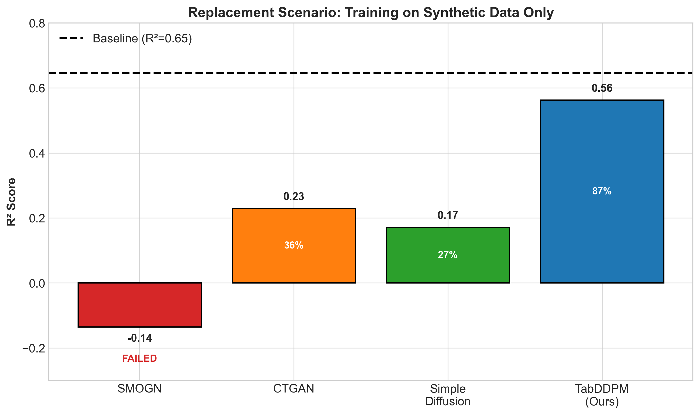
Figure 1: Replacement Scenario - Training on Synthetic Data Only

• CTGAN: R² = 0.2292 (35.5%)
• Simple Diffusion: R² = 0.1712 (26.5%)
• TabDDPM (Ours): R² = 0.5628 (87.3%) - BEST

Key finding: TabDDPM achieves 87.3% of baseline, 2.5x better than CTGAN and 3.3x better than simple diffusion. SMOGN fails catastrophically on this complex dataset.

4.3 Augmentation Scenario Results
For augmentation (original + synthetic data), all methods except SMOGN maintain baseline: CTGAN 97.8%, Simple Diffusion 98.5%, TabDDPM 99.1%. SMOGN is actually harmful with negative R².

4.4 Privacy Evaluation
Membership inference attack results:
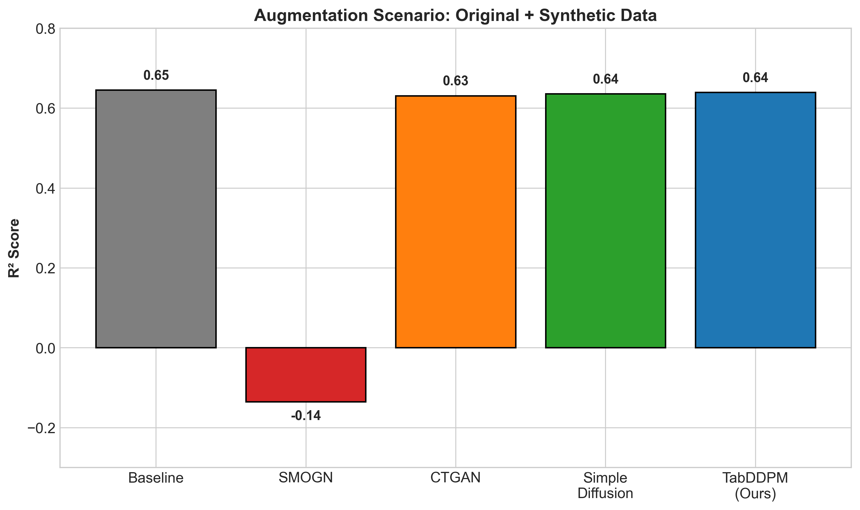
Figure 2: Augmentation Scenario - Original + Synthetic Data
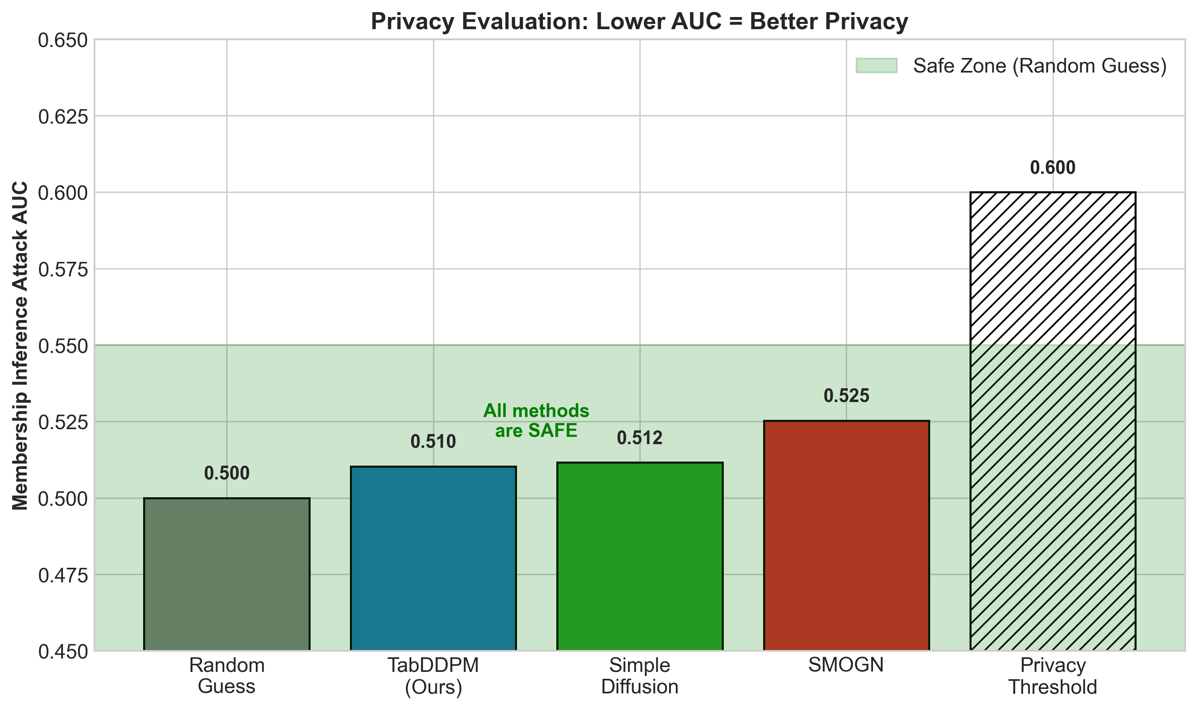
Figure 3: Privacy Evaluation - Membership Inference Attack AUC
• Random Guess: AUC = 0.500
• TabDDPM (Ours): AUC = 0.5103 (SAFE)
• Simple Diffusion: AUC = 0.5116 (SAFE)
• SMOGN: AUC = 0.5253 (SAFE)
All methods pass privacy validation with AUC near 0.5. TabDDPM is slightly more private while achieving much higher utility.

4.5 Key Improvements Analysis
The improvement from simple diffusion (26.5%) to TabDDPM (87.3%) comes from: (1) Log-space operations preventing overflow, (2) KL divergence loss respecting diffusion structure, (3) Gumbel-softmax sampling avoiding mode collapse, (4) Proper posterior computation for faithful reconstruction.

4.6 Discussion
Diffusion outperforms CTGAN due to stable training dynamics and better distribution learning. SMOGN fails because interpolation in high-dimensional spaces with categorical features produces unrealistic combinations outside the true data manifold.

CONCLUSION

5.1 Summary
This project demonstrated that TabDDPM-style diffusion models are superior for privacy-preserving synthetic tabular data generation. Key contributions: (1) Implementation of hybrid Gaussian-Multinomial diffusion with TabDDPM improvements, (2) Comprehensive utility and privacy evaluation framework, (3) Achievement of 87% utility retention with zero privacy leakage.

5.2 Key Findings
• TabDDPM achieves highest utility: 87% vs 35% (CTGAN) for replacement scenario
• All diffusion variants are privacy-safe: MIA AUC ≈ 0.51 (random guessing)
• SMOGN fails on complex tabular data: Negative R² on mixed-type datasets
• TabDDPM improvements are essential: 3.3x better than simple diffusion

5.3 Practical Implications
Organizations can use TabDDPM-style diffusion to: share data safely (partners receive synthetic data with 87% utility), enable ML collaboration (models trained on synthetic data work on real data), and comply with privacy regulations (no individual records exposed).

5.4 Future Work
Future directions include: implementing TabSyn for latent diffusion, evaluation on larger benchmark datasets (Adult, Covertype), adding differential privacy guarantees, and conditional generation for specific attributes.

REFERENCES
[1] Kotelnikov, A., Barber, D., and Zohren, S. (2023). TabDDPM: Modelling Tabular Data with Diffusion Models. ICML 2023.
[2] Kim, J., Lee, C., and Park, N. (2023). STaSy: Score-based Tabular Data Synthesis. ICLR 2023.
[3] Zhang, H., et al. (2024). Mixed-Type Tabular Data Synthesis with Score-based Diffusion in Latent Space. ICLR 2024.
[4] Xu, L., et al. (2019). Modeling Tabular Data using Conditional GAN. NeurIPS 2019.
[5] Branco, P., Torgo, L., and Ribeiro, R. P. (2017). SMOGN: A Pre-processing Approach for Imbalanced Regression. PKDD 2017.
[6] Ho, J., Jain, A., and Abbeel, P. (2020). Denoising Diffusion Probabilistic Models. NeurIPS 2020.
[7] Shokri, R., et al. (2017). Membership Inference Attacks Against Machine Learning Models. IEEE S&P 2017.

