SEDS 504 – HW2 - Project Report: Online Event Ticket Reservation System
Team Members and Contributions
Name | Contribution
Umut Akın | Designed the overall system architecture. Implemented the main classes and core functions.
Toprak Zeybek | Enhanced and extended the initial implementation. Replaced UUIDs with internal ID management.
Yasin Türk | Wrote and executed unit tests. Verified application functionality and prepared the project report.

UML DIAGRAM

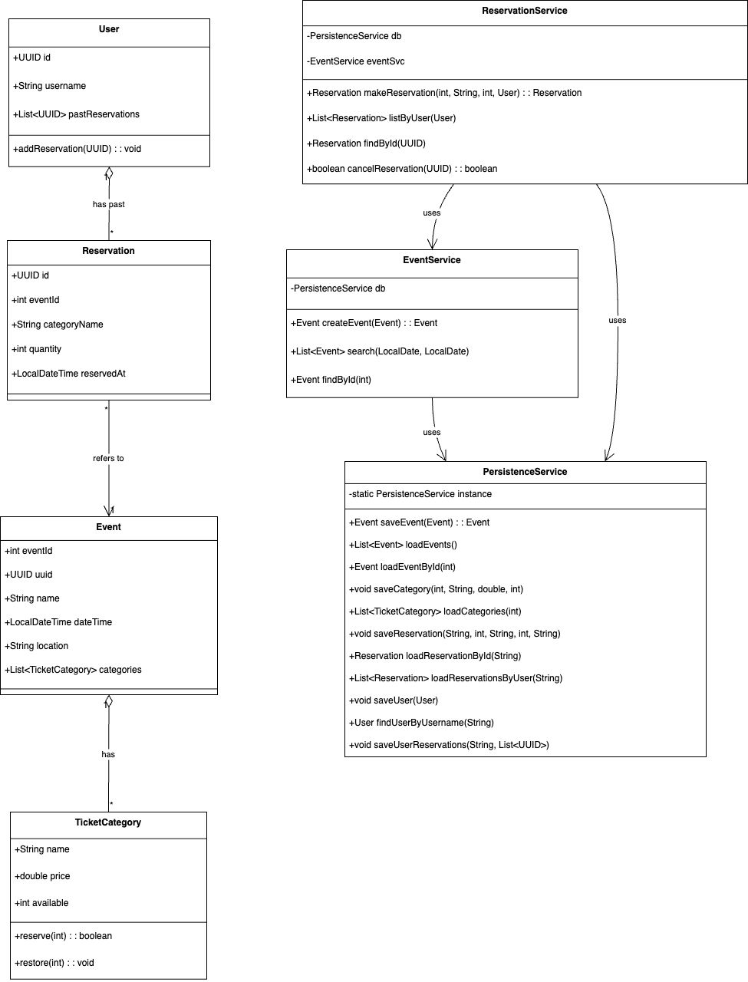

Usage Scenarios
- Guest Ticket Reservation
A user launches the application and selects the "Continue as Guest" option or User can sign up. They search for concerts in December 2025 and find a suitable one. Without signing up, they reserve 2 VIP tickets. A unique reservation number is shown for tracking.
- User Login and Reservation History
A registered user logs in with their username. They search for sports events in the next month and book 3 regular tickets. They then view their current and past reservations using the "List My Reservations" option.
- Event Creation by Firm
A firm logs into the system backend and creates a new theatre event. They specify date, location, ticket categories, and ticket prices. The event immediately becomes available to users.
- Reservation Cancellation
A user who previously made a reservation logs in and chooses the “Cancel Reservation” option. They select the reservation ID to cancel, and the system confirms the cancellation.

Explanation of Inheritance
The system leverages inheritance to create a clean and maintainable hierarchy:
- User Type Hierarchy:
A base class User is extended by specialized subclasses like GuestUser and RegisteredUser, allowing for differentiated behavior while sharing common functionality.
- Command Pattern:
An abstract Command interface is implemented by concrete classes such as SearchEventsCommand, CreateEventCommand, and ListMyReservationsCommand. This enables dynamic execution of commands via polymorphism.

Explanation of Polymorphism
Polymorphism is employed primarily in the command execution mechanism. Each menu option corresponds to a class implementing the Command interface. The UI executes commands uniformly without knowing their specific type:

```
Command cmd = commandMap.get(userChoice);
cmd.execute();
```
This design promotes scalability and cleaner code, making it easy to add new commands without altering the central logic.

Explanation of Data Persistence
The system uses a SQLite database (.db file) for data persistence. The database schema includes tables for:
- users – to store login credentials
- events – event name, date, location, and metadata
- ticket_categories – for ticket type and price per event
- reservations – linked to users or anonymous reservations
Java interacts with the SQLite database using the sqlite-jdbc driver. Queries are executed via JDBC to insert, retrieve, and update data. All operations (login, search, reservation, cancellation) result in real-time updates to the .db file, ensuring data consistency and permanence between sessions.

USAGE SCENARIOS WITH SCREEN SHOTS
Login and Create an Event

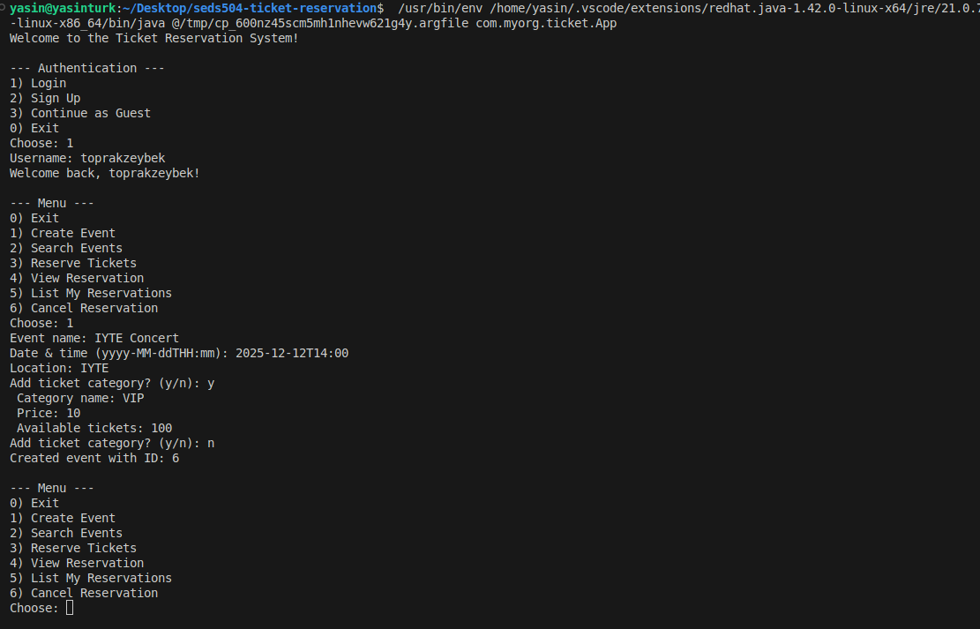
Search for Events
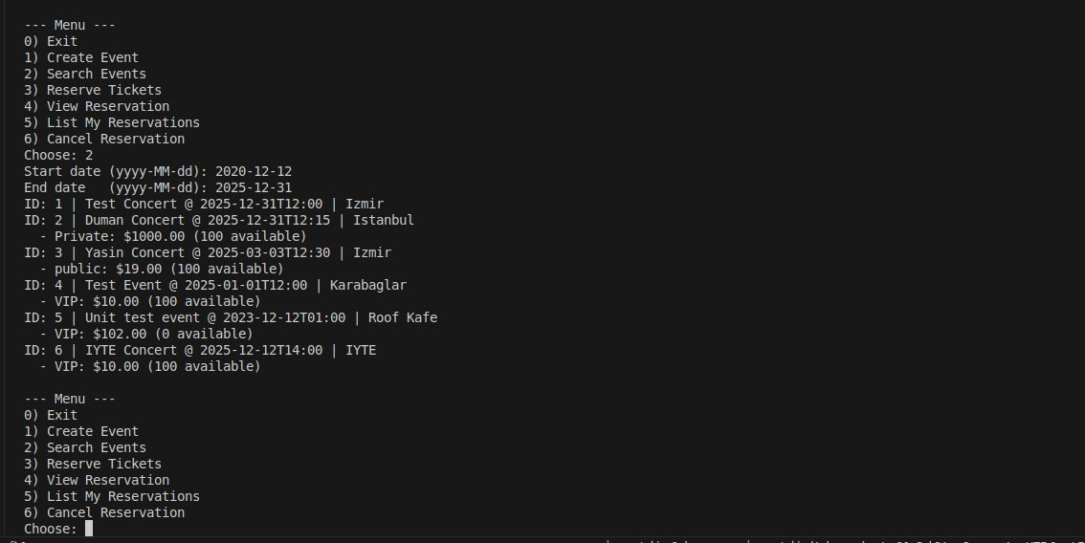
Reservation and List Reservations
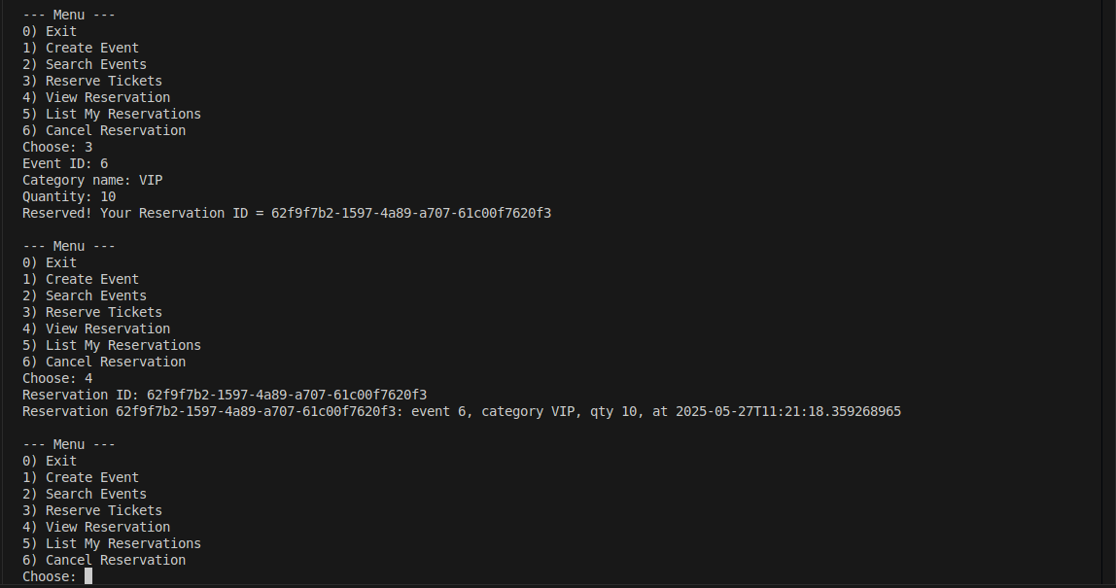
Cancellation
