**ANKARA UNIVERSITY**

**COMPUTER ENGINEERING DEPARTMENT**

**COM2058 LAB1**

Create the following table using MySQL command line. Later do the same operation using MySQL workbench. Print out the table in both command line and workbench.

|  |  |  |  |  |
| --- | --- | --- | --- | --- |
| **Rank** | **Name** | **Type** | **Channel** | **Rating** |
| 1 | COLD CASE | Serial | CNBC-E | 8.9 |
| 2 | SEKSENLER | Serial | TRT 1 | 7.5 |
| 3 | STADYUM | Sport | TRT 1 | 6.6 |
| 4 | ATV ANA HABER | Newscast | ATV | 6.5 |
| 5 | KANAL D HABER | Newscast | KANAL D | 5.2 |

(The rating order and rating values are not real. They are just given for the purpose of Lab study)

You can learn creating and printing table operations studying following steps:

Example (MySQL command line):

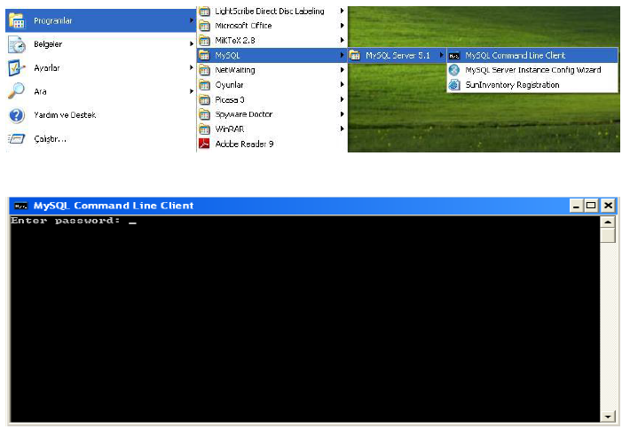

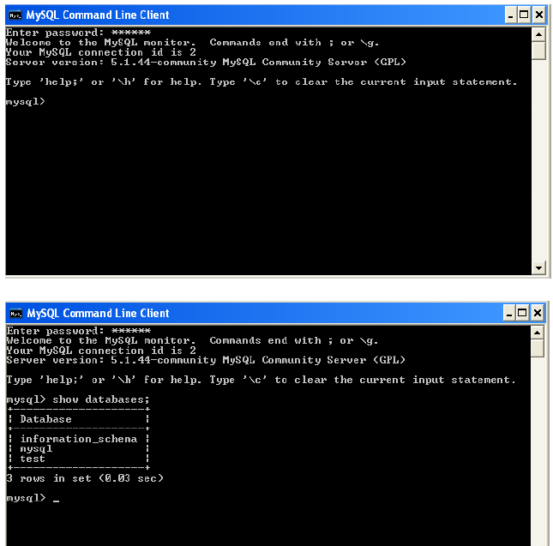

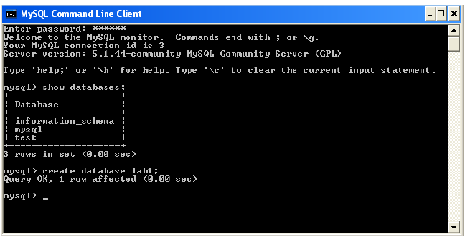

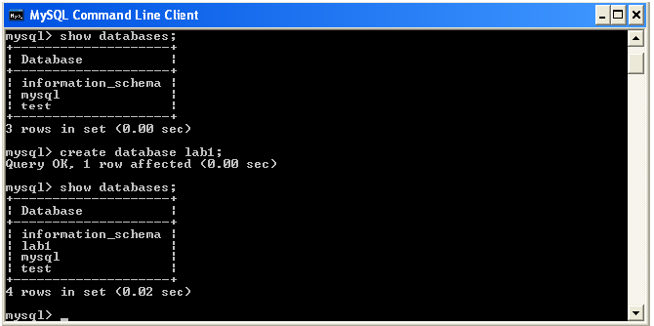

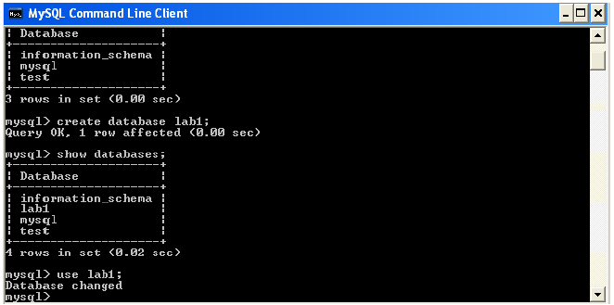

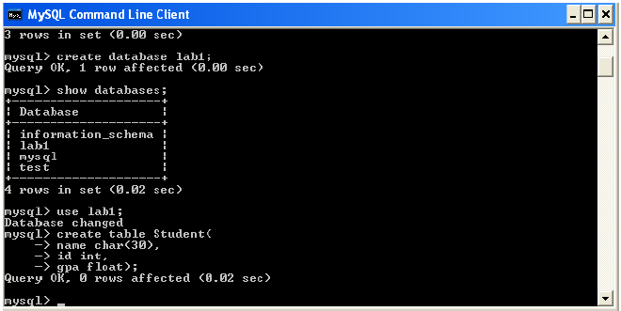

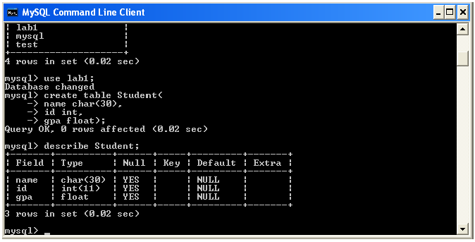

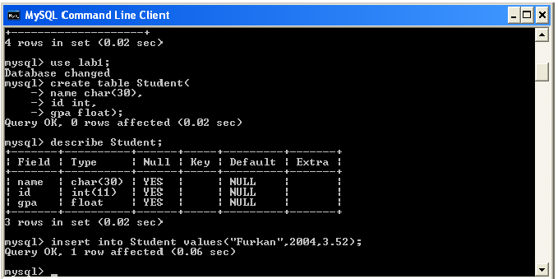

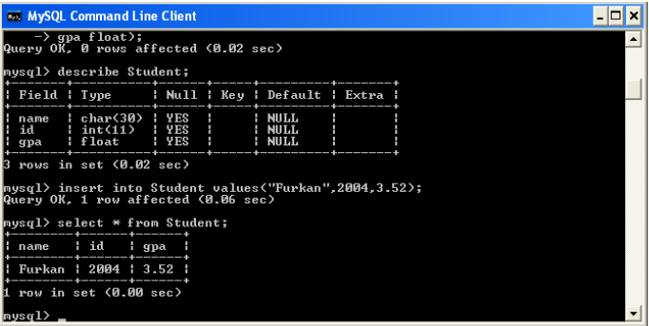

Example (MySQL workbench):

