**ANKARA UNIVERSITY**

**COMPUTER ENGINEERING DEPARTMENT**

**COM2058 LAB4**

**TABLEL4**

|  |  |  |
| --- | --- | --- |
| **A** | **B** | **C** |
| 3 | 20 | 12 |
| 3 | 10 | 13 |
| 4 | 30 | 11 |
| 4 | 40 | 10 |
| 4 | 50 | 10 |
| 5 | 20 | 15 |

select A, sum(B), avg(B) from TABLEL4 group by A;

Output:

3 30 15

4 120 40

5 20 20

select A, sum(B), avg(B) from TABLEL4 group by A having sum(B) < 50;

Output:

3 30 15

5 20 20

Create the following table and answer the questions using SQL queries.

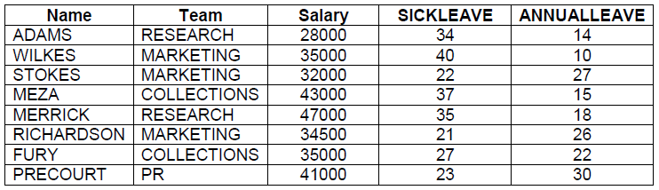

1. Show the average salary in each team. Group the output into teams.
2. Find the teams that have average salaries under 39000.
3. Find the salary of everyone with less than 25 days of sick leave and order the results by name.
4. Find out how many people on each team have less than 30 days of sick leave.
5. Find people (name) whose sick leave is more than annual leave.