**ANKARA UNIVERSITY**

**COMPUTER ENGINEERING DEPARTMENT**

**COM2058 LAB5**

Do the following operations to import lab5comblm258 schema from the self-contained file ‘2058Lab5.sql’. Do not forget to copy this file into appropriate folder.

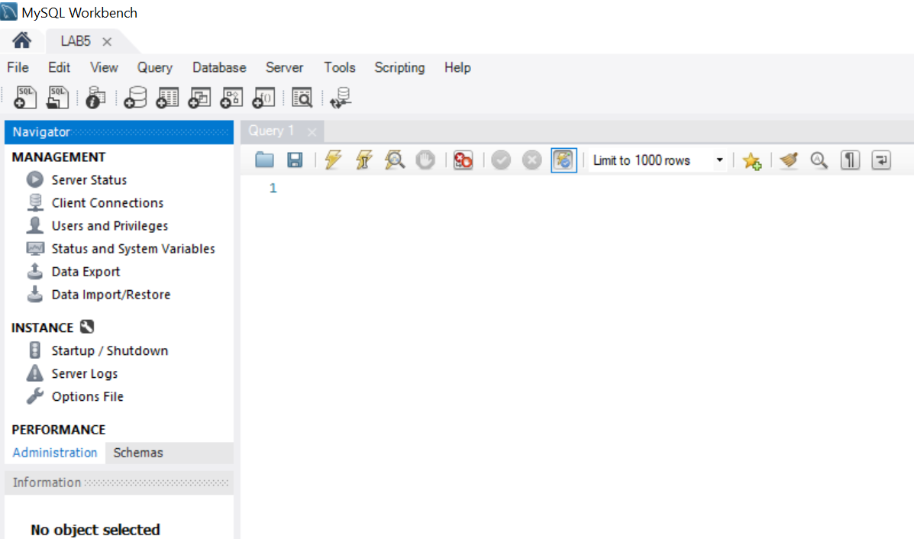

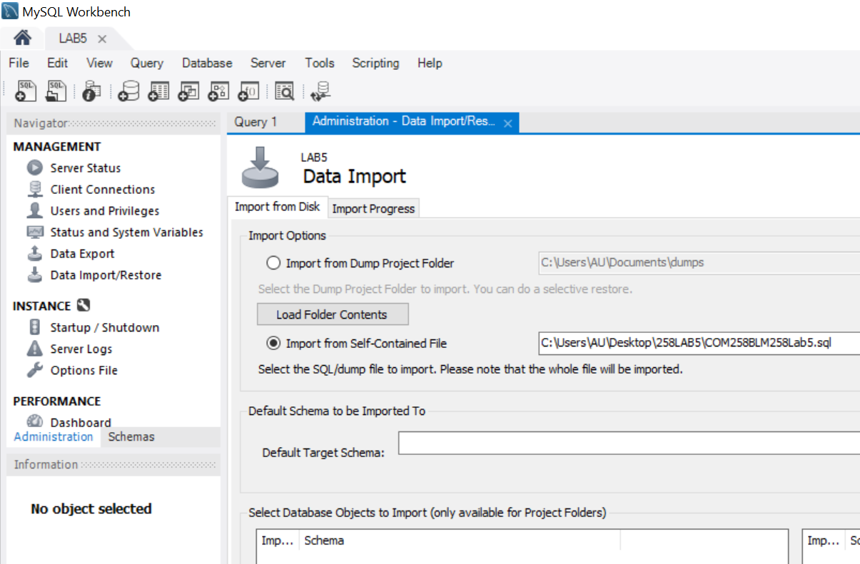

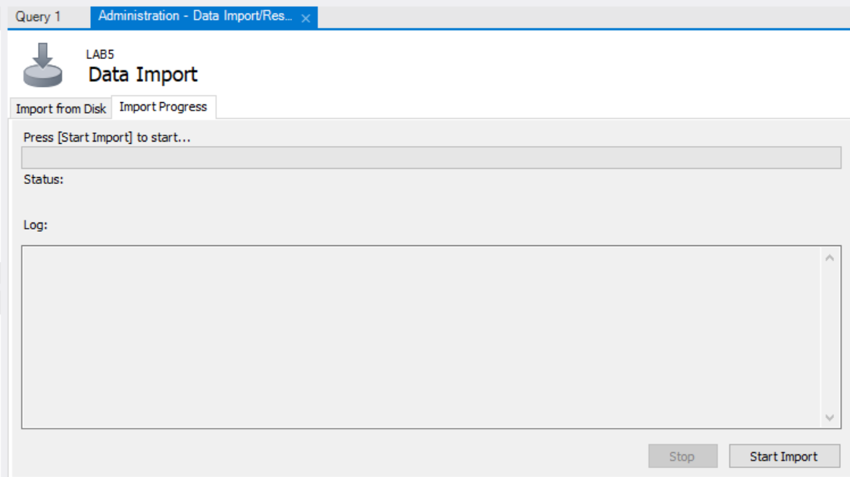

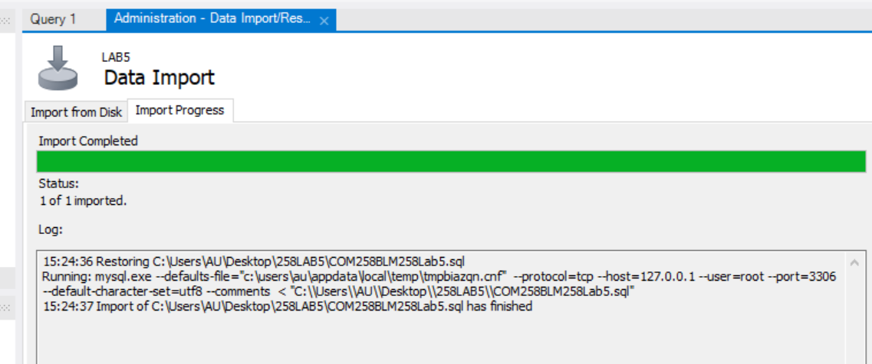

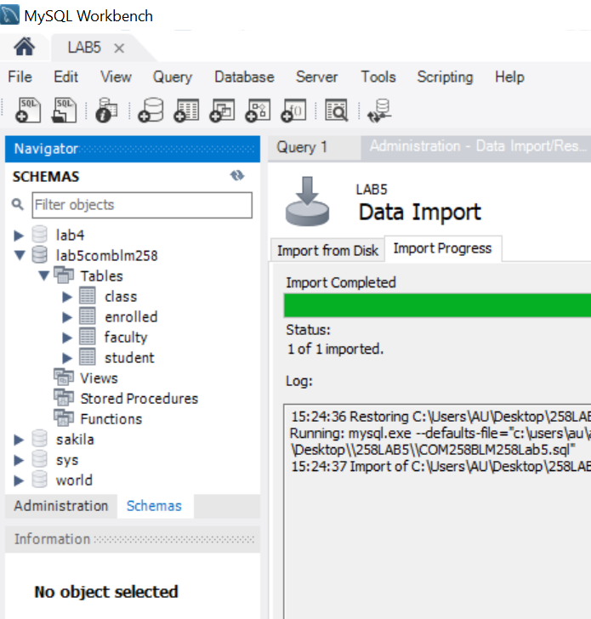

**Student**

|  |  |  |  |  |
| --- | --- | --- | --- | --- |
| **snum** | **sname** | **major** | **level** | **age** |
| 1234 | Ahmet Kartal | History | Senior | 21 |
| 3456 | Mehmet Sahin | Math | Junior | 18 |
| 2356 | Hasan Dogan | Statistics | Freshmen | 17 |
| 3345 | Ali Serce | Comp. Eng. | Sophomore | 18 |
| 1256 | Murat Baykus | History | Junior | 20 |
| 9874 | Fatma Seyhan | History | Junior | 18 |
| 5643 | Emine Ceyhan | Comp. Eng. | Senior | 19 |
| 5649 | Gulay Sakarya | Comp. Eng. | Senior | 20 |

**Class**

|  |  |  |  |
| --- | --- | --- | --- |
| **name** | **meetsat** | **room** | **fid** |
| HIS105 | Tuesday 10:30 | R128 | 48 |
| MAT108 | Thursday 13:30 | R128 | 48 |
| MAT107 | Friday 14:30 | R111 | 45 |
| HIS207 | Monday 15:30 | R111 | 48 |
| HIS105 | Wednesday 15:30 | R345 | 48 |
| ENG208 | Monday 15:30 | R345 | 46 |
| MAT101 | Wednesday 11:30 | R345 | 45 |
| ENG205 | Friday 10:30 | R128 | 41 |

**Faculty**

|  |  |  |
| --- | --- | --- |
| **fid** | **fname** | **deptid** |
| 45 | Bugra H. | 1298 |
| 46 | Demir R. | 1317 |
| 48 | Semih Z. | 1405 |
| 41 | Selin C. | 2396 |
| 47 | Zeynep Z. | 2453 |
| 49 | Zafer K. | 2198 |

**Enrolled**

|  |  |
| --- | --- |
| **snum** | **cname** |
| 1234 | HIS105 |
| 1234 | HIS207 |
| 1234 | ENG208 |
| 1234 | ENG205 |
| 3456 | MAT108 |
| 3456 | MAT107 |
| 3456 | MAT101 |
| 2356 | MAT107 |
| 3345 | MAT101 |
| 3345 | ENG208 |
| 1256 | HIS105 |
| 1256 | HIS207 |
| 1256 | MAT101 |
| 1256 | ENG208 |
| 9874 | HIS207 |
| 9874 | HIS105 |
| 9874 | MAT108 |
| 5643 | ENG208 |
| 5643 | MAT107 |
| 5643 | ENG205 |

**fid:** faculty(instructor) id,

**fname:** faculty(instructor) name,

**deptid:** faculty(instructor)’s department id,

**snum:** student number,

**cname:** class name

No duplicates should be printed in any of the answers.

1. Find the names of all juniors who are enrolled in a class taught by faculty with the id of 45.

2. Find the age of the oldest student who is either a History major or enrolled in a course taught by faculty with the id of 45.

3. Find the names of all classes that either meet in room R128 or have three or more students enrolled.

4. Find the names of all students who are enrolled in two classes that meet at the same time.

5. Find the names of faculty members who teach in every room in which some class is taught.

6. Find the names of faculty members for whom the combined enrollment of the courses that they teach is less than five.

7. For each level, print the level and the average age of students for that level.

8. For all levels except juniors, print the level and the average age of students for that level.