**ANKARA UNIVERSITY**

**COMPUTER ENGINEERING DEPARTMENT**

**COM2058 LAB6**

**(The sample outputs given in the questions may not include the correct answers. It is added only to show the output format.)**

Customer (Primary Key: NAME)

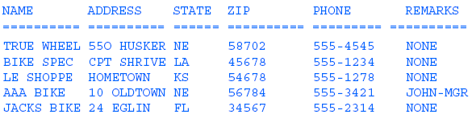

Part (Primary Key: PARTNUM)



Orders (Primary Key: ORDEREDON, NAME, PARTNUM)

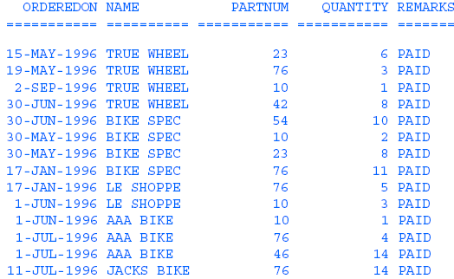

1. (15) Write the query that finds the total amount of money earned.

Sample Output:

24356

1. (15) Write the query that finds the amount of sale to each customer.

Sample Output:

BIKE SPEC 12000

AAA BIKE 8000

….

1. (20) Write the query that finds the number of parts (for each type) that were sold.

Sample Output:

ROAD BIKE 37

PEDALS 10

…

1. (15) Write the query that finds how much money has been earned by selling mountain bikes.

Sample Output:

19652

1. (20) Write the query that gives the following output:



1. (15) Write the query that gives the following output:

