**ANKARA UNIVERSITY**

**COMPUTER ENGINEERING DEPARTMENT**

**COM2058 LAB8**

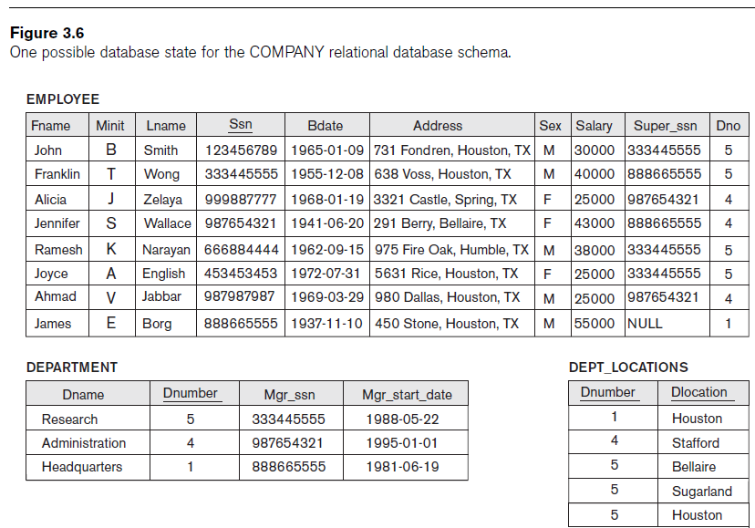

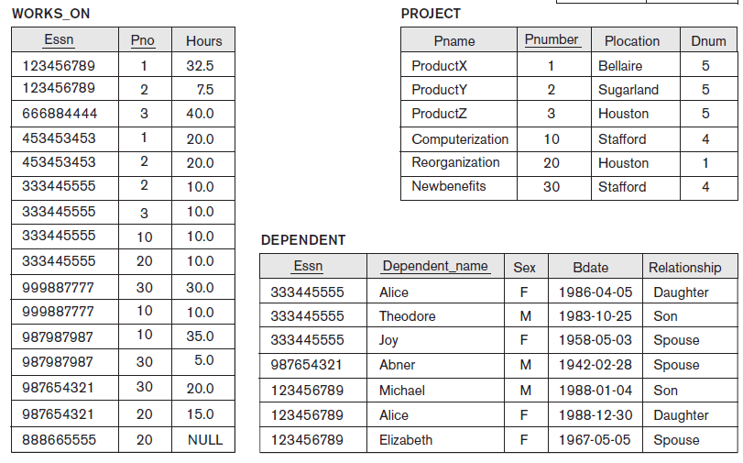

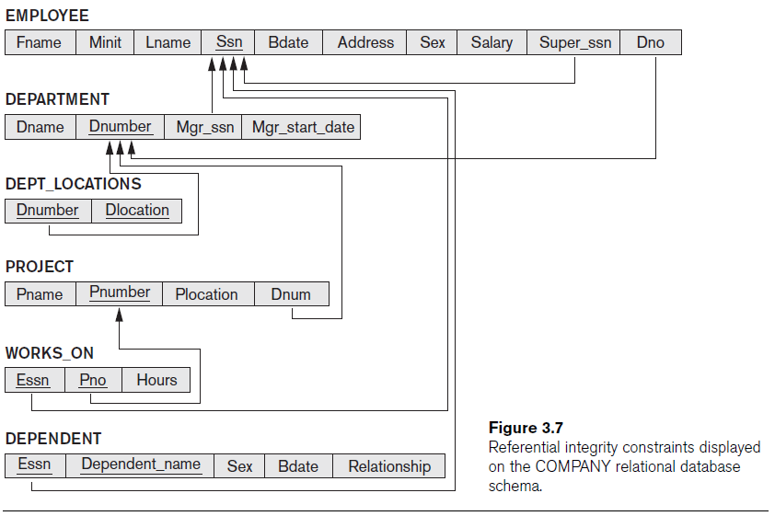

**(RELATIONAL ALGEBRA)** Specify the following queries on the COMPANY relational database schema shown in Figure 3.7 using the **relational operators** discussed in **Chapter 6.** Also show the result of each query as it would apply to the database state of Figure 3.6. (Fundamentals of Database Systems, Ramez Elmasri, Shamkant B. Navathe)

1. Retrieve the names of all employees in department 5 who work more than 10 hours per week on the ProductX project.
2. Retrieve the names of all employees who work on every project.
3. For each department, retrieve the department name and the average salary of all employees working in that department.
4. Retrieve the names of all employees who do not work on any project.
5. Retrieve the average salary of all female employees.