## FIGURES and TABLES

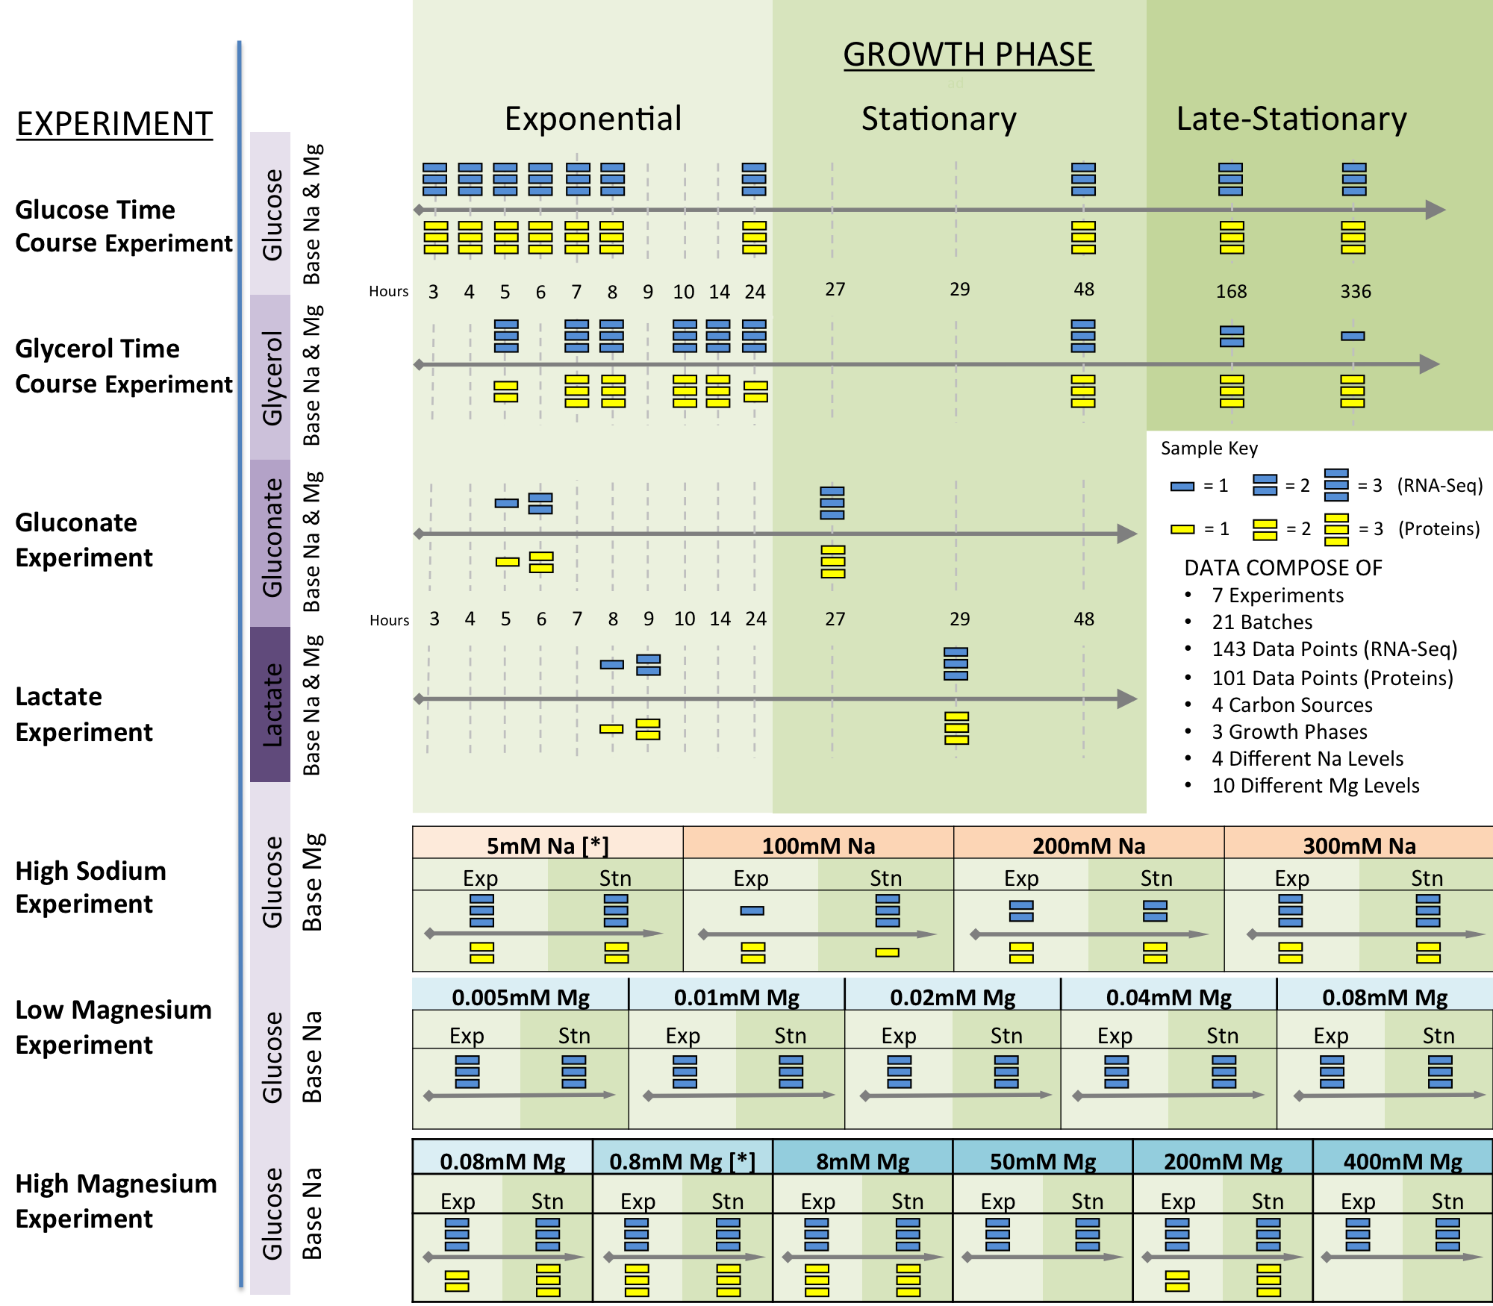

Figure 1. Experimental setup. The illustration shows the structure of the experimental setup for RNA-Seq & Protein data after cleaning out inconsistent data points in a general perspective. There are seven different sets of experiments; glucose time course experiment, glycerol time course experiment, gluconate experiment, lactate experiment, high sodium experiment, low magnesium experiment and high magnesium experiment. We have RNA-Seq data for all seven experiments and protein data for six of them. The four different carbon sources used for the experiments and varying MG and Na levels are also shown in figure. The shapes representing number of biological replicates for specific experiment and time; circles represent a single biological replicate and square and triangles represent two and three biological replicates respectively. There are 21 different batches in total. The colors of carbon source background refer to the carbon sources used in experiments; glucose, glycerol, gluconate and lactate are represented with light purple to dark purple. The green tones in the background represent the growth phase of the experiment. Light green is exponential phase, darker green is stationary phase and dark green is late-stationary phase. The x-axis shows time and for glucose, glycerol, gluconate and lactate experiments we show the exact hours that the samples are collected. On the other hand for Na and Mg experiments the x-axis is divided into pieces representing different concentrations of Na and Mg. The asterisk “[*]” near the concentrations of Mg and Na levels represent the base value. The geometrical shapes above the axis represent the RNA samples and geometrical shapes below the time axis represent the protein samples.

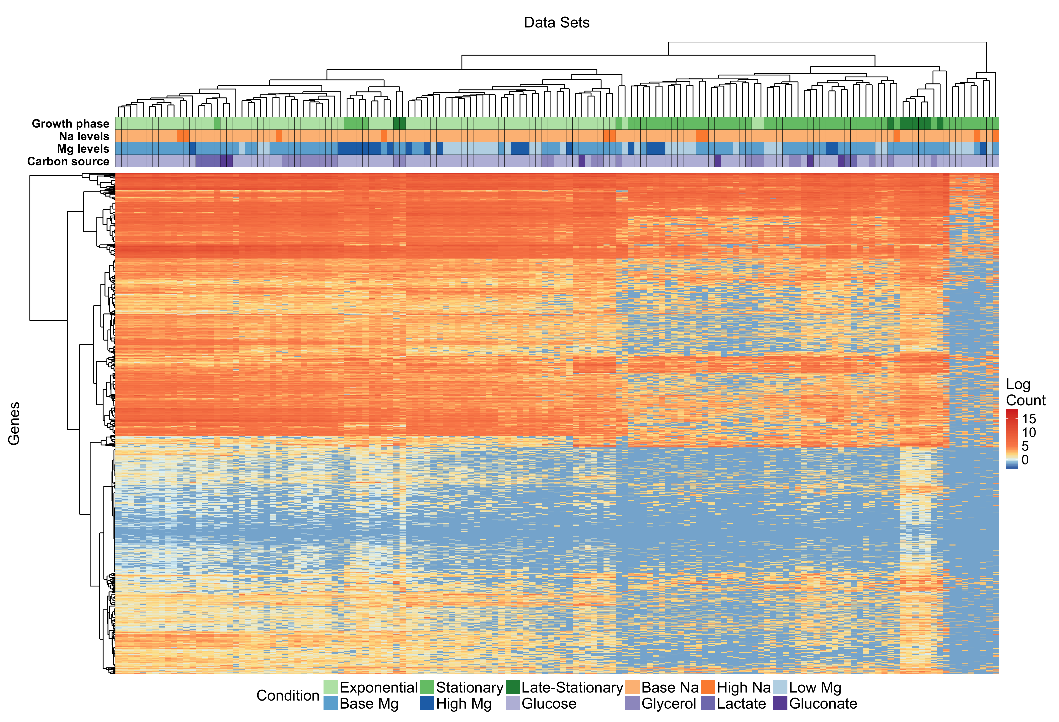

Figure 2: Heatmap of all mRNAs data. The figure represents the heatmap of all 143 samples with 4279 different mRNAs. The x-axis shows different samples and the dendogram of x-axis calculates the clustering of the data using Euclidian distance. A similar approach is used to cluster different mRNAs also and generated dendogram is shown on y-axis. The reddish area represents the highly abundant mRNAs and bluish area represents less abundant mRNAs. The clustered data sets are color coded with 12 different conditions with in 4 different categories. Different growth phases, Mg levels, Na levels and carbon sources are represented by green tones, blue tones, orange tones, and purple tones respectively. The four different variables are represented in a color table at top. The variables are ordered with respect to quality of clustering. The order of categories is growth time, Mg level, Na level and carbon source from best clustered to least clustered category.

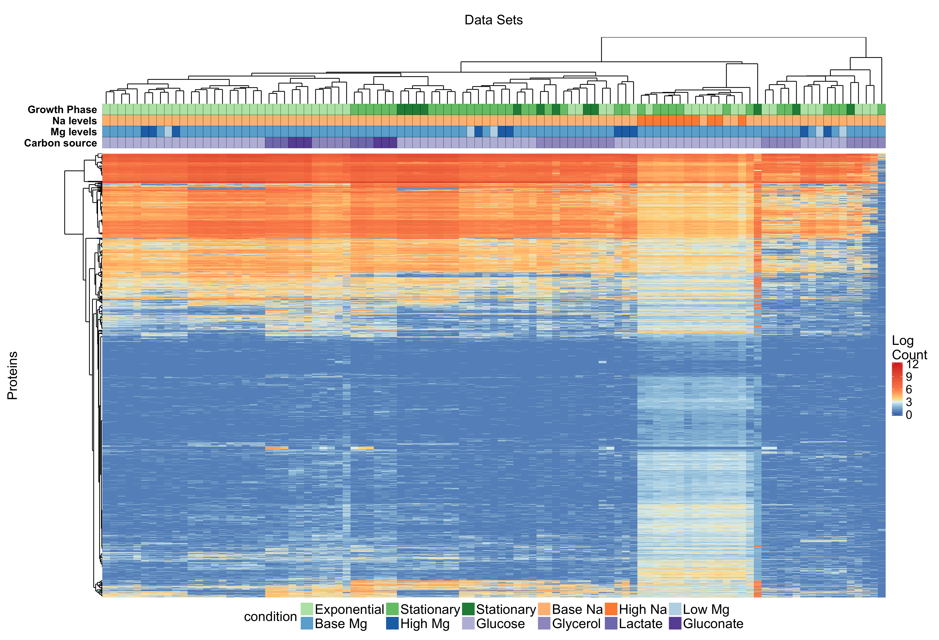

Figure 3. Heatmap of all protein data. The figure represents the heatmap of all 101 samples with 4279 different normalized protein levels. The x-axis shows different samples and the dendogram of x-axis calculates the clustering of the data using Euclidian distance. A similar approach applied in order to generate heatmap for mRNA data is used to cluster different proteins and generated dendogram is shown on y-axis. The reddish area represents the highly abundant proteins and bluish area represents less abundant proteins. The clustered data sets are color coded with 12 different conditions with in 4 different categories. Different growth phases, Mg levels, Na levels and carbon sources are represented by green tones, blue tones, orange tones, and purple tones respectively. The four different variables are represented in a color table at top. The variables are ordered with respect to quality of clustering. The order of categories is carbon source, Na-level, growth phase and Mg-level from best clustered, to least clustered category.



Figure 4. Cell response comparison between different categories of variables. We count the number of significantly differentiated mRNAs and proteins with respect to different variables by using DeSeq2 algorithm. We do the same analysis for both proteins and mRNAs and for both stationary and exponential phases. Raw data is directly given to DeSeq2 algorithm no log like normalization is applied to data. For exponential phase the base data is exponential glucose time course and exponential phase base level of high Na and high Mg experiments. For stationary phase base data is stationary glucose time course and stationary phase base level of high Na and high Mg experiments. All other changes are calculated with respect to relevant base levels. For both exponential and stationary phase we count the number of significantly differentiated mRNAs and proteins by using a threshold of P’<0.05 and Log2 fold change >1. As an overall trend stationary phase have less change with respect to its base level compared to exponential phase. The change of Na levels has the biggest impact in protein levels both in exponential and stationary phase.

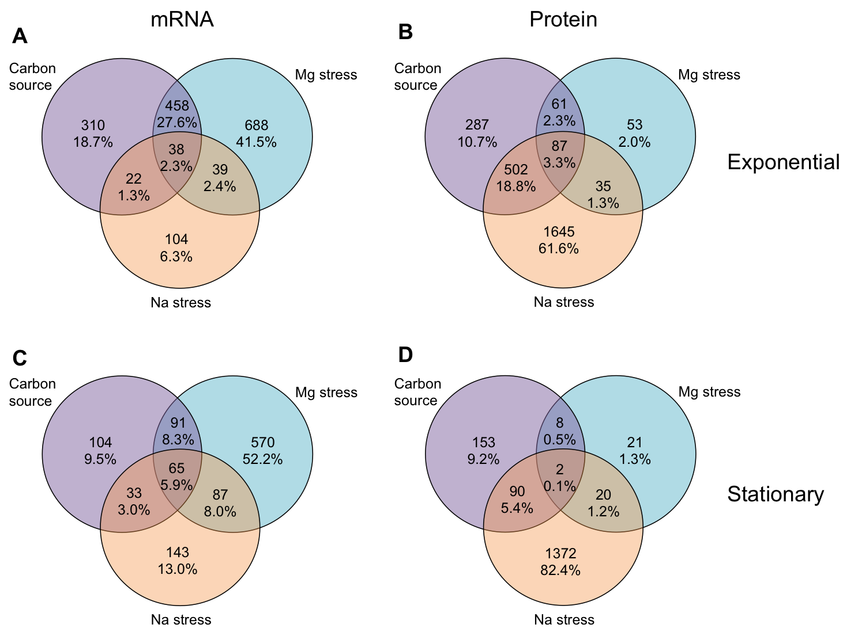

Figure 5. Distribution of different responding mRNAs and proteins between with different variables. Figures represent how the significantly responding (P’<0.05 and Log2 fold change>1) mRNAs and proteins are distributed under three different categories. The categories are carbon source, Mg stress and Na stress. Carbon source includes all up or down-regulated mRNAs or proteins that are changing by the change of carbon source. Mg and Na stresses include all up-regulated or down-regulated mRNAs or proteins that are changing by the change of the Mg or Na levels respectively. The numbers in the Venn diagrams represents the number of significantly altered mRNAs and proteins. We do the same analysis for both stationary and exponential phases. (A) Co-altered mRNAs in exponential phase. Most of the altered mRNAs are shared between Mg stress and carbon source. (B) Co-altered proteins in exponential phase. Most of the altered proteins are shared between Na stress and carbon source. (C) Co-altered mRNAs in stationary phase. Most of the responding mRNAs are related with Mg stress. (D) Co-altered proteins in stationary phase. Most of the responding proteins are related with Na stress



Figure 7. Regulation of metabolism related mRNAs and proteins under different stress conditions. Metabolism related mRNAs and proteins mostly down regulated under different stress conditions, with one exception of stationary phase high Mg mRNA reads. This down regulation trend might be a response to unfavorable conditions.



Figure 6. Conditions affecting flagellar assemble pathway. Although REL606 do not have flagellum flagellar assembly pathway is highly affected from different stresses. Especially high Mg and high Na down regulates the flagellar assembly. Figure shows the fold change difference of top 10 significantly changing genes (if there are 10 or more significantly changing genes) associated with flagellum assembly under different stress conditions. Colors of the points represent gene score which is derived by –sign(change)*log10(P’)

|  |  |  |  |  |  |  |
| --- | --- | --- | --- | --- | --- | --- |
| **mRNA** | | | | | | |
| **Variable** | **Overall_Z_score** |  | **Condition** | **Z_score** |  | **num_elements** |
| Growth phase | −23.99 | * | Exponential | −12.27 | * | 77 |
| Stationary | 1.08 |  | 57 |
| Late stationary | −3.04 | * | 9 |
| Carbon source | 1.16 |  | Glucose | 1.23 |  | 107 |
| Glycerol | −1.08 |  | 24 |
| Lactate | −1.42 |  | 6 |
| Gluconate | −0.42 |  | 6 |
| Mg Levels | −1.46 |  | Low Mg | 1.01 |  | 35 |
| Base Mg | −0.90 |  | 85 |
| High Mg | −2.17 | * | 23 |
| Na Levels | −1.54 |  | Base Na | −1.53 |  | 132 |
| High Na | 1.36 |  | 11 |
| Batch number | −2.82 | * |  |  |  |  |
|  |  |  |  |  |  |  |
|  |  |  |  |  |  |  |
| **Protein** | | | | | | |
| **Variable** | **Overall_Z_score** |  | **Condition** | **Z_score** |  | **num_elements** |
| Growth phase | −4.21 | * | Exponential | −2.19 | * | 53 |
| Stationary | −0.14 |  | 36 |
| Late stationary | −0.37 |  | 12 |
| Carbon source | −3.15 | * | Glucose | −1.80 |  | 64 |
| Glycerol | −0.75 |  | 25 |
| Lactate | −3.26 | * | 6 |
| Gluconate | −3.22 | * | 6 |
| Mg Levels | 0.82 |  | Low Mg | −1.11 |  | 5 |
| Base Mg | 1.08 |  | 85 |
| High Mg | −2.86 | * | 11 |
| Na Levels | −4.78 | * | Base Na | −3.31 | * | 90 |
| High Na | −8.01 | * | 11 |
| Batch number | −23.39 | * |  |  |  |  |

Table 1: Clustering quality of different categories. Table shows different categories of parameters and their z-scores in terms of clustering quality. To calculate the clustering quality with respect to experimental variables, we calculate cophenetic distance between all pairs and calculate the mean value for all categories and conditions. We repeat the same calculation thousand times with mixed data labels and calculate the z score of original mean value with respect to mean values of randomly mixed runs.