AIDI 2005 Capstone Term II

Group 2 - Save T-Rex MVP Version 1

Gavin Rowsell

Sravan Pingali

Srikanth Chowdry Thumati

Umutcan Asutlu

Game

The current game designed as a clone of Google Chrome’s Dino endless runner is available in our project Github repository. To try the game for yourself clone the repository to your local machine:

$ git clone <https://github.com/umutcanasutlu/Capstone-AIDI-2005.git>

Once you have the repository, navigate to the [Save-T-Rex_Game_Folder](https://github.com/umutcanasutlu/Capstone-AIDI-2005/tree/main/Save-T-Rex_Game_Folder) and run the application:

[Save-T-Rex.exe](https://github.com/umutcanasutlu/Capstone-AIDI-2005/blob/main/Save-T-Rex_Game_Folder/Save-T-Rex.exe)

To play the game simply press the “space” key to jump over the various obstacles that will appear and block your path. There are four different objects which will appear from the right side of the screen they are: cactus, pterodactyl, coin, and mole.

Below are some screenshots from in game:

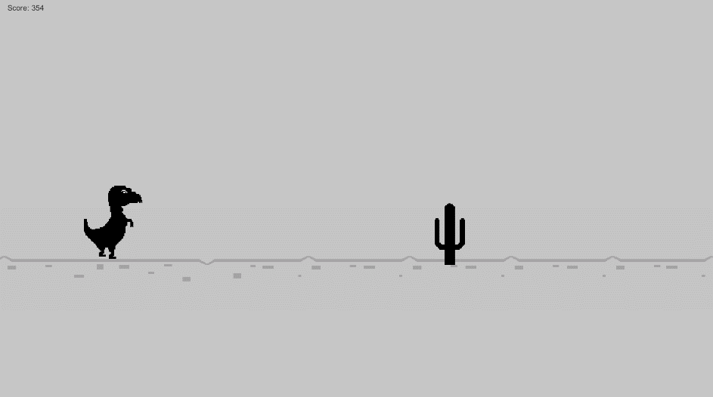

First, we have the cactus, the standard obstacle from the original game the player must jump over to avoid.

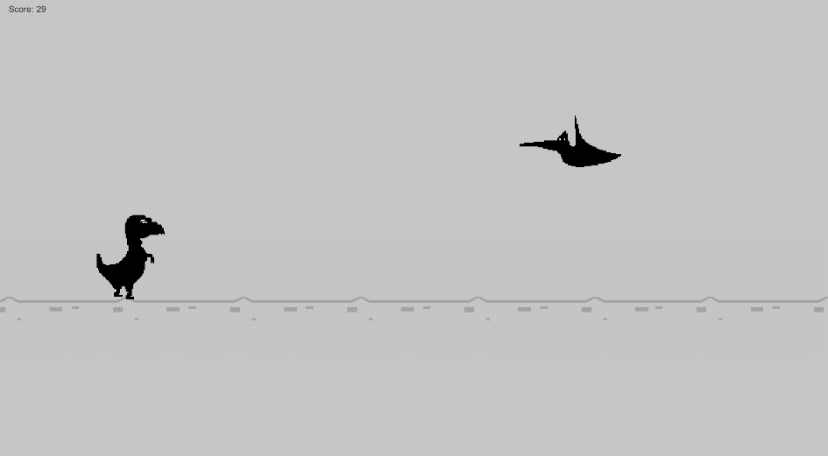

Next is the pterodactyl, another obstacle from Google’s version however this one fly’s above the player so if they jump into it, they will lose. Currently these only will spawn in the upper half however in a future version they will stay true to the original game and vary in height, forcing the player to decide if they must jump to avoid them or not.

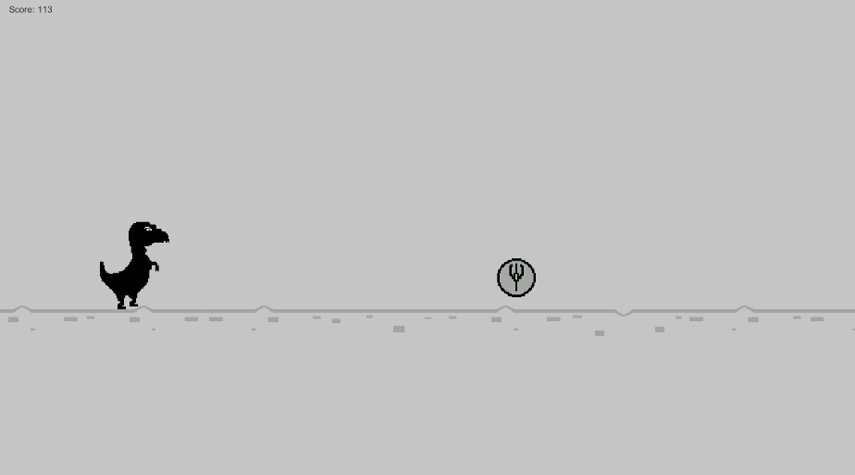

Third we have the coin, the first new object added to the game. The coin is the only object the player should make contact with, and will result in an additional 100 points. Like the pterodactyl, the coin currently only spawns at a fixed y position however it as well will be made to spawn at a varying height.

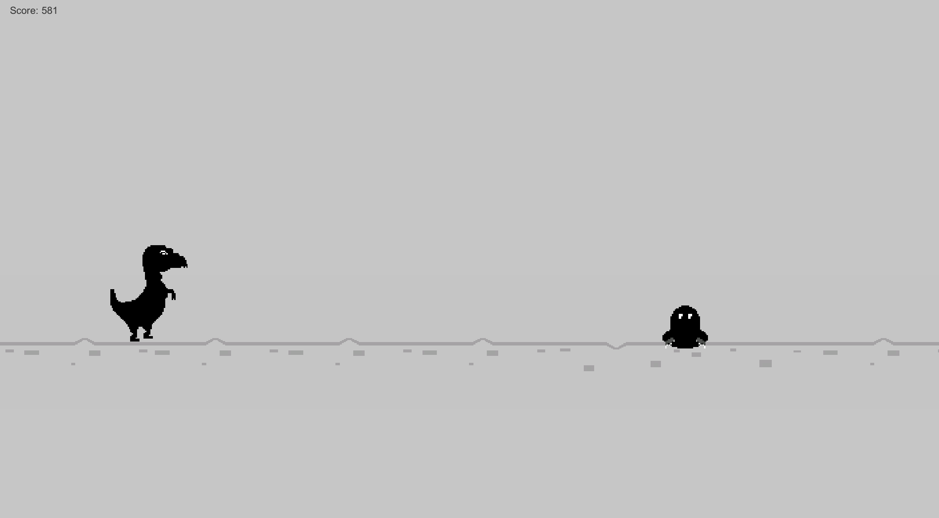

The mole is the other additional component not found in Google’s version. The mole is a tricky obstacle which will jump in unison with the player as seen below.

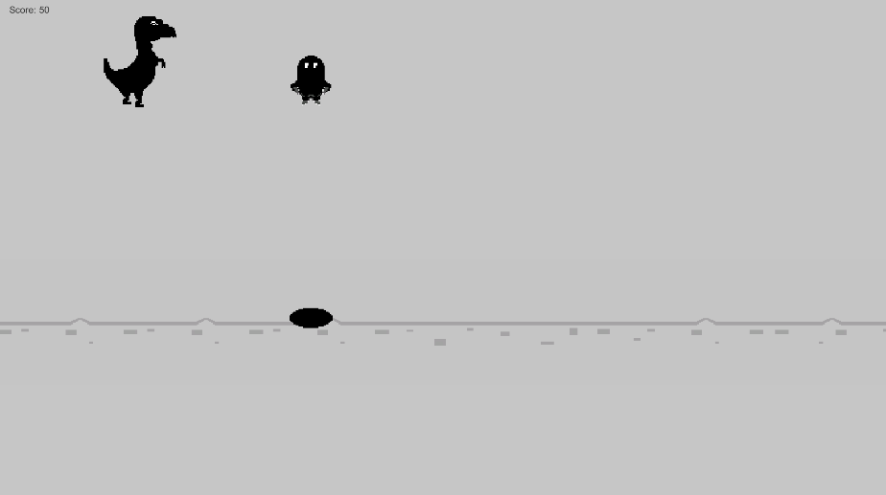

This means that if the player waits to try and jump over the mole, they will still run into it and lose the game.

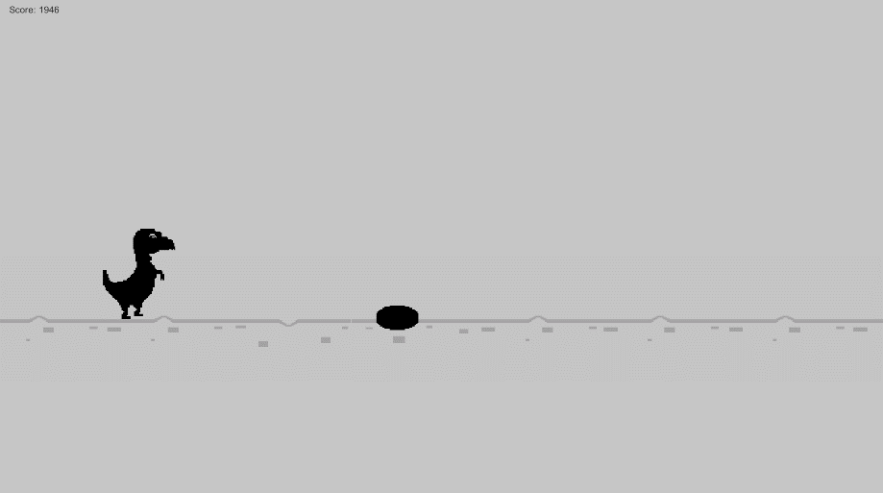

The only way to get past the mole is to “scare” it away by jumping and landing in front of the mole. Doing so will cause the mole to retreat into its hole and the player can safely pass over it.

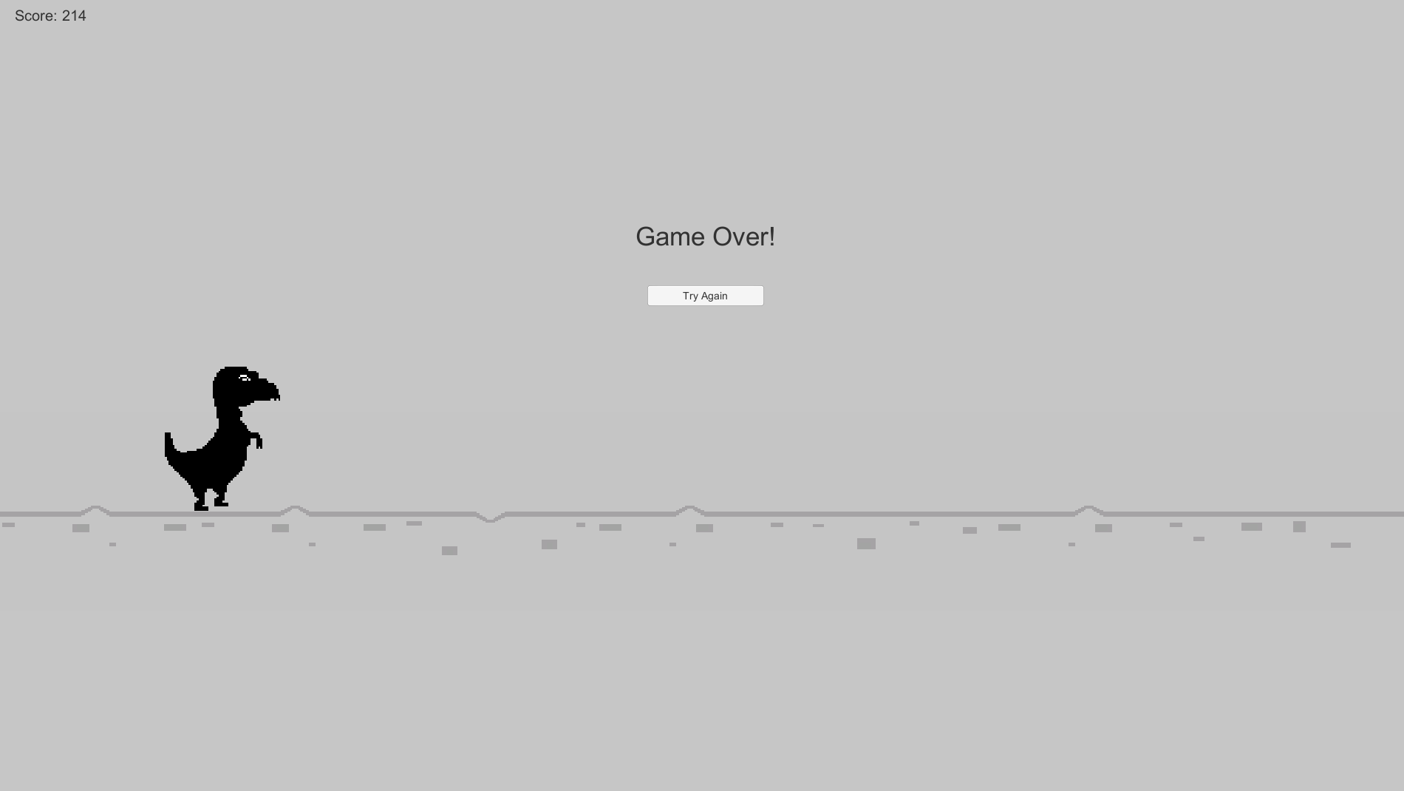

Coming into contact with a cactus, pterodactyl or mole will result in a game over and players can choose to restart by clicking the try again button.

Model

The computer vision model we will be training and using will work by detecting objects in a fixed region on the right side of the screen (shown in red).

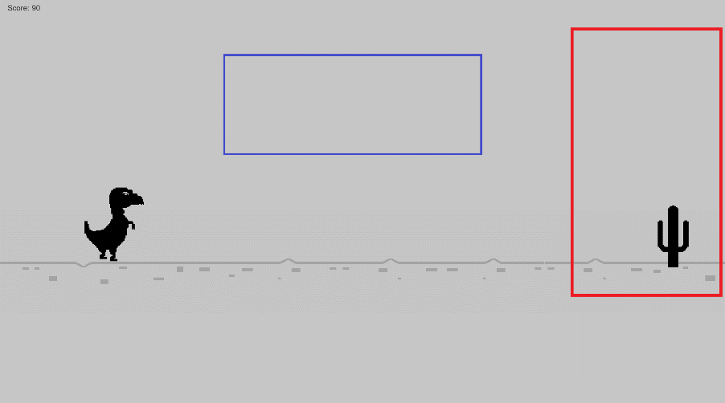

Our model will be trained to detect and classify any objects that appear in this red region. By providing annotated images we can train the model to perform different reactions based on the classification of objects it detects within this box. For example, if a cactus is detected, the model will have to correctly classify it as a cactus then perform the action jump (space key) at the right time. If it performs the action at the wrong time the second detection box (shown in blue) will detect the game over text and the model will be punished in this case (negative reinforcement). If a second object is detected in the red box and the game over text was detected in the blue box, the model will be rewarded since it must have avoided the previous obstacle (positive reinforcement). This combination of positive and negative reinforcement will hopefully allow the model to quickly learn how to play the game. To test the model’s capabilities, we will be adding the option to choose what objects will spawn through the games UI. This will also allow us and future users to train the model on one obstacle and see how that knowledge is transferred to the domain of multiple obstacles.