AIDI 2005 Capstone Term II

Group 2 - Save T-Rex MVP Version 2

Gavin Rowsell

Sravan Pingali

Srikanth Chowdry Thumati

Umutcan Asutlu

Game

The current game designed as a clone of Google Chrome’s Dino endless runner is available in our project Github repository. Download the [Save-T-Rex_Game_Folder](https://github.com/umutcanasutlu/Capstone-AIDI-2005/tree/main/Save-T-Rex_Game_Folder) and run the application: [Save-T-Rex.exe](https://github.com/umutcanasutlu/Capstone-AIDI-2005/blob/main/Save-T-Rex_Game_Folder/Save-T-Rex.exe) to try the game for yourself.

The additions made to the game for this milestone are as follows:

High score implemented to save the highest achieved score for the session, it resets to zero if the player closes and reruns the application but will update between attempts if the application is kept running.

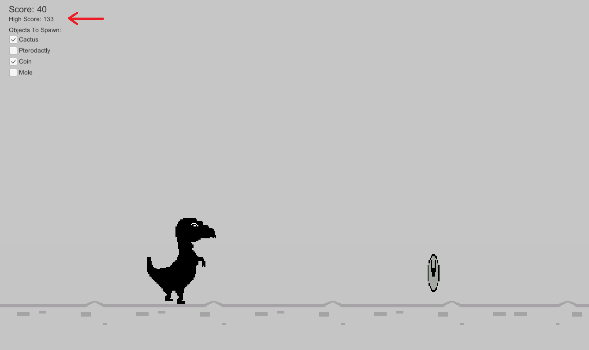

Added a list of all the objects that will spawn in the game, the player can interact with the list and select objects to be included/excluded. At least one object must remain selected, the game will prevent the user from deselecting all the boxes.

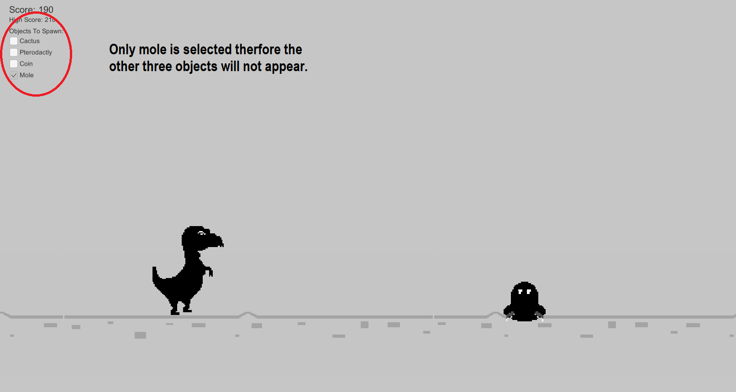

To improve user interaction a start game button was added so the player can select what objects will spawn before playing.

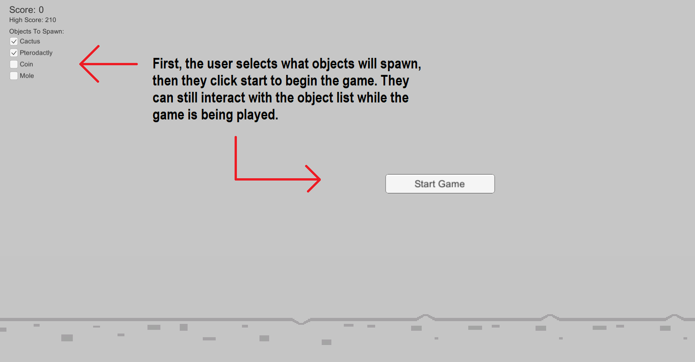

With the new interaction feature of object spawn selection users will be able to train and test the algorithms performance in a more controlled environment. This feature allows them to train the model with one or more objects and then see how it responds to the sudden introduction of a new object.