Program 1

It takes a file as an argument and reads numbers in file line by line and prints star as much as number for each line.

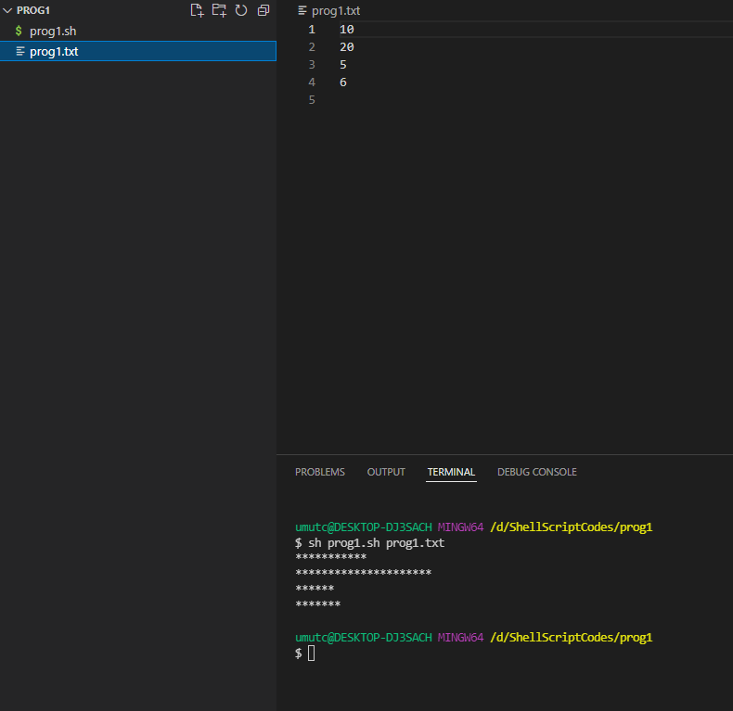

Program 2

It takes user inputs line by line and compares given numbers if the given number is bigger than previous ones updates the biggest number until it sees “end” input. When user enters “end” it finishes the process and prints the maximum number.

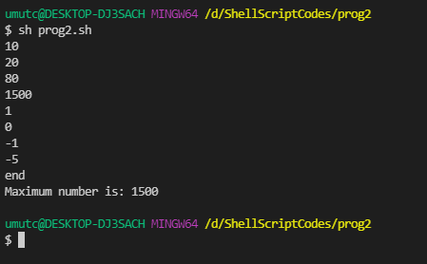

Program 3

Program deletes 0 length files and exits with 1 if you give invalid directory

