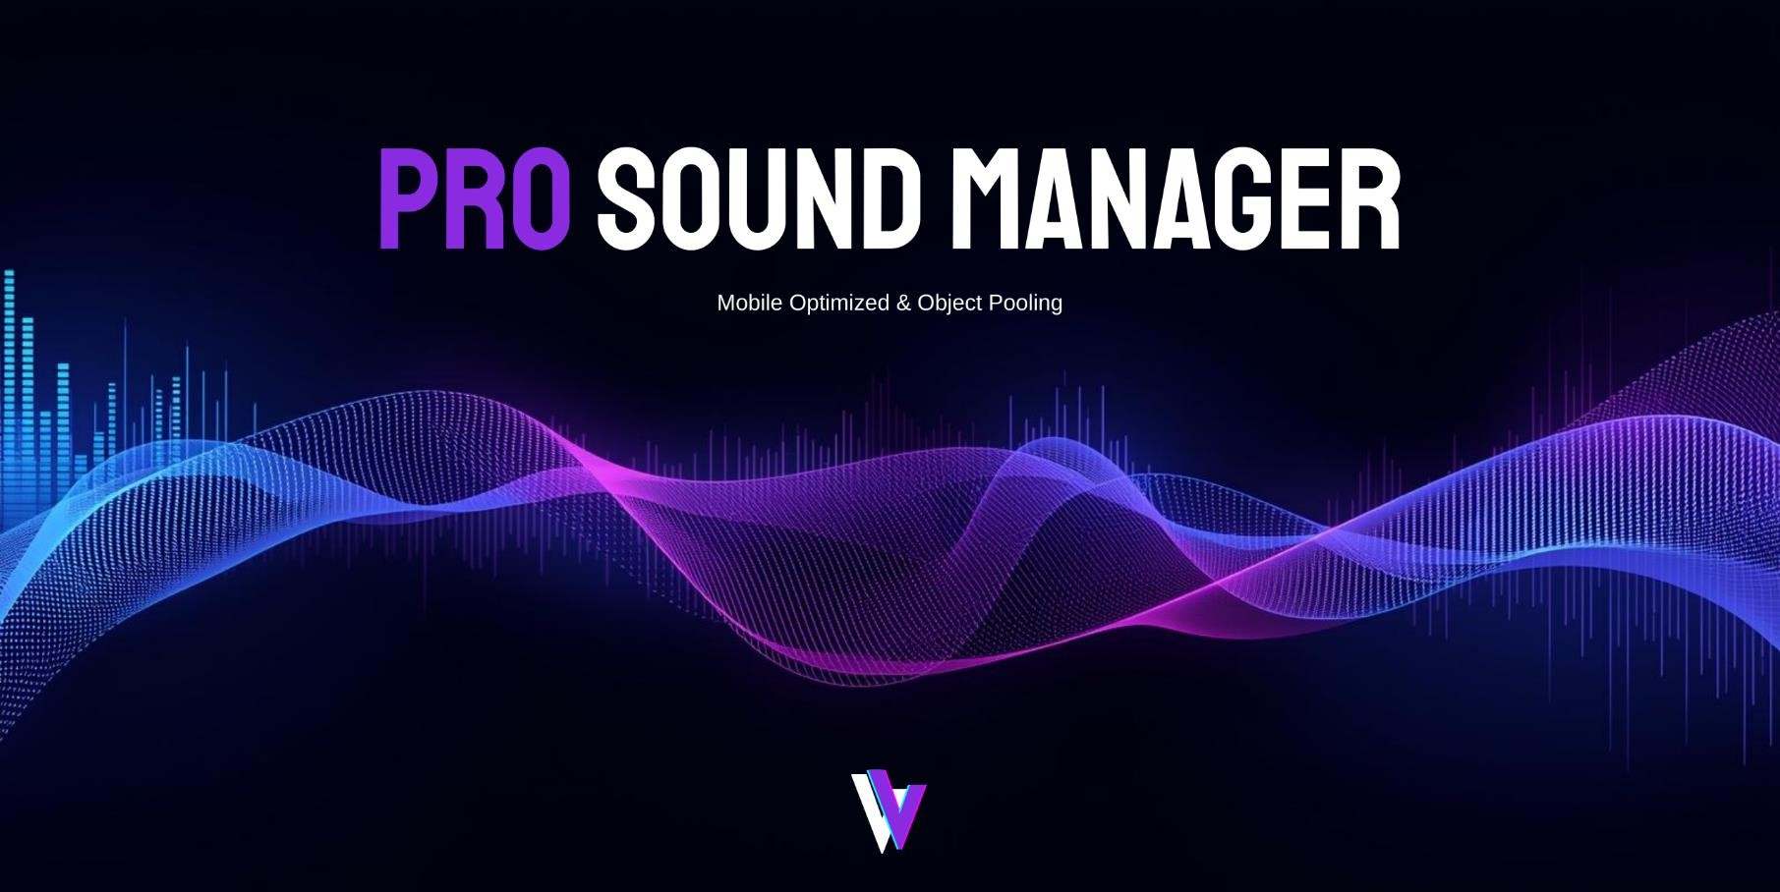

Pro Sound Manager - Documentation
Version 1.0 | Created by Vector Violet Studio
Thank you for choosing Pro Sound Manager! We built this tool to be the most performance-friendly and easy-to-use audio solution for Unity.

- Getting Started (Installation)
Setup
  - Navigate to VectorViolet/ProSoundManager/Prefabs in the Project window.
  - Drag and drop the SoundManager prefab into your first scene (e.g., Main Menu or Splash Screen).
  - Select the prefab and fill the SFX Data List and Music Data List in the Inspector with your SoundData scriptable objects.
  - That's it! The system is persistent (DontDestroyOnLoad) and will survive scene changes.

Cheat Sheet
1. Play background music
SoundManager.Instance.PlayMusic("LevelTheme");
2. Play a simple 2D sound (UI click, level up)
SoundManager.Instance.PlaySFX("Click");
3. Play a 3D sound at a specific position (Explosion)
SoundManager.Instance.PlaySFX("Explosion",transform.position);
4. Play with delay (e.g., play 'Win' sound after 2 seconds)
SoundManager.Instance.PlaySFX("Win", 2.0f);

2. Key Features & Architecture & Performance
This system uses advanced software engineering patterns to ensure maximum performance, especially for mobile devices.
- Singleton Pattern: Ensures a single, persistent entry point (SoundManager.Instance) throughout the game lifecycle.
- Smart Object Pooling: Eliminates runtime instantiation lag (Garbage Collection spikes). AudioSources are recycled intelligently.
- Dictionary Lookup: Uses Dictionary<string, SoundData> for O(1) complexity access to sound clips, ensuring zero lookup lag even with hundreds of sounds.
- 3D Spatial Audio: Seamlessly switch between 2D UI sounds and 3D world sounds.
- Audio Mixer Integration: Ready-to-use volume control for Music and SFX.
- Random Pitch: Add variety to repetitive sounds (like footsteps or gunfire) automatically.
- Independent Volume Control: Granular control over Master, Music, and SFX channels.

3. API Reference

A. Music Methods

PlayMusic
Plays the specified music track. Handles fading and looping automatically based on SoundData settings.
C#
public void PlayMusic(string clipName, float delay = 0f)
- Parameters:
  - clipName (string): The unique name of the AudioClip defined in your SoundData list.
  - delay (float): Overload. Time in seconds to wait before playing. Default is 0f.
- Description: Checks if the requested music is already playing to avoid restarting the track.

SetMusicVolume
Adjusts the music volume channel via the main AudioMixer.
C#
public void SetMusicVolume(float sliderValue)
- Parameters:
  - sliderValue (float): A value between 0.0 (Mute) and 1.0 (Max Volume). Ideally used with UI Sliders.

B. SFX Methods (Sound Effects)
PlaySFX (2D)
Plays a sound effect globally (non-spatial). Best for UI sounds.
C#
public void PlaySFX(string clipName)
- Parameters:
  - clipName (string): The name of the sound clip to play.
  - delay (float): Overload. Time in seconds to wait before playing. Default is 0f.
- Returns: void (Fire and forget).

PlaySFX (3D)
Plays a sound effect at a specific world position. The sound will have 3D spatial blend applied automatically.
C#
public void PlaySFX(string clipName, Vector3 position)
- Parameters:
  - clipName (string): The name of the sound clip.
  - position (Vector3): The world coordinates where the sound originates.
  - delay (float): Overload. Time in seconds to wait before playing. Default is 0f.
- Note: The system automatically configures SpatialBlend to 3D for this call and reverts it to 2D for subsequent UI calls.

PlaySFX (Overloads)
The system supports multiple overloads for flexibility:
- Performance Tip: All play methods include overloads that accept SoundData objects directly. Using SoundData references is faster than using string names, as it bypasses the dictionary lookup

StopSFX
Stops a specific sound effect if it is currently playing.
C#
public void StopSFX(string clipName)
- Description: Iterates through the active pool and stops all instances of the specified clip.

C. Configuration (SoundData)
SoundData is a ScriptableObject that holds all settings for a specific audio clip.
Property | Type | Description
Clip | AudioClip | The actual audio file (mp3/wav).
Volume | float | Individual volume (0-1). Useful for balancing loud sounds.
Pitch |  |  | float | Base pitch level. Default is 1.
Random Pitch |  |  | bool | If true, applies random variance to pitch (great for repetitive sounds like gunfire).
Spatial Blend |  |  | float | 0 for 2D, 1 for 3D. Overridden by PlaySFX(pos) methods.

4. System Diagrams
Visual representations of the system structure and workflow.
A. Use Case Diagram (Workflow)
Illustrates how different stakeholders interact with the Pro Sound Manager.
- Developer: Interacts via code API (Play, SetVolume).
- Game Designer: Interacts via Unity Inspector (SoundData, Configuration).

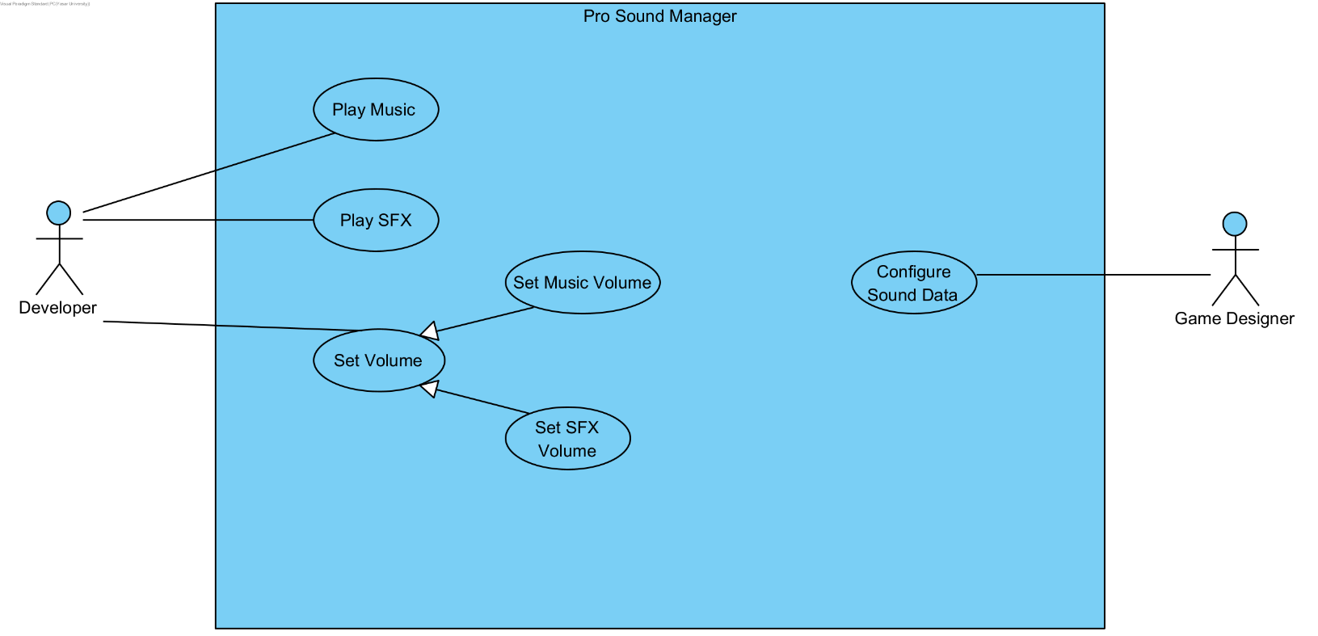

B. Class Diagram (Architecture)
Shows the relationship between the Singleton SoundManager, the SoundData scriptable objects, and the Object Pooling mechanism.
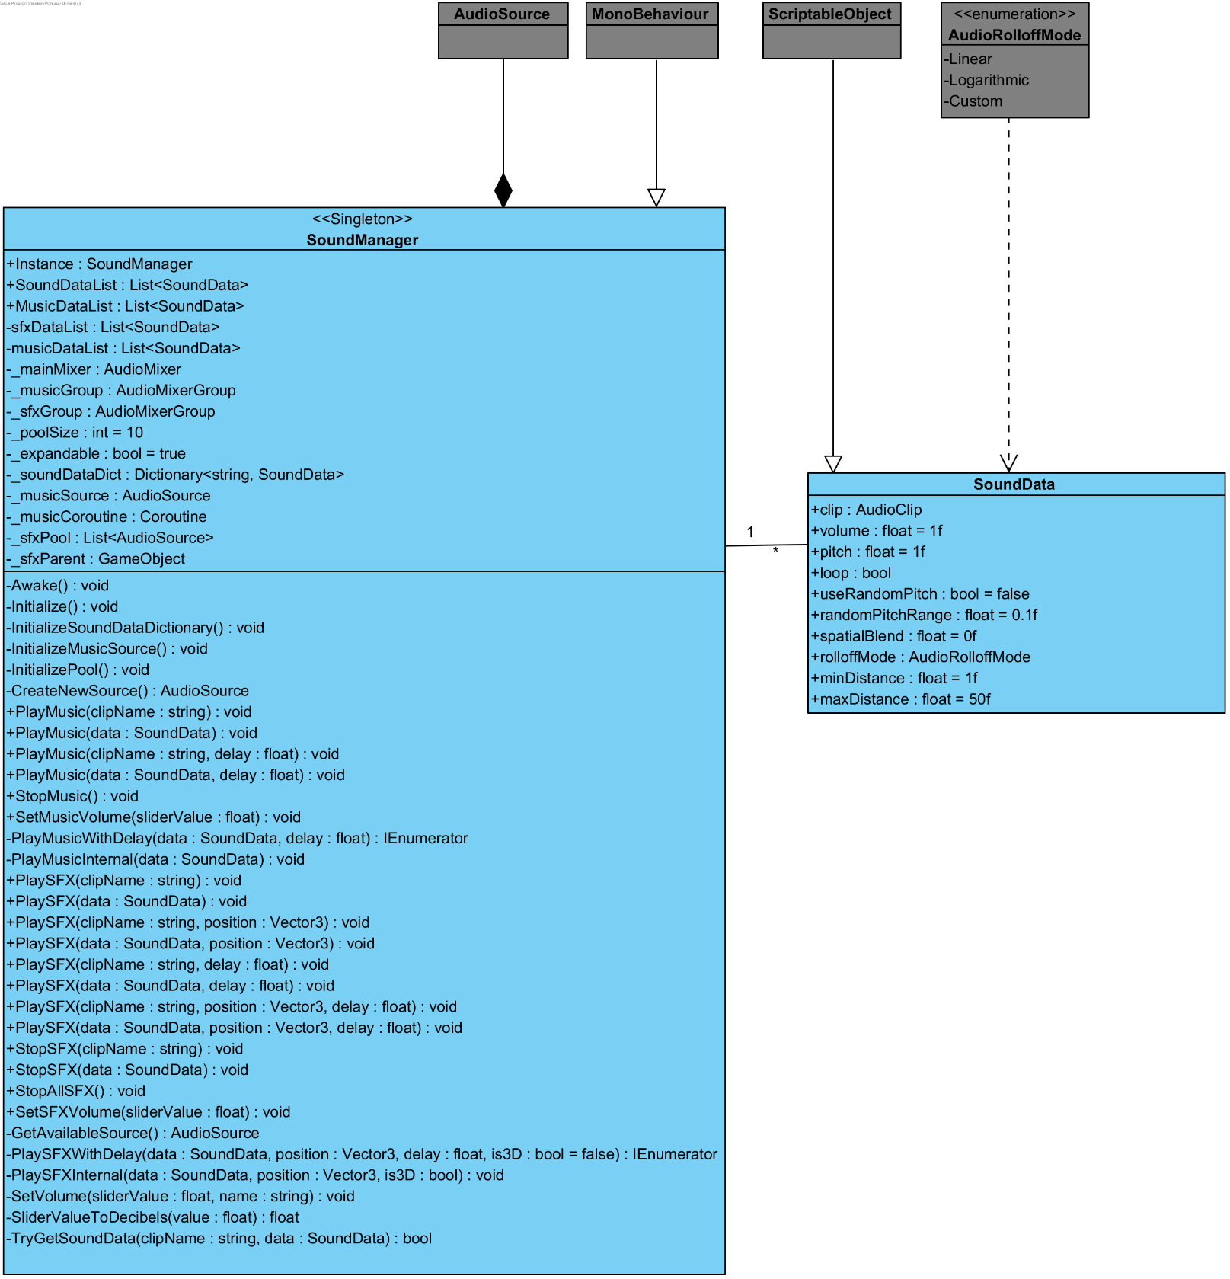

C. Sequence Diagram (Logic Flow)
Visualizes the runtime logic of the PlaySFX request, demonstrating the prioritization of object pooling and resource management.

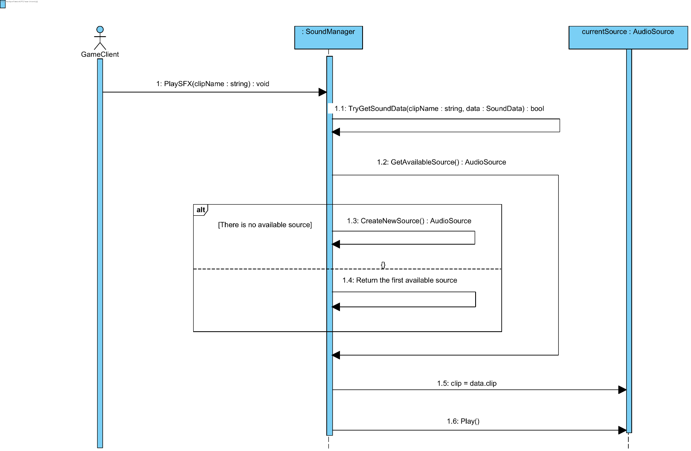

Support: If you have any questions, reach us at: vectorvioletstudio@gmail.com

