State Feedback Design of Cooperative Control Protocols

- Full state of each agent is avaliable → itself and neighbors in graph
- Local optimal design, spanning tree.

Cooperative regulator problem: There is no leader node.
Cooperative tracking problem: N identical follower agents and one leaeder agent.

Followers:

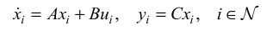

(A, B, C) are stabilizable and detectable.

Leader:
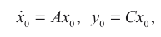

Objective of the cooperative tracking problem is to design local distributed controllers u_i for all follower nodes

Cooperative SVFB Control

- Assumed full state variable of each node is measureble (C = I)
- Leader node is pinned to some of other nodes. Pinning gains is kept in G(g_i)

Neighborhood tracking error:
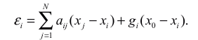

SFVB Control protocol:
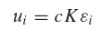

c > 0 = coupling gain. K = feedback gain matrix.

Closed-loop:
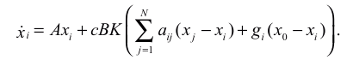

L = D – A
D = diagonal of indegree matrix, A = adj, L = laplacian
G = [g0; g1; …] diagonal of pinning gains.

Disagreement error wrt leader:
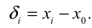

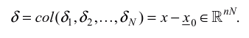

Cooperative tracking problem is solved if

Global disagreement error dynamics:
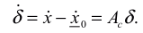

NASIL???????

