Contents

Overview 2

Background 2

UN Sustainable Development Goal Indicators 2

US Reporting for SDG Global Indicators 2

Purpose of the National Reporting Platform 3

Who Contributes Platform Data 4

Which Data Sources are Eligible 4

How are Data Providers Selected 4

Signing up for a Data Provider Account and Authorizing Edits 4

Authorizing Edits 6

Accessing the SDG Reporting Platform 7

How to Navigate the NRP 7

Logging in and logging out 8

Nomenclature of SDG Indicators 10

How to Input Statistics and Data Values 10

Reviewing and Saving Your Data 14

How to Input Metadata Values 15

Reviewing and Saving Your Metadata 19

Data Verification Process 22

Graphs 23

Troubleshooting Data Entry Errors 23

Reminder for Data Providers: Log Out 24

Platform Managers: What you need to know about the NRP 24

How do I graph indicator data? 24

Common graph errors and solutions 26

# Overview

This document provides instructions and guidance for **national statistics and metadata entry** into the **U.S. National Reporting Platform (NRP)** for reporting national statistics for the United Nations **Sustainable Development Goals (SDGs) Indicators**. Certification of these entries is also described. For purposes of context and use, this guide also provides a brief background to SDGs, the purpose of the NRP, who should report information to this platform, and information for platform managers.

# Background

## UN Sustainable Development Goal Indicators

The United Nations General Assembly adopted the [2030 Agenda for Sustainable Development](https://sustainabledevelopment.un.org/post2015/transformingourworld)[1] in September 2015. A core element of this Agenda is the agreement by the U.S. and all UN members to achieve 17 Sustainable Development Goals (SDGs) and 169 associated targets. In March 2016, the UN Statistical Commission (UNSC) endorsed the 238 indicators [proposed](http://unstats.un.org/unsd/statcom/47th-session/documents/2016-2-IAEG-SDGs-Rev1-E.pdf) by its Interagency and Expert Group on SDGs (IAEG-SDGs) to monitor and review global and country-level progress on the SDGs.[2]

The Secretariat for the IAEG classified the agreed indicators, based on their level of methodological development and overall availability, into three different tiers:

Tier I – Indicator conceptually clear, established methodology and standards available and data regularly collected by countries.

Tier II – Indicator conceptually clear, established methodology and standards available, but data are not regularly collected by countries.

Tier III – Indicator for which there are no established methodology and standards, or methodology/standards are being developed/tested.

## US Reporting for SDG Global Indicators

The U.S. contributed input to the tiering of indicators according to the presence of established, global methodology and scope of collection. The U.S. also identified indicators which it would not report, given policy concerns. Most recently, the availability of Federal statistics for reporting against these global indicators was examined.

A set of global indicators‎ have now been identified that meet initial reporting requirements: tier 1 indicators which present no USG policy concerns for which Federal statistics (or the underlying data) are available.  The U.S. will begin reporting national statistics for global indicators in September 2016, starting with Tier I indicators that are also consistent with USG policy.

# Purpose of the National Reporting Platform

Most of the global SDG indicators require national statistics as their basis. In the US, the majority of these national statistics are produced by our Federal Statistical System; they are not modeled in the absence of recent data by international organizations. Nor are US statistics the result of data collections sponsored by UN or other development organizations, such as the Demographic Health Surveys. Therefore, in the majority of cases, U.S. statistics would not be appropriately provided through other non-governmental organizations. However, several international organizations will require access to US national statistics to adjust values for global comparability.

The reporting requirements for global SDG indicators to the US Federal government will be substantial, given their volume, breadth, available metadata, and reporting period (2015-2030). In the US, there are 127 Federal statistical programs, and therefore many potential contributors to US SDG reporting.[3]

The SDG indicators also will be of interest to a wide audience, spanning not only international organizations but also stakeholders in academia and civil society. Perhaps most centrally, SDG indicators will be of interest to the general public. Reporting these indicators in a way that is accessible and transparent to these varied audiences is essential.

To manage this task efficiently, responsibly, and transparently, data science expertise was applied to develop a scalable, interoperable, and sustainable solution.

Accordingly, a national reporting platform (NRP) was built to accommodate contributions from multiple data providers on a flow basis, through secure access and automated tracking of revisions to ensure that reporting reflects high quality, official Federal statistics. The NRP was built in collaboration with other national statistical offices and interested international organizations[4] to promote interoperability of functions to support use for international reporting requirements. The platform is also accessible to the general public to promote transparency and accountability. Further, the platform uses open source technology and can be shared freely with other countries interested in receiving such technical assistance.[5]

# Who Contributes Platform Data

## Which Data Sources are Eligible

The USG has a highly decentralized Federal Statistical System, comprising 127 Federal statistical programs. These statistics are used to inform public and private decision making. Given the importance the USG has placed on ensuring the quality of data and statistics on which policy decisions are based, the Office of the US Chief Statistician, located in the Office of Information and Regulatory Affairs in the Office of the Management Budget, has the authority to coordinate the US Federal Statistical System. The US Chief Statistician does this by issuing and enforcing Federal statistical standards and guidance to ensure the relevance, accuracy, objectivity, and confidentiality of Federal statistical products. (See [USG Statistical Policy Directive 1](https://community.max.gov/plugins;jsessionid=A38810B82A06170FF9140F3706D01004/servlet/webdav/Global/OMB/%24893485711/Statistical%20Policy%20Directive%20No.%201:%20Fundamental%20Responsibilities%20of%20Federal%20Statistical%20Agencies%20and%20Recognized%20Statistical%20Units).)

In some cases, USG may not currently generate data relevant to reporting on a particular SDG indicator, even though the indicator has been identified as Tier I by the IAEG Secretariat (and therefore, expected to be conceptually clear and routinely collected). In those circumstances, USG will examine opportunities to leverage existing statistical programs to allow the production of official Federal statistics for a given SDG indicator. In some cases, as is our current practice, USG will examine other, non-Federal data sources to assess their quality and transparency and, if found suitable for the intended use, will provide statistics and available metadata.

## How are Data Providers Selected

To assess current availability of Federal data for reporting SDG indicators, the USG convened an Expert Group on SDG Indicators. This group comprises policy experts who contributed to negotiations of the sustainable development goals, targets, and, with OMB, the specification of indicators. Under the direction of OMB, the group was expanded to include Federal statistical agency experts engaged in the production of Federal statistics relevant to the SDG indicators. These statistical experts also contributed to the specification of SDG indicators.

The Expert Group identified Federal data providers for each indicator for which Federal data were available. For statistical indicators, data providers are staff from Federal statistical agencies. For non-statistical indicators, data providers are generally staff from Federal policy agencies.

## Signing up for a Data Provider Account and Authorizing Edits

Data input/editing is limited to authorized staff from U.S. statistical agencies. Therefore, data/metadata providers will **need a password protected account before scheduled training**.

The SDG NRP uses a **shared, open-source collaboration platform called GitHub** to update and maintain reporting statistics. Check with your agency to see if an organizational GitHub account already exists at your agency so that you can join according to their guidelines. Otherwise, if you do not already have a GitHub account, you need to create a GitHub account to provide or edit statistics.

1. Go <https://help.github.com/articles/signing-up-for-a-new-github-account/> for a detailed overview, then click in GitHub's **Sign-up page**: <https://github.com/join>
2. Under "Create your personal account," type your username, email address, and password, then click **Create an account**.

Example:

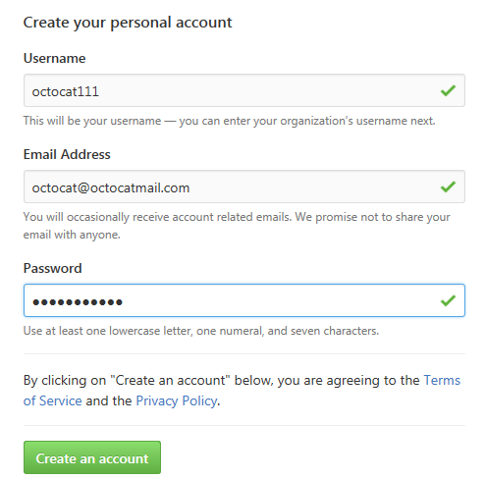

1. **Select your plan type**. Select the **Free** account type.

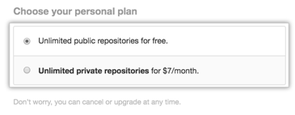

1. Click **Continue. The next screen shows options under GitHub but they not needed for NRP purposes. Click “SKIP THIS STEP.”**
2. You are now done creating your account. You should receive an e-mail from GitHub that prompts you to **verify your e-mail address**. Please click verify email address in order to be able to make updates to the NRP site.
3. **Send your username** to [sdgs@omb.eop.gov](mailto:sdgs@omb.eop.gov) and [philip.ashlock@gsa.gov](mailto:philip.ashlock@gsa.gov).
4. Please **log off after account creation**. To log out within https://github.com, click on your account profile menu in the upper right and then select “Sign out” from the drop down menu.

## Authorizing Edits

Go to the Login/Logout page on the NRP website (gsa.github.io/sdg-indicators/admin) and follow instructions under the heading "Initialize Your Account".

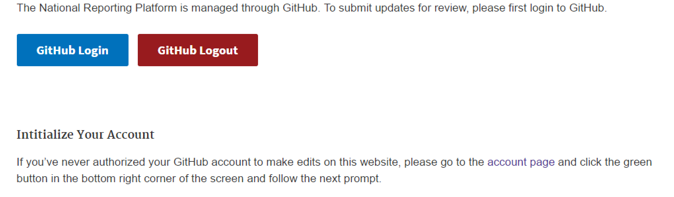

Click the "account page" text.

From there, click the **green** button to initialize your account for the first time.

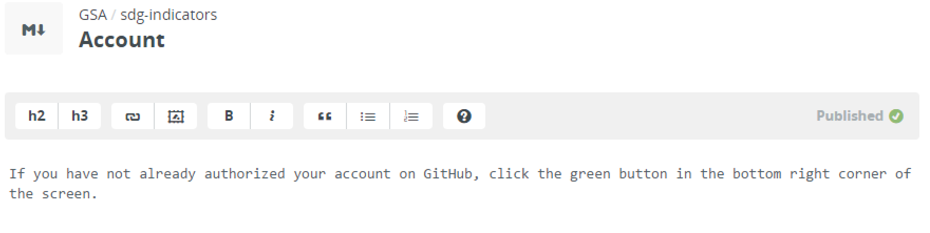



## Accessing the SDG Reporting Platform

You can directly access the SDG reporting platform by going to <https://gsa.github.io/sdg-indicators/> in a **Google Chrome** browser.



NOTE: Using **Chrome is recommended** to ensure optimal performance.

## How to Navigate the NRP

The navigation bar is located at the top of each page throughout the site.

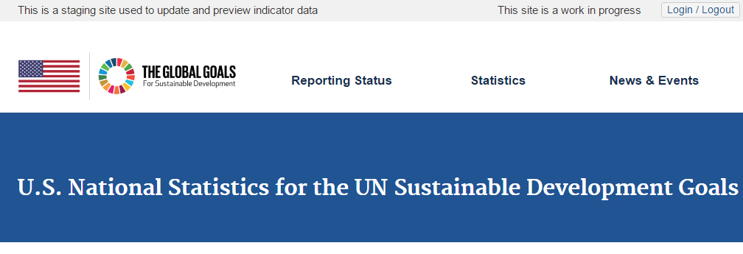

*Login/Logout*

Click on the Login/Logout tab (top right) to login to or logout from your account.

*The Global Goals Icon*

Displays the 17 UN Sustainable Development Goals. From here, you can select a goal and, subsequently, access associated targets and indicators.

*Reporting Status*

(Under development.) This page will provide a dashboard describing national reporting status against the global indicators.

*Statistics*

Features data icons for each SDG goal. From these icons, users can access indicators for data entry (if authorized) or viewing and downloading.

*News and Events*

(Under development.) Check this page for news regarding the reporting of US statistics for global indicators and opportunities to contribute to measuring achievement of the sustainable development goals.

.

The SDG team is interested in your feedback regarding this website and its contents.

* For content questions, email [SDGs@omb.eop.gov](mailto:SDGs@omb.eop.gov)
* For site functionality, email [datagov@gsa.gov](mailto:datagov@gsa.gov)

## Logging in and logging out

**1. Click on Login/Logout tab in the NRP home page** in the upper right-hand corner**.** (Circled in red below.)

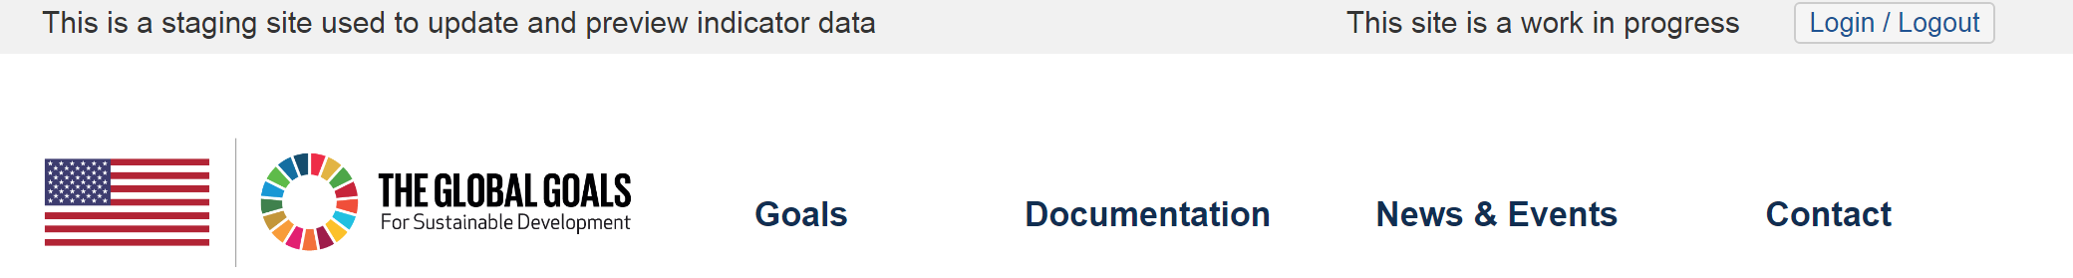

This will open a new window in the ‘GitHub’ site that hosts the NRP.

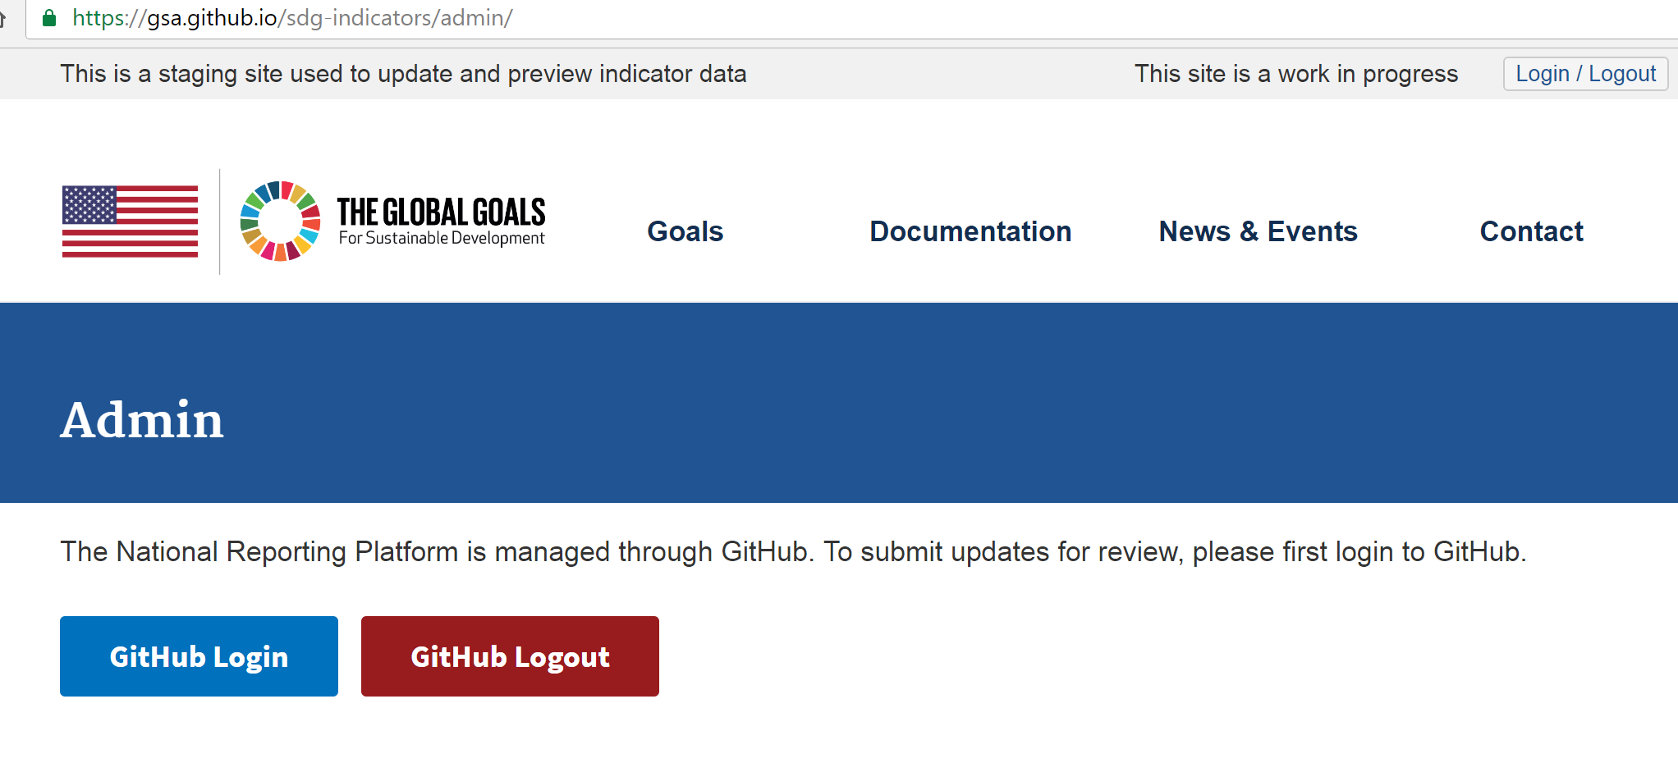

**2.** To log in, click the ‘GitHub Login’ tab and then **enter your username and password**. To return to the NRP site, hit the back key.

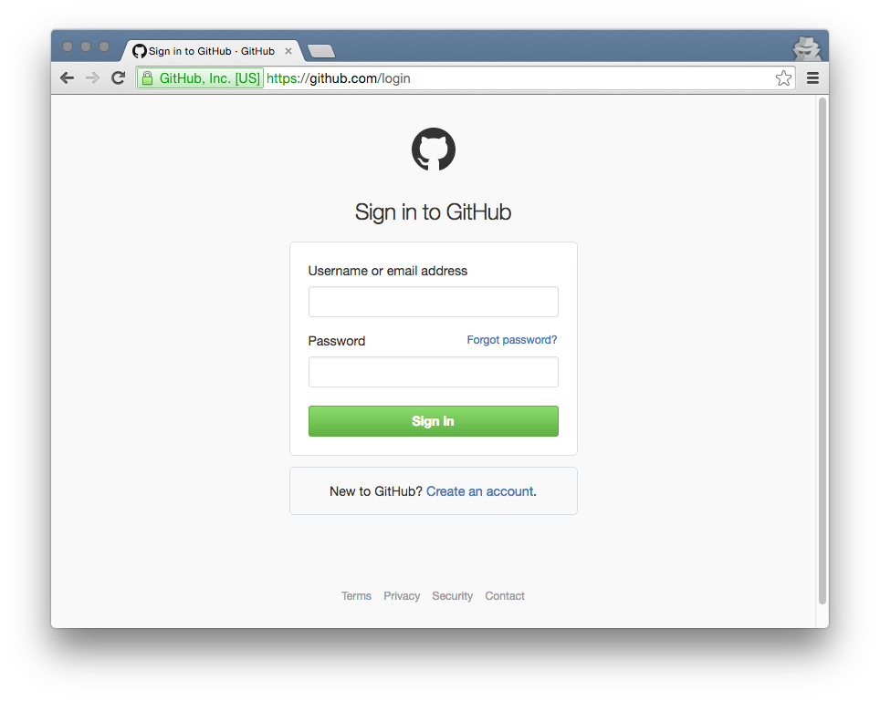

For data integrity purposes,

data providers **must log out** when done editing data/metadata.

**3. To log out, click the ‘GitHub Logout’ tab and then click on your account profile menu in the upper right. Select “Sign out”** from the drop down menu.

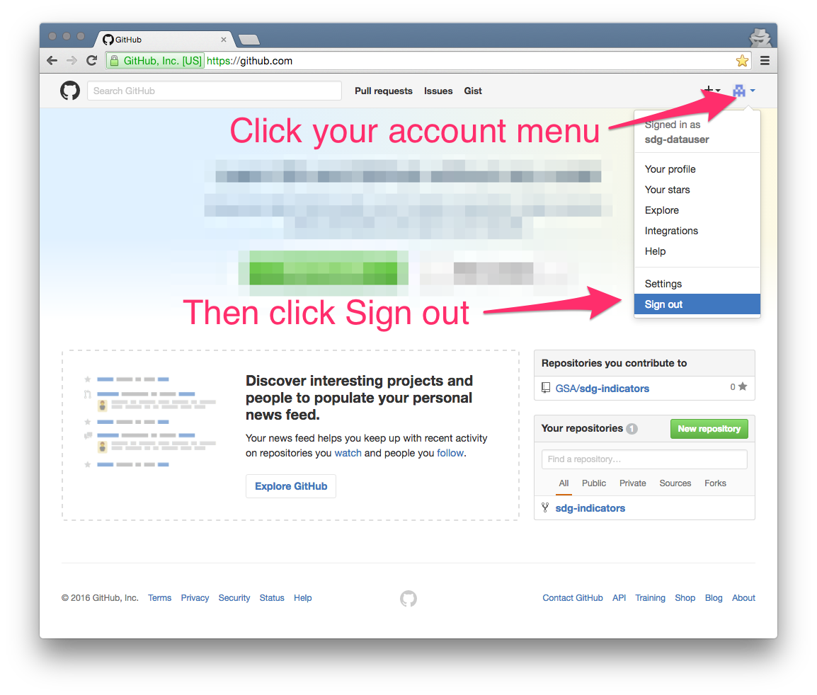

## Nomenclature of SDG Indicators

All SDG indicators are identified by a **three digit code** that indicates Goal, Target, and the specific Indicator. See example below for indicator 3.1.2.

* Goal: 3 Ensure healthy lives and promote well-being for all at all ages
* Target: 3.1 By 2030, reduce the global maternal mortality ratio to less than 70 per 100,000 live births
* Indicator: 3.1.2 Proportion of births attended by skilled health personnel

Some indicators within a goal are labeled with letters, such as indicator 3.a.1: *Age-standardized prevalence of current tobacco use among persons aged 15 years and older.*

When the indicators were initially developed, the use of letters in the naming convention was meant as a way of identifying indicators that would measure the means of implementing a sustainable development goal, rather than directly measuring the achievement of a sustainable development goal.

As the indicators continued to evolve through the negotiation process, the salience of the use of a letter in the taxonomy diminished. For reporting purposes, the use or absence of a letter in the naming convention has no practical significance.

## How to Input Statistics and Data Values

*Choose Goal > Choose indicator > Edit tab > Edit Data button > Copy & Paste > Save*

1. **Click on the goal associated the indicator** (shown as icons) from the NRP goals page <https://gsa.github.io/sdg-indicators/>. The goal number is the first digit in an indicator’s three digit code.

*Example: For indicator 8.5.2, click the icon for Goal 8.*

1. This takes you to a list of the indicators associated with the selected goal. Click on the desired indicator. **For this example, click on indicator 8.5.2.**

1. The indicator page will display a dynamic table with 3 tabs: ‘Data’, ‘Metadata’, and ‘Edit (Requires Password)’. The ‘Data’ tab is selected by default and should display an empty table (until data have been entered and certified).

**Click on the ‘Edit (Requires Password)’** tab.

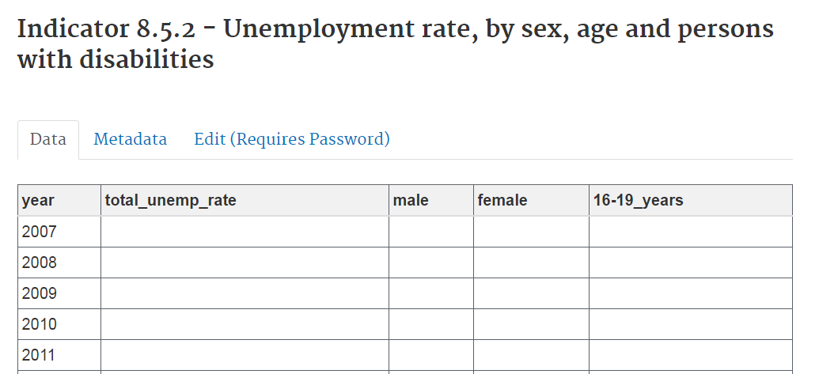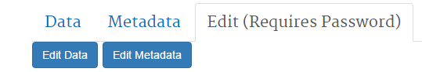

1. The next window shows two buttons with two options: edit data or edit metadata.
2. **Click on the** ‘**Edit Data**’ tab. This tab will open the Edit Data page. See the example for 8.5.2 below.

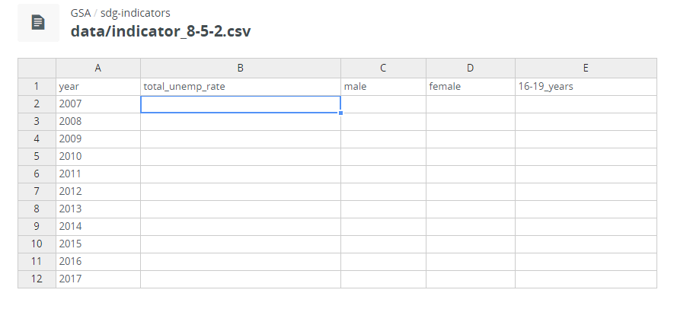

**Before you make any edits, click the green icon** in the bottom right corner to authorize your account.

Click to Authorize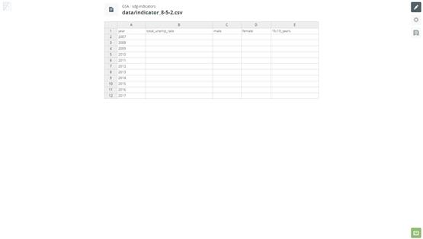

**If you ever see this green icon**, **it means you need to click it to re-authorize your account**. See the Troubleshooting section if you get an error.

**FIRST TIME USERS**: If you did not Authorize edits for the first time (see section Authorize edits) you will be automatically redirected to an intermediary page at GitHub.com.

**Click the “Authorize application” button** to finalize the authorization. (After the first time, this happens in the background.)

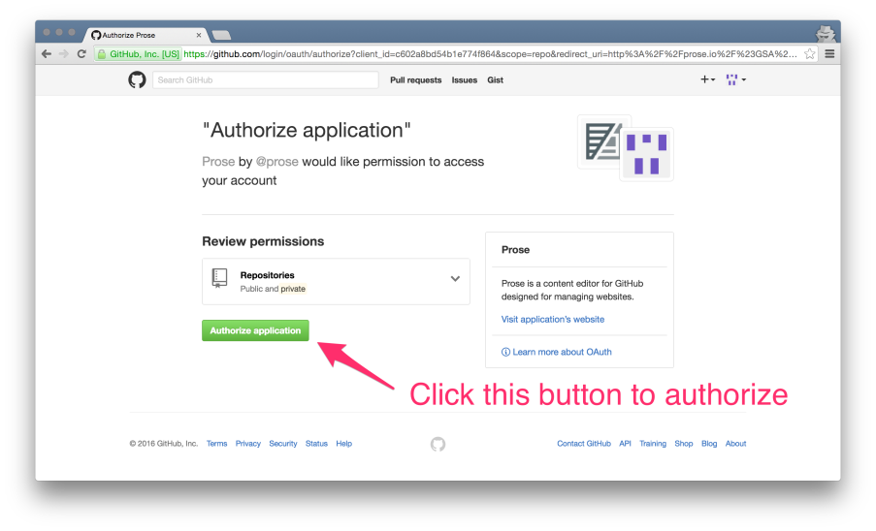

After clicking this button, you will be sent back to the data editing page you were on previously.

After clicking the green icon, you may be prompted “Do you want to leave this site? You may lose your changes.” **Click on “Leave” in order to complete the Authorize step. (Disregard warnings about losing changes.)**

1. Insert data into the template

Organize and format your source data.

**Format data** exactly as in the data input template (including years in first column).

* 1. For example: **Remove commas from all numbers** (e.g., years, dollars). See **BEST PRACTICES** in #7 below.

Copy/paste single statistic or range of statistics:

1. **Copy** requested formatted data from Excel/spreadsheet cells.
2. **Select** corresponding cell(s) in NRP template by left clicking and holding down the mouse and dragging over the cells.
3. **Click CTRL + V** (if PC) [or **CMD + V** (if Mac)] to paste**.**

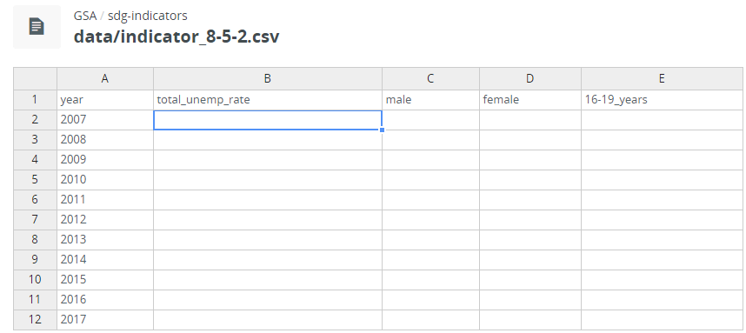 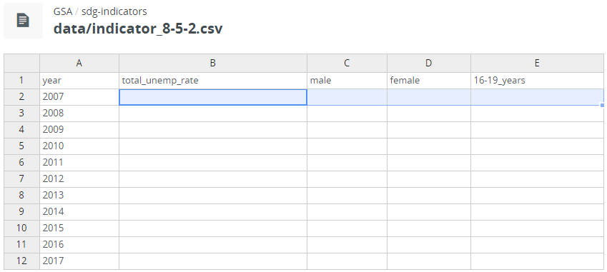

Inserting individual numbers:

1. **Click** on a cell in NRP data input template
2. **Type**
3. Use the arrow keys or your mouse to **select** the next cell
4. **BEST PRACTICES:**

**Remove commas (and any other formatting)** from all numbers (e.g., years, dollars).

Files used to copy/paste data should only contain as many rows and columns as needed (and available).

If necessary, you may add or remove columns by right clicking and selecting the appropriate option from the menu.

A good way to ensure that the data template only contain as many rows and columns as needed is to select only the columns/rows with desired data, copy/paste them to a new sheet, and then **save that as an CSV file before copying and pasting into the NRP data template**. See detailed steps below.

**Copy and paste** from agency-approved estimates, formatted as indicated, is **strongly recommended**.

Conventions for creating the data files in your computer before copy/paste into NRP data template:

* Edit column labels to best reflect the actual data shown. Click on the desired label at the top of the column and edit the label - there should be **no blank column headings**.
* For column labels **use** **short variable names**. Short variable names are intended to be machine readable: **all lowercase and with NO spaces or special characters**. **Use underscores**, rather than spaces, to aid readability.
* **Do not include "comment boxes**" or extra metadata and only include columns and rows where data should exist (ensure that your spreadsheet doesn't include extra empty columns or rows - select the area that should contain data and copy and paste to a new sheet to be sure)
* If necessary, transpose the table so that the labels are the table column headings and year is the first column. See [this animation](http://dropbox.ashlock.us/temp/skitch/csv-transpose2.gif) for an example.
* Before saving, ensure your data is the only thing on a sheet.
* Save the sheet as a CSV file with a name like the following "indicator_8-5-2.csv"

## Reviewing and Saving Your Data

Disk Icon > Review Changes > Submit (if no further changes)

**Click on** the disk icon  (third icon in the top right corner) to save your updates. You will be prompted to review your changes.

**Review** your changes.

If you are ready to submit, **enter the indicator number** and **describe** your changes in the comment box. (See green arrow.)

If you find **errors** or need to make additional changes, click **Cancel** to return to the data table. (See red arrow.)

Describe your changes.

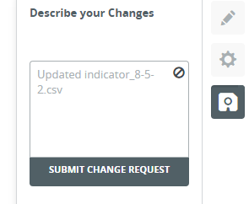

**Click to Cancel**

Then**, click** the **Submit Change Request** button.

../Desktop/save-icon.pngYou will see the floppy disk icon change into a spinning icon and then a **green checkmark** when your update has been successfully submitted. (You do not need to click on the floppy disk icon.)

Your changes will go into the verification queue before appearing on the live public website.

If you are done making data edits, **please proceed to enter metadata information** by **using the back button** (next section).

If you are done with edits, **Please Log Out**.

*Note: If you see a “DONE” bar at the bottom of the template, please ignore it.*

Example of **completed and saved** data input.

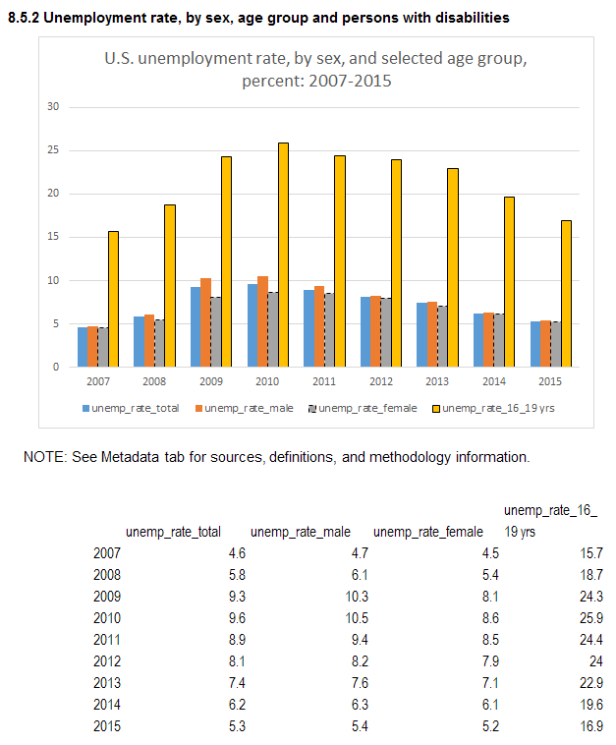

## How to Input Metadata Values

*Choose Goal >Choose indicator > Edit tab > Edit Metadata button > Copy & Paste > Save*

1. Click on the ‘**Edit Metadata**’ tab.



1. This tab will open another page. Once the next page opens, **click on the third icon** shown at the right hand side of the page **to access the** **metadata template**.
2. Insert text in editable metadata template.

Copy/paste text:

1. **Copy** requested metadata from source
2. **Select** corresponding cell(s) in NRP template
3. **Click CTRL + V** (if PC) [or **CMD + V** (if Mac)] to paste**.**

Inserting individual numbers:

1. **Click** on a cell
2. **Type t**ext
3. Use the arrow keys or your mouse to **select** the next cell

**If a metadata element is not applicable**, please **type NA for that element**.

1. Guidance on requested metadata elements

The first seven lines in the metadata template show metadata either for global SDG indicators as defined by the UN as guidance or otherwise by use of SDG staff. Please **do not** edit these metadata lines. If you have questions on global metadata, email [SDGs@omb.eop.gov](mailto:SDGs@omb.eop.gov).

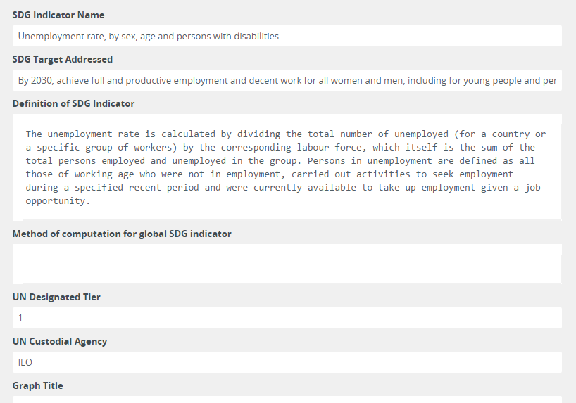

Note that the 7th line, Graph title, is for the use of the SDG team. The line ‘Scheduled Update by SDG Team’ (see completed example below) is also for use by the SDG team.

Therefore **please update all other lines with U.S. metadata for your indicator starting with** “Actual indicator available.” See description of lines to be completed and example below.

* Actual indicator available: **Name of indicator or statistic, as publicly released** by your agency, of data and sub-categories reported in this site. (NOTE: In some cases, national statistics may cover only part of a global SDG indicator or may use a different metric than the global indicator. Therefore, it is important for data providers to specifically label actual national indicator reported.)
* Description of actual indicator available: 1) **Brief description** of reported data (e.g., scope of total and sub-categories). 2) **Provide a longer (human readable) name for each machine readable variable name** (used in data column names) in this line.
* Method of computation: Definitions of **key terms/formulas.** Brief description of **type of data collection** (census/sample/administrative data) and **methods of data collection, frame and sampling units**. (NOTE: Please provide title and web site of **latest full methodology report**. See completed example below.)
* Comments and limitations: **Quality-related information** such as conceptual limitations and brief information on sampling/non-sampling error. *If available*, you may also include information on *standard errors.* Include **information or caveats that may facilitate use, interpretation, or comparability** over time and/or internationally, if available from existing methodology and related reports or papers (please cite references with web links).
* Periodicity: Annual, quarterly, monthly.
* Time Period: Time period covered in reported data.
* Unit of measure: Unit of reported data. **Include (and define) all applicable units**. For example, some indicators include components with different measures such as **levels, growth rates, or intensity**). Please also indicate any adjustments (e.g., **nominal vs. inflation adjusted US dollars, or seasonal adjustment**) as applicable.
* Disaggregation #1 (Industry or social categories): If applicable, list of industries or social categories (age, etc.) reported for this indicator.
* Disaggregation #2 (Geographical coverage): If applicable, list of sub-national categories reported for this indicator.
* Date of public data release from National source: MONTH YEAR
* Date of last Update of This Page: MONTH YEAR
* Scheduled Update by National source: MONTH/YEAR (Next Agency Release)
* Scheduled Update by SDG Team: MONTH/YEAR (NRP Database) – This line is for the **SDG team only**.
* Data Source1 (Agency STAFF NAME): The data provider’s name (so we can follow up with you for future updates).
* Data Source2 (Staff E-MAIL): The data provider’s email (so we can follow up with you for future updates).
* Data Source3 (Agency/Survey/Dataset name)
* Indicator web address (closest to data provided)
* International and National References: Title and web site of applicable **agency and international statistical manuals**.

Note: See also an example of completed metadata entry later in this section.

## Reviewing and Saving Your Metadata

Disk Icon > Review Changes > Submit (if no further changes)

**Click on** the disk icon  (third icon in the top right corner) to save your updates. You will be prompted to review your changes.

**Review** your changes.

If you are ready to submit, **enter the indicator number** and **describe** your changes in the comment box. (See green arrow.)

If you find **errors** or need to make additional changes, click **Cancel** to return to the metadata table. (See red arrow.)



**If you ever see this green icon**, **it means you need to click it to re-authorize your account**. See the Troubleshooting section if you get an error.

Describe your changes.



**Click to Cancel**

Then, **click** the **Submit Change Request** button.

../Desktop/save-icon.pngYou will see the disk icon change into a spinning icon and then a **green checkmark** when your update has been successfully submitted.

Your changes will go into the verification queue before appearing on the live public website.

If you need to work with another indicator, **use the back button** until you see the full list of indicators **or click ‘The Global Goals’ icon** at the top of the page.

If you are done with edits, **Please Log Out**.

*Note: If you see a “DONE” bar at the bottom of the template, please ignore it.*

*Note: If you see a section labeled “Raw Metadata” in the metadata template, please ignore it.*

Example of **completed** metadata entry. [indicator 8.5.2.]

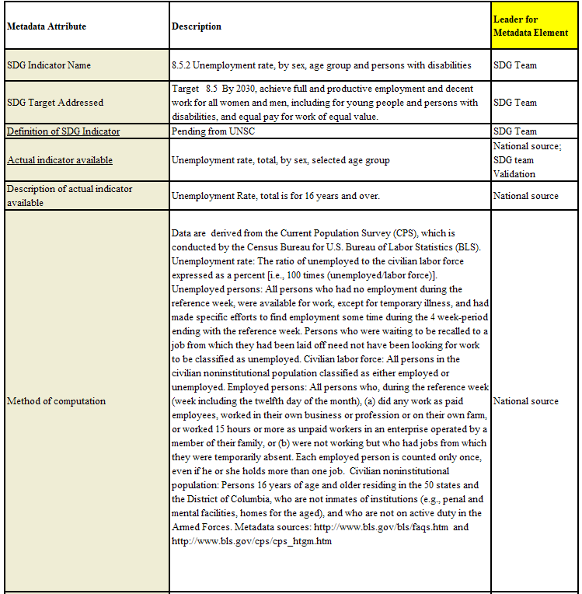

Example of completed metadata input, continued (indicator 8.5.2.)

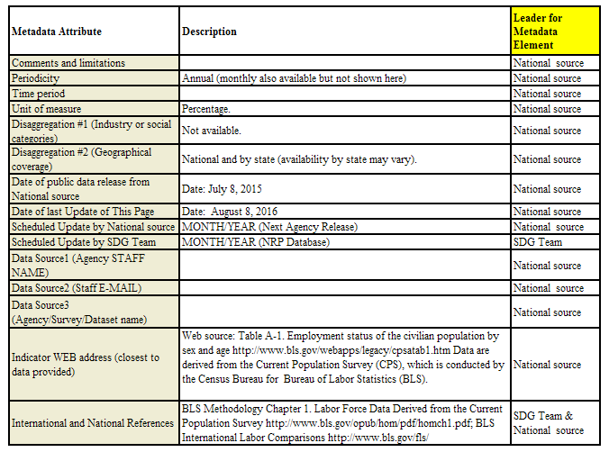

## Data Verification Process

Each time you make an update and submit with the “**Submit Change Request**” button, the change goes into a verification queue where it will be reviewed by OMB.

**You will not be able to see the content you submitted** until OMB has “accepted” your submission and it has been merged with the live website.

**Avoid submitting multiple change requests for the same indicator** data page or the same indicator metadata page until the first request has been resolved. This can create “snarls” when processing several merge requests.

1. Verification

OMB will **review for obvious completeness** or function errors. An email will be sent to the data provider from Github.

If OMB has questions, please address them by **making any further edits**, and/or **providing an explanation** in the comment box, and submit in the usual manner.

When the data provider has addressed all questions from OMB, OMB will **merge the data and metadata input into the live website**. The inputs will then be viewable to the public on the Github site <https://gsa.github.io/sdg-indicators/> that you’ve used to enter data.

On a periodic basis (generally, weekly), **we “refresh” the official NRP website** at [sdg.data.gov](mailto:sdg@data.gov) with content from the github (staging) site. The official site is tagged by Google for web searches.

1. Consultation

When the inputs have been merged onto the live website, the data provider should **email his/her expert group co-chairs** to notify them of the posting. An example email is below. If you need the contact information for your expert group chairs, please contact [sdgs@omb.eop.gov](mailto:sdgs@omb.eop.gov).

Please address any questions/make any further edits necessary using the usual editing process.

## Graphs

When your data and metadata inputs have been verified, we will generate a graph for your data. These will be either line graphs or bar graphs.

When the graph is complete, the hypertext for the indicator on the site will change from light grey to bold blue. This indicates to the viewer that the indicator is complete.

## Troubleshooting Data Entry Errors

You may encounter these errors while using the NRP. Here are solutions. If you get stuck, contact [sdgs@omb.eop.gov](mailto:sdgs@omb.eop.gov).

Saving data error: A red icon illustrated below indicates a problem with the saving process. Usually, this occurs because you have not properly logged into your GitHub account or Authorized edits.

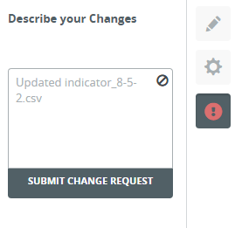

Persistent error window: If an error window like the one shown below appears repeatedly while saving a submission, **restart** your computer and **log out/log** back in <https://github.com/> (see prior section of training guide).

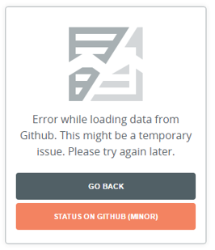

## Reminder for Data Providers: Log Out

For data integrity purposes, data providers **must log out** when done editing data/metadata. See Logging in and logging out section for instructions.

## Platform Managers: What you need to know about the NRP

How do I graph indicator data?

To graph data on the site, please log in and do the following:

Click to navigate to the specific goal and indicator. If you are not able to see data in the table, then the indicator is not ready to be graphed. The table data must be entered first.

If table data exists, click “Edit (Requires Password)” tab above the table. Click on the “Edit Metadata” button near the bottom-left.

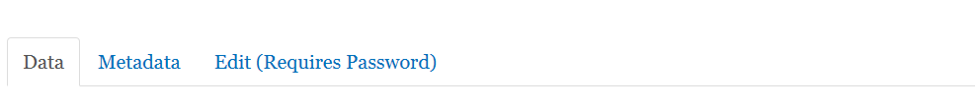

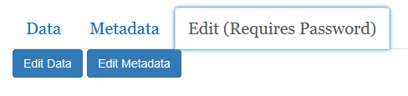

You will see the prose.io page displayed. Click on the green square button in the bottom-right corner to activate your editing session. Note that you will not see the green button if you have already activated the session recently.

Click on the third square button in the top-right corner for the ‘Metadata’ option.

Scroll down the page to the box under “Raw Metadata” to enter the lines of text.

You’ll have to enter the information for “indicator_variable” and “graph.” You may also want to include notes under “graph_type_description,” and possibly update the status for “graph_status_notes.”

graph: longitudinal

A line graph.

graph: bar

A histogram, usually favored when only a year or two of statistics are available for graphing.

graph: binary

Usually used for non-statistical indicators receiving a yes/no response, this allows the indicator to be read as “complete.” The function currently does not allow for actual graphing.

Upon completion, it should look like one of the following three (3) examples.

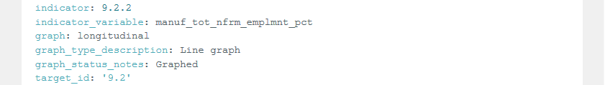

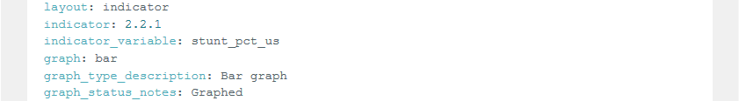

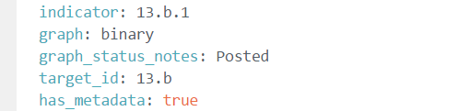

Before you click “Done”, be sure information in “Graph Title” box has been entered. You can return to enter this information at any time if your title is unknown.



Click **“Done”**. Then, click “Save” (the fifth square in the top-right corner) to commit changes. If you receive an error message, wait a few seconds and click “Save” again.



Common graph errors and solutions

Graph does not appear (space only): Check capitalization of variable names in data table. All variable names should be in lower case, with no spaces, commas, or special characters.

No values are graphed (graph frame only): Check the spelling of the indicator variable name. It may be misspelled.

1. <https://sustainabledevelopment.un.org/post2015/transformingourworld>.
2. <http://unstats.un.org/unsd/statcom/47th-session/documents/2016-2-IAEG-SDGs-Rev1-E.pdf>
3. See Statistical Programs of the United States Government [Blue Book] <https://www.whitehouse.gov/sites/default/files/omb/assets/information_and_regulatory_affairs/statistical-programs-2016.pdf>. For related information and upcoming FY 2017 Blue Book see <https://www.whitehouse.gov/omb/inforeg_statpolicy>.
4. Insert detail.
5. See [M-13-13, Open Data Policy - Managing Information as an Asset](https://www.whitehouse.gov/sites/default/files/omb/memoranda/2013/m-13-13.pdf).