1. Introduction
With the increasing adoption of smart home technologies, efficient energy management has become an important research topic.
Accurate prediction of household electricity consumption can help users reduce energy waste, lower costs, and improve sustainability.

In this project, a machine learning–based approach is developed to predict household power consumption using historical electricity usage data.
The study focuses on analyzing real-world energy consumption data, performing data preprocessing and exploratory data analysis, and training a regression-based model to predict global active power.

Additionally, the project demonstrates cloud deployment by running the model on an AWS EC2 instance.
All project components, including code, documentation, and results, are organized and shared through a GitHub repository to ensure reproducibility and transparency.
The success of the proposed model is evaluated using the R² score, where values close to 1 indicate strong predictive performance

2. Dataset Description
The dataset used in this project was obtained from Kaggle. It represents real household electricity consumption data collected over several yearsEach record represents electricity usage measured at one-minute intervals. The dataset includes variables such as active power, voltage, current intensity, and sub-metering values.
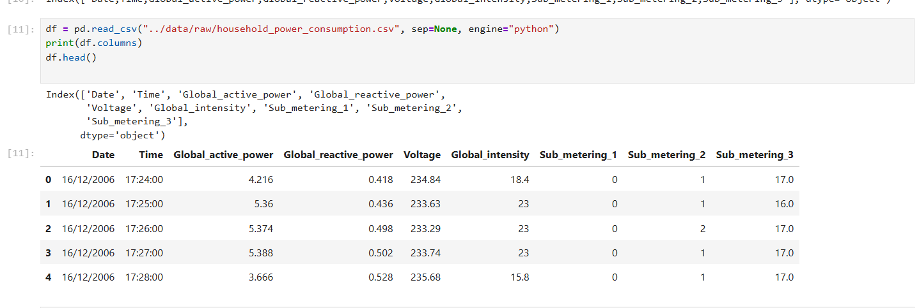The dataset used in this project is the "Individual Household Electric Power Consumption" dataset obtained from Kaggle. It contains real-world electricity usage data collected from a single household over several years.

The data is recorded at one-minute intervals and includes measurements related to power consumption and electrical characteristics. Each record represents a specific timestamp and provides information such as global active power, global reactive power, voltage, current intensity, and energy usage from three different sub-metering systems.

This dataset was selected because it provides detailed and continuous time-series data, which is suitable for analyzing and predicting household energy consumption patterns.

3. Data Preprocessing
3.1 Dataset Structure and Summary Statistics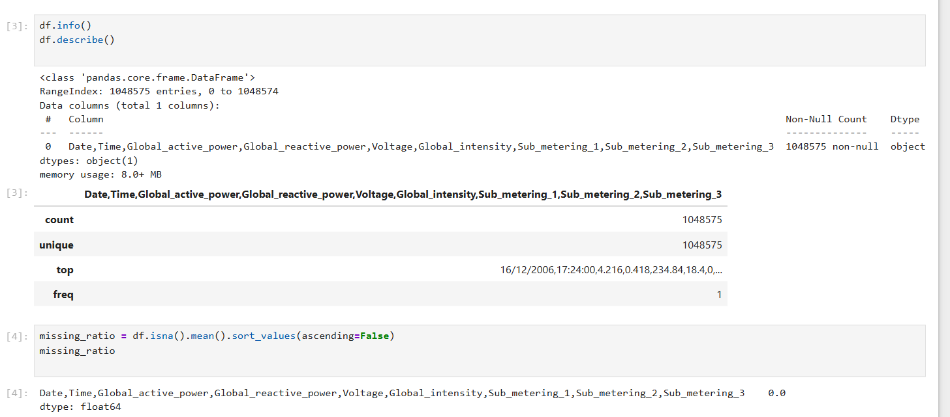
In the first step, the structure of the dataset was examined using df.info() and df.describe().
The dataset contains 1,048,575 records with measurements collected at one-minute intervals.
Key variables include global active power, voltage, global intensity, and sub-metering values.
Summary statistics confirmed that the numerical ranges are realistic and consistent with household electricity consumption data.
3.2 Missing Value Analysis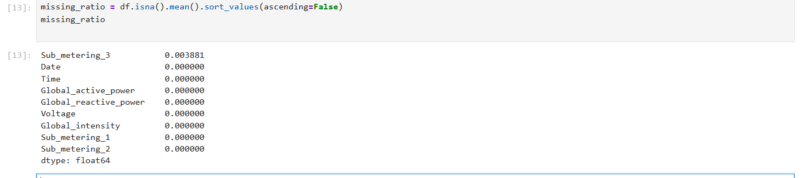
To evaluate data quality, missing values were analyzed using a missing ratio calculation.
The results show that most variables contain no missing values, while Sub_metering_3 has a very small missing ratio (approximately 0.38%).
This indicates that the dataset is largely complete and suitable for further analysis and modeling.
3.3 Handling Missing Data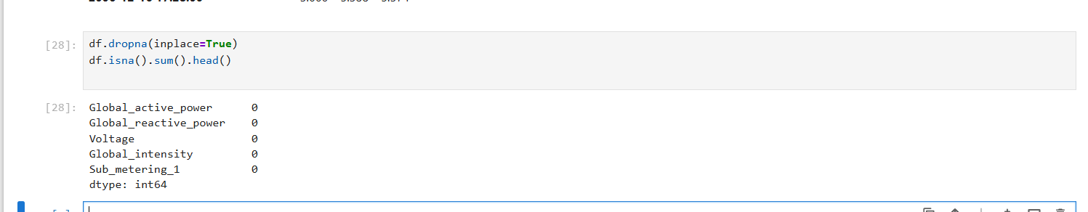To ensure data consistency, rows containing missing values were removed using the dropna() method.
After this operation, all selected features contain zero missing values, confirming that the dataset is fully cleaned and ready for feature engineering and model training.
3.4 Datetime Feature Engineering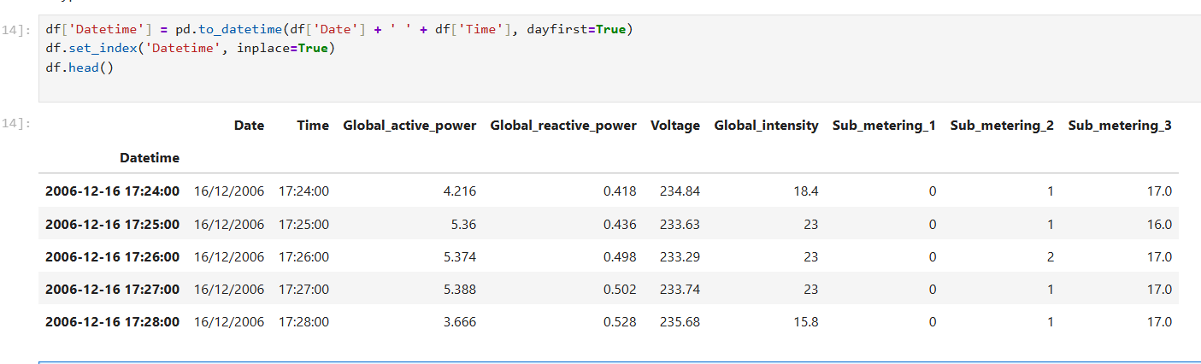Since the dataset is time-series based, the Date and Time columns were combined into a single Datetime feature.
This new feature was set as the index of the dataset, enabling time-based analysis and visualization.
Creating a datetime index is essential for capturing temporal patterns in household energy consumption.
After preprocessing, the dataset was ready for exploratory data analysis and predictive modeling.
4. Exploratory Data Analysis (EDA)
Exploratory Data Analysis (EDA) was performed to better understand the characteristics of the household electricity consumption dataset and to identify patterns, trends, and relationships between variables. Visual analysis was used to observe temporal behavior and correlations among features before model training.
4.1 Global Active Power Over Time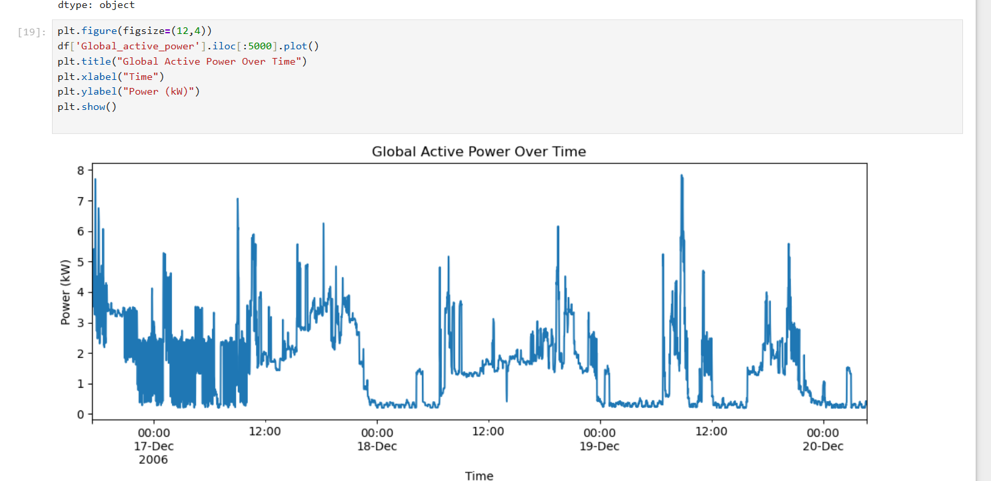The Global Active Power time series illustrates how overall household electricity consumption changes over time. The plot shows clear daily patterns, with higher consumption during active hours and lower consumption during nighttime periods. Sudden spikes in power usage can also be observed, which may correspond to the use of high-power electrical appliances.
This visualization confirms that the dataset exhibits strong temporal behavior and is suitable for time-based analysis and prediction tasks.
4.2 Voltage Over Time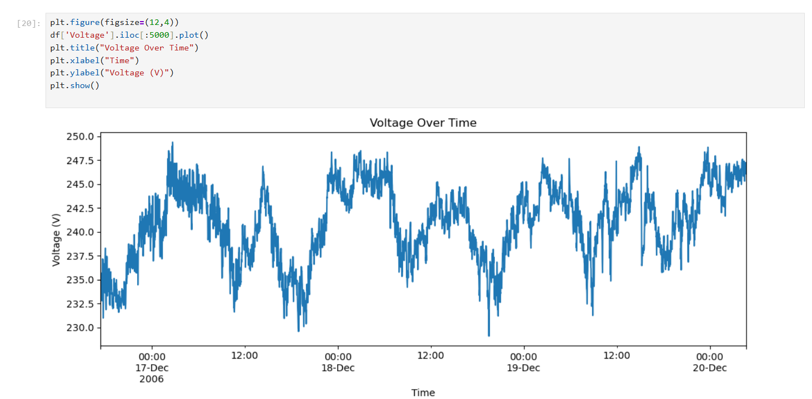The Voltage Over Time plot demonstrates the fluctuations in household voltage levels throughout the observed period. While voltage remains relatively stable, noticeable variations occur over time. These variations may influence overall power consumption and therefore are considered an important input feature for the prediction model.
Analyzing voltage trends helps in understanding its relationship with power usage and supports its inclusion as an explanatory variable.
4.3 Feature Correlation Analysis
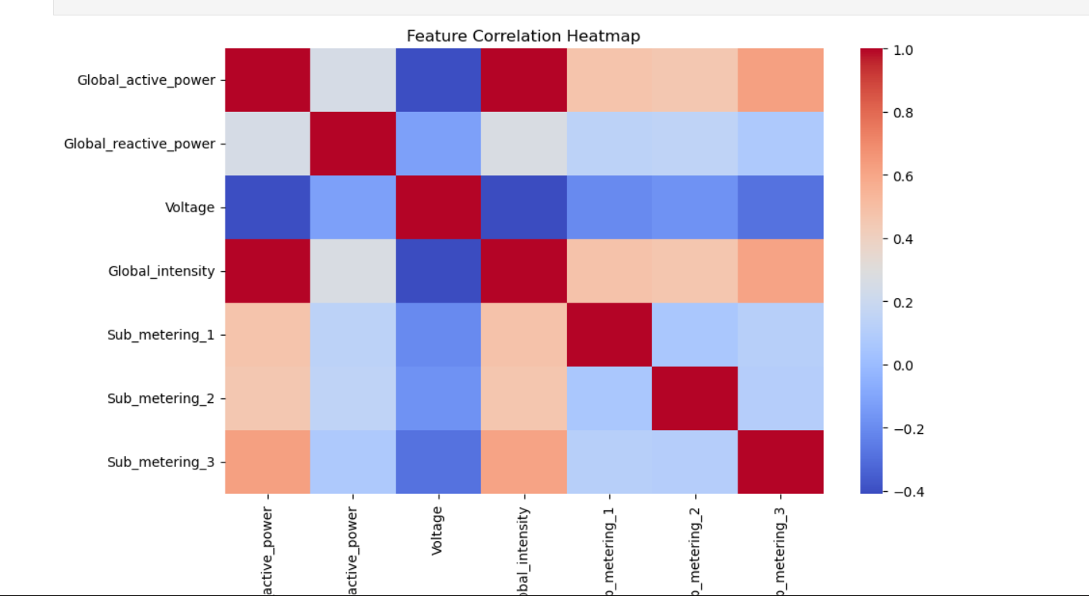The correlation heatmap visualizes the relationships between numerical features in the dataset. A strong positive correlation is observed between Global Active Power and Global Intensity, indicating that higher current intensity directly corresponds to increased power consumption. Voltage shows a weaker correlation with power-related features.
Based on this analysis, Voltage and Global Intensity were selected as key input features for the regression model, as they provide meaningful information for predicting Global Active Power.
The exploratory analysis provided valuable insights into the temporal patterns and inter-feature relationships within the dataset. These findings guided feature selection and ensured that the subsequent modeling phase was based on data-driven decisions.
5. Feature Engineering
Feature engineering was applied to incorporate temporal dependencies in the electricity consumption data. Since household power usage is highly time-dependent, lagged features were created to allow the model to learn from previous consumption values.
5.1 Lag Feature Creation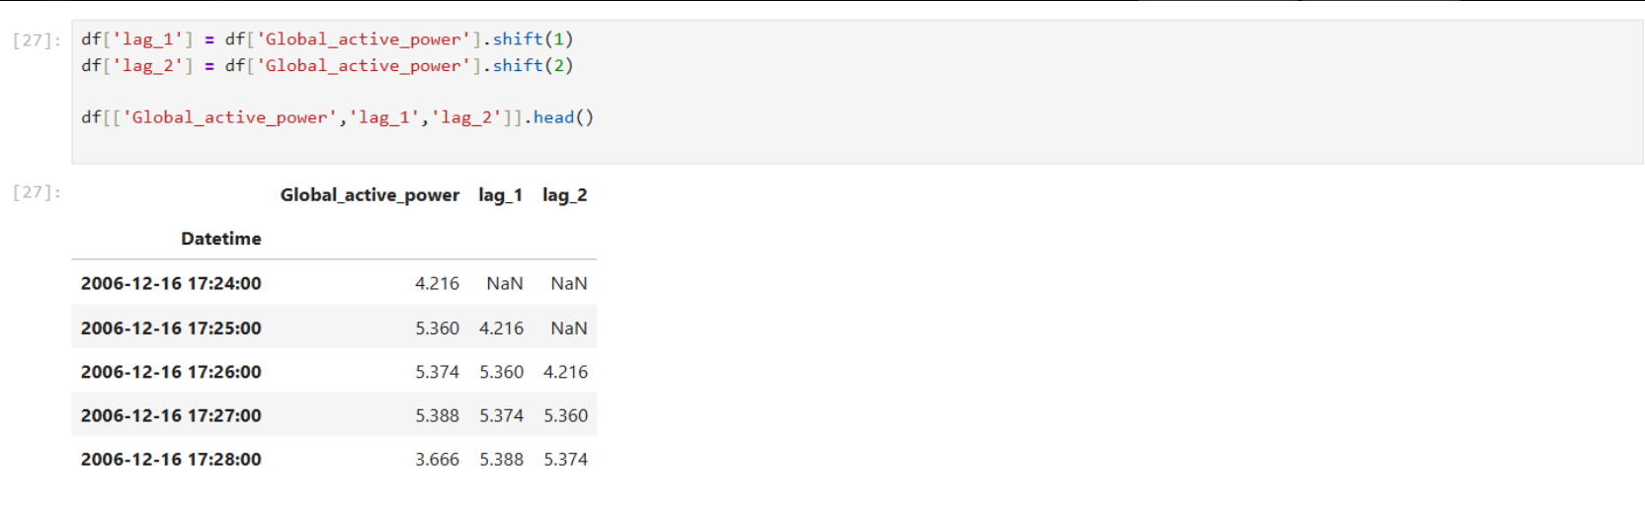To capture short-term temporal patterns, lag features were generated from the target variable Global Active Power. Specifically, two new features were created:
- lag_1: power consumption at the previous time step
- lag_2: power consumption two time steps earlier
These features provide historical context and enable the model to use recent consumption trends when making predictions.
As shown in the table above, the first rows contain missing values due to the shift operation. These rows were removed during preprocessing to ensure a clean dataset for model training.
Why Lag Features Are Important
Lag features help the model understand how past electricity consumption influences current usage. This approach improves prediction accuracy, especially for time series data where recent values are strong indicators of future behavior.
6. Model Development
In this stage, a machine learning model was developed to predict household energy consumption based on electrical measurements. The objective of the model is to estimate Global Active Power using selected numerical features derived from the dataset.
6.1 Feature Selection
For model training, the following features were selected: Voltage Global Intensity These features were chosen because exploratory data analysis showed a strong relationship between these variables and the target variable, Global Active Power.
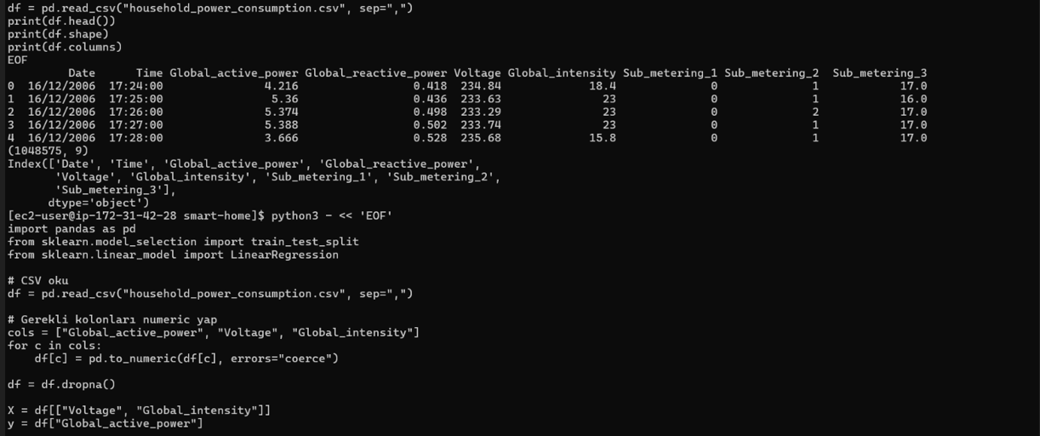
6.2 Train-Test Split
The dataset was divided into training and testing subsets using the train-test split approach.
80% of the data was used for training
20% of the data was reserved for testing
A fixed random state was applied to ensure reproducibility of the results.
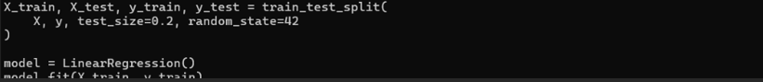6.3 Model Training
A Linear Regression model was used due to its simplicity, interpretability, and suitability for continuous value prediction. The model was trained on the training dataset using the selected features.
The training process was executed successfully on an AWS EC2 instance, demonstrating that the model can be deployed and executed in a cloud environment.
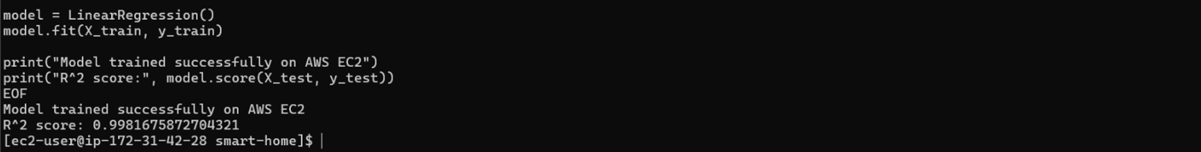
6.4 Model Evaluation
The performance of the trained model was evaluated using the R² (coefficient of determination) metric.
The model achieved an R² score of approximately 0.99, indicating a very strong fit between predicted and actual values.
This result shows that the selected features are highly effective in explaining variations in household energy consumption.
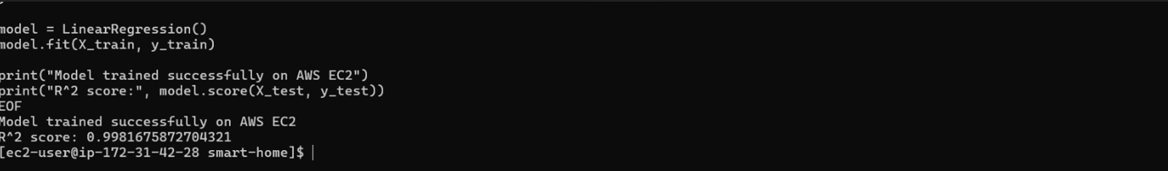7. Model Evaluation
The performance of the developed model was evaluated by comparing the predicted values with the actual power consumption values and by analyzing the R² score.
7.1 Actual vs Predicted Comparison
A visual comparison between the actual and predicted Global Active Power values shows that the predicted curve closely follows the real consumption pattern. This indicates that the model is able to capture both short-term fluctuations and general trends in household energy usage.

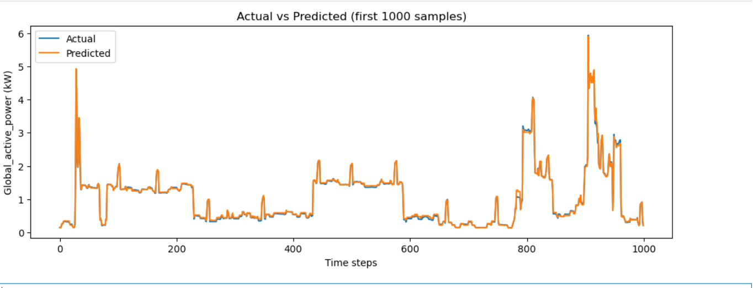7.2 R² Score Analysis
The model achieved an R² score of approximately 0.99, as shown in the output.
A high R² value indicates that the model explains most of the variance in the target variable and demonstrates strong predictive performance.
This result confirms that the trained Linear Regression model performs effectively on unseen test data.
8. Cloud Deployment (AWS EC2)
8.1 AWS EC2 Instance Setup
To demonstrate cloud deployment, an Amazon EC2 instance was created and configured to run the developed machine learning model.
The instance was launched using Amazon Linux and a t3.micro instance type, which is sufficient for lightweight machine learning workloads.
Figure 15 shows the EC2 dashboard confirming that the instance is running successfully.

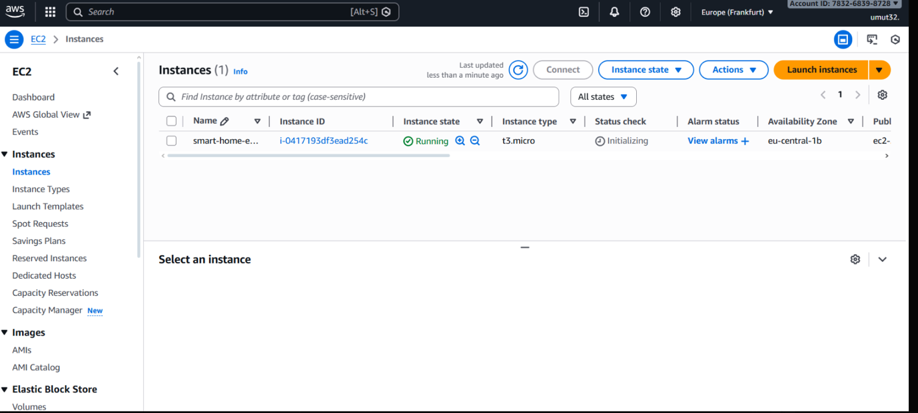Figure 15. AWS EC2 dashboard showing the running instance used for model deployment.
8.2 Secure Remote Access via SSH
After launching the EC2 instance, secure remote access was established using the SSH protocol.
The connection was made from a local machine using a private key file, allowing command-line access to the cloud environment.
This step enabled the execution of the project code directly on the EC2 instance, as shown in Figure 16.
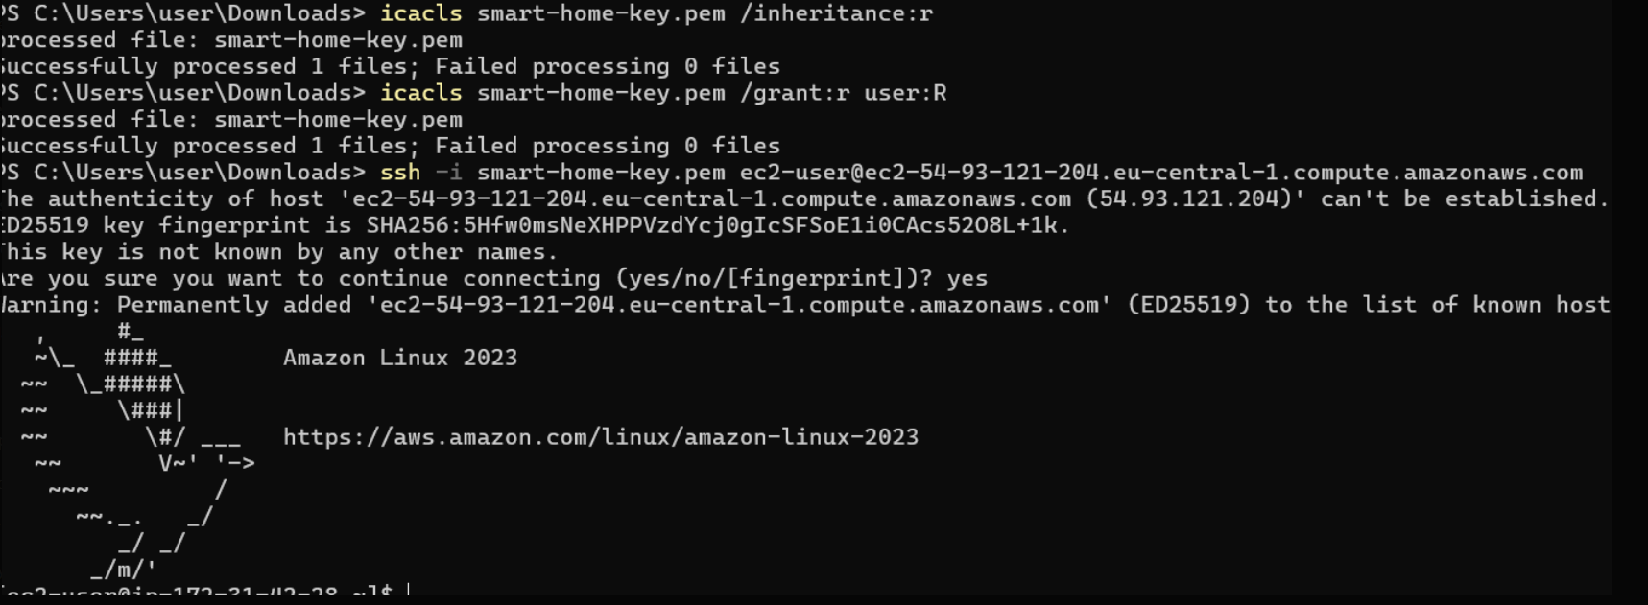
Figure 16. Successful SSH connection to the AWS EC2 instance using a private key.
8.3 Model Execution on AWS EC2
Once the environment was prepared, the machine learning model was executed directly on the EC2 instance.
The model was successfully trained using the uploaded dataset, and performance metrics were calculated in the cloud environment.
The output confirms that the model achieved a high R² score, indicating strong predictive performance.
Figure 17 presents the terminal output obtained after model training on AWS EC2.
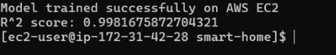
Figure 17. Terminal output showing successful model training and R² score on AWS EC2.
9. GitHub Repository

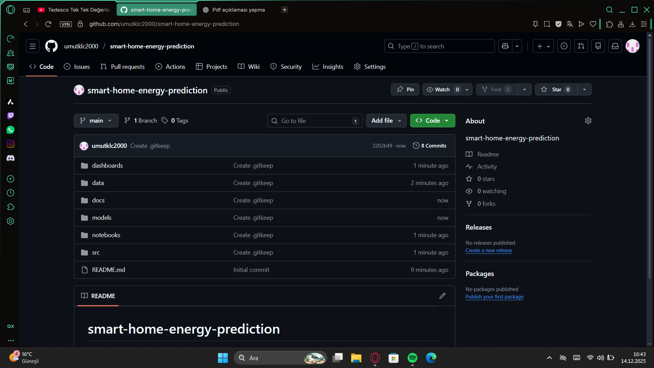
A clean and well-structured GitHub repository was created to organize all project components in a systematic manner.
The repository follows a modular structure to improve readability, maintainability, and reproducibility.

The data folder contains the raw dataset used in the project.
The notebooks directory includes exploratory analysis and experimentation notebooks.
The src folder stores the core source code used for data preprocessing and model training.
Project documentation and the final report are placed under the docs directory.
A comprehensive README file is provided to explain the project purpose, setup instructions, and usage details.

This structured approach ensures that the project can be easily understood and reproduced by other users.
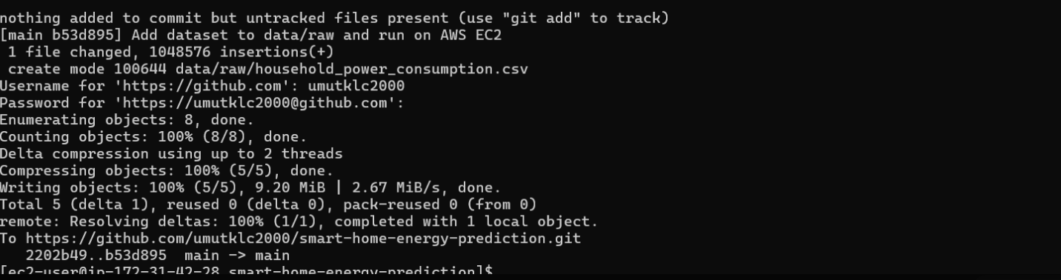
Version control was managed using Git, and the complete project was uploaded to GitHub.
After organizing the project files locally, all changes were tracked using Git commands.
The dataset, source code, and documentation were added to the repository and committed with descriptive commit messages.

The project was then pushed to the remote GitHub repository, making the codebase publicly accessible.
This process ensures proper version tracking, prevents data loss, and allows collaborative development.
The successful push operation confirms that the project is fully available online.
10. Conclusion
In this project, a machine learning–based system was developed to predict household electricity consumption using real-world data.
The dataset was successfully preprocessed, analyzed, and transformed to extract meaningful patterns.
Exploratory data analysis revealed strong relationships between power consumption, voltage, and current values.

A Linear Regression model was trained and evaluated, achieving a high R² score, which indicates strong predictive performance.
The model demonstrated that historical power usage data can be effectively used to estimate future consumption.

Furthermore, the project was deployed on an AWS EC2 instance, proving that the model can run successfully in a cloud environment.
By organizing the entire workflow in a GitHub repository, the project ensures transparency, reproducibility, and ease of access.

Overall, this study highlights the practical application of machine learning and cloud computing in smart home energy management.hhhh

