Umut Mücahit Köksaldı

Semih Sert

21402234

ENG401 – 1

**A Proposal to Investigate Solutions to the Electricity Waste in Bilkent Dormitory 78**

1. **Introduction**

Bilkent University dormitories cater to more than 4000 students in order to provide them with accommodation during their studies [1]. This proposal will focus on the use of electricity in said dormitories, specifically, the Dormitory 78. The dormitory features 89 rooms reserved for female students and 147 rooms for the male students. Ultimately, the building has the ability to host a grand total of 586 students [1]. Alongside so many students living in one building, come certain issues that need to be addressed such as the water and energy consumption of the students, as well as the infrastructure to dispose of the waste produced by such a vast crowd. One such topic to be examined relating to Dormitory 78 is the consumption of electricity by its inhabitants.

In an interview made with İsmail Türesin Özpineci on 29 June 2017, who is the electrical engineer responsible for the management and application of the electrical system of Bilkent University, it was found that the Dormitory 78 uses, on average, 1582 kWh of eletricity per day. Moreover, an average household in Turkey consisting of four people uses 3036 kWh of electricity per year [2]. If one were to compare the two numbers: an inhabitant of Dormitory 78 uses 2.69 kWh of electricity per day; whereas a person living in their home uses 2.07 kWh energy per day. Inside dormitories, students use less space and also do not have nearly the same number of appliances inside their rooms compared to what can be found in a Turkish home. In light of these reasons, one might expect that the electricity consumption of a student living inside Dormitory 78 to be less than someone who lives in their personal home. However, the data found out shows results that contradict with this expectation. An inhabitant of Dormitory 78 uses about 30% more electricity compared to an individual living in their personal residence. This proposal will investigate the possible causes of this excessive usage of electricity inside Dormitory 78, and also will present potential solutions to the problem.

1. **Problem Definiton**

The problem at hand is the excessive consumption of electricity inside Bilkent Dormitory 78. As an attempt to further explore the problem and its components, three root causes have been identified.

* 1. **Human error and lack of control mechanisms**

One big issue that could be causing the waste of electricity inside Dormitory 78 is that students are forgetting to turn off the lights in the common-use spaces inside the building. There is a kitchen, and bathrooms on each of the floors and sections inside the dormitory, all of which are shared by the students [1]. In addition, there are the hallways which must always be kept lit. In a survey conducted to the residents of Dormitory 78 with the aim of finding out student habits related to the lights inside their dormitory; it was found that 74% of students often forget to turn off the lights in the common use areas. Moreover, 67% of students stated that they have found the lights left on unnecessarily in these common use areas more than 5 times a month.

Finally, the students leave the lights in their own rooms on unnecessarily while leaving their rooms or falling asleep without turning the lights off, causing the lights to operate all night. In the survey, about 22% of the students stated that they leave their lights running or their computer turned on while they leave the room to go to class. Another 13% forgets to turn off the lights in their rooms as they fall asleep more than once a month. Consequently, electricity usage inside the dorms raise unnecessarily.

* 1. **Out-of-date and worn-out lightbulbs**

The lights used inside the dorm are fluorescent lights which are relatively old in terms of technology and as a result, they are not up to the standards when it comes to energy savings. Moreover, some of the lights inside the dormitory are worn-out as a result of heavy use and they are now consuming more unnecessary power. These worn-out lights consume the same amount of electricity but produce much less illumination as a result of most of the energy turning into heat. The equipment inside the dormitory is not maintained properly and it is technologically inferior; as a result, electricity waste arises.

* 1. **Unplanned installment of lamps**

The illumination of the dormitory building was not designed with efficiency in mind, resulting in redundant quantities of lighting to be distributed along the commonly used areas on the floors, as well as the needlessly large fluorescent lights to be placed inside smaller areas that do not require such devices. The figure below shows the floor plan of Dormitory 78, with the placement of the lights mapped out according to observation. As can be observed, the lights are distributed unnecessarily close to each other, especially in the commonly used areas such as the kitchen, where 3 fluorescent light strips are placed approximately every 1.5 meters. Furthermore, in the survey conducted 42% of the students stated that they do not need all of the lights turned on to see properly in the common-use areas. However, 64% of the students said they turn on all the lights in the room when they enter as a habit. Considering the possibility that these lights can be left on as the students leave the room, the unnecessary electricity consumption that emerges significantly increases.

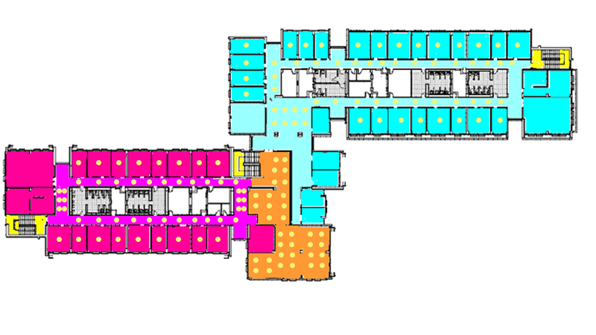

**Figure 1, Lighting distribution inside Dormitory 78 (Source image taken from Bilkent Dormitory Website with the light sources mapped as part of observation) [1]**

1. **Proposed Solutions**
   1. **Use of sensors and timers to cut down on unnecessary up-time**

Proximity sensors could be installed on the areas used commonly by all students, so that the lights will only be turned on if there is someone present to use the facilities. In addition, timers can be installed on each of the rooms in the building so that they will automatically turn off after a certain hour ensuring that the students will not leave the lights on as they go to sleep.

* 1. **Incorporating energy efficient lightbulbs**

Energy expenditure can be reduced by installing energy saving lightbulbs that use new technology instead of the traditional lights currently used inside the building. The most efficient form of lightbulb available currently are LED lights. On average, one LED lightbulb saves 2.5$ annually if it is used instead of the traditional incandescent lightbulbs [3]. Taking into account that the building features a total of 236 rooms, simple math leads us to the conclusion that the replacement of the lightbulbs of the student rooms inside the dorm will result in 590$ saved annually if we were to install LED lights in place of the fluorescent ones currently in use.

* 1. **Optimizing the distribution of lightbulbs**

The placement of the lights can be designed in such a way to optimize the quantity and the power of the lights installed in each of the rooms, in order to maximize the usability while keeping down the energy use as minimal as possible. First off, the color of the walls inside the building are mostly light-yellow or white, which are appropriate colors for reflection. The light sources can be constructed near the walls in order to benefit the most from the reflection, as the reflection will also provide some amount of illumination. Moreover, LED lights provide different a different amount of illumination compared to fluorescent lights. As a result, the placement of LED lights should be different than fluorescent lights to provide adequate lighting to desired areas. Lastly, in accordance with the survey results it can be inferred that currently there is an excessive amount of lighting installed in the common use areas and the corridors. These can be further reduced and optimized by taking into account how much lighting an area needs to receive to be considered illuminated, and the placement of the lightbulbs should be arranged accordingly.

1. **Criteria for Assessing Solutions**

The solutions will be examined according to the following criteria:

**Cost - effectiveness**: There should be a reasonably satisfactory value (savings) returned from the implemented solutions in relation to the monetary cost of realizing such systems. For instance, if one considers the solution of installing sensors; then the electricity savings resulting from installing the sensors should be satisfying in relation to the cost of installing the system.

**Acceptability:** The proposed solutions should be easy for the students to adapt to, and they should not interfere with the students’ day-to-day life. For example, some students might have a problem with LED lights because it may cause them eye-strain, which would make this solution less acceptable. In addition, the building management and the Bilkent Dormitory Management will be consulted to see if they are supporting the changes that will be brought about by the solutions to the building and its inhabitants.

**Feasibility:** The solutions should be technically rational and suitable for the building’s status. For example, a redesign of the building’s lighting layout may or may not be possible depending on the construction of the building and the installation of sensors may not be possible depending on the technical specification of the lighting system. Lastly, the technology that is aimed to be implemented should be reasonably achievable with the technical staff and qualifications that the project has.

1. **Research Methodology**

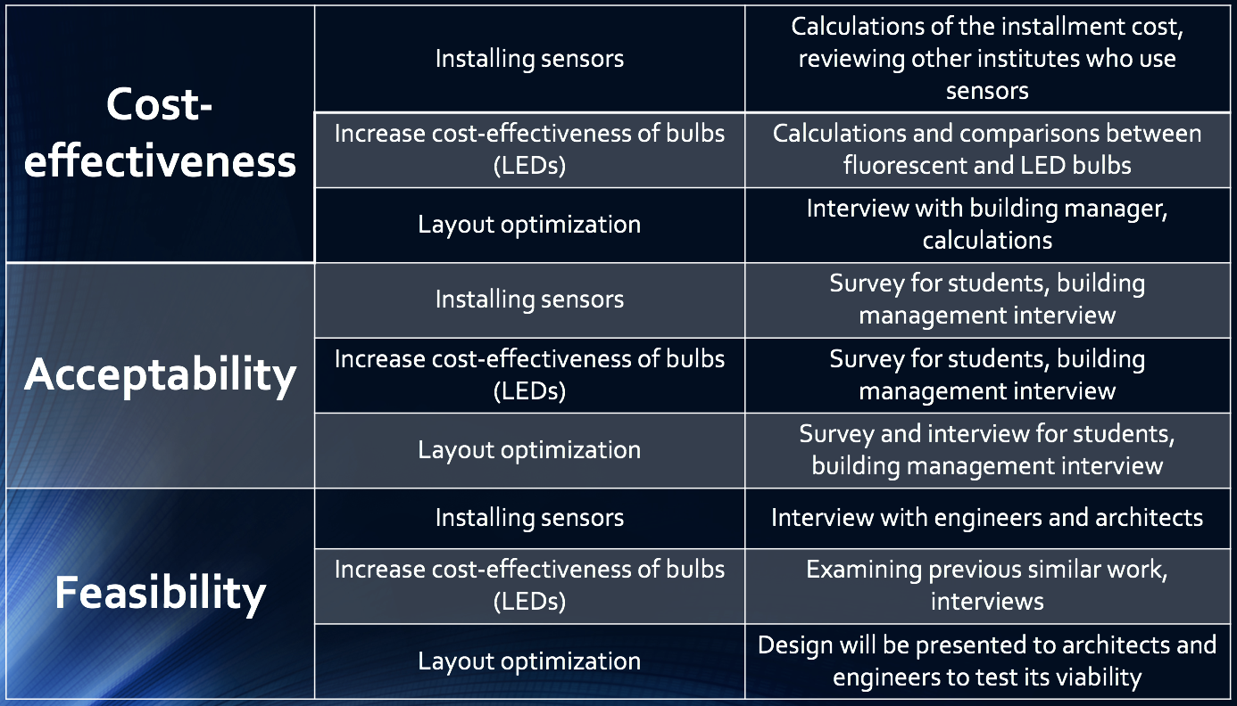 Multiple interviews, surveys and calculations will be made in order to assess the criteria in relation to the proposed solutions. A table detailing each of the proposed methods can be found below.

Table 1

For cost-effectiveness, calculations will provide sufficient quantitative data, enabling an educated decision to be made. In addition, reviewing other institutions that use such systems will provide a better understanding of both the implementation and the effectiveness of the system without having to test it in the field.

For acceptability, interviews and surveys will provide both qualitative and quantitative data in order to judge whether the solution we want to implement is suitable for the people who are going to use it.

For feasibility, experts will be consulted to see if the solutions are reasonable enough in a technical sense which will give appropriate information to judge the solutions’ workability.

*References*

[1] Bilkent University, ‘Hizmet ve Olanaklar’, 2013. [Online].

Available: http://www.yurt.bilkent.edu.tr/78a.html [Accessed: 26-Jun-2017]

[2] Esra KARAKIŞ, ‘TÜRKİYE 2013 YILLIK ENERJİ İSTATİSTİKLERİ RAPORU’, 2013. [Online].

Available: http://www.enerji.gov.tr/File/?path=ROOT/1/Documents/EİGM%20Periyodik%20Rapor/2013_Yili_Enerji_Istatistikleri_Raporu.pdf [Accessed: 30-Jun-2017]

[3] Earthled.com, ‘LED Light Bulbs Vs. CFL Light Bulbs: Which is Best for Me?’, 2015. [Online]. Available: <https://www.earthled.com/blogs/light-2-0-the-earthled-blog-led-lighting-news-tips-reviews/35906628-led-light-bulbs-vs-cfl-light-bulbs-which-is-best-for-me>

[Accessed: 30-Jun-2017]