Main Program - Solution with "GA" and "ML" for VES data
% It was used "Damped Least-Squares Method" oth.called "Marquart-Levenberg"
% It was developed from Ekinci and Demirci (2018) by Murat Ayaz (2019)...
% within the scope of the undergraduate graduation project.
close all; clear all; clc; format long;
% Input Parameters and Data for Two Algorithms
filename = 'Multi.xls'; %Input MS Excel File
sheet='Forw';
ab2=xlsread(filename,sheet,'E6:E60'); %Observed AB/2 Values
roa=xlsread(filename,sheet,'F6:F60'); %Observed Resistivity Values
realRo=xlsread(filename,sheet,'C6:C16');%Real Res.Value (Just Forward Sol.)
realH=xlsread(filename,sheet,'D6:D16'); %Real Thickness (Just Forward Sol.)
% Multi Solution for GA
%Input Parameters and Data for just GA
sheet4='GA';
NumG=xlsread(filename,sheet4,'B7:B500');
Olculen=roa;
RoDownM=xlsread(filename,sheet4,'C7:C500'); %Search Space for
RoUpM=xlsread(filename,sheet4,'D7:D500'); % resistivity and
ThiDownM=xlsread(filename,sheet4,'E7:E500');% thickness
ThiUpM=xlsread(filename,sheet4,'F7:F500'); % parameters
ChrM=xlsread(filename,sheet4,'J7:J500'); %Chromosome(candidate solution)
GenM=xlsread(filename,sheet4,'H7:H500'); %Gene(parameter on cand. sol.)
maxIterationM=xlsread(filename,sheet4,'I7:I500'); %Number of Iteration
pCrossM=xlsread(filename,sheet4,'K7:K500'); %Crossover probability
pMutationM=xlsread(filename,sheet4,'L7:L500'); %Mutation probability
pEltM=xlsread(filename,sheet4,'M7:M500'); %Elite Ratio
ntM=xlsread(filename,sheet4,'G7:G500'); %Number of Layers
cnk=20; %Is the population in search space? A check in each cnk steps.
%Calculation
for ga=1:length(NumG)
RoDown=RoDownM(ga,:); RoUp=RoUpM(ga,:);ThiDown=ThiDownM(ga,:);
ThiUp=ThiUpM(ga,:);Chr=ChrM(ga,:);Gen=GenM(ga,:);
maxIteration=maxIterationM(ga,:);pCross=pCrossM(ga,:);
pMutation=pMutationM(ga,:);pElt=pEltM(ga,:);nt=ntM(ga,:);
sheet5=sprintf('GA%d',NumG(ga));
[roGA,thiGA,TimeGA,bRoa,bV] = MultiGA(RoDown,RoUp,ThiDown,ThiUp,Chr...
,Gen,maxIteration,pCross,pMutation,pElt,nt,sheet5,cnk,ab2,Olculen,...
realRo,realH);
xlswrite(filename,ab2,sheet5,'A3');
xlswrite(filename,bRoa,sheet5,'B3');
TimeGAO(ga,:)=TimeGA;roGAO(ga,:)=roGA;thiGAO(ga,:)=thiGA;bVO(ga,:)=bV;
% Output to .xls File
sheet6=sprintf('AH%d',NumG(ga)+6);
sheet7=sprintf('N%d:W%d',NumG(ga)+6,NumG(ga)+6);
sheet8=sprintf('X%d:AF%d',NumG(ga)+6,NumG(ga)+6);
sheet9=sprintf('AG%d',NumG(ga)+6);
xlswrite(filename,TimeGA,sheet4,sheet6);
xlswrite(filename,roGA,sheet4,sheet7);
xlswrite(filename,thiGA,sheet4,sheet8);
xlswrite(filename,bV,sheet4,sheet9);
TimeGA=[];roGA=[];thiGA=[];bV=[];
end
% Multi Solution for Inversion
%Input Parameters and Data for just ML
sheet2='ML'; %MS Excel Sheet
Num=xlsread(filename,sheet2,'B7:B100');
Mr=xlsread(filename,sheet2,'C7:C100:L7:L100');%Prediction Resistivity par.
Mt=xlsread(filename,sheet2,'M7:M100:U7:U100');%Prediction Thickness par.
Mmaxiteration=xlsread(filename,sheet2,'V7:V100'); %Number of Iteration
Mkr=xlsread(filename,sheet2,'W7:W100'); %Acceptable difference
% Calculations
for mu=1:length(Num)
r=Mr(mu,:); t=Mt(mu,:); maxiteration=Mmaxiteration(mu,:); kr=Mkr(mu,:);
sheet3=sprintf('ML%d',Num(mu));
[r,t,roa4,rms,TimeMarq] = ...
MultiInv(ab2,roa,r,t,maxiteration,kr,sheet3,realH,realRo);
Or(mu,:)=r; Ot(mu,:)=t; Orms(mu,:)=rms;
OTimeMarq(mu,:)=TimeMarq;
xlswrite(filename,ab2,sheet3,'A3');
xlswrite(filename,roa4,sheet3,'B3');
% Output to .xls File for each option
sheet10=sprintf('AQ%d',Num(mu)+6);
sheet11=sprintf('X%d:AG%d',Num(mu)+6,Num(mu)+6);
sheet12=sprintf('AH%d:AP%d',Num(mu)+6,Num(mu)+6);
sheet13=sprintf('AR%d',Num(mu)+6);
xlswrite(filename,r,sheet2,sheet11);
xlswrite(filename,t,sheet2,sheet12);
xlswrite(filename,rms,sheet2,sheet10);
xlswrite(filename,TimeMarq,sheet2,sheet13);
end
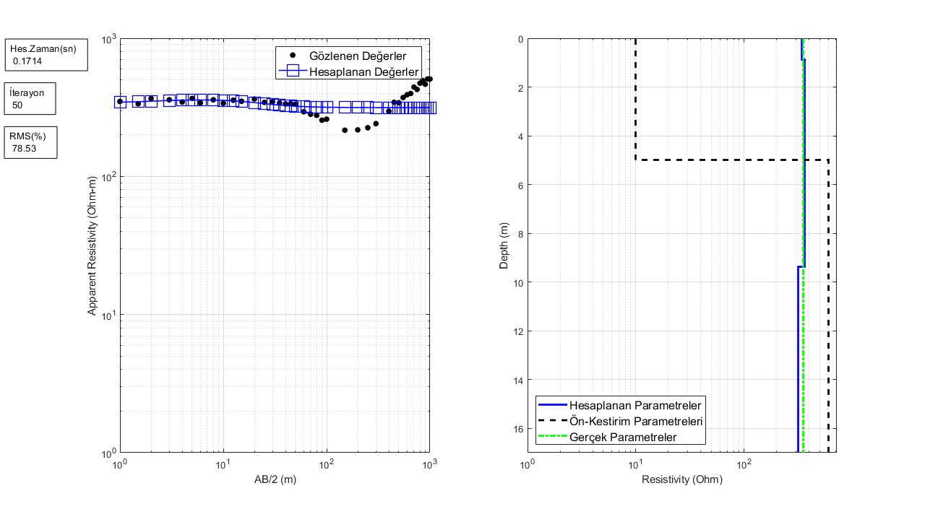
Published with MATLAB® R2019a

