Forward Solution for Vertical Electrical Sounding
% It was developed from Oruç (2012) by Murat Ayaz (2019) ...
% within the scope of the undergraduate graduation project.
close all; clear all; clc; format long;
% Input Parameters and Data
filename = 'Multi.xls'; %Input MS Excel File
sheet='Forw'; %MS Excel Sheet
ab2=xlsread(filename,sheet,'A6:A60'); %AB/2 Values
ro=xlsread(filename,sheet,'C6:C16'); %Resistivity Values
h=xlsread(filename,sheet,'D6:D16'); %Thickness of Layers
RatNoi=xlsread(filename,sheet,'C22'); %Noise Ratio
%Filter Coefficients (Guptasarma, 1982)
a(1)=-0.17445;a(2)=0.09672;a(3)=0.36789;a(4)=0.63906;a(5)=0.91023;
a(6)=1.18143;a(7)=1.45257;
fi(1)=0.1732;fi(2)=0.2945;fi(3)=2.1470;fi(4)=-2.1733;
fi(5)=0.6646;fi(6)=-0.1215;fi(7)=0.0155;
%Number of Data and Layers
nv=length(ab2); nt=length(ro);
% Calculations
for ii=1:nv
l=ab2(ii);
top=0;
for r=1:7
lamda(r)=10^(a(r)-log10(l));
for jj=nt-1:-1:1
if jj==nt-1
uu(jj)=exp(-2*h(jj)*lamda(r));
kk(jj)=(ro(jj)-ro(jj+1))/(ro(jj)+ro(jj+1));
t(jj)=ro(jj)*(1-kk(jj)*uu(jj))/(1+kk(jj)*uu(jj));
else
u(jj)=exp(-2*h(jj)*lamda(r));
w(jj)=ro(jj)*(1-u(jj))/(1+u(jj));
t(jj)=(w(jj)+t(jj+1))/(1+(w(jj)*t(jj+1))/ro(jj)^2);
end
end
t(r)=t(1);
top=top+fi(r)*t(r);
end
roa(ii)=top;
end
% Add Noise
while RatNoi~=0
for ppp=1:nv
rs=unifrnd(0,RatNoi/100);
Noi=rs*roa(ppp);
rNoi=unifrnd(-1,1);
if rNoi<0
roaNoi(ppp)=roa(ppp)-Noi;
else
roaNoi(ppp)=roa(ppp)+Noi;
end
end
roa=roaNoi;
RatNoi=0;
end
% Output to .xls File
xlswrite(filename,ab2,sheet,'E6');
xlswrite(filename,roa',sheet,'F6');
% Plotting The Figure
%-----------------------------------------------------------------
% Create figure
figure1 = figure;
% Create axes
axes1 = axes('Parent',figure1,...
'Position',[0.407407407407407 0.125996810207337 ...
0.575852504486866 0.759170653907496]);
hold(axes1,'on');
% Create loglog
loglog(ab2,roa,'DisplayName',' Gözlenen (ohm.m)','Parent',axes1,...
'MarkerSize',7,...
'Marker','o',...
'LineWidth',2);
% Create ylabel
ylabel('roa (ohm.m)');
% Create xlabel
xlabel('ab/2 (m)');
box(axes1,'on');
grid(axes1,'on');
% Set the remaining axes properties
set(axes1,'XMinorTick','on','XScale','log','YMinorTick','on',...
'YScale','log');
set(axes1,'ylim',[min(roa)*0.4 max(roa)*2]);
% Create legend
legend1 = legend(axes1,'show');
set(legend1,...
'Position',[0.485516856040417 0.82028980209614 ...
0.14298978359365 0.033381550333531]);
% Create axes
axes2 = axes('Parent',figure1,...
'Position',[0.0518518518518519 0.543859649122807...
0.289814814814815 0.341307814992026]);
hold(axes2,'on');
% Create bar
bar(ro,'DisplayName','Özdirenç Değerleri (ohm)','Parent',axes2,...
'FaceColor',[0 0.447058823529412 0.741176470588235]);
% Create ylabel
ylabel('Özdirenç (ohm-m)');
ylim([0 max(ro)*1.4]);
% Create xlabel
xlabel('Tabaka No');
box(axes2,'on');
% Set the remaining axes properties
set(axes2,'XMinorTick','on','XTick',[1 2 3 4],'YGrid','on','YMinorGrid',...
'on','YMinorTick','on','ZMinorTick','on');
% Create legend
legend2 = legend(axes2,'show');
set(legend2,'Visible','off',...
'Position',[0.215209884205591 0.71766822242299 ...
0.190377931966427 0.0329662774804008]);
% Create axes
axes3 = axes('Parent',figure1,...
'Position',[0.0527777777777778 0.124401913875598 ...
0.289814814814815 0.301435406698564]);
hold(axes3,'on');
% Create bar
bar(h,'DisplayName','Tabaka Kalınlıkları (m)');
% Create ylabel
ylabel('Kalınlık (m)');
ylim([0 max(h)*1.5]);
% Create xlabel
xlabel('Tabaka No');
box(axes3,'on');
% Set the remaining axes properties
set(axes3,'XTick',[1 2 3],'YGrid','on','YMinorGrid','on');
% Create legend
legend3 = legend(axes3,'show');
set(legend3,'Visible','off',...
'Position',[0.179367862664603 0.448185620512542 ....
0.16946937314803 0.0329662774804012]);
% Figure Output
set(gcf,'Position', [0 0 1280 720]);
picName = sprintf('%sSol',sheet);
print(picName,'-r600','-djpeg');
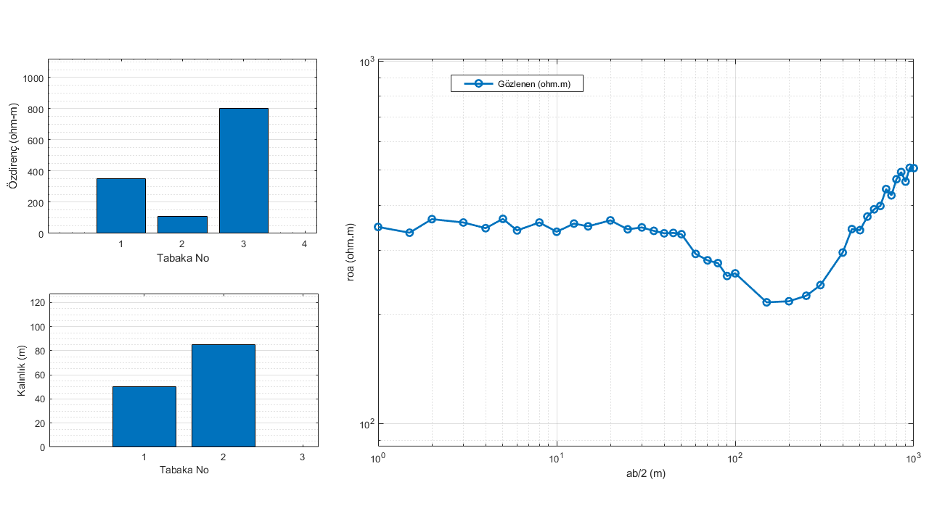
Published with MATLAB® R2019a

