TEAM 7 (PROJECT SIMULATION)
LIST OF TEAM 7 MEMBERS.

S/N | NAME | STUDENT ID | EMAIL | COURSE
1. | David Joshua | VEPH/20B/PM058 | vpm05820bdavid@gmail.com | Project management
2. | Adeolu James Oluwasola | VEPH/20B/DA226 | vda22620bjames@gmail.com | Data analytics
3. | Njoku Ogechi | VEPH/20B/DA075 | ogechi075vda20b@gmail.com | Data analytics
4. | Ezeadikwa Chidera Emmanuel | VEPH/20B/DA060 | vda06020bchidera@gmail.com | Data analytics
5. | Adetunji Iswat Oluwatosin | VEPH/20B/DA125 | vda12520biswat@gmail.com | Data analytics
6. | Ogboaka Starry | VEPH/20B/DA107 | vda10720bstarry@gmail.com | Data analytics
7 | Osamudiamen Umweni | VEPH/20B/DA191 | vda19120bosamudiamen@gmail.com | Data analytics
8 | Essien, Ephraim Effiong | VEPH/20B/DA218 | vda21820bephraim@gmail.com | Data analytics

ATTENDANCE

S/N | NAME | STUDENT ID | Apr.25 | Apr.27 | May 04 | May 07 | May 11 | May18 | May 22
1. | David Joshua | VEPH/20B/PM058 | present | present | present | present | present | present | present
2. | Adeolu James Oluwasola | VEPH/20B/DA226 | present | present | present | Absent | present | present | present
3. | Njoku Ogechi | VEPH/20B/DA075 | present | present | present | present | present | present | present
4. | Ezeadikwa Chidera Emmanuel | VEPH/20B/DA060 | present | present | present | present | present | present | present
5. | Adetunji Iswat Oluwatosin | VEPH/20B/DA125 | present | present | present | Absent | present | present | present
6. | Ogboaka Starry | VEPH/20B/DA107 | present | present | present | present | present | present | present
7 | Osamudiamen Umweni | VEPH/20B/DA191 | present | present | Absent | present | present | present | present
8 | Essien, Ephraim Effiong | VEPH/20B/DA218 |  |  | present | Absent | present | Absent | Absent

Technical Report for Global Road Accidents Analysis
Outline
- Introduction
- Story of Data
- Data Splitting and Preprocessing
- Pre-Analysis
- In-Analysis
- Post-Analysis and Insights
- Data Visualizations & Charts
- Recommendations and Observations
- Conclusion
- References & Appendices

- Introduction

The objective of this project is to carry out a comprehensive analysis of Global Road Accidents, using data from multiple countries. This analysis seeks to uncover patterns, evaluate contributing factors, and assess the human and economic impacts of road accidents across different countries and regions. This analysis will help inform safety strategies, policy recommendations, and safeguard awareness globally with specific effort to include underrepresented regions such as Africa.

One of the major causes of injury and death globally are Road accidents, with significant economic implications. However, the scale, severity, and causes of these accidents vary across countries and regions. This project aims to answer the following key questions:
- What is the global trend of road accidents?
- Which Countries and regions have the highest and lowest rates of road accidents?
- What are the most common types of road accidents?
- What times of the day, days of the week or season do most accidents occur?
- What are the leading causes of road accidents? (e.g speeding, weather, drunk driving or poor road infrastructure).
By addressing these questions, the project will highlight trends and disparities in global road safety and support data-driven decision-making.
The dataset used for this analysis contains over 132,000 records of road accidents from 13 countries across various continents, including recent additions from Nigeria, Kenya, and South Africa to ensure African representation. Each record includes 30 variables such as:
- Geographic data (country, region)
- Time data (year, month, day of the week, time of day)
- Environmental conditions (weather, road type, traffic volume)
- Human factors (driver gender, alcohol level, fatigue)
- Outcomes (injuries, fatalities, economic loss)
Methodologies used in Microsoft Excel include:
- Pivot Tables: For summarizing accident counts, fatalities, and regional distributions.
- Data Manipulation and Cleaning: To ensure consistency across merged datasets and eliminate missing values.

- Story of Data

2.1 Data Source
The dataset was gotten from a combination of publicly available global road safety records, supplemented with structured data from official sources such as the:
- National Bureau of Statistics (Nigeria),
- Kaggle
- National Transport and Safety Authority (Kenya),
- Road Traffic Management Corporation (South Africa), as well as records verification from North America, Europe, Asia, and Oceania. These sources ensure a wide-ranging, multinational view of road accident conditions and impacts.
2.2 Data Collection Process
The dataset was obtained from Kaggle. The African representation was manually enriched based on credible reports and expert estimates to improve global inclusiveness. The final dataset reflects both real-world data points and simulated approximations where gaps existed particularly in Africa to allow for comparative analysis.
2.3 Data Structure
The dataset contains 132,003 rows, with each row representing a single road accident event.
It includes 30 columns, each capturing a specific variable related to the accident such as:
  - Location (Country, Region)
  - Time (Year, Month, Day of Week, Time of Day)
  - Road and Environmental Conditions (Weather, Road Type, Visibility, Road Condition)
  - Driver Information (Age Group, Gender, Alcohol Level, Fatigue)
  - Outcome Metrics (Injuries, Fatalities, Emergency Response Time, Medical Cost, Economic Loss)
This structure allows for both broad aggregations (e.g., total fatalities by country) and deep multivariate analysis (e.g., how visibility and fatigue influence severity).
2.4 Important Features and Their Significance
Feature | Significance
Accident Severity | The dependent variable representing the impact levelof the accident (Minor, Moderate, Severe, Fatal).
Driver Alcohol Level | Helps assess the influence of drunk driving on accidents.
Driver Fatigue | shows whether tiredness and stress was a contributing factor.
Emergency Response Time | Helps to measure post-accident intervention effectiveness.
Weather Conditions and Visibility Level | shows how environmental factors contribute to accidents.
Number of Injuries / Fatalities | Provides direct measures of human impact.
Economic Loss and Medical Cost | Measures the financial burden of each incident.
Region and Country | Enable geographical comparisons and policy benchmarking.

2.5 Data Limitations and Biases
- Underrepresentation of Africa: The dataset underrepresents data from African countries. However, the small sample size (3 African entries) may not fully represent the region.

3.0 Data Splitting and Preprocessing
3.1 Data Cleaning
Microsoft Excel was used to review and clean the raw. The following cleaning steps were performed:
- Removal of header inconsistencies
- Column realignment
- Removal of blanks
- Duplicate check
3.2 Handling Missing Values
The dataset was reviewed for missing values across all 30 columns. Fortunately, no missing values were detected.
3.3 Data Transformations
No data transformations were performed on this dataset.
3.4 Data Splitting
The dataset was divided into independent and dependent data points for structured analysis.
- Dependent Data Points:
Accident Severity,number of injuries,number of fatalities, economic loss, Insurance claims.
- Independent Data Points:
All other 25 columns that describe the conditions, environment, and human behavior surrounding each accident.
  - Industry Context

This dataset primarily cuts across the government and public transport sector and the Road and safety Sectors.

  - Stakeholders

Stakeholders for this project include Vephla mentors, Government transport agencies, Non governmental organizations, General public and Road users.

  - Value to the Industry
The dataset facilitates important decision-making in public policy creation, emergency response improvement, insurance risk assessment, and transportation planning by providing comprehensive records of accident severity, driver behaviour, environmental circumstances, and economic repercussions. It enables stakeholders to assess the financial impact of traffic accidents, identify high-risk situations, and more efficiently deploy resources.

- Pre-Analysis
4.1 Identified Key Trends
Road accidents are fairly evenly distributed across the year, but May (11,158), June (11,122), and March (11,072) recorded the highest number of accidents, suggesting slight seasonal peaks likely due to increased travel activity during these months.
Accidents are highest on Tuesdays (19,061) and Wednesdays (19,001). Surprisingly, weekends do not lead the chart, which contrasts with expectations of higher weekend travel risks.
Accidents are slightly more common at Night (33,231) and Evening (33,024) than in the Afternoon or Morning. This supports common road safety concerns about nighttime visibility and fatigue.
All weather types show relatively balanced distributions, but Clear conditions still record fatal accidents, challenging the idea that weather alone drives severity.
Rainy and Foggy weather lead slightly to Severe outcomes.
Fatal accidents are more frequent on Highways and Main Roads, as expected.
Interestingly, Streets lead in Moderate injuries, possibly due to pedestrian involvement or dense urban traffic.

4.2 Initial Insights
- Night-time accidents are slightly more severe, warranting investigation into visibility and fatigue-related causes.
- Tuesday and Wednesday are unexpectedly the most accident-prone days, suggesting work-related commuting might be a risk factor.
- Economic loss varies more with injury counts than vehicle counts, indicating that human harm drives financial impact.
- Weather conditions alone do not strongly predict fatality, but still influence severity distribution.
- Fatal accidents are rare but appear on all road types, which suggests that road type is not the only trigger for fatal outcomes.

5.0 In- analysis

5.1 Unconfirmed Insights

- Minor, moderate, and severe accidents occur at almost the same rate. Fatal accidents are rare, which could mean safety measures are working or that some deaths aren’t being reported properly.
- The top five countries (Canada, Australia, Germany, Brazil and India) have very close number of accidents. This suggests road accidents are a global issue and not just limited to specific regions, likely due to high vehicle use and urban traffic.
- The severity of accident peaks during midweek, with Tuesday having the highest number of incidents, followed closely by Wednesday, contradicting typical assumptions that weekends pose greater risk.
- Accident rates is highest in May, declined in August, and increased again in September, these changes may be tied to weather patterns, holidays, or school schedules.
- Even though drunk driving is the leading cause of accident with 26460 cases, the weather being the least cause has 26245 cases, the fewer difference suggests that focusing on just one cause in public policy might be ineffective.

5.2 Recommendations

- Since all accident causes (drunk driving, distracted driving, mechanical failure, speeding and weather) appear equally significant, safety interventions should be broad-based.
- Given that accidents are severe on Tuesdays and Wednesdays, additional traffic monitoring and increased patrols could help reduce pressure.
- May and September, show higher accident rates. Targeted campaigns or stricter road checks during these times could help reduce incidents.
- With only three fatal cases recorded, it’s likely some data is missing. Better reporting, especially in underrepresented regions, is key to understanding the true impact.

5.3 Analysis Techniques Used in Excel

- Pivot Tables and charts
- Sorting and Filtering

6 Post-Analysis and Insights

6.1 Key Findings:

- Total Road Accidents (2000–2024):
  - A total of 132,003 accidents occurred between 2000 and 2024.
- Top Accident Cause:
  - Drunk Driving is the leading cause of road accidents, accounting for 26,245 accidents, other causes include distracted driving and speeding.
- Country with Most Accidents:
  - Canada is the country with the highest country with the most accident reporting 13,349 accidents, slightly ahead of Australia, Brazil, Germany, and India.
- Most Affected Age Group:
  - Individuals under 18 years were the most affected age group, with 26,524 accidents involving them.
- Peak Accident Day:
  - The highest number of accidents occurred on Tuesday (19,061 incidents), making it the riskiest day of the week.
- Most Hazardous Weather Condition:
  - Accidents occurring during Windy weather led to the highest number of injuries (252,369 injuries), slightly ahead of rainy and clear conditions.
- Urban vs. Rural Accidents:
  - Accident distribution was nearly even with 50.3%of the accidents occurring in rural areas and 49.7% occurring in the urban areas.
- Road Accident Severity:
  - The majority of the accident cases were reported to be minor(44,063) , Moderate (44,002) and severe(43935) in nature. Only 3 were reported as Fatal.
- Yearly Trend of Road Accidents:
  - The annual accident count fluctuated across the years, without a clear upward or downward trend.
  - Comparison with Initial Expectations:

- Expectation: Drunk driving and speeding were suspected to be leading causes of road accidents.
  - Validated: Drunk driving was confirmed as the top cause, closely followed by distracted driving and speeding.
- Expectation: Younger drivers are more accident-prone.
  - Validated: The <18 age group was indeed the most affected demographics.
- Expectation: Weekends would see more accidents due to higher activities which translates to higher travels.
- Contrary to the expectation, Tuesday and Wednesday had the most accidents.
- Expectation: Snowy or foggy weather would be most hazardous.
  - Contrary to expectation, accidents that occurred during Windy weather caused the most injuries, even more than snowy or foggy conditions.
7 Data Visualizations & Charts
Purpose:
To present complex accident data trends in a visually digestible format that supports better understanding and decision-making.

Dashboard Overview (As Seen in the Image below)
The dashboard (Microsoft Excel) contains multiple visualizations:
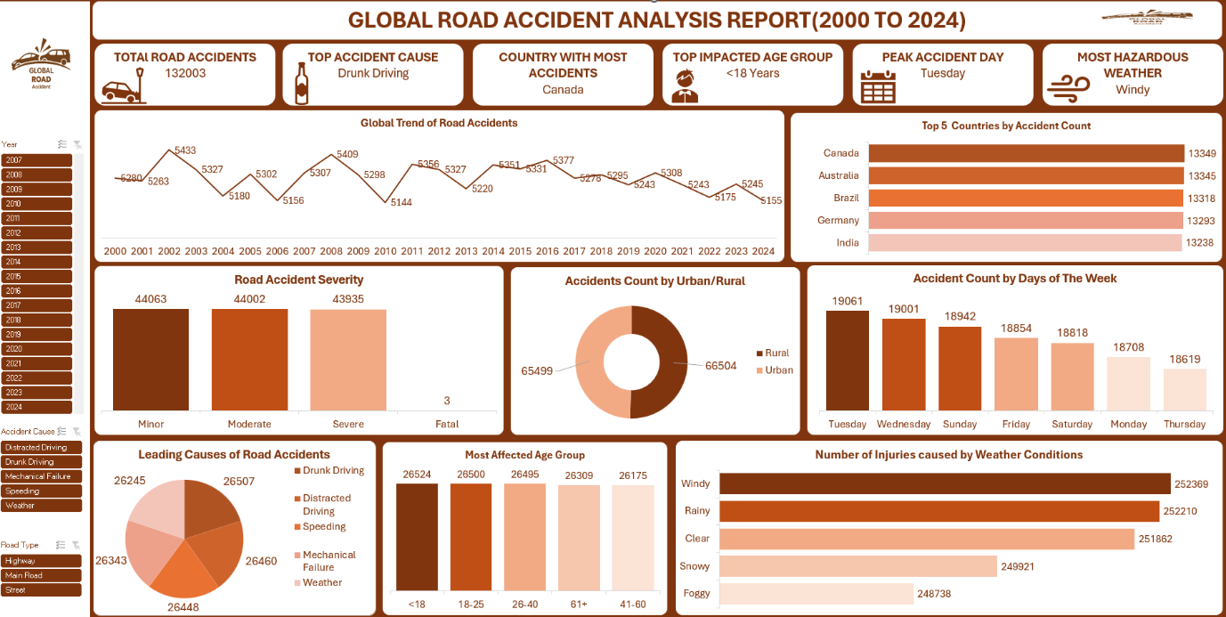

PowerBi

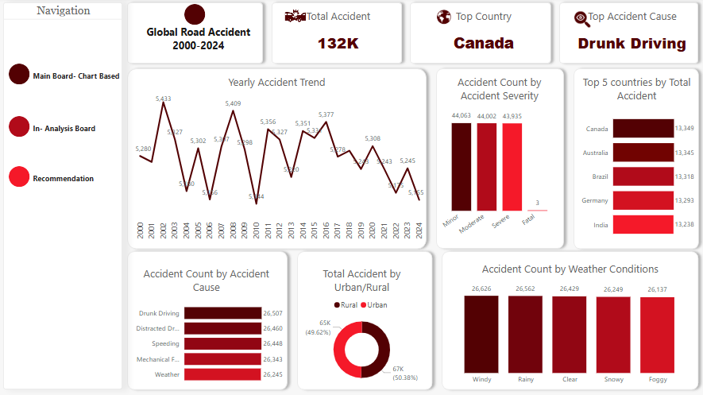

- Global Trend of Road Accidents (Line Graph):

(Microsoft Excel)
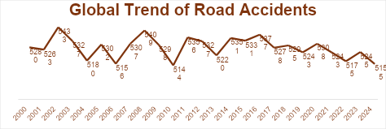

PowerBi
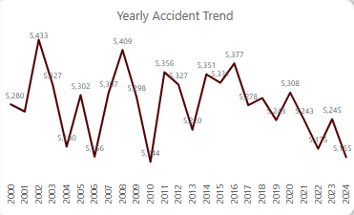

Insight: The number of accidents has fluctuated slightly from 2000 to 2024, with no significant increasing or decreasing trend. Peak years include 2002, 2008,2011,2014 and 2016. Road accident frequency has remained fairly stable, showing the need for new interventions rather than depending on natural decline.
- Top 5 Countries by Accident Count (Bar Chart):
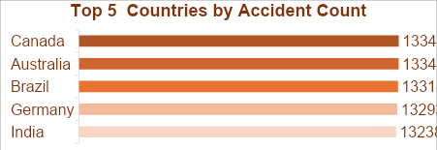

PowerBi
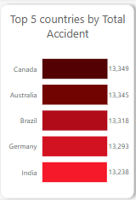
Insight: Canada, Australia, and Brazil lead in road accident numbers. These countries will need target interventions to reduce accidents focusing on policy awareness campaigns.

- Road Accident Severity (Bar Chart):
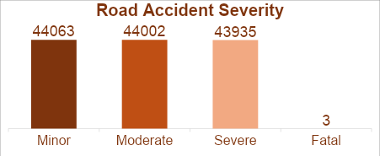

PowerBi

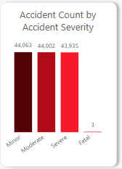

Insight: Most of the accidents are minor or moderate, with only three fatal cases reported. While fatality rates are low, prevention of frequent minor and moderate accidents is still important for reducing burden on the healthcare system and economic loss.

- Accidents Count by Urban/Rural (Donut Chart):
Insight: Urban and rural areas have nearly equal accident counts.
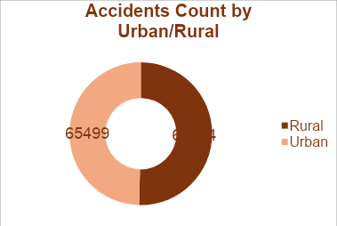Safety strategies should be evenly distributed between urban and rural areas.

PowerBi
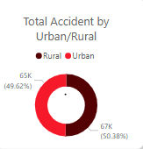

- Accident Count by Days of the Week (Bar Chart):
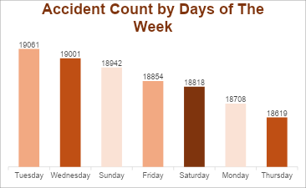

Insight: Tuesday had the highest accident count, followed by Wednesday. Safety campaigns should be targeted during midweek with emergency response team on available at the various hotspots.

- Leading Causes of Road Accidents (Pie Chart):
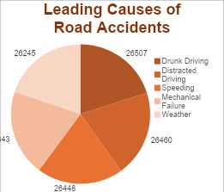

PowerBi
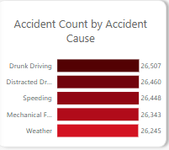

Insight: Drunk driving is the top cause, followed closely by distracted driving and speeding. There is a need to enforce already existing laws on drunk driving and educate the populace on the dangers of drunk driving and other risky behaviours.

- Most Affected Age Group (Bar Chart):
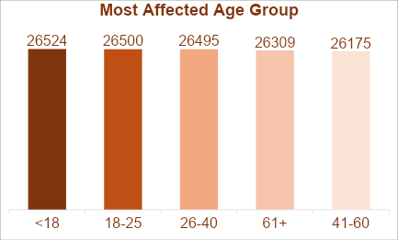

  - Insight: Individuals under 18 are most vulnerable. Driving education and early-age interventions may yield safety benefits.
- Injuries by Weather Conditions (Bar Chart):
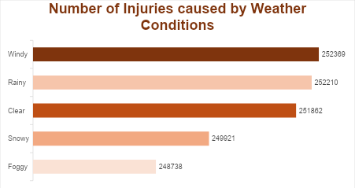

PowerBi
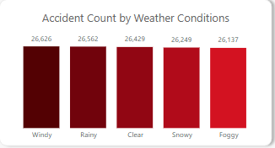
  - Insight: Accidents that happened during Windy and rainy conditions lead to the most injuries. Emergency planning and traffic alerts during such weather should be in place to reduce injuries.

8. Recommendations and Observations

8.1 Actionable Insights:

- Increase Drunk Driving Enforcement:
  - Implement stricter rules, enforce penalties and awareness campaigns, especially in high-incidence countries like Canada.
- Launch Youth Road Safety Programs:
  - Develop and implement school and community initiatives focused on the <18 age group.
- Weather-Responsive Safety Alerts:
  - Deploy real-time hazard warnings and adjust road traffic protocols during windy and rainy weather.
- Urban & Rural Infrastructure Upgrades:
  - Since accidents are evenly split between urban and rural areas, targeted interventions in both regions is necessary.
- Midweek Traffic Monitoring:
  - Focus law enforcement efforts on Tuesdays and Wednesdays, days with the highest accident counts.
8.2 Optimizations or Business Decisions:
- Resource Allocation: It is important that the government redirect funds for awareness campaigns targeting drunk driving and distracted behaviour.
- Insurance Risk Adjustment: Insurance companies can use these patterns to better assess risk and adjust premiums.
- Policy Development: Policymakers should focus on weather-adaptive infrastructure and accident-prone age groups.
8.3 Unexpected Outcomes:
- Windy Weather Impact: Accidents occurring during windy conditions caused the most injuries more than fog, rain, or snow. This can be attributed to the fact that High winds may cause quick visibility loss or affect vehicle control, especially for high-profile vehicles.
- Peak Accidents on Tuesday: Contrary to common assumptions, weekends were not the most dangerous. Routine weekday commutes and higher weekday traffic congestion may be contributing factors.
9. Conclusion

Key Learnings:
- Most of the accidents occur as a result of behavioural issues like drunk and distracted driving.
- Young people (<18) and midweek travel are more prone to accidents.
- Windy weather is surprisingly hazardous and should be given greater attention in safety planning.
Limitations:
Unavailability of data from African Countries. One of the major draw backs of this analysis is the unavailability of data from African countries, which restricts the global representativeness and could cause it to miss important regional patterns and issues unique to the continent.
.
Future Research:
- Expand Geographic Scope: Include more diverse datasets, particularly from underrepresented regions like Africa, to improve global validity.
- Time-Based Analysis: Integrate accident timing (hour of the day) to identify peak accident periods more precisely.

- Severity Analysis: Further classify injury levels and economic costs to support insurance modeling and healthcare planning.

- Intervention Impact Studies: Evaluate how road safety policies or awareness campaigns have affected accident trends in specific regions.

REFERENCES:
Dataset Used: https://www.kaggle.com/datasets/ankushpanday1/global-road-accidents-dataset
Tools Used: Microsoft Excel, PowerBi
Final Dashboard Using Microsoft Excel:

Final Dashboard Using PowerBi

