Evidence screenshots
AUCA Big Data Analytics, Final Project: Distributed Multi-Model Analytics for E-commerce Data
Student: ODILE UMWIZA, ID 101365. Screenshots are in project order; each one is also stored as a PNG in the screenshots folder of the repository.

Setup and data generation
Figure 1. Machine check: 8,056 MB RAM and Docker 29.8.1
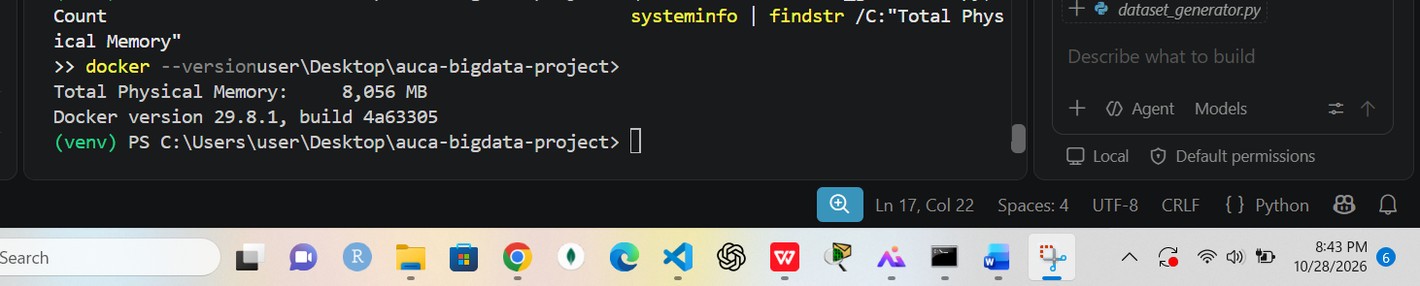
Supports: Environment used (8 GB laptop), explains why the dataset was reduced
Figure 2. Dataset generation finished: 200,000 sessions and 50,000 transactions
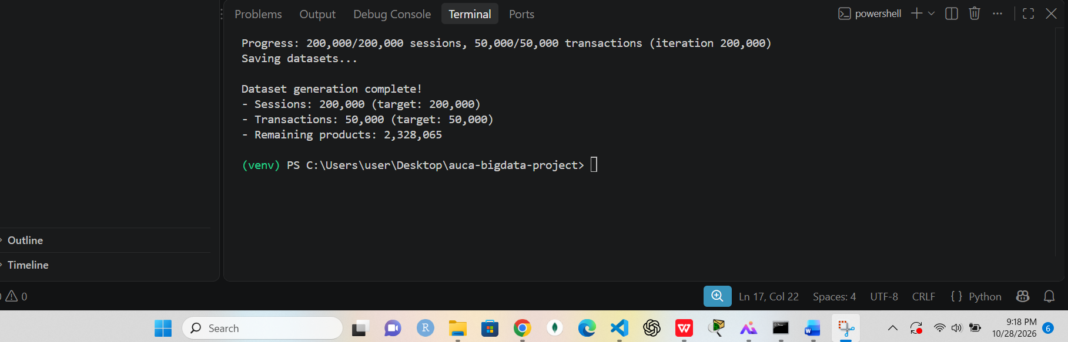
Supports: Dataset created with the lecturer's generator
Figure 3. Generated files and their sizes (about 400 MB, sessions are 94%)
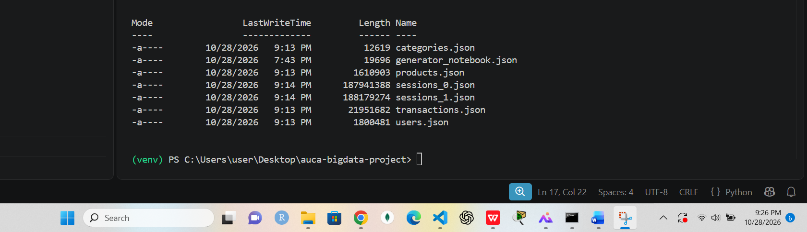
Supports: Data volume; sessions dominate, so they go to HBase and Spark
Figure 4. One real session document (nested page_views, cart_contents)
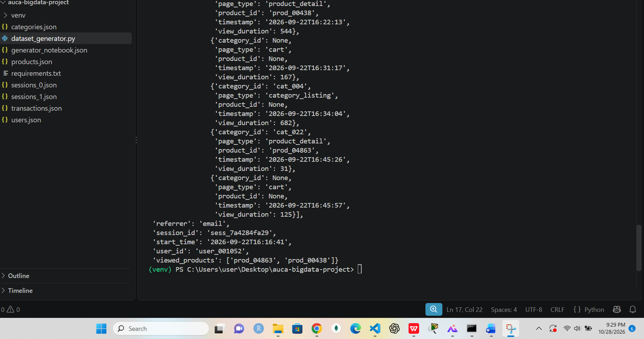
Supports: Nested structure that motivates the schema choices

MongoDB (document model)
Figure 5. MongoDB 7 image downloaded with Docker
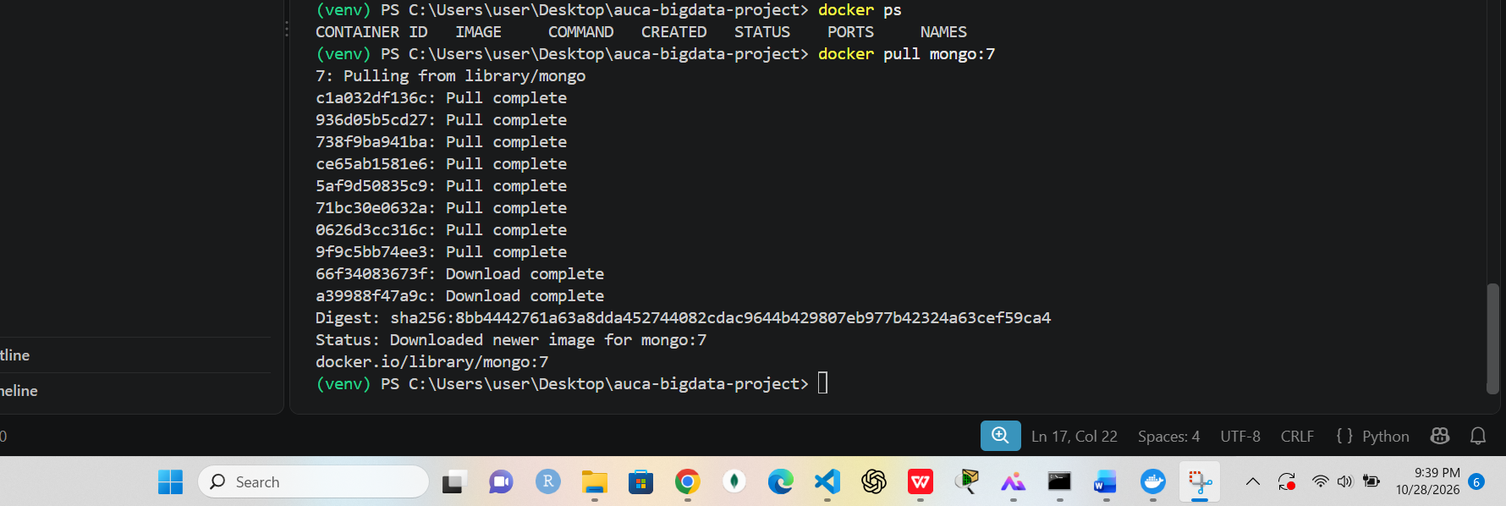
Supports: MongoDB setup
Figure 6. First MongoDB container, mapped to port 27017 (before the port conflict was found)
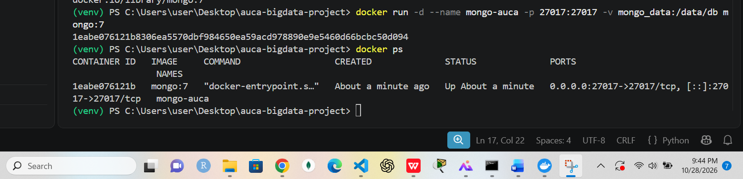
Supports: Lesson learned: port 27017 was also used by a local MongoDB
Figure 7. MongoDB 7.0.45 answers ping ({ ok: 1 }) from the shell
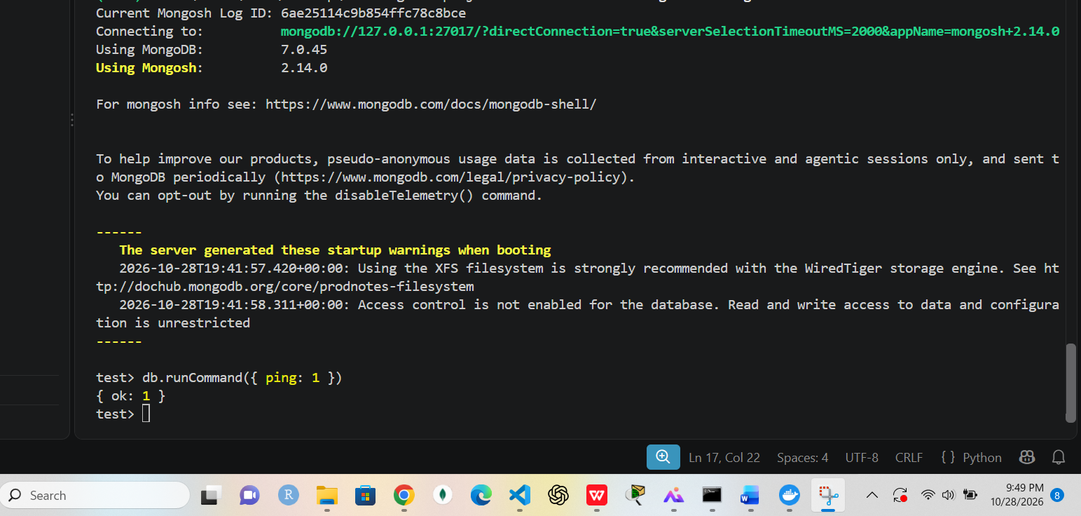
Supports: MongoDB running
Figure 8. Loader output: 25 / 5,000 / 10,000 / 50,000 / 20,000 documents (first run, before the port fix)
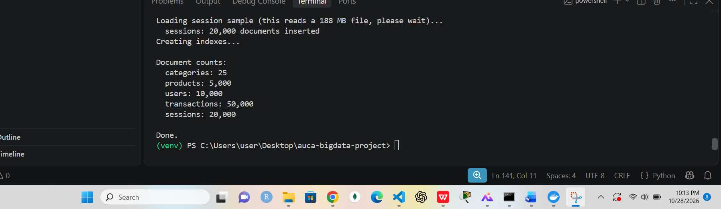
Supports: Load counts; this run went to the local MongoDB, the Docker load was verified in figures 10 and 11
Figure 9. MongoDB container recreated on port 27018
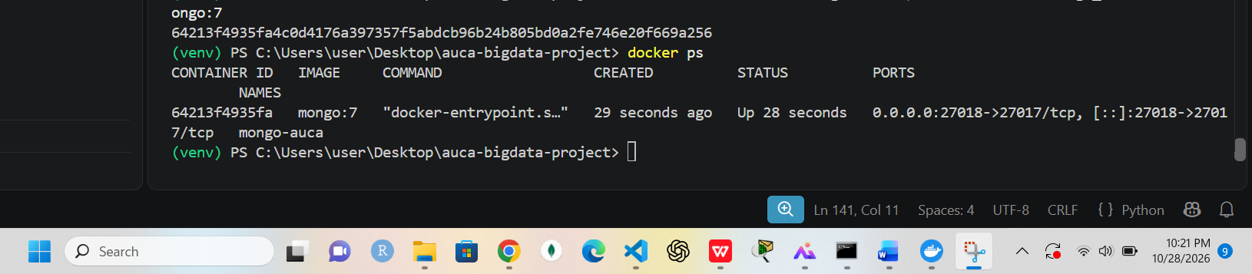
Supports: Port conflict fixed
Figure 10. A transaction document with its items embedded (Docker MongoDB)
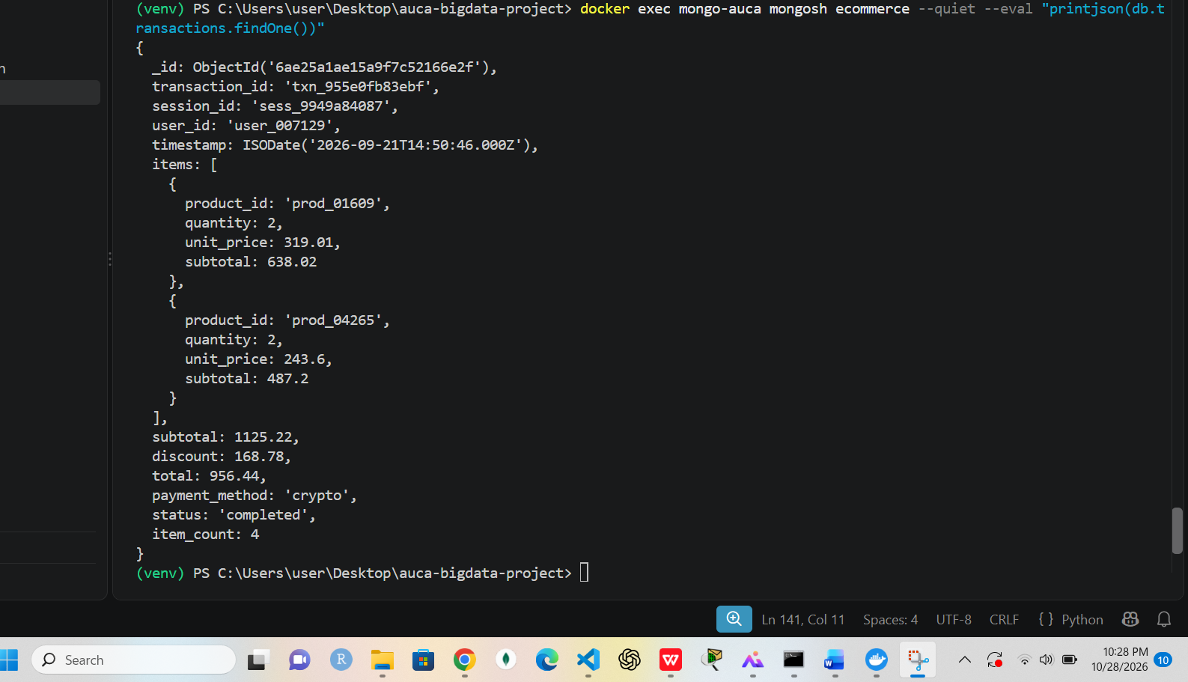
Supports: Embedded line items design
Figure 11. A user document with the computed purchase summary (Docker MongoDB)
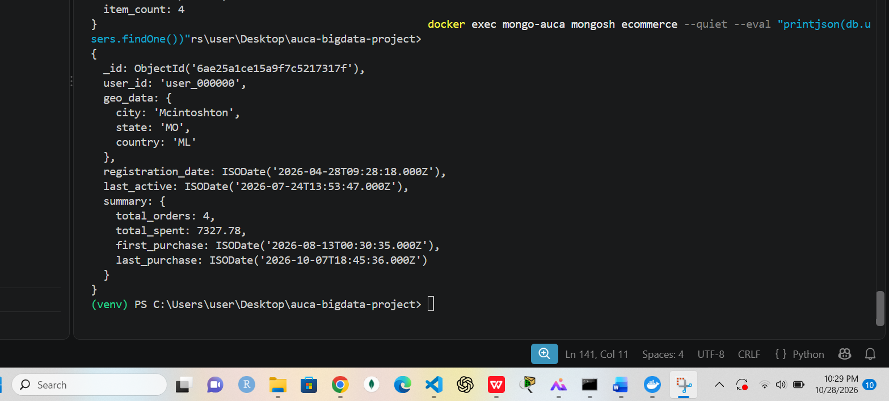
Supports: Computed pattern: total_orders, total_spent, first/last purchase
Figure 12. Aggregation pipeline 1: revenue by category
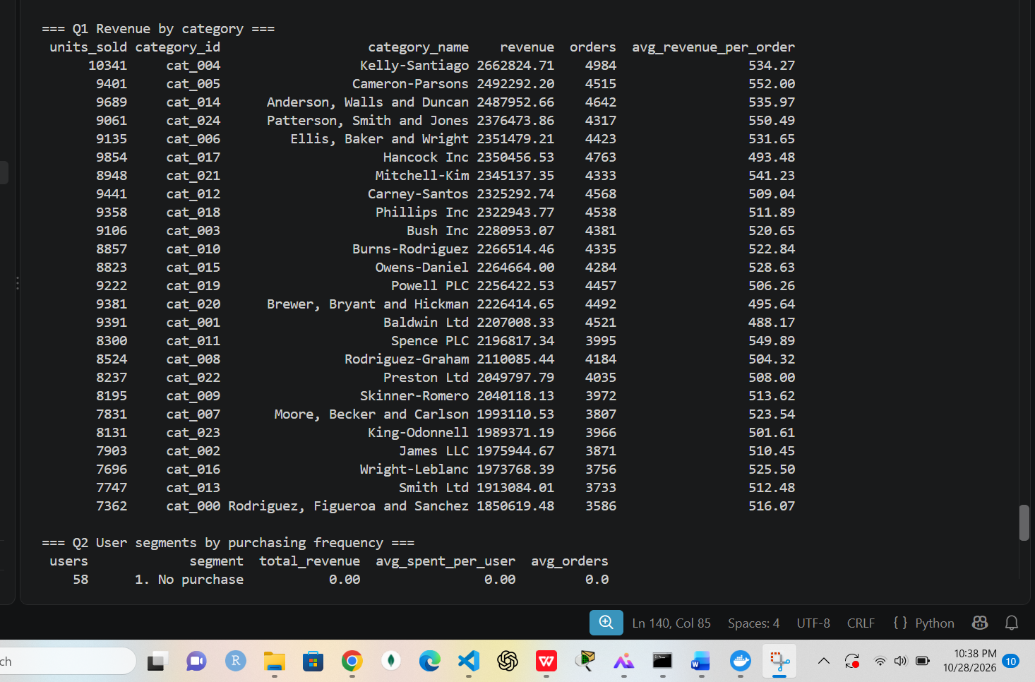
Supports: Non-trivial aggregation ($unwind, $lookup, $group)
Figure 13. User document with summary (second view, duplicate of figure 11)
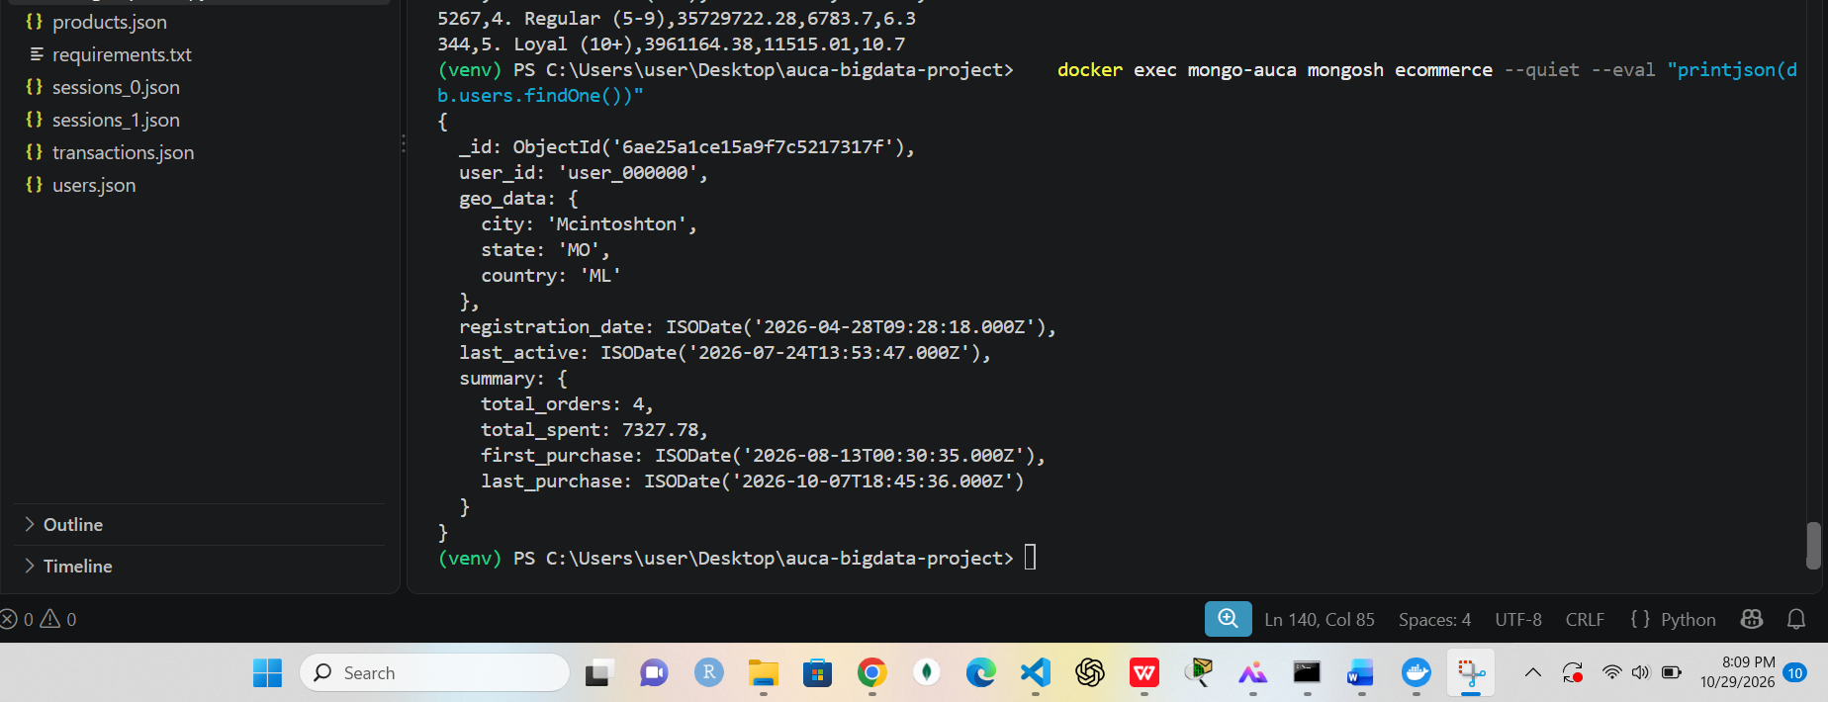
Supports: Optional duplicate
Figure 14. Pipelines 2 and 3 (user segments, top products) and the index demonstration
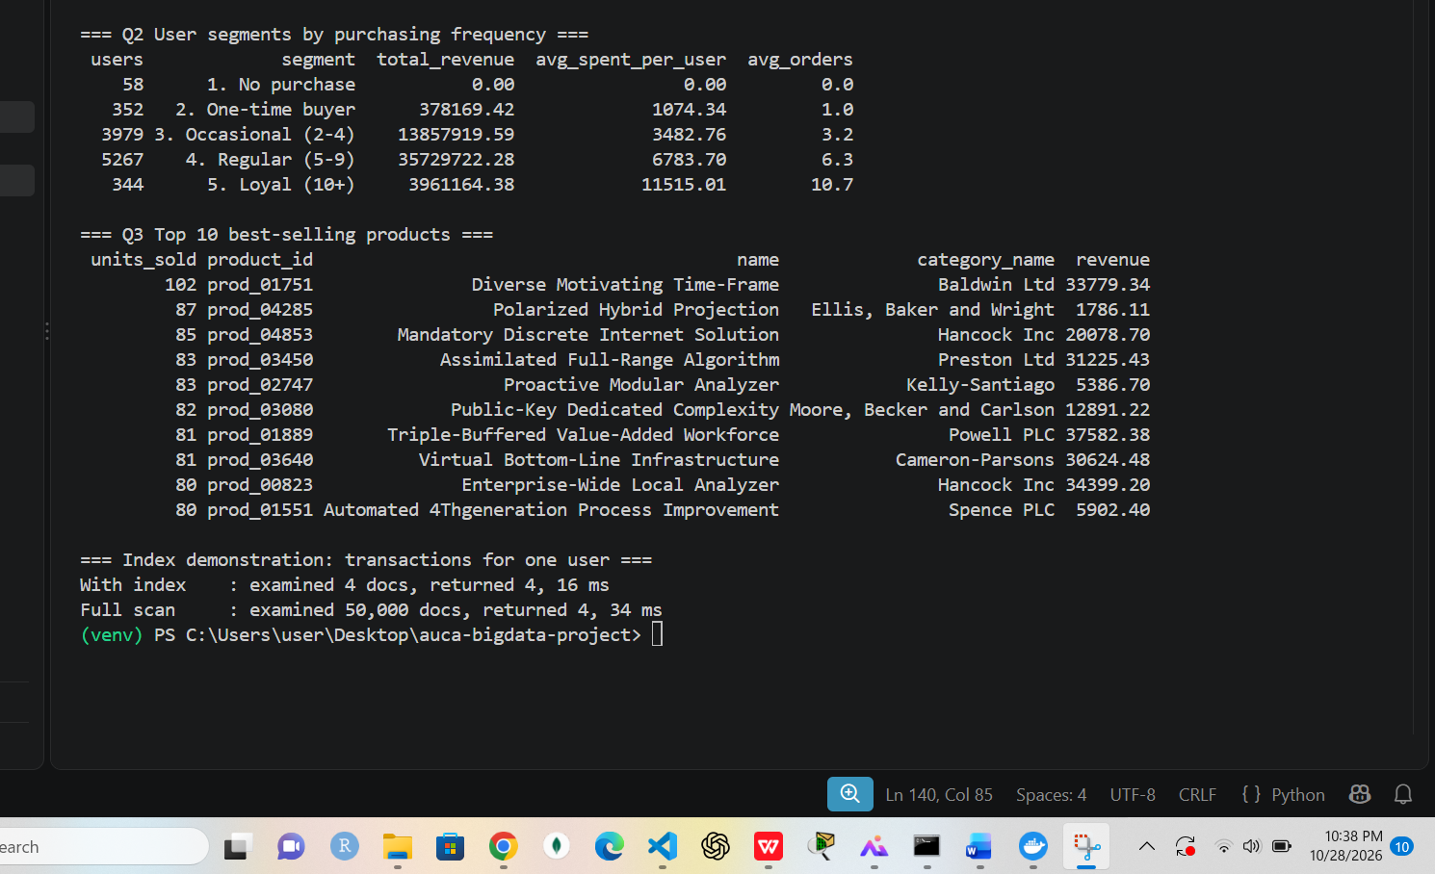
Supports: Index: 4 documents examined instead of 50,000

HBase (wide-column model)
Figure 15. HBase 1.4 image downloaded (ports 9090 and 16010 checked free first)
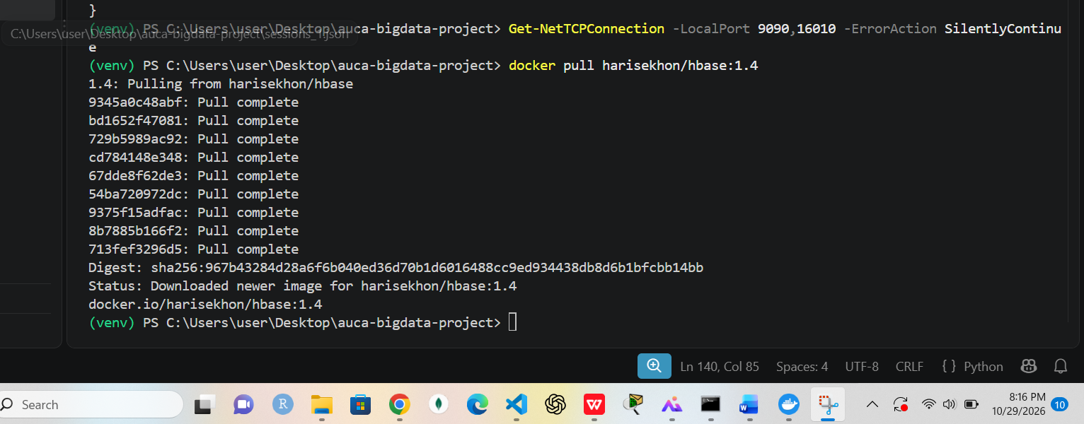
Supports: HBase setup
Figure 16. Both containers running: HBase and MongoDB
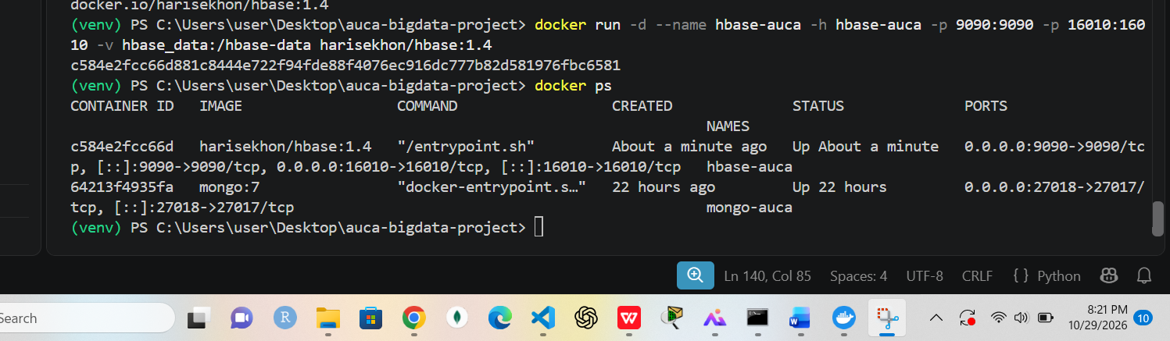
Supports: Both databases up
Figure 17. HBase shell 1.4.7: 1 active master, 0 dead, 1 server
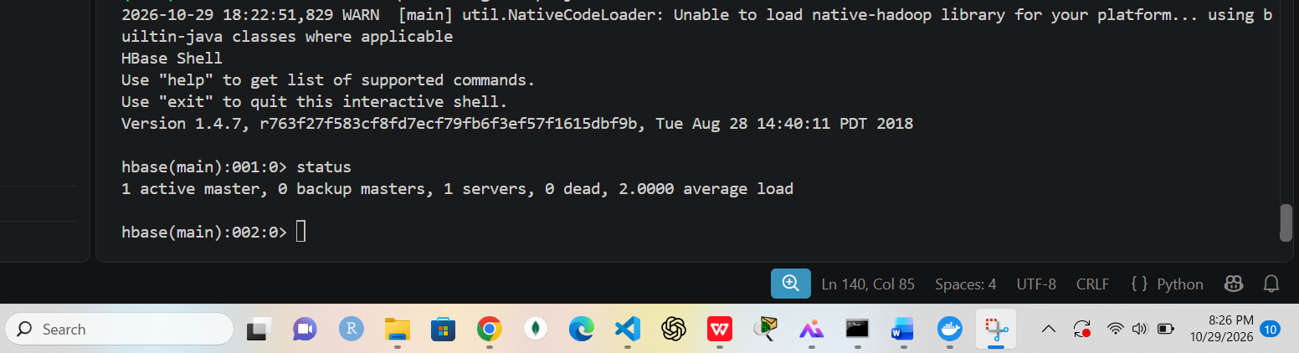
Supports: HBase healthy
Figure 18. Tables user_sessions and product_daily created
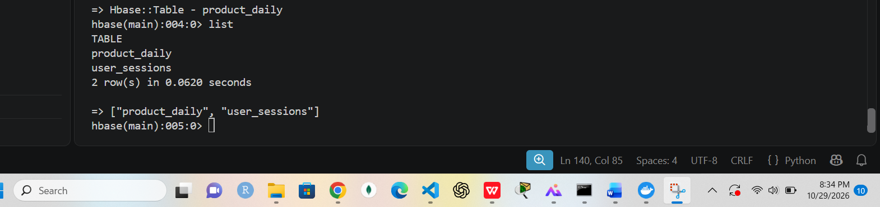
Supports: HBase schema in place
Figure 19. describe user_sessions: column families cart, info, pv
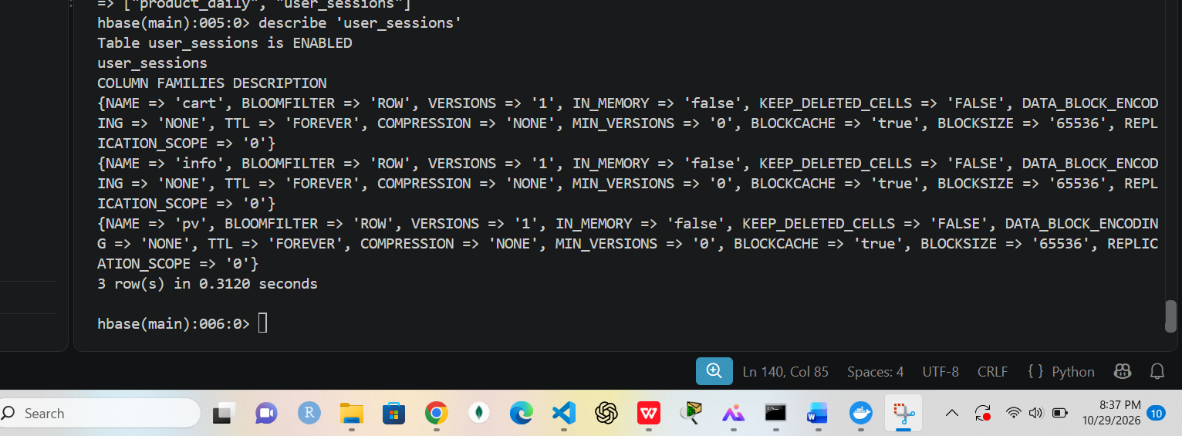
Supports: Column-family design
Figure 20. HBase load: 50,000 sessions and 142,040 product_daily rows
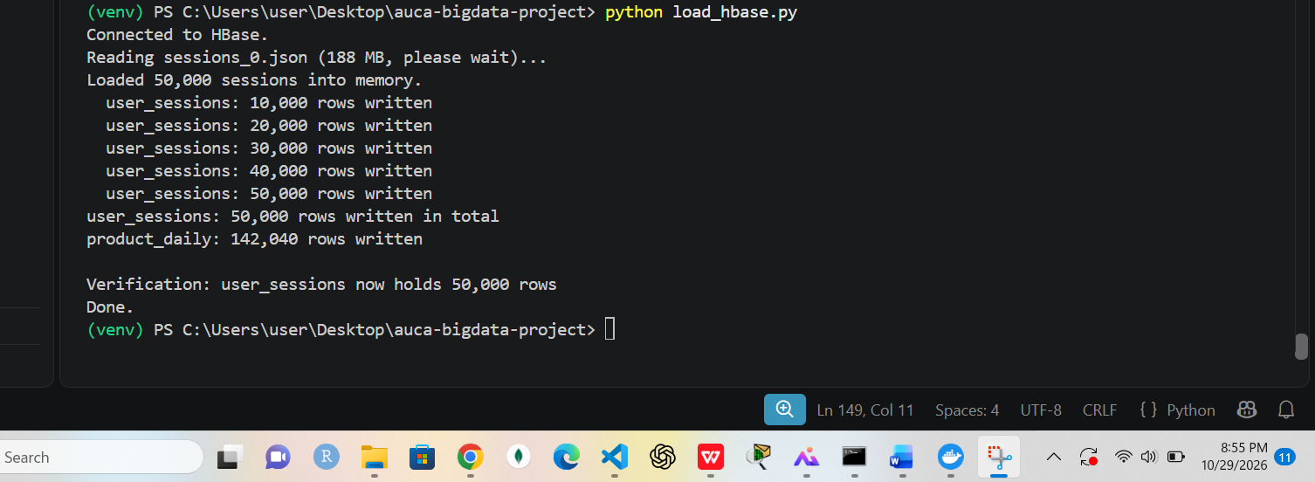
Supports: Sessions loaded into HBase
Figure 21. HBase queries Q1 to Q4: latest sessions, page views, time window, family pruning
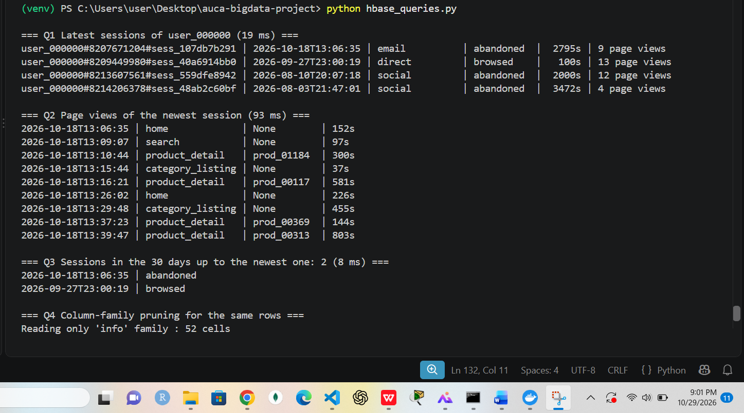
Supports: Prefix scan, wide row, range scan
Figure 22. HBase queries Q4 and Q5: 52 vs 94 cells; product metrics for September
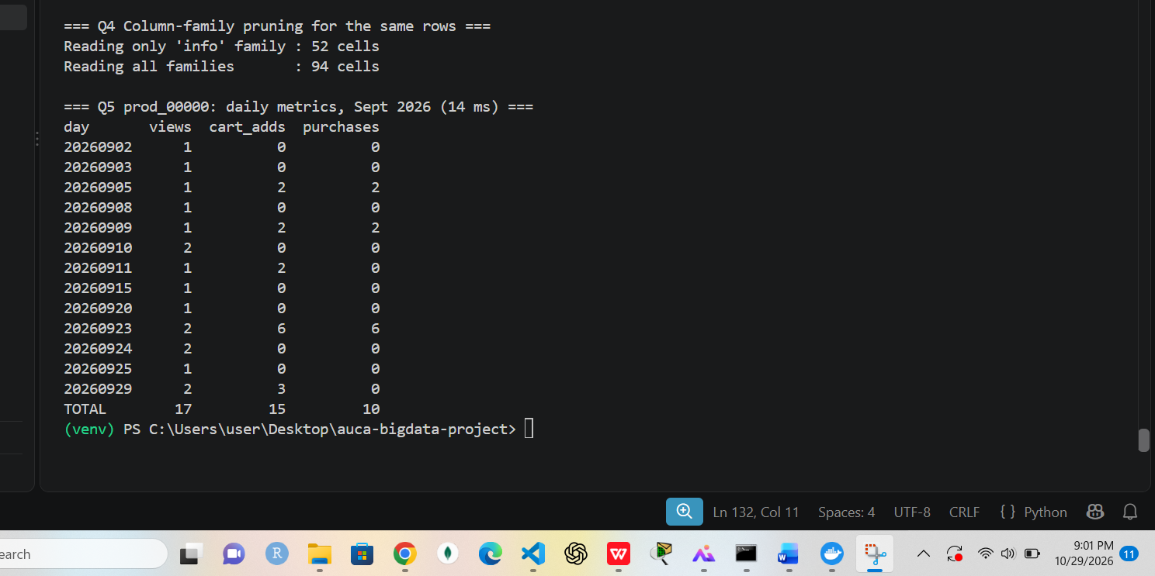
Supports: Family pruning; product time series
Figure 23. HBase shell prefix scan for one user (info family only)
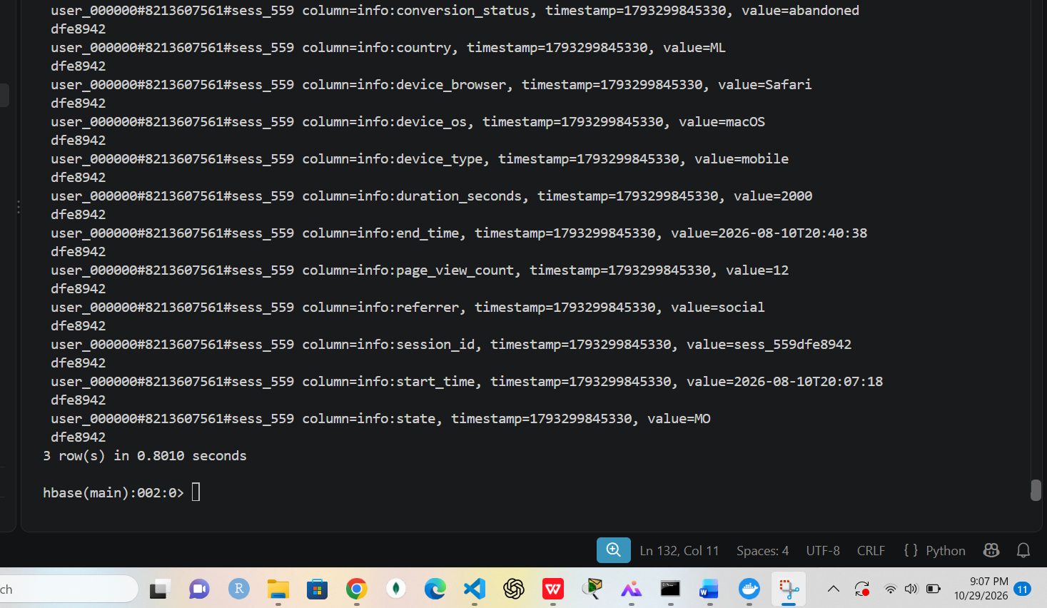
Supports: Shell query example
Figure 24. HBase shell count: 50,000 rows
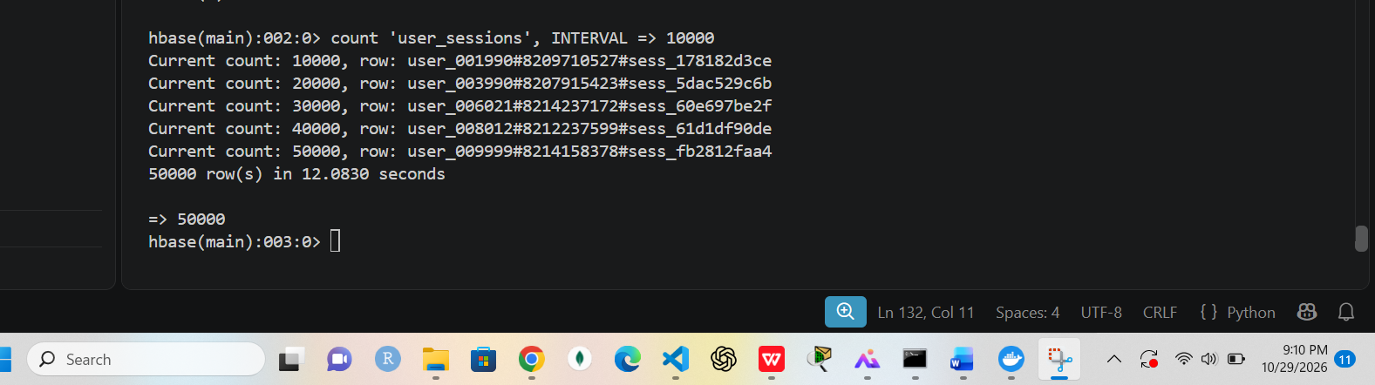
Supports: Row count matches the loader

Apache Spark: cleaning and data quality
Figure 25. Spark 3.5.9 running in local mode
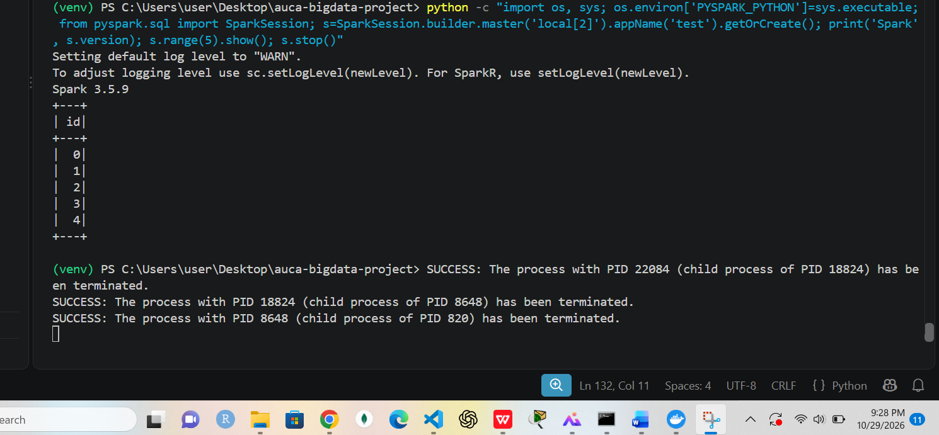
Supports: Spark setup
Figure 26. Conversion of JSON arrays to JSON Lines (400,000+ records)
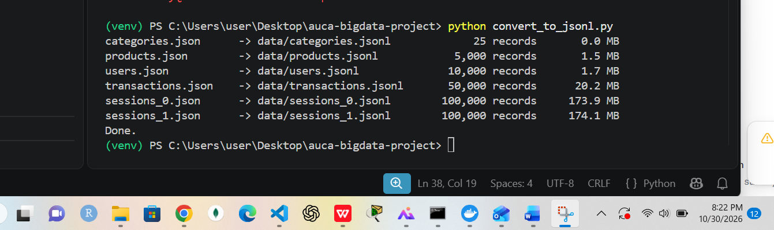
Supports: Optimization: splittable input for Spark
Figure 27. Data quality report, part 1
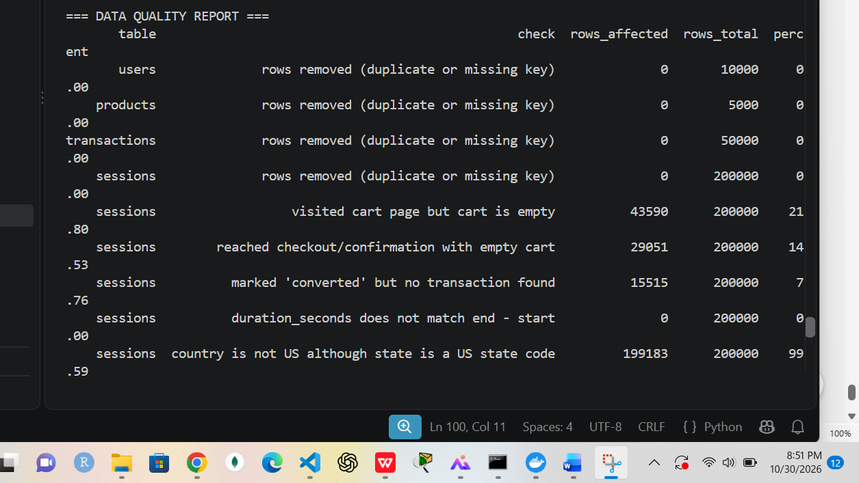
Supports: Cleaning job output
Figure 28. Data quality report, part 2
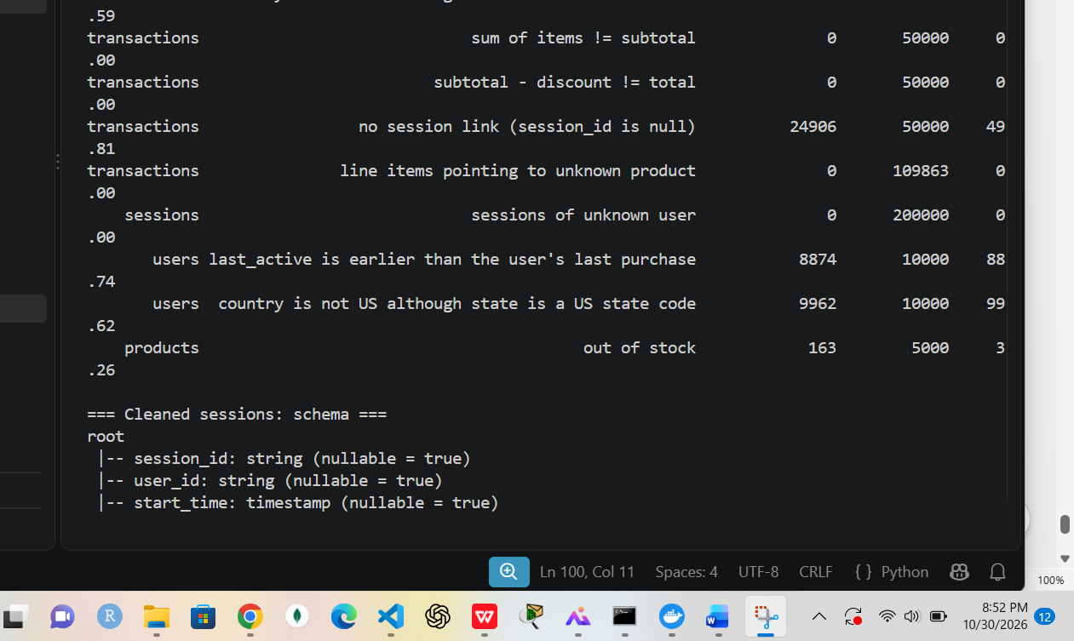
Supports: Quantified data problems
Figure 29. Cleaned sessions schema, part 1
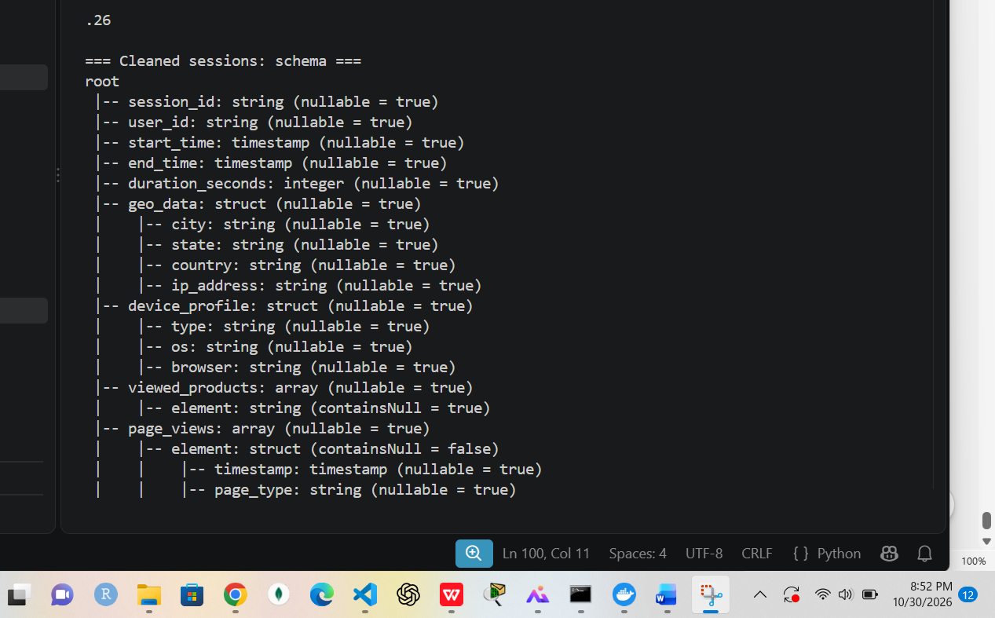
Supports: Typed, normalized data
Figure 30. Cleaned sessions schema, part 2 (flag columns)
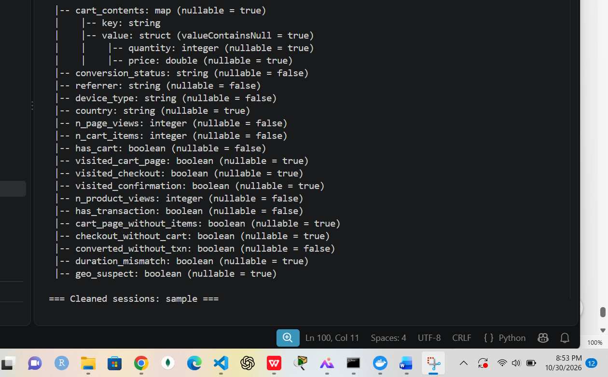
Supports: Flag, don't delete
Figure 31. Cleaned sessions sample
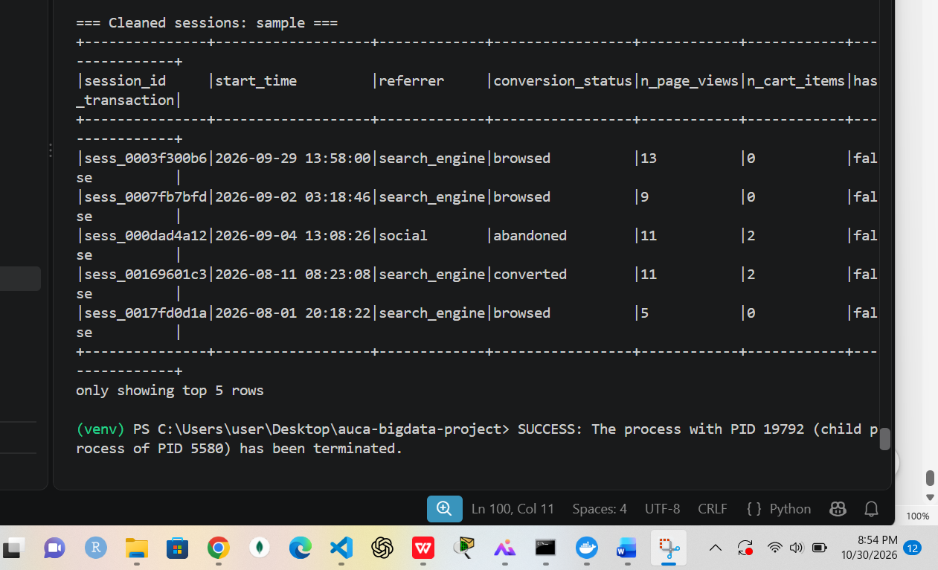
Supports: Cleaning result

Apache Spark: recommendations and Spark SQL
Figure 32. Co-viewed products: observed pairs vs random baseline
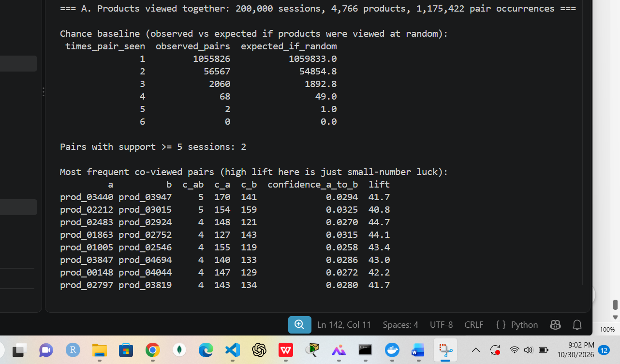
Supports: Recommendation indicators with validation
Figure 33. Category affinity (relative lift) and start of recommendations
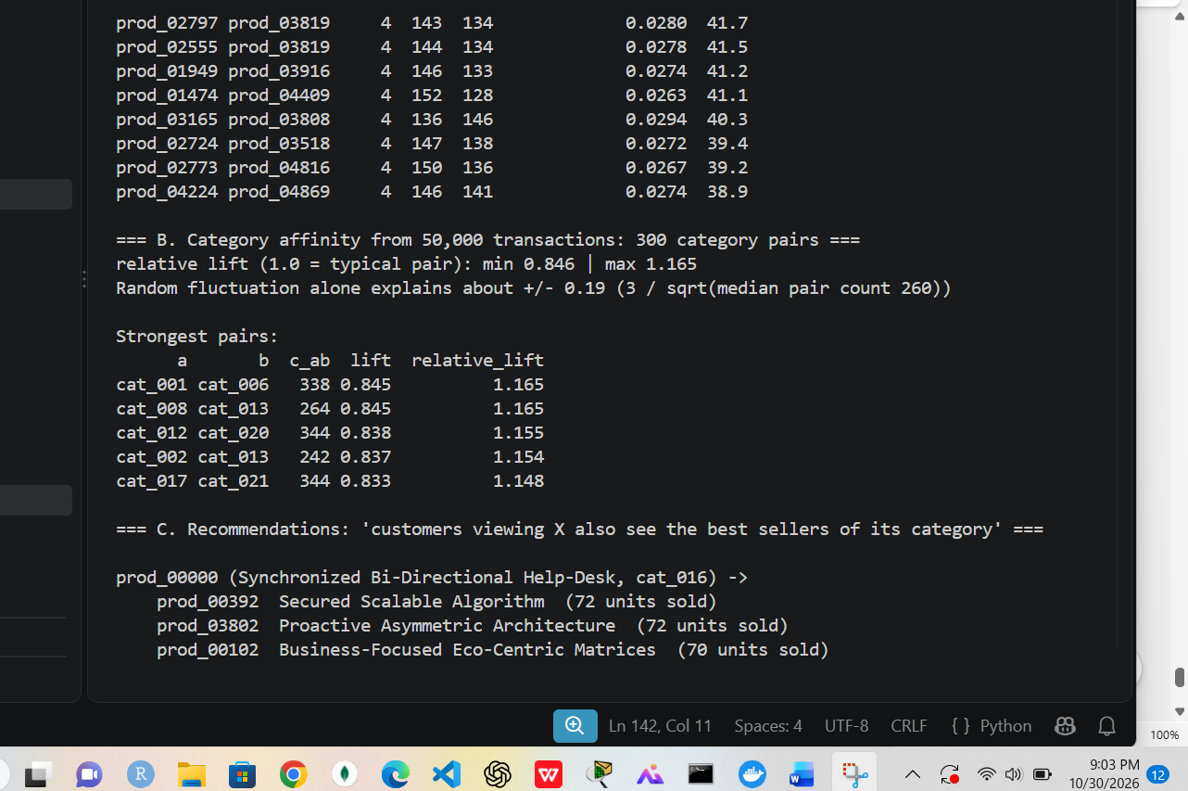
Supports: No category pair beyond random noise
Figure 34. Category best-seller recommendations
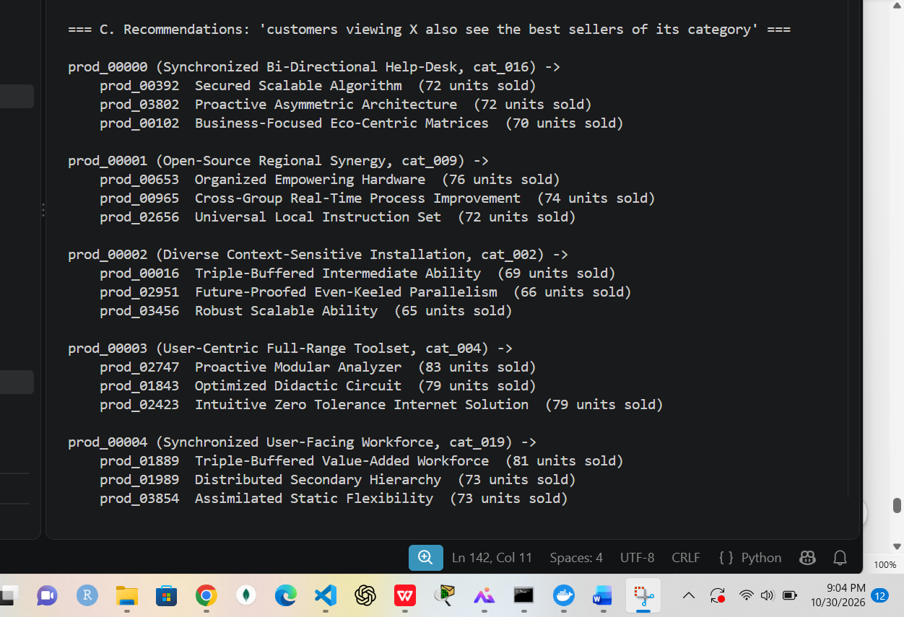
Supports: Fallback recommender
Figure 35. Spark SQL Q1: monthly revenue with per-day growth
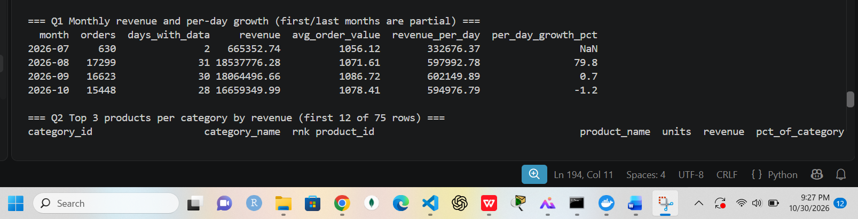
Supports: SQL with window functions
Figure 36. Spark SQL Q2: top 3 products per category
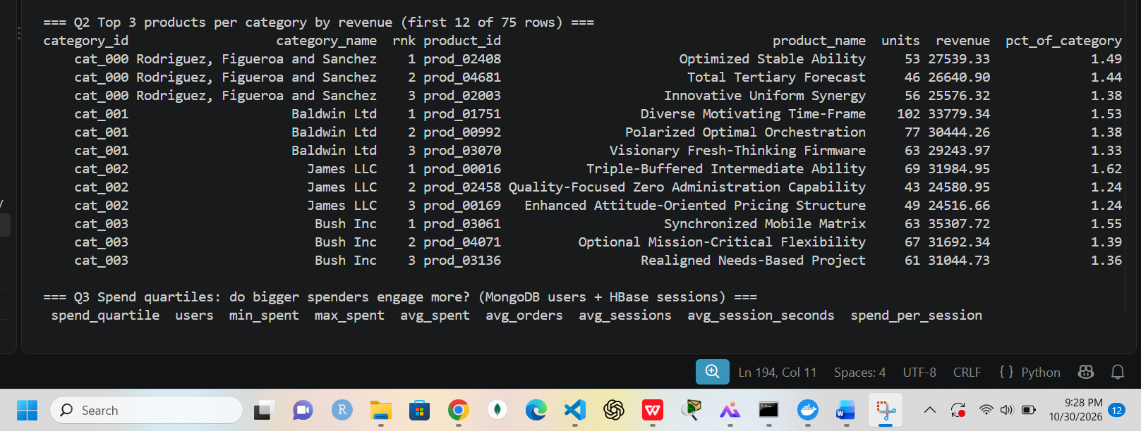
Supports: RANK and SUM OVER
Figure 37. Spark SQL Q3: spend quartiles vs engagement
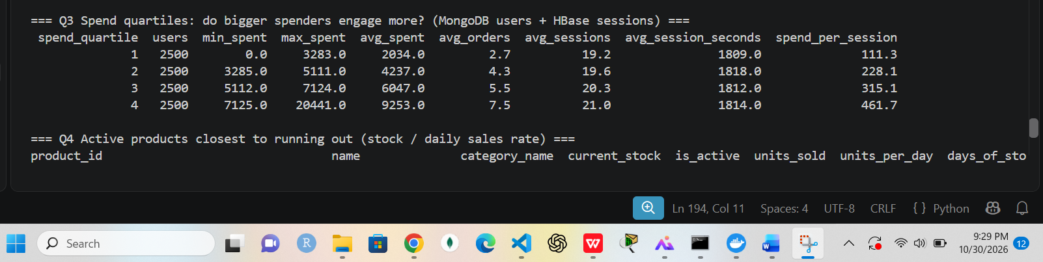
Supports: MongoDB-style users joined with HBase-style sessions
Figure 38. Spark SQL Q4: active products already out of stock, ranked by demand
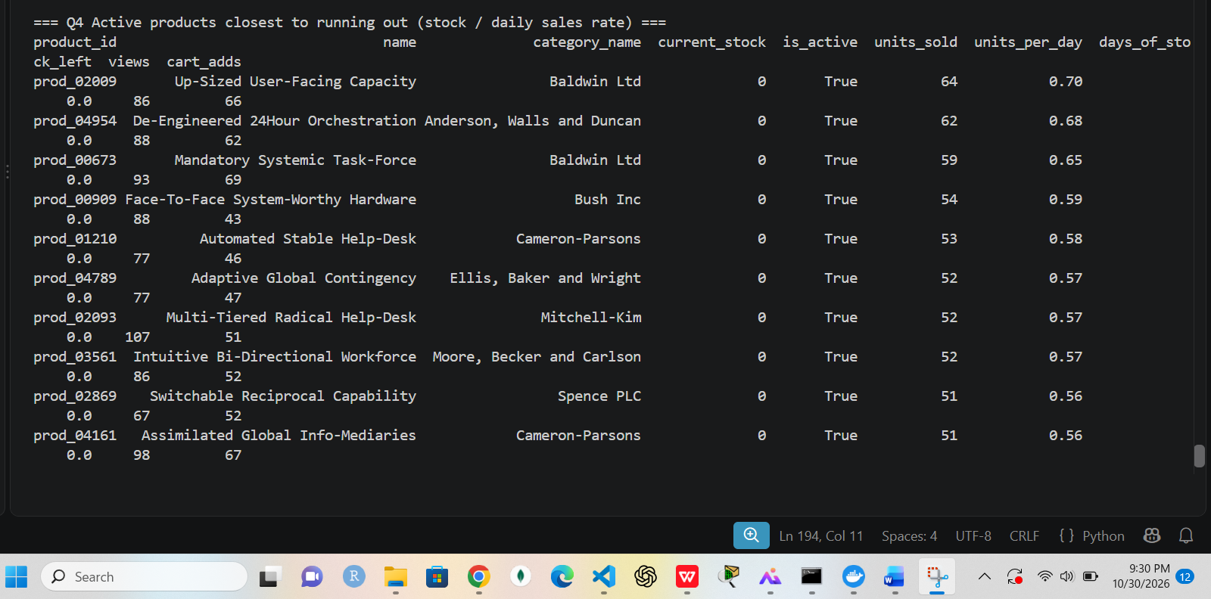
Supports: Three-way join
Figure 39. Spark SQL Q5: cohort analysis by registration month
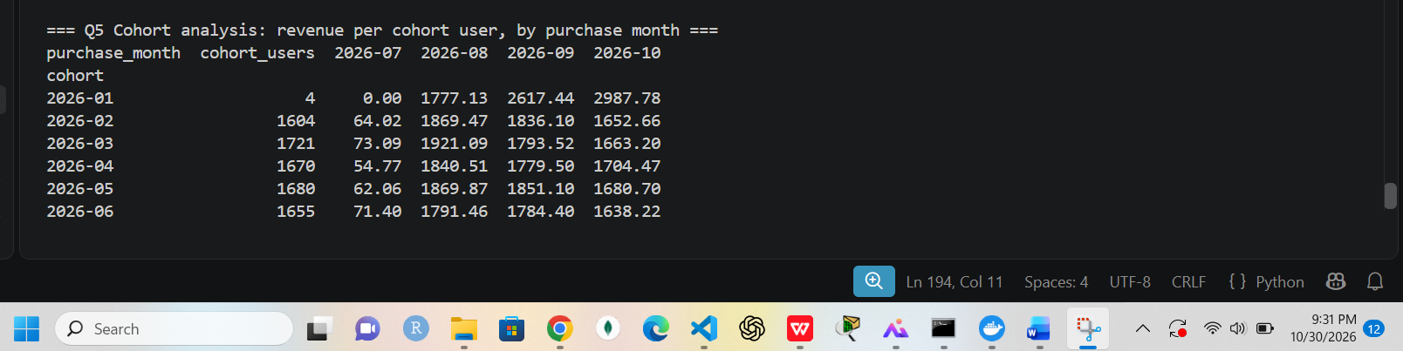
Supports: Cohort matrix

Persistence, integrated analysis and charts
Figure 40. HBase queries after restarting both databases (same results)
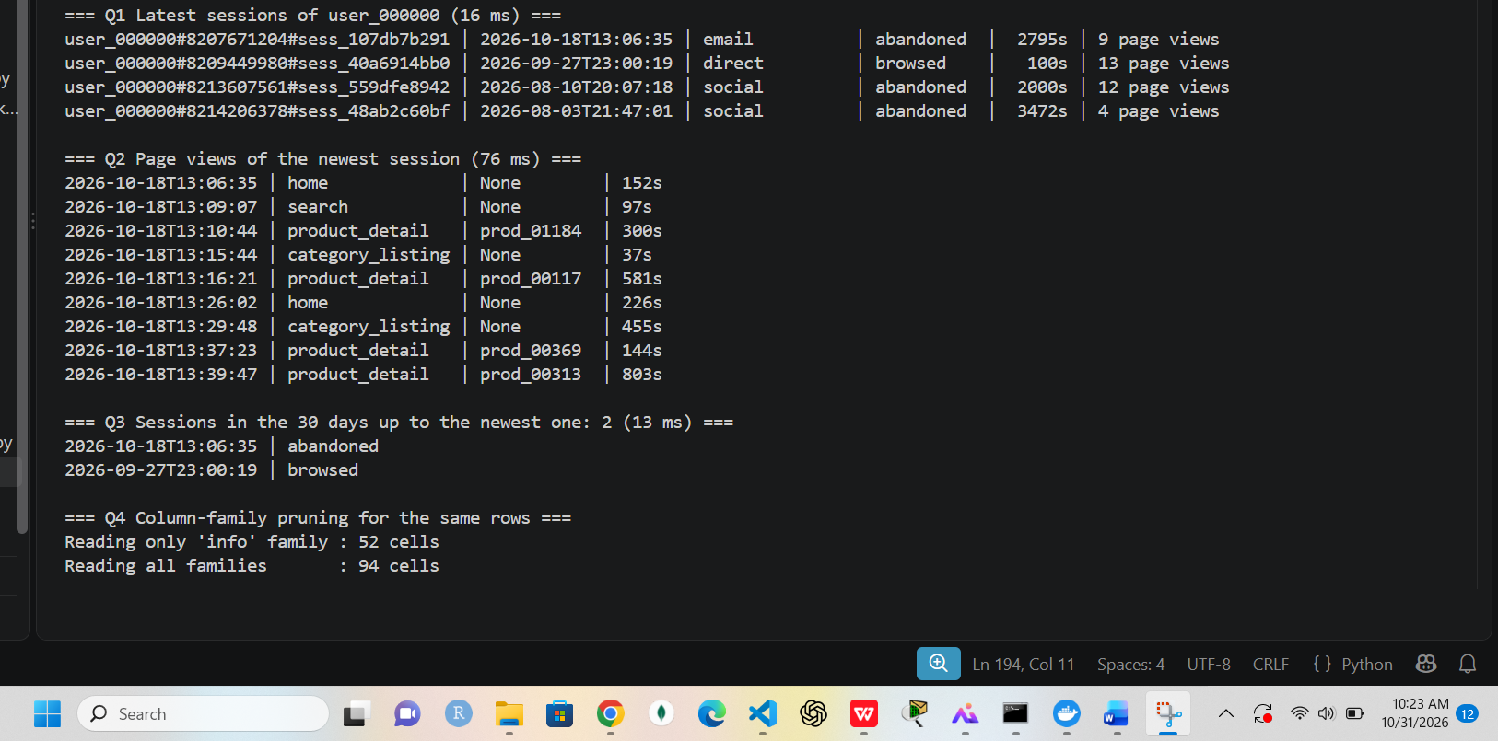
Supports: Data persistence across restarts
Figure 41. HBase queries after restart, continued
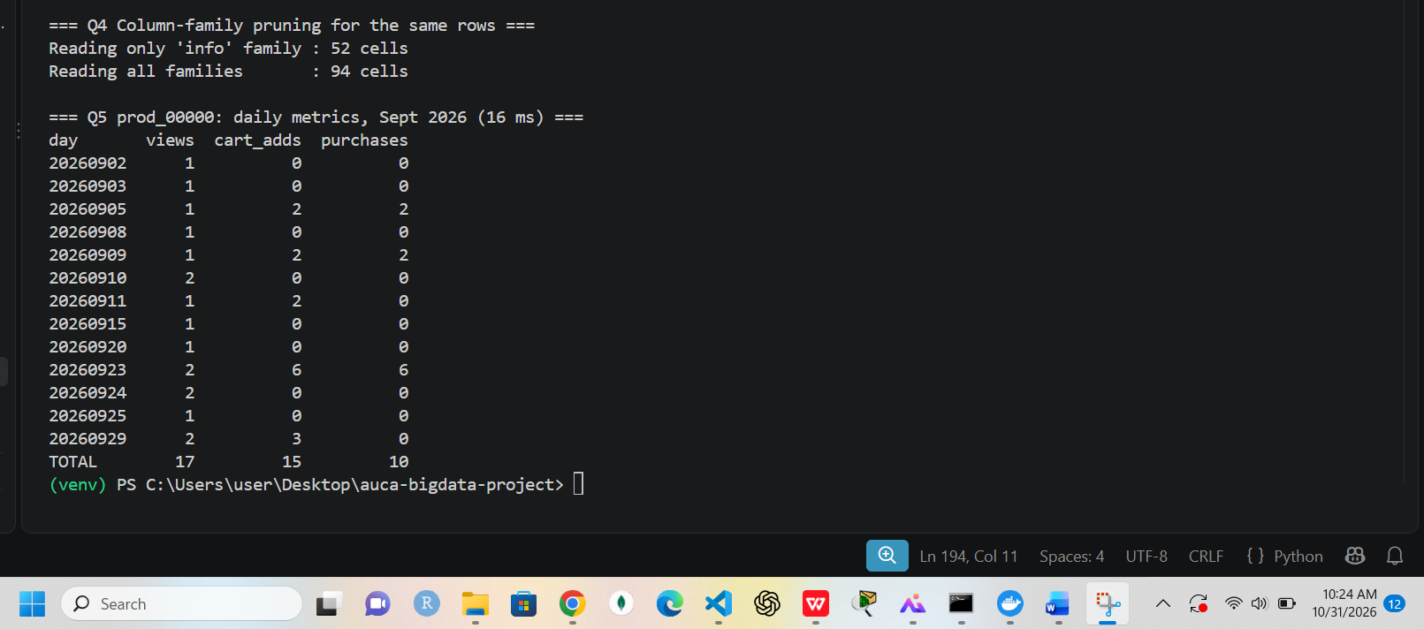
Supports: Persistence
Figure 42. Integrated funnel (HBase + MongoDB + Spark): integrity check and overall funnel
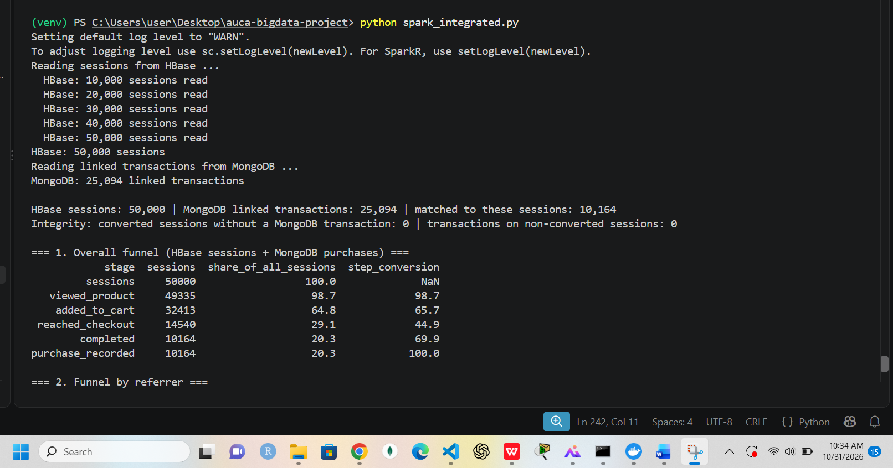
Supports: Part 3 integrated query
Figure 43. Funnel by referrer and device, abandoned carts, cross-check with all sessions
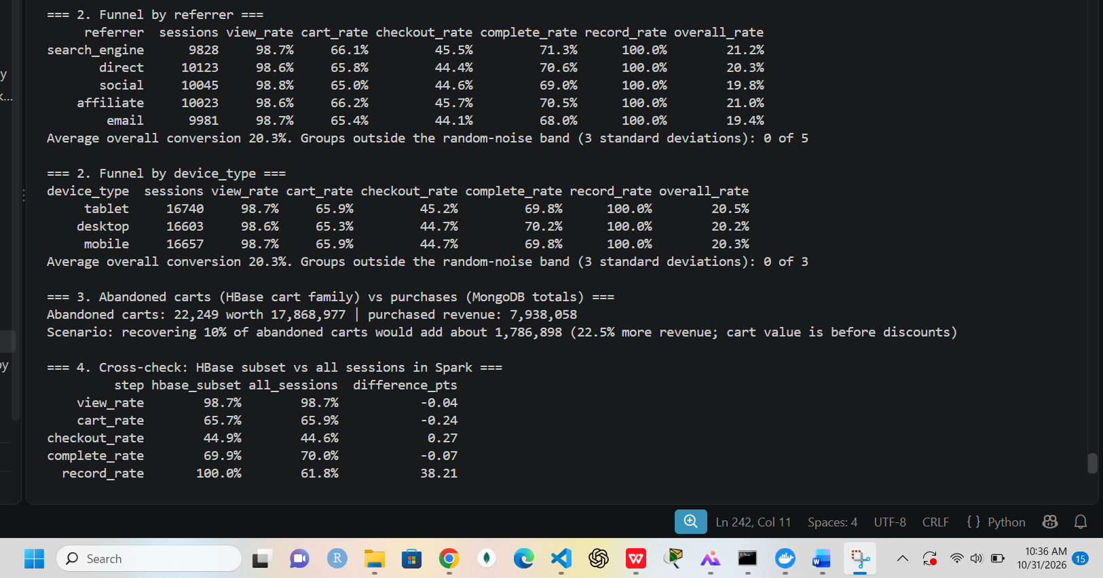
Supports: Part 3 results and validation
Figure 44. Chart generation: five PNG charts saved
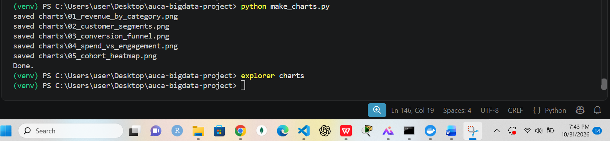
Supports: Part 4 visualizations

