# 第十三次周报

## 这两周工作内容

### 阅读的文献

* 《Physically Interpretable Wavelet-Guided Networks With Dynamic Frequency Decomposition for Machine Intelligence Fault Prediction》

重新仔细阅读了该论文，深入其数学推导中，该模型将多分辨率小波分解集成到CNN中，输入信号经过Mallat算法。。。

### 上周投的论文审稿意见如下：

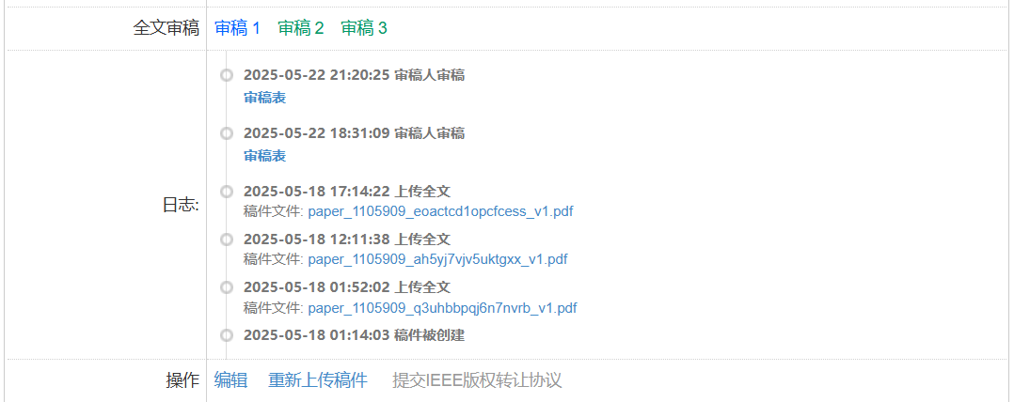

审稿2：

(1) The thesis is carefully formatted according to the given template, such as the table examples.

(2) Some parts (such as the mathematical derivation of QCNN and the description of multi-scale design) are too lengthy and not concise enough. Please simplify them.

(3) Although the conclusion section summarizes the research results, the discussion on the future research direction is rather general and lacks specificity.

审稿3：

1、Figure font is too small, poor clarity, poor readability.

2、The data precision of Table 3 is inconsistent, and it is suggested to be unified as 0.01%.

3、Figure format and reference format are carefully modified according to the template file.

In conclusion, the overall quality of the paper is high, and the method is innovative and practical application value. It is recommended that the authors accept the paper after minor revision.

## 遇到的问题

### 2.1 对Mallat算法的具体数学推导不熟悉，仅会使用。

## 收获与启发

### 3.1 可

## 下两周计划

### 4.1 继续阅读轴承故障预测物理可解释性相关文献。

### 4.2 尝试将小波分解等信号处理技术融合进深度学习模型，为深度学习模型提供物理支撑。