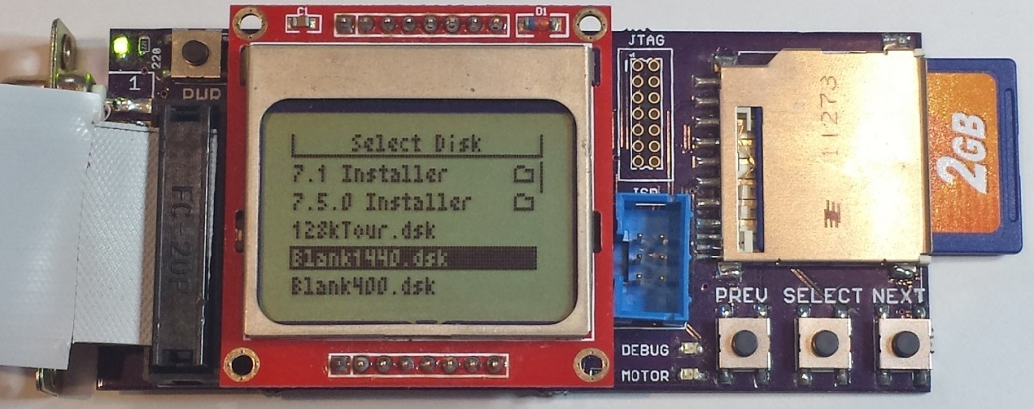

Floppy Emu is a prototype floppy disk drive emulator for classic Macintosh computers. It uses an SD memory card and custom hardware to mimic a 400K, 800K, or 1.4MB 3.5 inch disk drive and floppy disk. Floppy Emu plugs into the Mac’s external or internal floppy drive connector, and behaves exactly like a real disk drive, requiring no special software on the Mac.

**Compatibility**

This is experimental hardware, so expect some bugs. Floppy Emu should work with any classic Macintosh from the original 128K to the Power Macintosh series and beyond, though not every Mac model has been tested. For Macs without an external floppy port, you can unplug the internal floppy drive and connect Floppy Emu in its place. Some older Mac models (Mac Plus and earlier) aren't designed to use 1.4MB disks, and will be limited to 400K and 800K disk images. The full source code is available for download, so if you’re a programmer, you can help improve the software and add new features.

**Requirements**

You’ll need an SD or SDHC card that’s fast when transferring small data blocks. A lower capacity card will normally perform better for small transfers. A card with a capacity of 2 GB or less is recommended.

It's not required, but you may want a DB-19 to IDC-20 extension cable, such as this cable from IEC:

<http://www.iec-usa.com/cgi-bin/iec/L1561>

You’ll also need a collection of Macintosh floppy disk images. A small number of sample disk images are available at: <http://www.bigmessowires.com/mac-disk-images.zip>

**Usage**

When it’s turned on, the Floppy Emu scans the SD card for files with a .dsk, .img, or .image extension, and shows a menu of available disk images. Use the PREV/NEXT buttons to select a disk image file, then press the SELECT button to insert it into the emulated disk drive. After the disk is inserted, the LCD display shows the current track number and active side of the drive.

The Floppy Emu expects 400K, 800K, or 1.4MB disk images in either raw format (the .dsk images typically used with Macintosh emulators), or DiskCopy 4.2 .image format. Raw image files support reading and writing to the emulated floppy disk. DiskCopy 4.2 images are read-only.

Floppy Emu supports normal sector-by-sector writing, such as copying files in the Finder, or saving data from within a program. It does not support formatting the emulated floppy, or using it with format-and-write disk copy tools. If you need a blank disk image file, create one on your PC and then copy it to the SD card.

If the Floppy Emu appears to be malfunctioning, press the RESET button. There's no eject button, because the Mac OS handles disk ejection through software. To eject a disk, use the Macintosh Finder 's "Eject" menu item in the File menu, or drag the disk icon onto the Trash icon.

**More Info**

For the latest Floppy Emu information, visit the Big Mess o' Wires website at: http://www.bigmessowires.com/macintosh-floppy-emu

**FAQ**

* Can I boot from an emulated floppy? *Yes you can!*
* Does this require a special driver or INIT on the Mac? *No, nothing special is required.*
* What types of disk image files are supported? *400K, 800K, or 1.4MB disk images in raw .dsk format or DiskCopy 4.2 .image format.*
* Can I write to the emulated floppy, as well as read from it? *Yes, with raw .dsk images. DiskCopy 4.2 images are read-only.*
* What if my SD card is too slow? *Reading will work, but writing may fail.*
* Can I format the emulated floppy, or use it with disk copy programs that format and write? *No. Floppy Emu emulates “normal” sector-by-sector writing, such as copying files in the Finder, or saving data from within a program.*
* Can I emulate multiple floppies at once? *Floppy Emu can store as many disk image files as your SD card will hold, but only one can be “inserted” in the drive at any given time.*
* Can I save Mac files to the emulated floppy, then put the SD card in my PC to read them back? *Yes. Your files will be inside the disk image. A disk image tool like HFVExplorer or a software-based Mac emulator can extract individual files from the image.*