**PART I**

**Question 1**

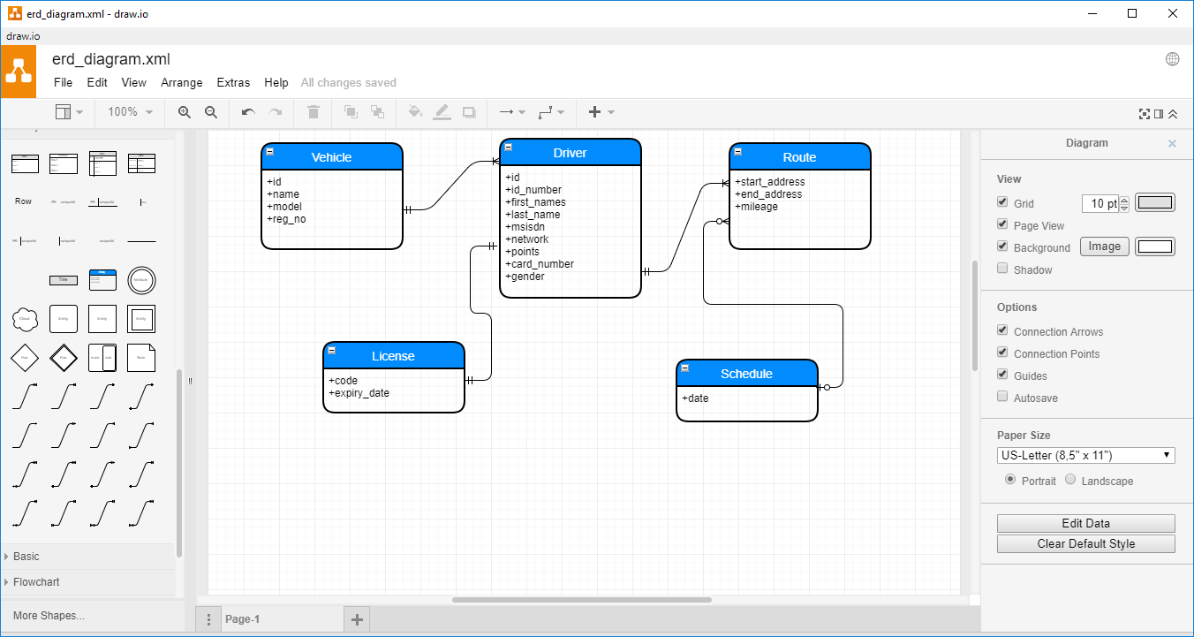

**Question 2**

* Link to gradle project
* Go to ../resource/db/migration directory to see flyway scripts from the gradle project above.

**Question 3**

* Commands to execute read from the file and insert into the user table.

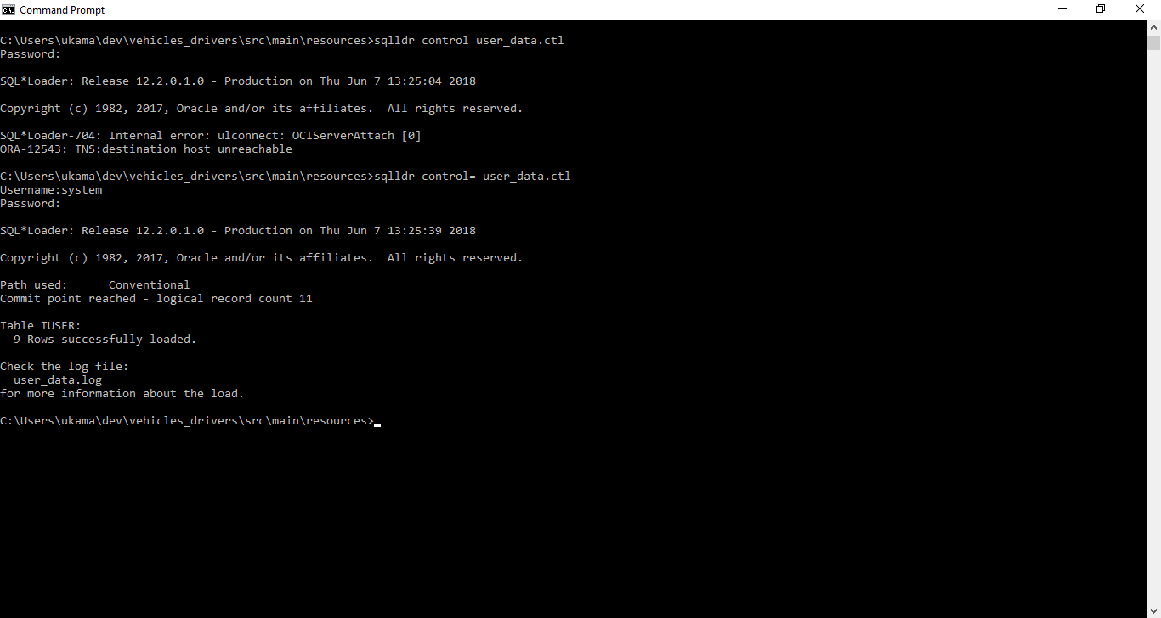

* Screen shot to verify what comes back from the DB.

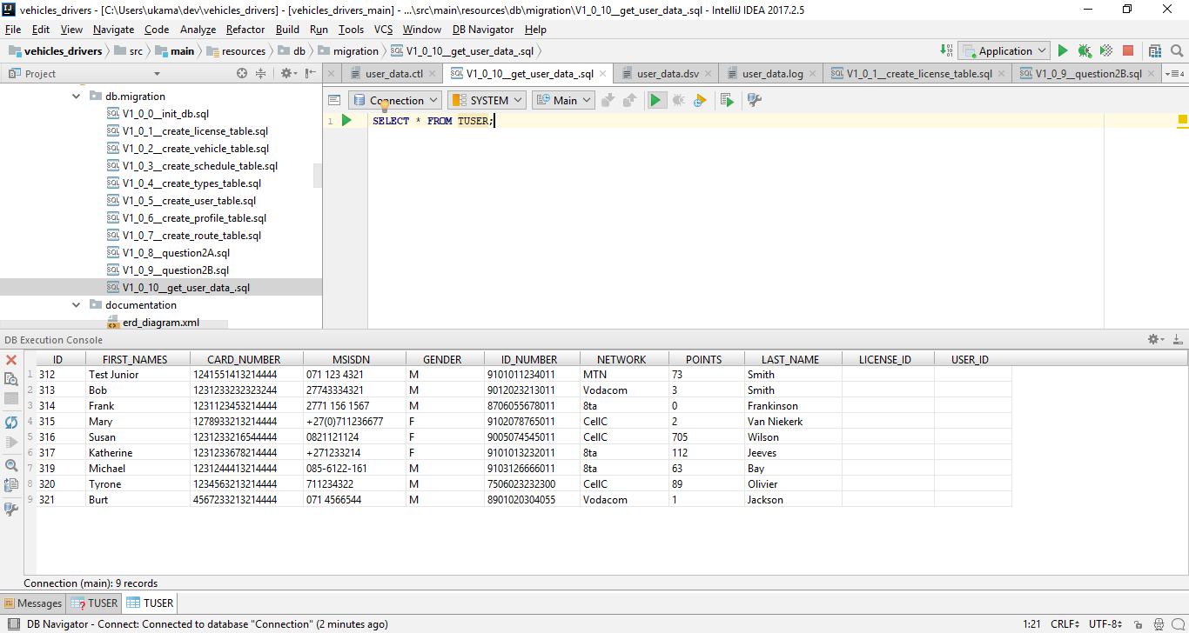

**Question 4**

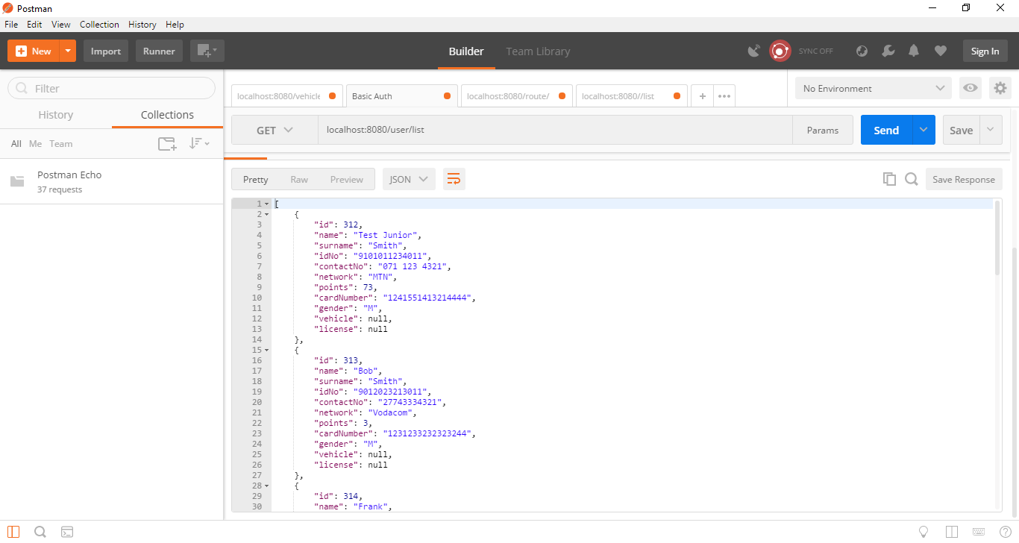

**Question 5**

* grep $YESTERDAY1 /path/to/file/FILE_PREFIX_$YESTERDAY2.dsv greps for the value of yesterday's date in the file /path/to/file/FILE_PREFIX_$YESTERDAY2.dsv and outputs that to stdout
* grep -v 'ERROR' greps for everything *other* than lines containing ERROR. It does that on the input from stdin and also writes to stdout.
* cut -d "|" -f 2 assumes the input line (from stdin) is delimited by pipe characters (-d "|", note how the pipe character is in a string here!) and picks the second field (-f 2) and writes that to stdout.
* sed 's/^0/27/' substitutes (s/.../.../) all strings from stdin (remember, second field from original input) starting (^) with 0 by 27 and writes them to stdout.

**PART II**

**1.1** There will be 15 meals

**1.2** There will be 16 meals

**1.3** The will 10 meals and N drinks types

**2.** We guarantee that ResultSet will hold all the rows data should we need to use it

**3.** Normalise user database

**4.**

* **The INTERSECT of the tables**: Many-to-many relationship need an intersect table to communicate.
* **The MINUS of the tables**: Minus includes only those members of the set on the left side of the expression that are not contained in the set on the right side of the expression
* **The UNION of the tables**: Union includes members of either or both sets (with no duplicates)