**Question 1**

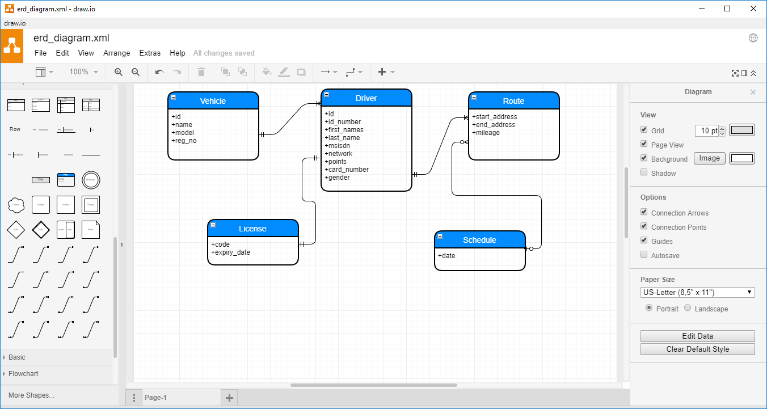

**Question 2**

* Link to gradle project
* Go to ../resource/db/migration directory to see flyway scripts from the gradle project above.

**Question 3**

* Commands to execute read from the file and insert into the user table.
* Screen shot to verify what comes back from the DB.

**Question 5**

**PART II**

**1.1**

**1.2**

**1.3**

**2.**

**3.**

**4.**