Whack a’ mole

Milena Wilkinson

Summary

* The game follows the concept of the traditional whack a’ mole game
* There will be 5 different holes, in one of the holes a mole will peak his head out, the player must predict where the mole will be and then hit it with a hammer in time
* The game gets faster over time
* If the player misses a mole 3 times, then they lose
* The aim of the game is to see how many points you can get before missing 3 moles and losing

Gameplay

**Controls**

* The players hammer will be controlled by the mouse. The hammer will directly replace the mouse cursor.
* The player swings the hammer by clicking

**Camera movement**

* The camera will shake when a mole is hit

**Lighting**

* The golden mole mentioned below, will cause the background to temporarily dim around it as it appears. This mole will shine significantly brighter than the other moles.

**Moles**

* The moles will spawn in a random place between 5 different holes
* When the moles are hit the player will gain points
* A special golden mole will occasionally appear on a small chance, hitting this mole will give you 20 points instead of 5

**Interesting mechanics**

**High score Database**

* The database will include the top 5 highest scoring players
* A higher score will replace a player with a lower score

**Powerups**

**Decomposition diagram**

**Timeline/Development milestones**

* Target release date
* Development milestone
* Phases of work
* Judging from the pattern so far, actual time = (estimated time x 2) + 2

|  |  |  |  |  |  |
| --- | --- | --- | --- | --- | --- |
| **Task** | **Estimated Hrs** | **Actual Hrs** | **Start Time/Date** | **Estimated end Time/Date** | **Actual end Time** |
| Milestone 1: ~~Sprites render and disappear on the user’s mouse click.~~ A mole will appear in a ~~random~~ hole ~~between~~ for 1 and 9. | 2 hours | 6 hours | 25/11/22 |  | 30/12/2022 |
| Milestone 1.1: Sprites disappear on a user’s mouse click ~~and reappear after a certain time.~~ | 4 hours | 10 hours | 01/12/22 | 07/12/22 | 09/12/22 |
| Milestone 1.2: One mole appears in a random hole | 4 hours | 30 minutes | 12/12/2022 – 03:09 | 12/12/2022 – 5:00 | 12/12/2022 – 3:45 |
| Milestone 1.3: A mole will disappear when hit, and will reappear after a few seconds | 1 hour | 24 minutes | 12/12/2022 – 10:18AM | 12/12/2022 – 11:18 | 12/12/2022 – 10:42 |
| Milestone 2: A score in the bottom left corner will be incremented by 5 every time the player hits a mole. ~~A special mole will increment the players score by 10. The score will be displayed at the end of the game~~ | 1 hour 30 minutes | 3 hours | 14/12/22 | 14/12/22 | 15/12/22 |
| Milestone 2.1: Get text to render | 1 hour | 2 hours | 13/12/2022 – 1:30pm | 13/12/2022 – 2:30pm | 14/12/22 – 4pm |
| Milestone 3: Implementation of a timer that counts down from 1 or 2 minutes. When the timer runs out~~, the game ends and the users score is output.~~ | 3-4 hours | 2 hours | 15/12/22 | ----- | 15/12/22 |
| Milestone 4: A game over is caused if the player runs out of time (Implement a simple game over screen with no buttons) | 1 hour | 2 hours | 16/12/22 – 10:20am | 11:30pm | 16/22/22 – 2pm |
| Milestone 5: A start screen and a replay option on the end screen. | ^ | ^ | ^ | ^ | ^ |
| Milestone 6: Each score is stored in a vector; at the end of the game the high score is output.  (High score is saved to file, score is yet to be output on to the end screen) | 2 hours | 2 hours | 17/12/22 – 10:32am | 12:32pm | 18/12/22 – 11:41am (did one hour each day) |
| Milestone 6.1: Highest score is output at the end screen | 1 hour | 30 minutes | 18/12/22 – 2:30pm | 3:30pm | 3pm |
| Milestone 7: Sprite animation: the moles slowly move out of their holes, and the hammer swings when the player clicks. | 1-3 hours |  |  |  |  |
| Milestone 8: Implement background music and sound effects | 1 hour |  |  |  |  |
| Milestone 9: 3D models for the moles and the player’s hammer | 10 hours |  |  |  |  |
| Milestone 10: Camera movement: the camera will shake when the player hits a mole | 30 minutes |  |  |  |  |
| Milestone 11: Lighting: A mole with a headlamp is a special mole that only appears sometimes, this will cause the background to become darker and the mole’s headlamp to shine brighter. | 2 hours |  |  |  |  |
| Milestone 12: The score will be stored in a database which will hold the scores of the top 5 highest scoring players, along with their names (3 letters). A higher score will replace the previous player of that position. | 7 hours |  |  |  |  |
| **Total** | 35 hours and 30 minutes |  |  |  |  |

**Sprites**

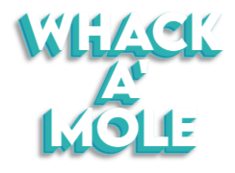

Mole.dds

Background.dds

Hammer.dds

Logo.dds

**Game in a frame**

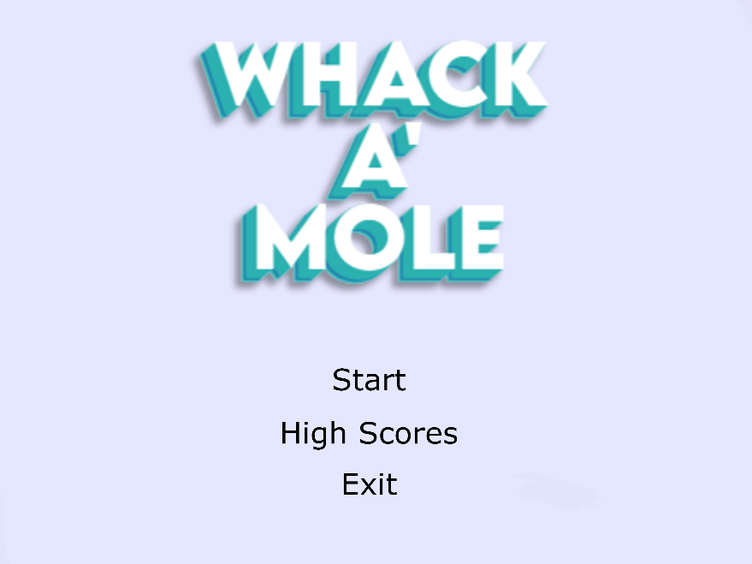

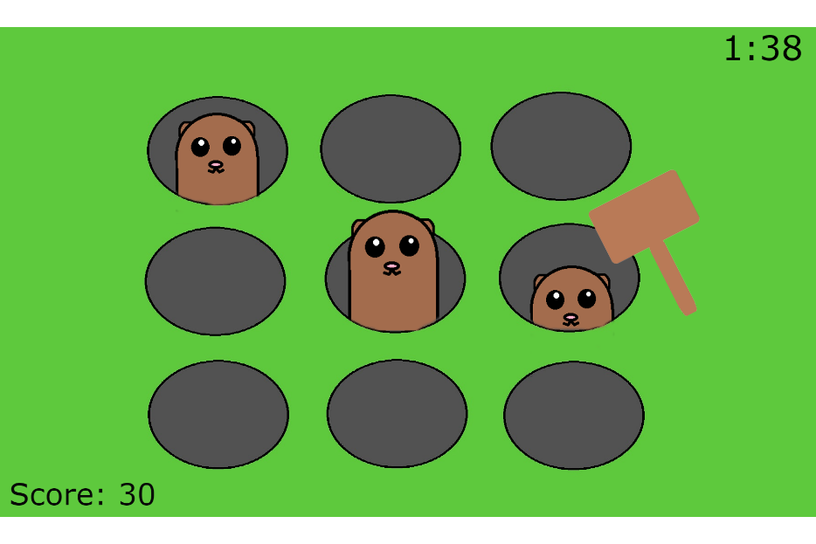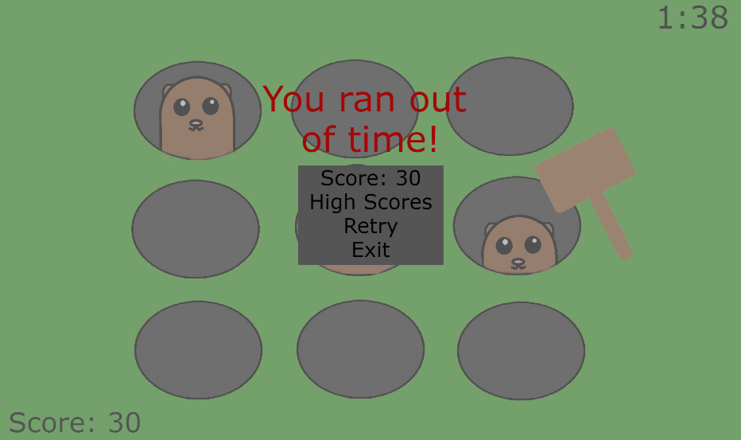

**Test Plan**

|  |  |  |  |
| --- | --- | --- | --- |
| **Test** | **Expected response** | **Actual response** | **Any other comments** |
| Interaction with mole and hammer | The mole will disappear when the it interacts with the hammer in any place. |  |  |
|  |  |  |  |
|  |  |  |  |

**Git Log**

