vlog v0.0.1.1 © 2013-24 unattended.ch

Supported server formats :
Microsoft IIS, Nginx and Apache

Download logfile, analyze it and upload .htaccess

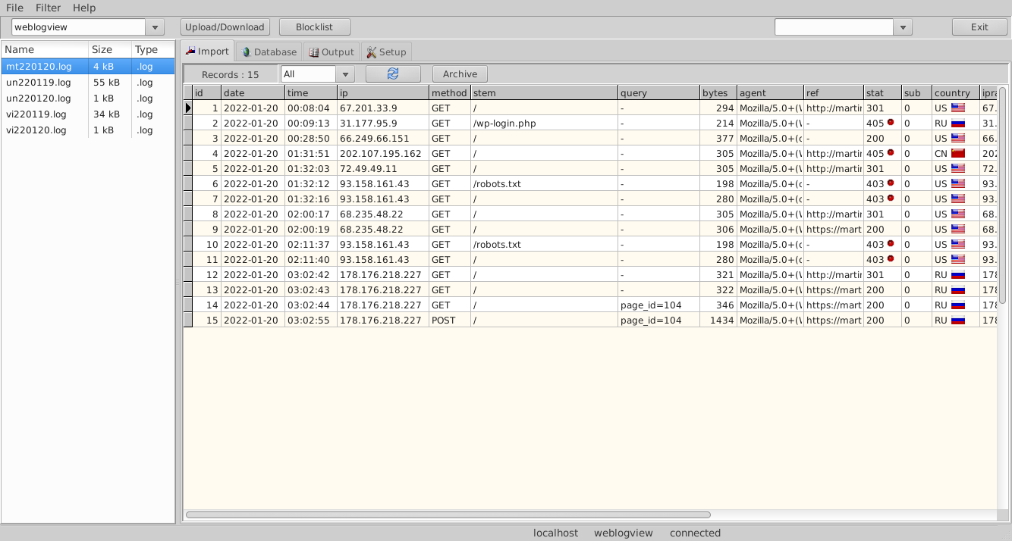
Table of Contents
1 Description 3
2 Prerequisites 4
3 First steps 5
4 Import log 6
5 Add entry to blocklist 7
6 Edit blocklist 8
7 Upload .htaccess file to server 9

Description

This software was designed to analyze Webserver log files and create .htaccess files.
You can execute the following steps :
1. Import log files from webserver and analyze it.
2. Add entry’s to blocklist
3. Upload .htaccess file to webserver

Prerequisites

You must have installed a mySQL-Server 8.0 on your computer.
And you need a mysqlclient library for database connection.

First steps
Install vlog from Debian Installationpackage.

Import log
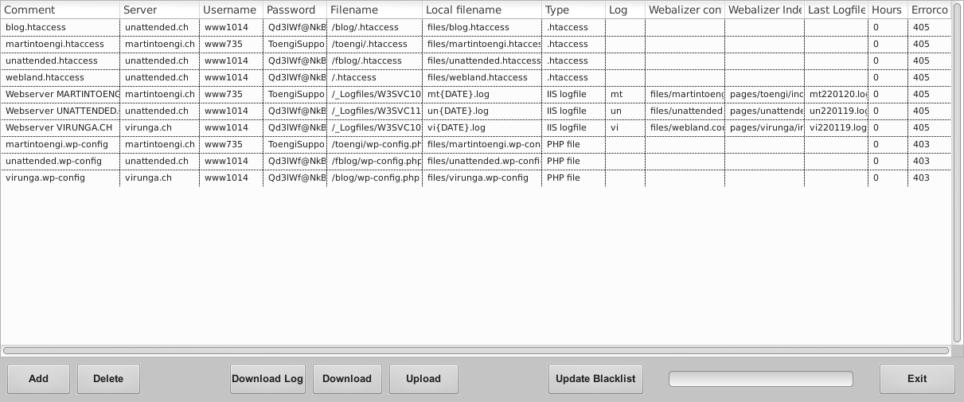

Add entry to blocklist

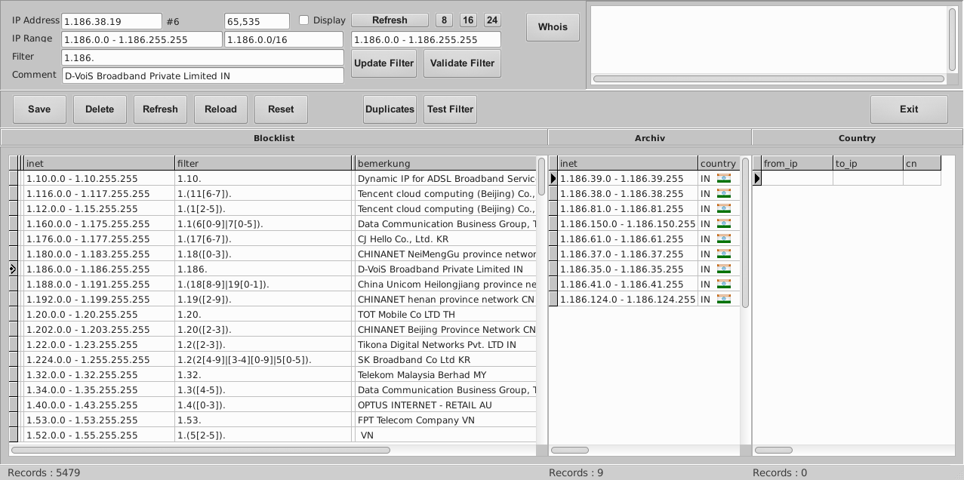
Edit blocklist

Upload .htaccess file to server

