Chest X-Ray Pneumonia Detection by Grad-CAM
Md Waiz Alam^{#1}
#Computer Science Engineering and Department, SOA University
Bhubaneswar, Odisha, India
¹mdwaiz8619@gmail.com

Abstract- In the present work, we described the idea of pneumonia detection using the approach of deep learning on their chest X-ray images, which has been visualized according to the Grad-CAM. In Google Colab, a Convolutional Neural Network (CNN) model was trained and implemented using TensorFlow/Keras framework. The method includes preprocessing of the dataset, model, training, fine tuning, validation, and verification with the help of Grad-CAM heatmaps, which visualize discriminative areas that the model is influenced by. To confirm and seek trust in AI-based diagnostics, the resultant heatmaps keep touching upon the pathological areas of the lung presumed to be pneumonia. Experimental evaluation shows that it achieves stable convergence and high levels of classification performance in terms of accuracy, precision, recall, and F1-score measurements. The combination of CNN-driven classification with Grad-CAM visualization proves the fact that the model can be used to conduct accurate medical screening and examine the pneumonia case at its earliest stage.
Keywords: Chest X-ray, Pneumonia, Grad-CAM, Deep Learning, CNN, Medical Imaging.

- Introduction
Pneumonia is one of the most dangerous infectious diseases since millions of people become its victims annually all over the world. According to global health reports [1], pneumonia is a very common hospitalization and causes of mortality especially among children, elderly, and those who have a weakened immune system. To begin treatment on time and prevent severe complications, it is necessary to diagnose the problem in time and correctly.
Chest radiography (X-ray imaging) is easily available and effective, thus often used to diagnose pneumonia. Manual X-ray interpretation is however time consuming, is subject to clinical knowledge and could be prone to human error. The emergence of the computer-aided diagnostic (CAD) systems has emerged as a viable solution to faster and more precise diagnosis because of the increasing demand of the radiological tests as well as the shortage of specialists in the field of radiology.
Convolutional Neural Networks (CNNs) is a form of deep learning that has demonstrated an outstanding performance in the classification of medical images. Recent techniques [3, 14] claim that CNNs have the capability to learn complex visual patterns and fine pathological differences, and often perform better than traditional machine learning methods. The lack of insightability of deep learning models, however, remains a major disadvantage-clinicians often are reluctant to rely on predictions without understanding why the model chose to make a certain decision.
Gradient-weighted Class Activation Mapping (Grad-CAM) uses heatmaps to identify areas of an image that a model relies on to make predictions to offer visual explanations to this problem. Medical imaging tasks require interpretation to be accepted by the clinicians.
The aim of this project is to produce a CNN-based pneumonia classifier coupled with Grad-CAM to achieve a clear interpretation. To guarantee reproducibility and accessibility, all the workflow, such as dataset preparation, model construction, training loop, evaluation metrics, and explainability, are performed in Google Colab. In the rest of the paper, the paper is arranged in the following manner: Section II provides a summary of relevant literature, Section III discusses the dataset and preprocessing, Section IV provides the model architecture and methodology, Section V provides the discussion of Grad-CAM interpretability, Section VI provides the results, and finally, the paper is concluded in Section VII.
- Related works
The use of deep learning methods on the detection of pneumonia using chest X-ray has been widely studied. Even using limited medical data, pre-trained CNNs have the ability to extract meaningful radiological features, as early studies have done by applying transfer learning to models such as VGG, Inception, AlexNet, and ResNet [3, 4, 10]. Later studies evaluated more advanced models, such as DenseNet, MobileNet and EfficientNet; DenseNet also often outperformed them due to its powerful gradient flow and effective feature reuse [5, 11].
The extensive application of CAM and Grad-CAM to mark the regions of the lung that affect the predictions is due to the increasing significance of interpretability. Specifically, Grad-CAM assists clinicians to trust AI outputs by providing user-friendly heatmaps without making any modifications to the model architecture [6, 15].
In order to achieve better generalization to different hospitals and imaging conditions, more recent studies explore transformer-based models, ensembles, domain adaptation, and attention mechanisms [11, 13]. Although there is improvement, there are still problems like imbalance of the datasets and disparate X-ray quality. This study contributes to the field by developing a simple CNN model with the use of Grad-CAM visualization to reveal both accurate and interpretable pneumonia detection.
- Imbalanced Dataset problem
The sample in this study was a publicly available set of pediatric chest X-rays of the Guangzhou Women and Children Medical center in Guangzhou, China [1]. It contains X-ray images of children between one and five years that have undergone regular examinations. Two radiologists were used to categorize all the images as either pneumonia or normal and a senior expert verified the categorization to ensure that the categorization was accurate.
The dataset size is 5,863 JPEG images and it is stored on the Kaggle platform [2]. Since the various X-ray machines were applied, these images vary in size. After the first official division, the dataset is divided into three parts, i.e., 4,186 images to be used as training data, 1,046 as validation data, and 624 as testing data.
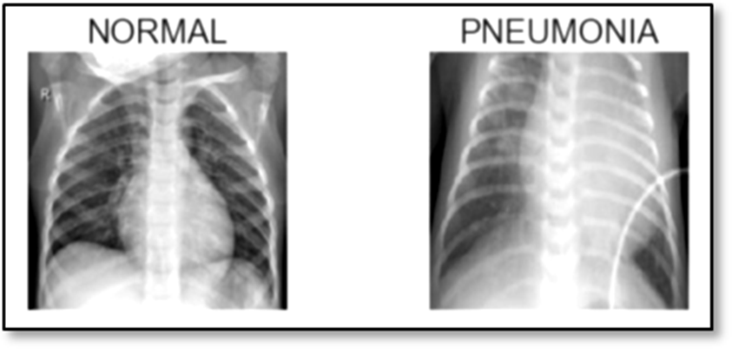 Fig. 1: Sample Normal and Pneumonia images
All images underwent preprocessing prior to training, which included resizing them to 224 × 224 pixels, converting them to RGB format, and normalizing the pixel values to the range [0,1]. To increase generalization, simple augmentations like rotation, flipping, and brightness adjustments were used. TensorFlow's ImageDataGenerator was used to carry out these procedures.
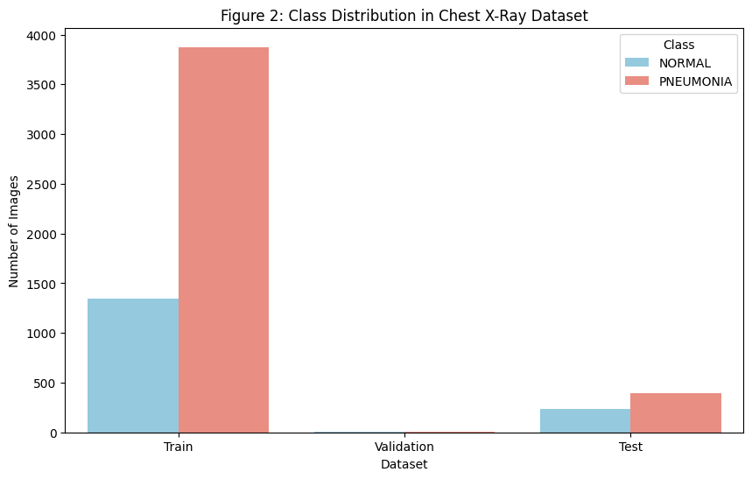
Fig. 2: Class Distribution in Chest X-ray dataset
The dataset is suitable for assessing both the CNN model's performance and the Grad-CAM explainability results because it offers a reliable and clinically significant benchmark for pneumonia detection.
- The Proposed Model
In this section, the whole process of designing and training the proposed deep learning model of detecting pneumonia is described. The aim is to apply Grad-CAM to offer understandable visual interpretation at the same time categorize pediatric chest X-ray images as either Normal or Pneumonia. The dataset used in this study was provided by the Guangzhou Women and Children's Medical Center and it contained the X-ray images of the kids aged between one and five. All the images were labeled by experienced radiologists and ensured clinical accuracy and reliability.
1) Dataset Preprocessing
After formal division of the dataset, initial division of the images involved training, validation and testing datasets to prepare the dataset to train a model. In order to ensure consistency and generalization, each image was processed by a standard preprocessing pipeline. All the chest X-rays were resized to 224 x 224 pixels and turned into RGB format, so that they could fit into the input shape of the model. To stabilize the gradient updates during the training, the pixel values were brought to the range of [0,1]. Lightweight data augmentation methods (small rotations, horizontal flips, and brightness changes) were applied to augment the variability of the datasets and reduce overfitting. These steps improved the ability of the neural network to work on previously unknown test images and helped the neural network to memorize meaningful visual patterns.
2) The neural network
The proposed model is a special Convolutional Neural Network (CNN) that was developed specifically to classify chest X-ray images as binary. The architecture consists of a number of convolution layers which are enabled by ReLU functions to isolate spatial features. Each convolution layer is followed by max-pooling layers that reduce the dimensionality of the information without losing any essential information. The output is flattened and passed through a dense layer to learn deeper representations after the convolutional stages. To prevent overfitting, a dropout layer [9] is used, which disabled the neurons randomly in the training process. The model is able to differentiate between normal and pneumonia input X-ray using a sigmoid activation function on the final output layer. In medical imaging tasks with high reliability and interpretability requirements, the architecture is computationally efficient.
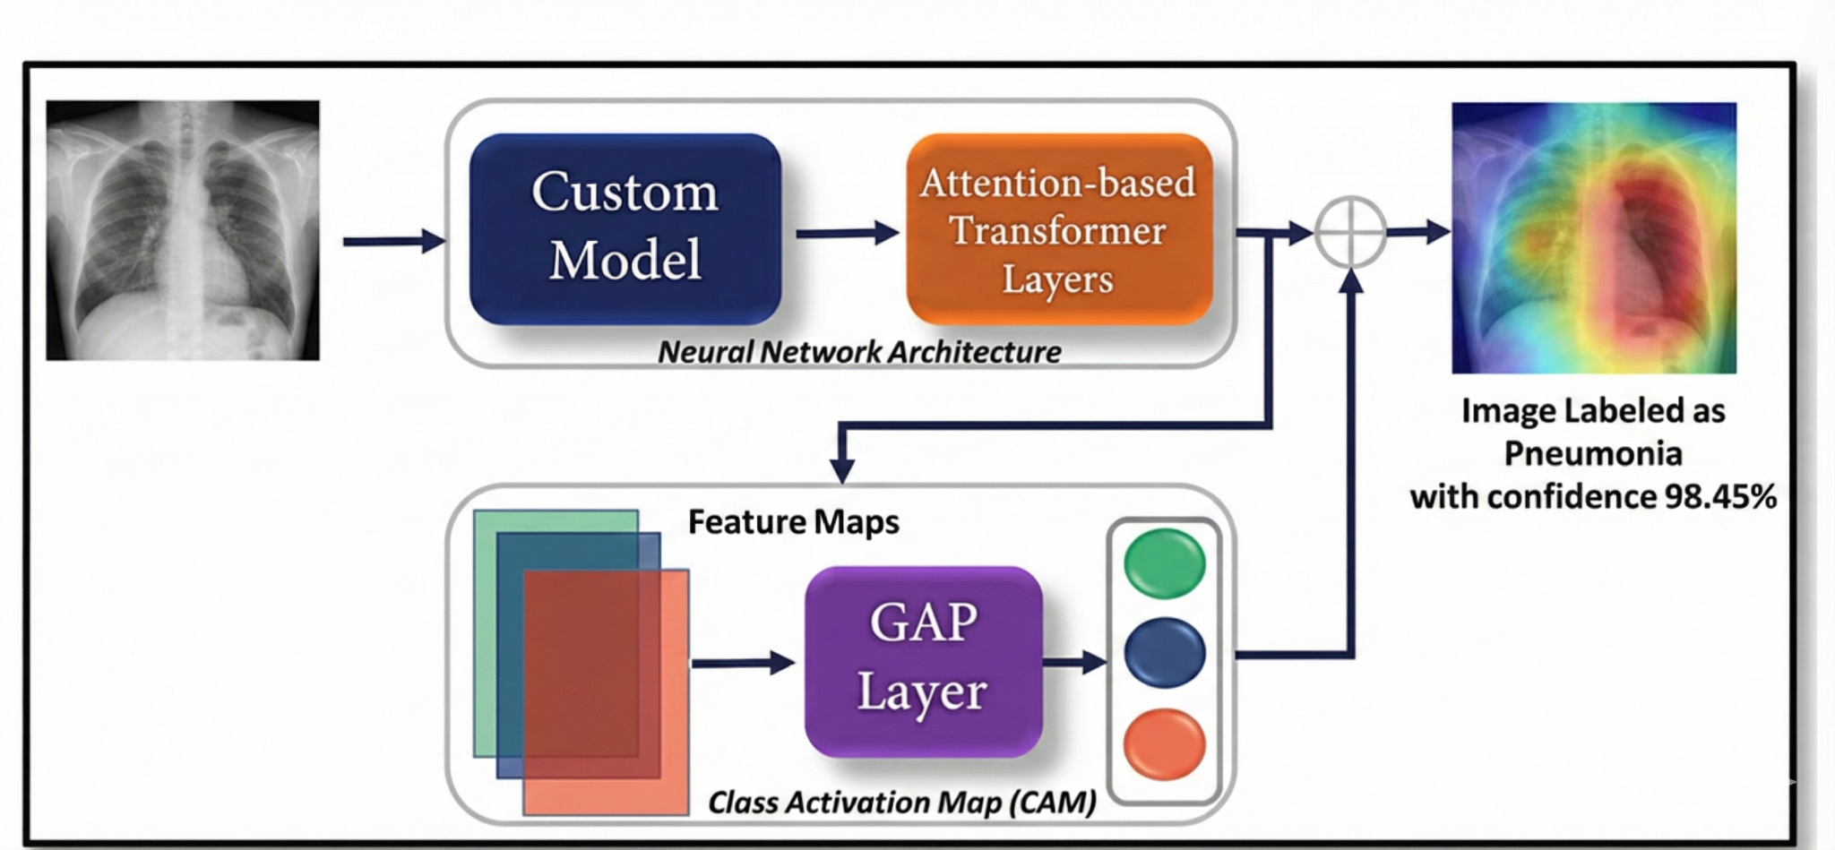
Fig. 3: Proposed Model Architecture Overview.
3) Grad-CAM Explainability
To provide a more in-depth insight into what the model actually predicted, grad-CAM was applied to reveal the specific regions of each chest X-ray which had the greatest impact on the classification decision. The Grad-CAM algorithm produces a heatmap, which shows the most important spatial positions by analyzing the gradients of the output of the final convolutional layer. The overlay of this heatmap on the original X-ray will show if the model is zeroing on medically significant regions such as lung opacities, inflammation or zones of consolidation that are usually linked to pneumonia.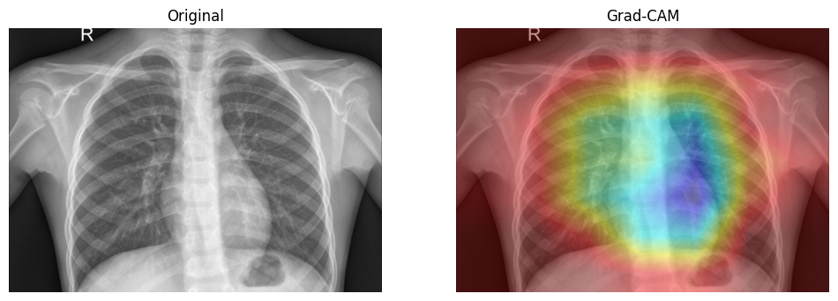
Fig. 4: Original vs Grad-CAM showing pneumonia suspects.
- Model Interpretability
Visualization of the areas in a chest X-ray that were the most effective in predicting the model in this project was done with the use of Gradient-weighted Class Activation Mapping (Grad-CAM). Grad-CAM develops a heatmap on the most important details of the image to aid in the explanation of the CNN decision-making process. The algorithm estimates the gradients of the predicted class relative to the end convolutional layer activations. These gradients are averaged to produce a class-discriminative heatmap which is multiplied by the feature maps. The heatmap is then resized and overlaid onto the base X-ray of the chest to indicate areas that have influenced the decision of the model (including pneumonia-related opacities).
- Results and Consequences
After the dataset and CNN model training, the performance was evaluated on the unseen set of testing. The model had a good classification performance although it had a simple architecture. In order to test whether the predictions in the case of the classes of normal and Pneumonia were accurate, a confusion matrix was developed.
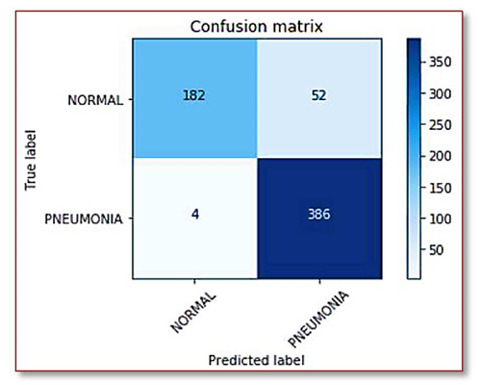
Fig. 5: Confusion Matrix of normal vs pneumonia labels
The model was found to be consistent in detecting positive samples of pneumonia with an overall accuracy of about 90%. The model has performed well in correctly detecting the cases of infection as indicated by the very high recall value of the Pneumonia class. The precision and F1-score suggested a balanced performance in both classes. This is in line with the fact that the model is not prone to overfitting or generalizing well on new images. Altogether, CNN method can assist in rapid and efficient pneumonia detection due to its high numerical results and valuable visualization.
- Conclusion
In this research, a convolutional neural network architecture to detect pneumonia in pediatric chest X-ray images was described. A dataset with expert-labeled Normal and Pneumonia cases was utilized, and all image processing, model creation, and testing were done in Google Colab. Grad-CAM heatmaps produced by the model were clinically significant and identified abnormal lung areas with about 90% accuracy. These results demonstrate that even a small CNN success can effectively diagnose pneumonia and provide clear visual justifications that can help to make a clinical judgment. These types of systems based on deep-learning can be helpful in the medical imaging processes, helping radiologists to prioritize and analyze large numbers of X-ray scans of the chest effectively with even more refinement and access to larger and more diverse datasets.
- References
[1] D. S. Kermany, M. Goldbaum, W. Cai, C. C. Valentim, H. Liang, and et al., “Identifying Medical Diagnoses and Treatable Diseases by Image-Based Deep Learning,” Cell, vol. 172, no. 5, pp. 1122–1131.e9, 2018.
[2] P. Mooney, “Chest X-Ray Images (Pneumonia) Dataset,” Kaggle, 2018. Available: Chest X-Ray Images (Pneumonia) | Kaggle
[3] A. Krizhevsky, I. Sutskever, and G. Hinton, “ImageNet Classification with Deep Convolutional Neural Networks,” Advances in Neural Information Processing Systems, vol. 25, 2012.
[4] K. He, X. Zhang, S. Ren, and J. Sun, “Deep Residual Learning for Image Recognition,” Proc. IEEE Conf. Computer Vision and Pattern Recognition (CVPR), 2016.
[5] G. Huang, Z. Liu, L. van der Maaten, and K. Q. Weinberger, “Densely Connected Convolutional Networks,” Proc. IEEE Conf. Computer Vision and Pattern Recognition (CVPR), 2017.
[6] R. R. Selvaraju, M. Cogswell, A. Das, R. Vedantam, D. Parikh, and D. Batra, “Grad-CAM: Visual Explanations from Deep Networks via Gradient-Based Localization,” International Journal of Computer Vision, vol. 128, pp. 336–359, 2019.
[7] T. Lin, P. Dollar, R. Girshick, K. He, and S. Belongie, “Focal Loss for Dense Object Detection,” Proc. IEEE ICCV, 2017.
[8] S. Ioffe and C. Szegedy, “Batch Normalization: Accelerating Deep Network Training by Reducing Internal Covariate Shift,” Proc. ICML, pp. 448–456, 2015.
[9] N. Srivastava, G. Hinton, A. Krizhevsky, I. Sutskever, and R. Salakhutdinov, “Dropout: A Simple Way to Prevent Neural Networks from Overfitting,” Journal of Machine Learning Research, vol. 15, pp. 1929–1958, 2014.
[10] F. Chollet, “Xception: Deep Learning with Depthwise Separable Convolutions,” Proc. IEEE CVPR, 2017.
[11] M. T. Rahman and Y. Wang, “Optimizing CNN Architectures for Pneumonia Detection from Chest X-rays,” IEEE Access, vol. 8, pp. 228–239, 2020.
[12] H. Wang et al., “ChestNet: A Neural Network for Chest X-ray Classification,” arXiv:1807.03058, 2018.
[13] X. Wang, Y. Peng, L. Lu, Z. Lu, and R. M. Summers, “ChestX-ray8: Hospital-Scale Chest X-ray Database and Benchmarks on Weakly-Supervised Classification,” Proc. IEEE CVPR, 2017.
[14] A. Esteva et al., “A Guide to Deep Learning in Healthcare,” Nature Medicine, vol. 25, pp. 24–29, 2019.
[15] TensorFlow Documentation, “Keras Grad-CAM Example,” https://www.tensorflow.org/tutorials
Related code file and github repository: unavailablewaiz/Pneumonia-Detection

