Umair Naveed
u0414943

CS 5530 – Project: Phase 1

ER Diagram
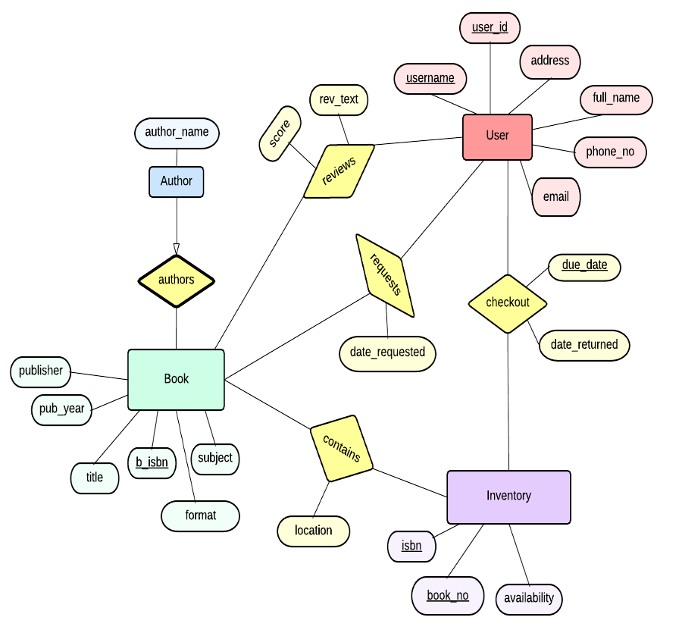

SQL Queries

create table Book( b_isbn char(20),
title varchar(50),
subject char(20),
publisher char(30),
pub_year year,
format char(20),
primary key (b_isbn))

create table Inventory( isbn char(20),
book_no int,
availability char(20) not null,
primary key (isbn, book_no))

create table User( username varchar(30),
user_id int auto_increment,
address varchar(40) not null,
full_name char(30) not null,
phone_no varchar(11),
email varchar(30),
primary key (username, user_id))

create table Author( isbn char(20),
author_name char(30),
primary key (isbn),
foreign key (isbn) references Book(b_isbn),
on delete cascade)

create table Reviews( isbn char(20),
username varchar(30),
user_id int,
score int not null,
rev_text varchar(100),
primary key (isbn, username, user_id),
foreign key (isbn) references Book(b_isbn),
foreign key (username, user_id) references User,
check (rating >= 1 and rating <= 10))

create table Requests( isbn char(20),
username varchar(30),
user_id int,
date_requested datetime,
primary key (isbn, username, user_id, date_requested),
foreign key (isbn) references Book(b_isbn),
foreign key (username, user_id) references User)

create table Checkout (isbn char(20),
book_no int,
username varchar(30),
user_id int not null,
due_date date,
date_returned date,
primary key (isbn, username, user_id, due_date),
foreign key (isbn) references Inventory,
foreign key (username, user_id) references User)

create table Contains ( isbn char(20),
book_no int,
b_isbn char(20),
location char(30),
primary key (isbn, book_no),
foreign key (isbn, book_no) references Inventory,
foreign key (b_isbn) references Book,
constraint sameBook check ( select i.isbn, i.book_no, c.location
from Inventory i, Contains c, Book B
where i.isbn = b.b_isbn))

